Experiment No.4

1)Write a program to create and display a list.
Program :-

n = int(input("Enter number of elements: "))
my_list = []

for i in range(n):
element = input("Enter element: ")
my_list.append(element)

print("The list is:", my_list)

OUTPUT :-
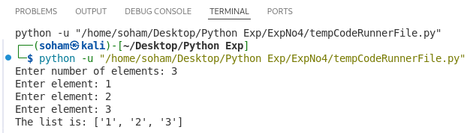
2)Write a program to find sum and average of list elements.
Program :-

n = int(input("Enter number of elements: "))
my_list = []

for i in range(n):
num = int(input("Enter number: "))
my_list.append(num)

total = sum(my_list)
average = total / n

print("List:", my_list)
print("Sum:", total)
print("Average:", average)

OUTPUT :-
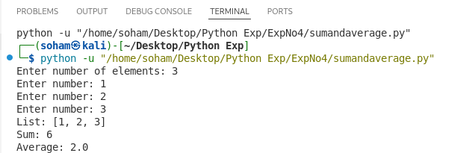
3)Write a program to find maximum and minimum element in a list.
Program :-

n = int(input("Enter number of elements: "))
my_list = []

for i in range(n):
num = int(input("Enter number: "))
my_list.append(num)

print("List:", my_list)
print("Maximum element:", max(my_list))
print("Minimum element:", min(my_list))

OUTPUT :-
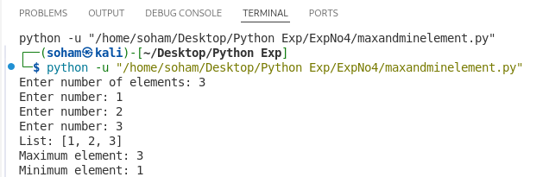
4)Write a program to sort elements of a list.
Program :-

n = int(input("Enter number of elements: "))
my_list = []

for i in range(n):
num = int(input("Enter number: "))
my_list.append(num)

my_list.sort()
print("Sorted list (ascending):", my_list)
OUTPUT :-
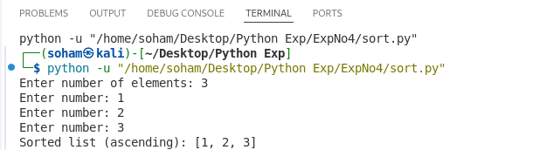
5)Write a program to remove duplicate elements from a list.
Program :-

n = int(input("Enter number of elements: "))
my_list = []

for i in range(n):
num = int(input("Enter number: "))
my_list.append(num)

new_list = []

for num in my_list:
if num not in new_list:
new_list.append(num)

print("Original list:", my_list)
print("After removing duplicates:", new_list)

OUTPUT :-
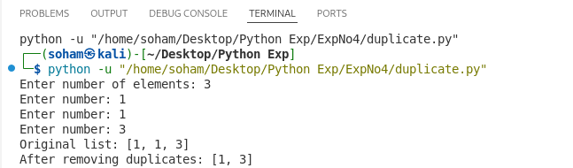
6)Write a program to search an element in a list.
Program :-

print("Found" if int(input("Enter element: ")) in list(map(int, input("Enter list: ").split())) else "Not Found")

OUTPUT :-
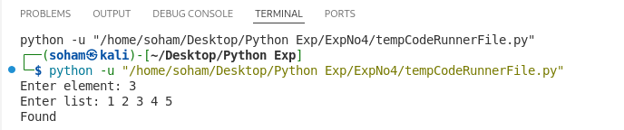
7)Write a program to merge two lists.
Program :-

list1 = [1, 2, 3]
list2 = [4, 5, 6]

merged = list1 + list2
print("Merged list:", merged)

OUTPUT :-
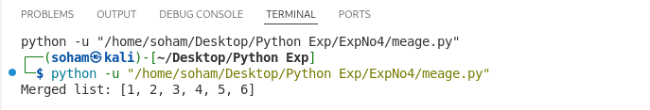
8)Write a program to count even and odd numbers in a list.
Program :-

n = int(input("Enter number of elements: "))
my_list = []

for i in range(n):
num = int(input("Enter element: "))
my_list.append(num)

even_count = 0
odd_count = 0

for num in my_list:
if num % 2 == 0:
even_count += 1
else:
odd_count += 1

print("List:", my_list)
print("Even numbers count:", even_count)
print("Odd numbers count:", odd_count)

OUTPUT :-
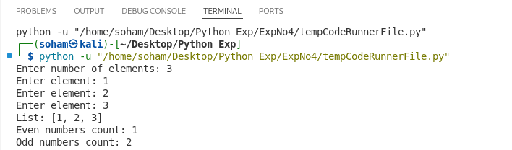
9)Write a program to find second largest element in a list.
Program :-

n = int(input("Enter number of elements: "))
my_list = []

for i in range(n):
num = int(input("Enter element: "))
my_list.append(num)

my_list.sort()

print("Second largest element:", my_list[-2])

OUTPUT :-
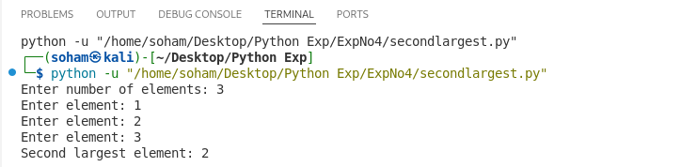
10)Write a program to demonstrate list slicing.
Program :-

# Original list
my_list = [10, 20, 30, 40, 50, 60, 70]

print("Original list:", my_list)

# Basic slicing
print("my_list[1:5]:", my_list[1:5])

# From beginning
print("my_list[:4]:", my_list[:4])

# Till end
print("my_list[3:]:", my_list[3:])

# Step slicing
print("my_list[0:7:2]:", my_list[0:7:2])

# Reverse list
print("my_list[::-1]:", my_list[::-1])

OUTPUT :-
