Experiment No.5

1)Write a program to create a tuple and display its elements.
Program :-

my_tuple = (10, 20, 30, 40, 50)

print("Tuple:", my_tuple)

print("Elements of the tuple are:")
for item in my_tuple:
print(item)

OUTPUT :-
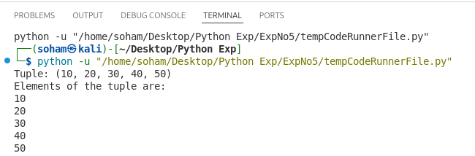
2)Write a program to find sum and average of tuple elements.
Program :-

my_tuple = (10, 20, 30, 40, 50)

total = sum(my_tuple)

average = total / len(my_tuple)

print("Tuple:", my_tuple)
print("Sum of tuple elements:", total)
print("Average of tuple elements:", average)

OUTPUT :-
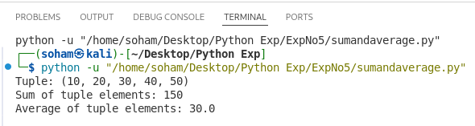

3)Write a program to find maximum and minimum in a tuple.
Program :-

my_tuple = (15, 5, 100, 25, 60, 3)

maximum = max(my_tuple)
minimum = min(my_tuple)

print("Tuple:", my_tuple)
print("Maximum element:", maximum)
print("Minimum element:", minimum)

OUTPUT :-
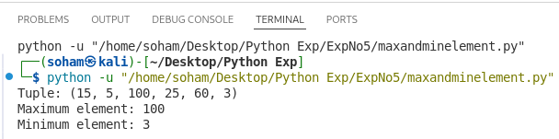
4)Write a program to demonstrate tuple packing and unpacking.
Program :-

my_tuple = 10, 20, 30, 40, 50

print("Packed Tuple:", my_tuple)

a, b, c, d, e = my_tuple

print("Unpacked values:")
print("a =", a)
print("b =", b)
print("c =", c)
print("d =", d)
print("e =", e)

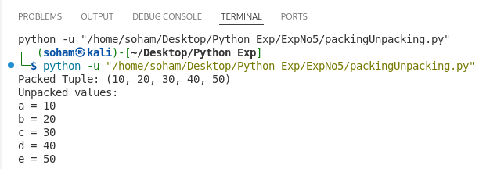
OUTPUT :-

5)Write a program to convert tuple into list.
Program :-

my_tuple = (10, 20, 30, 40, 50)

my_list = list(my_tuple)

print("Tuple:", my_tuple)
print("Converted List:", my_list)

OUTPUT :-
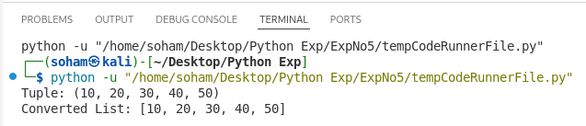
6)Write a program to create and perform set operations.
Program :-

set1 = {10, 20, 30, 40, 50}
set2 = {30, 40, 50, 60, 70}

union_set = set1 | set2

intersection_set = set1 & set2

difference_set = set1 - set2

sym_diff_set = set1 ^ set2

print("Set 1:", set1)
print("Set 2:", set2)

print("Union:", union_set)
print("Intersection:", intersection_set)
print("Difference (Set1 - Set2):", difference_set)
print("Symmetric Difference:", sym_diff_set)

OUTPUT :-
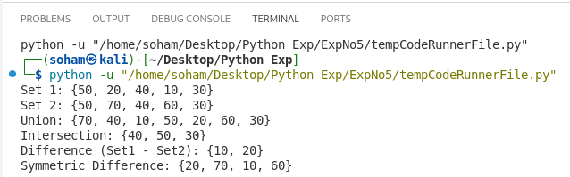
7)Write a program to find union, intersection and difference of sets.
Program :-

set1 = {1, 2, 3, 4, 5}
set2 = {4, 5, 6, 7, 8}

union_result = set1.union(set2)

intersection_result = set1.intersection(set2)

difference_result = set1.difference(set2)

print("Set 1:", set1)
print("Set 2:", set2)

print("Union:", union_result)
print("Intersection:", intersection_result)
print("Difference (Set1 - Set2):", difference_result)

OUTPUT :-
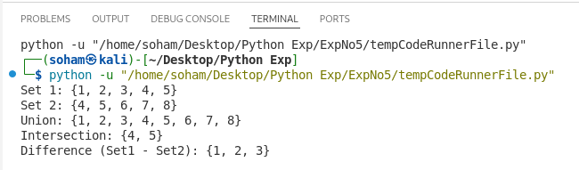
8)Write a program to remove duplicate elements using set.
Program :-

my_list = [10, 20, 30, 20, 40, 10, 50, 30]

print("Original List:", my_list)

unique_set = set(my_list)

unique_list = list(unique_set)

print("After removing duplicates (Set):", unique_set)
print("After removing duplicates (List):", unique_list)

OUTPUT :-
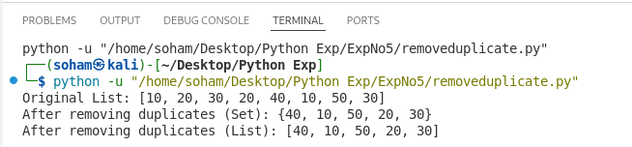
9)Write a program to check membership of an element in tuple.
Program :-

my_tuple = (10, 20, 30, 40, 50)

element = 30

if element in my_tuple:
print(element, "is present in the tuple")
else:
print(element, "is not present in the tuple")

OUTPUT :-
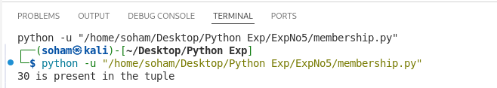
10)Write a program to count occurrences of an element in tuple.
Program :-

my_tuple = (10, 20, 30, 10, 40, 20, 10, 50)

element = 10

count = my_tuple.count(element)

print("Tuple:", my_tuple)
print("Element:", element)
print("Occurrence count:", count)

OUTPUT :-
