Experiment No.6

1)Write a program to create a dictionary of student details.
Program :-

student = {
"name": "Soham",
"roll_no": 101,
"class": "SYBtech",
"age": 18,
"marks": {
"Math": 85,
"Science": 90,
"English": 78
}
}

print("Student Details:")
for key, value in student.items():
print(key, ":", value)

OUTPUT :-
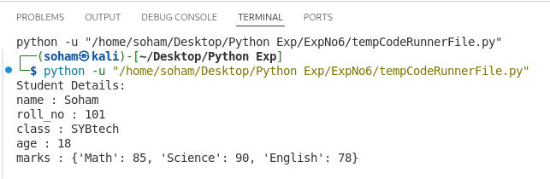
2)Write a program to access keys, values and items of a dictionary.
Pogram :-

student = {"name": "Soham", "age": 18, "roll_no": 101}

print("Keys:", student.keys())
print("Values:", student.values())
print("Items:", student.items())
OUTPUT :-
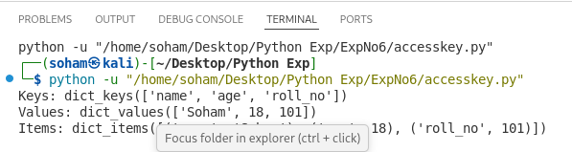
3)Write a program to add and update dictionary elements.
Program :-

student = {"name": "Soham", "age": 18}
student["roll_no"] = 101
student["age"] = 19
print(student)

OUTPUT :-
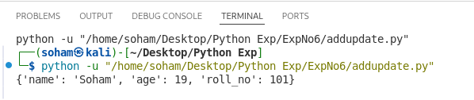
4)Write a program to delete elements from dictionary.
Program :-

# Create dictionary
student = {"name": "Soham", "age": 18, "roll_no": 101}
# Delete element using del
del student["age"]
# Delete element using pop()
student.pop("roll_no")
# Display dictionary
print(student)

OUTPUT :-
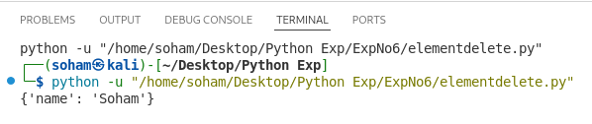
5)Write a program to count frequency of words in a sentence using dictionary.
Program:-

# Input sentence
sentence = input("Enter a sentence: ")
# Split into words
words = sentence.split()
# Create dictionary
freq = {}
# Count frequency
for word in words:
freq[word] = freq.get(word, 0) + 1
# Display result
print(freq)

OUTPUT :-
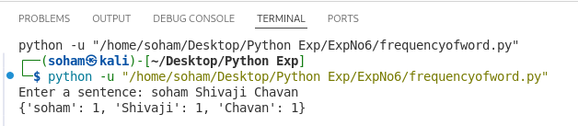
6)Write a program to merge two dictionaries.
Program :-

# Create two dictionaries
d1 = {"a": 1, "b": 2}
d2 = {"c": 3, "d": 4}
# Merge dictionaries
d1.update(d2)
# Display result
print(d1)

OUTPUT :-
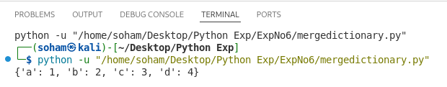
7)Write a program to convert hexadecimal to binary using dictionary.
Program :-

# Dictionary for hex to binary
hex_bin = {
'0': '0000', '1': '0001', '2': '0010', '3': '0011',
'4': '0100', '5': '0101', '6': '0110', '7': '0111',
'8': '1000', '9': '1001', 'A': '1010', 'B': '1011',
'C': '1100', 'D': '1101', 'E': '1110', 'F': '1111'
}
# Input hexadecimal number
hex_num = input("Enter hexadecimal number: ").upper()
# Convert to binary
binary = ""
for digit in hex_num:
binary += hex_bin[digit]
# Display result
print("Binary:", binary)
OUTPUT :-
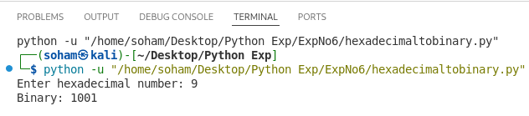
8)Write a program to find student with highest marks.
Program :-

# Dictionary of students and marks
students = {"Amit": 85, "Soham": 92, "Riya": 88}
# Find student with highest marks
top_student = max(students, key=students.get)
# Display result
print("Top Student:", top_student)
print("Marks:", students[top_student])

OUTPUT :-
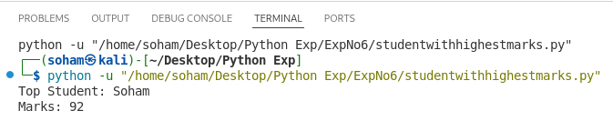
9)Write a program to sort dictionary by keys and values.
Program :-

# Create dictionary
student = {"b": 85, "a": 92, "c": 78}
# Sort by keys
print("Sorted by keys:")
for k in sorted(student):
print(k, ":", student[k])
# Sort by values
print("\nSorted by values:")
for k, v in sorted(student.items(), key=lambda x: x[1]):
print(k, ":", v)

OUTPUT :-
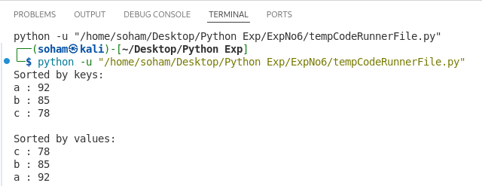
10)Write a program to demonstrate dictionary comprehension.
Program :-

# Create dictionary using comprehension
squares = {x: x*x for x in range(1, 6)}
# Display dictionary
print(squares)

OUTPUT :-
