Experiment No.7

1)Write a program to define and call a function
Program :-

# Define function
def greet():
print("Hello, Welcome!")
# Call function
greet()

OUTPUT :-
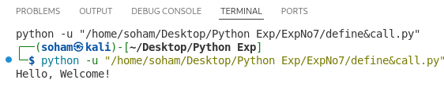
2)Write a program to pass arguments to a function.
Program :-

# Define function with parameters
def add(a, b):
print("Sum:", a + b)

# Pass arguments
add(5, 3)

OUTPUT :-
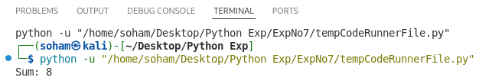
3)Write a program to return multiple values from a function.
Program :-

# Function returning multiple values
def calc(a, b):
return a + b, a - b
# Call function
sum_val, diff_val = calc(10, 5)
# Display results
print("Sum:", sum_val)
print("Difference:", diff_val)

OUTPUT :-
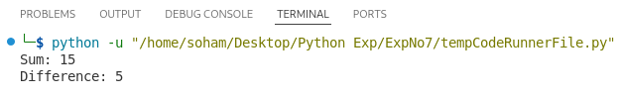
4)Write a program to calculate factorial using function.
Program :-

def factorial(n):
fact = 1
for i in range(1, n + 1):
fact *= i
return fact

num = int(input("Enter a number: "))

result = factorial(num)

print("Factorial:", result)

OUTPUT :-
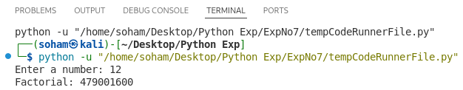
5)Write a program to calculate factorial using recursion.
Program :-

def factorial(n):
if n == 0 or n == 1:
return 1
return n * factorial(n - 1)

num = int(input("Enter a number: "))

print("Factorial:", factorial(num))

OUTPUT :-
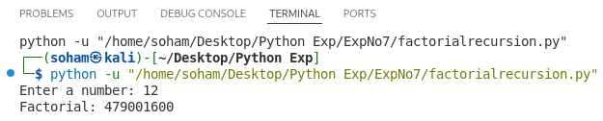
6)Write a program to generate Fibonacci series using recursion.

Program :-

def fibonacci(n):
if n <= 1:
return n
else:

num = int(input("Enter number of terms: "))

print("Fibonacci Series:")
for i in range(num):
print(fibonacci(i), end=" ")

OUTPUT :-
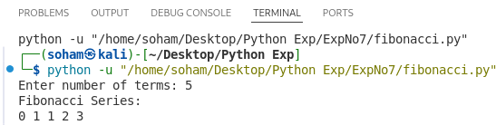
7)Write a program to demonstrate lambda function
Program :-

# Lambda function to find square
square = lambda x: x * x

print("Square:", square(5))

OUTPUT :-
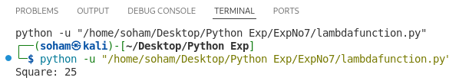
8)Write a program to use built-in functions.
Program :-

nums = [10, 20, 30, 40, 50]

print("Sum:", sum(nums))
print("Max:", max(nums))
print("Min:", min(nums))
print("Length:", len(nums))
print("Sorted:", sorted(nums))

OUTPUT :-

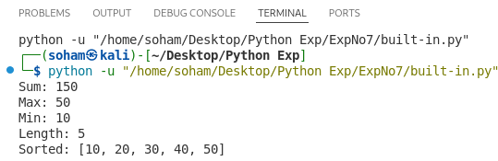
9)Write a program to demonstrate scope of variables.
Program :-

x = 10

def func():

x = 5
print("Inside function (local x):", x)

func()
print("Outside function (global x):", x)

OUTPUT :-
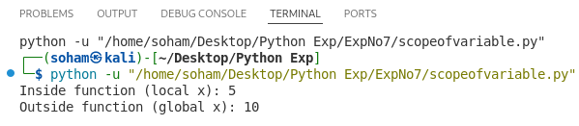
10) Write a program to check prime number using function.
Program :-

def is_prime(n):
if n <= 1:
return False
for i in range(2, n):
if n % i == 0:
return False
return True

num = int(input("Enter a number: "))

if is_prime(num):
print("Prime number")
else:
print("Not a prime number")

OUTPUT :-

