Experiment No.8

1)Write a program to create a class and object.
Program :-

class Student:
def __init__(self, name, age):
self.name = name
self.age = age

def display(self):
print("Name:", self.name)
print("Age:", self.age)

s1 = Student("Soham", 18)

s1.display()

OUTPUT :-
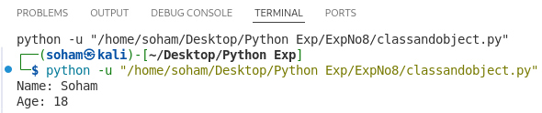
2)Write a program to demonstrate constructor.
Program :-

class Student:
def __init__(self, name, age):
self.name = name
self.age = age
print("Constructor called")

def display(self):
print("Name:", self.name)
print("Age:", self.age)

s1 = Student("Soham", 18)

# Call method
s1.display()

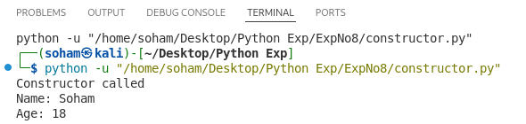
OUTPUT :-
3)Write a program to demonstrate instance and class variables.
Program :-

class Student:
school = "ABC School"
def __init__(self, name, age):

self.name = name
self.age = age

s1 = Student("Soham", 18)
s2 = Student("Amit", 19)

print("Class Variable:", Student.school)

print("\nInstance Variables:")
print(s1.name, s1.age)
print(s2.name, s2.age)

OUTPUT :-
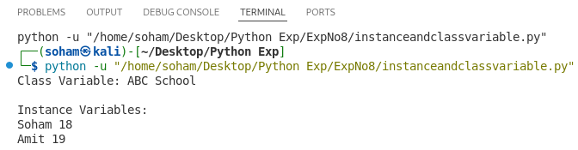
4)Write a program to demonstrate single inheritance.
Program :-

class Person:
def show(self):
print("This is parent class")

class Student(Person):
def display(self):
print("This is child class")

s = Student()

s.show() # Inherited method
s.display() # Own method

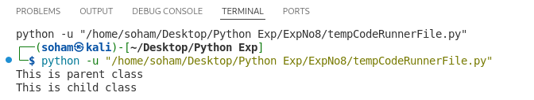
OUTPUT :-
5)Write a program to demonstrate multiple inheritance.
Program :-

class Father:
def show_father(self):
print("This is Father class")

class Mother:
def show_mother(self):
print("This is Mother class")

class Child(Father, Mother):
def show_child(self):
print("This is Child class")

c = Child()

c.show_father()
c.show_mother()
c.show_child()

OUTPUT :-
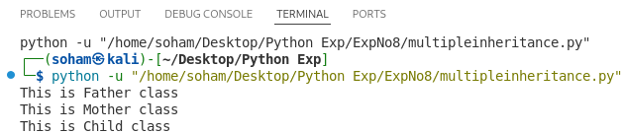
6)Write a program to demonstrate multilevel inheritance.
Program :-

class Grandparent:
def show_grandparent(self):
print("This is Grandparent class")

class Parent(Grandparent):
def show_parent(self):
print("This is Parent class")

class Child(Parent):
def show_child(self):
print("This is Child class")

c = Child()

c.show_grandparent()
c.show_parent()
c.show_child()
OUTPUT :-
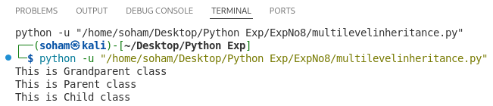
7)Write a program to demonstrate method overriding
Program :-

class Animal:
def sound(self):
print("Animal makes sound")

class Dog(Animal):
def sound(self):
print("Dog barks")

d = Dog()

d.sound()

OUTPUT :-
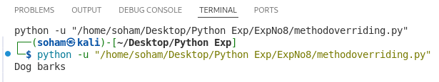
8)Write a program to calculate area of shapes using inheritance.
Program :-

class Shape:
def area(self):
pass

class Rectangle(Shape):
def __init__(self, l, b):
self.l = l
self.b = b

def area(self):
print("Area of Rectangle:", self.l * self.b)

class Circle(Shape):
def __init__(self, r):
self.r = r

def area(self):
print("Area of Circle:", 3.14 * self.r * self.r)

r = Rectangle(5, 3)
c = Circle(4)

r.area()
c.area()

OUTPUT :-
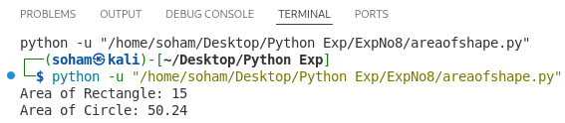
9)Write a program to demonstrate encapsulation.
Program :-

class Student:
def __init__(self, name, marks):
self.name = name
self.__marks = marks

def get_marks(self):
return self.__marks

def set_marks(self, marks):
self.__marks = marks

s = Student("Soham", 85)

print("Marks:", s.get_marks())

s.set_marks(90)
print("Updated Marks:", s.get_marks())

OUTPUT :-
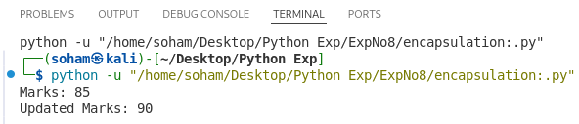
10)Write a program to demonstrate polymorphism.
Program :-

class Animal:
def sound(self):
print("Animal makes sound")

class Dog(Animal):
def sound(self):
print("Dog barks")

class Cat(Animal):
def sound(self):
print("Cat meows")

a = Animal()
d = Dog()
c = Cat()

for obj in (a, d, c):
obj.sound()

OUTPUT :-
