Experiment No.9

1)Write a program to create and write data into a file.
Program :-

# Create and write to a file
with open("example.txt", "w") as file:
file.write("Hello, this is a sample text written to file.")

print("Data written successfully.")

OUTPUT :-
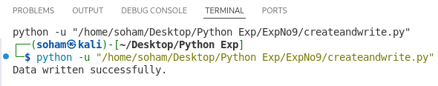
2)Write a program to read data from a file.
Program :-

# Open and read file
with open("example.txt", "r") as file:
data = file.read()
print(data)

OUTPUT :-
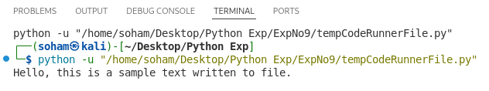
3) Write a program to append data into a file.
Program :-

# Open file in append mode
with open("example.txt", "a") as file:
file.write("This line is appended to the file.\n")

print("Data appended successfully.")

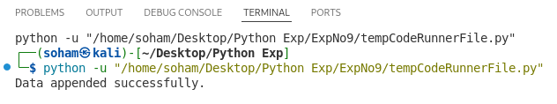
OUTPUT :-

4)Write a program to count lines words and characters in a file.
Program :-

with open("example.txt", "r") as file:
data = file.read()

lines = data.split('\n')
words = data.split()
chars = len(data)

print("Lines:", len(lines))
print("Words:", len(words))
print("Characters:", chars)

OUTPUT :-
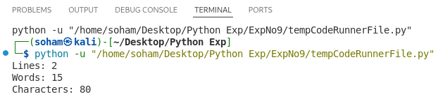
5)Write a program to copy contents from one file to another.
Program :-

# Open source file and read data
with open("ExpNo9/example.txt", "r") as source:
data = source.read()

# Write data into target file
with open("target.txt", "w") as target:
target.write(data)

print("File copied successfully.")

OUTPUT :-
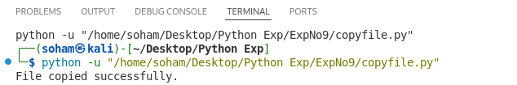
6) Write a program to handle division by zero exception.
Program :-

try:
a = int(input("Enter numerator: "))
b = int(input("Enter denominator: "))

result = a / b
print("Result:", result)

except ZeroDivisionError:
print("Error: Division by zero is not allowed.")

except ValueError:
print("Error: Please enter valid numbers.")

OUTPUT :-
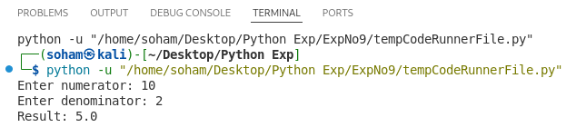
7)Write a program to handle invalid input exception.
Program :-

try:
num = int(input("Enter a number: "))
print("You entered:", num)

except ValueError:
print("Error: Invalid input! Please enter a valid integer.")

OUTPUT :-
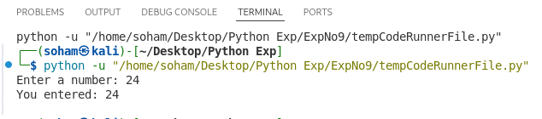
8)Write a program to use try-except-finally block.
Program :-

try:
a = int(input("Enter numerator: "))
b = int(input("Enter denominator: "))

result = a / b
print("Result:", result)

except ZeroDivisionError:
print("Error: Division by zero is not allowed.")

except ValueError:
print("Error: Invalid input.")

finally:
print("This block always executes.")

OUTPUT :-
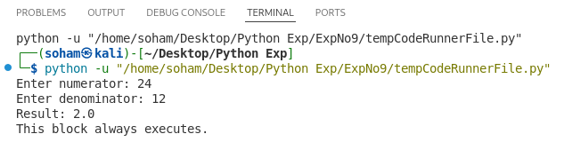
9)Write a program to create user-defined exception.
Program :-

# Create user-defined exception
class MyException(Exception):
pass

try:
num = int(input("Enter a positive number: "))

if num < 0:
raise MyException("Negative number is not allowed")

print("You entered:", num)

except MyException as e:
print("Error:", e)

except ValueError:
print("Invalid input.")

OUTPUT :-
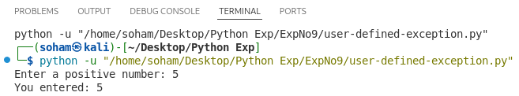
10) Write a program to demonstrate file exception handling.
Program :-

try:
# Try to open file
file = open("example.txt", "r")
data = file.read()
print(data)

except FileNotFoundError:
print("Error: File not found.")

except IOError:
print("Error: Problem reading the file.")

finally:
print("File handling operation completed.")

OUTPUT :-
