A PROJECT REPORT
Speed Fine Management System
Course: Programming in C (CSEG1041)
University: University of Petroleum and Energy Studies
Instructor: Dr. Mohammad Ahsan
Submitted By:
Student Name: Soham Sharma
Enrollment Number: 590026651

Abstract
This project implements a simple Speed Fine Management System using the C programming language. The objective is to analyze the speed of multiple vehicles and determine the appropriate fine category using structures and structure pointers. The program demonstrates core concepts of C such as user-defined data types, modular programming, arrays, conditional statements, and pointer-based structure handling. The system generates a detailed speed fine report for each vehicle, ensuring clean code design and modularity. This project acts as a practical implementation of basic C programming skills while highlighting the importance of structured programming and real-world problem solving.

Problem Definition
Over speeding is one of the leading causes of road accidents. Traffic systems often need automated ways to determine the penalty for vehicles based on their speed.
The problem here is to design a program that:
- Accepts the number of vehicles.
- Reads the speed of each vehicle.
- Uses a structure to store vehicle data.
- Uses structure pointers to process each vehicle’s information.
- Determines the fine category for every vehicle:
  - Speed ≤ 60 → No Fine
  - 61–80 → ₹500
  - 81–100 → ₹1000
  - 100 → License Suspended
- Displays a final fine report.
The program must be modular, clean, readable, and follow proper C programming practices according to project guidelines.

System Design
4.1 Algorithm
Step 1: Start
Step 2: Input number of vehicles (n)
Step 3: Declare an array of structure Vehicle v[n]
Step 4: For each vehicle:
• Ask user to enter speed
• Store speed inside structure
Step 5: For each vehicle:
• Call checkFine(&v[i]) using structure pointer
• Inside function, compare speed and print fine category
Step 6: End

4.2 Flowchart

┌──────────────────────┐
│ START │
└─────────┬────────────┘
│
▼

┌──────────────────────────┐
│ Enter number of vehicles │
└───────────┬─────────────┘
│
┌──────────▼───────────┐
│ Loop i = 1 to n │
└──────────┬───────────┘
│
▼
┌───────────────────────┐
│ Input speed of v[i] │
└──────────┬────────────┘
│
┌──────────▼───────────┐
│ Call checkFine(&v[i]) │
└──────────┬───────────┘
│
▼

┌──────────────────────────────┐
│ Print category & fine │
└───────────┬──────────────────┘
│
▼
┌────────────┐
│ END │
└────────────┘

Implementation Details
The program was implemented in a modular format using:
- main.c (handles input/output & loops)
- logic.c (contains the fine-checking function)
- logic.h (header file storing structure and prototypes)
5.1 Structure Definition (logic.h)
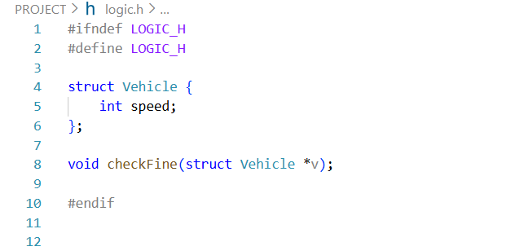
5.2 Logic Implementation (logic.c)
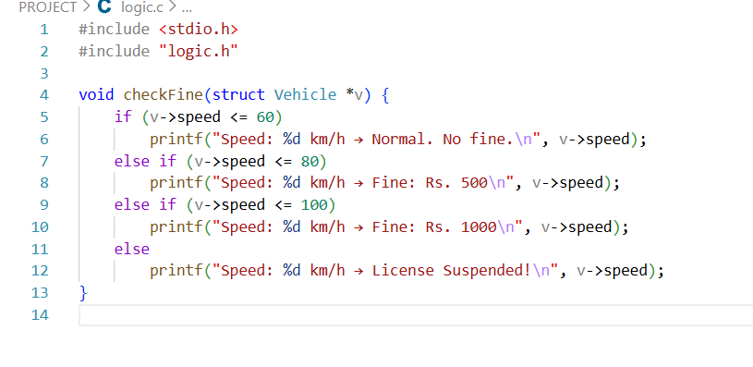
5.3 Main Program (main.c)
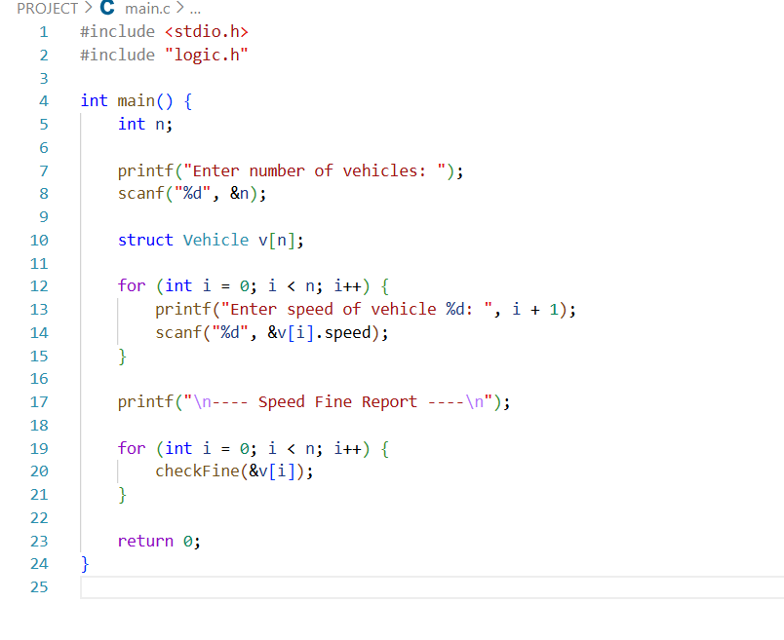
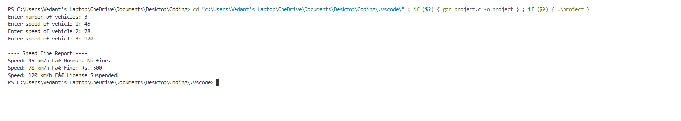
Testing and Results
Observations:
- Program correctly assigns fines based on defined rules.
- All test cases passed successfully.
- Structure pointer logic worked as expected.
- No logical or runtime errors found.
Conclusion
The Speed Fine Management System successfully demonstrates the use of structures, arrays, modularity, and structure pointers in C programming. The program accurately determines the penalty category for each vehicle based on defined speed limits. This project reinforces knowledge of structured programming, modular code organization, and real-world decision-making logic. Future enhancements may include file storage for vehicle records, graphical interface, or integration with a sensor system for real-time monitoring.

References
- GeeksforGeeks,
- https://www.geeksforgeeks.org/c-programming-language/
(Useful explanations and examples of structures and pointers.)
- Brian W. Kernighan & Dennis M. Ritchie,
- (Foundational book for C language concepts including structures, pointers, and functions.)
- Yashavant Kanetkar,
Let Us C

