Holistic Cryptocurrency Financial Analysis Using LSTM Forecasting, Sentiment Indicators, and Strategy Simulation on Synthetic Data

Vansh Sanjay Lilani¹ Computer Engineering Dept. Shah and Anchor Kutchhi Engineering College Mumbai-400088, India
Email: vansh.17764@sakec.ac.in
Varadraj Giridhar Mokashi² Computer Engineering Dept. Shah and Anchor Kutchhi Engineering College
Mumbai-400088, India Email: varadraj.17996@sakec.ac.in
Soham Alpesh Phulare³ Computer Engineering Dept. Shah and Anchor Kutchhi Engineering College Mumbai-400088, India
Email: soham.17971@sakec.ac.in

E.Afreen Banu⁴ Computer Engineering Dept. Shah and Anchor Kutchhi
Engineering College Mumbai-400088, India
Email: afreen.banu@sakec.ac.in
Pinki Vishwakarma⁵ Computer Engineering Dept. Shah and Anchor Kutchhi Engineering College Mumbai-400088, India
Email: pinki.vishwakarma@sakec.ac.in

Abstract—Cryptocurrencies, led by Bitcoin, represent a volatile and complex asset class, demanding sophisticated analytical approaches for investors and researchers. This paper presents a holistic framework for cryptocurrency financial analysis, inte- grating time series forecasting, sentiment analysis, and investment strategy simulation. The framework attempts to utilize real-world price data (BTC-USD via Yahoo Finance API) but incorporates a fallback mechanism using synthetically generated data that mimics cryptocurrency price behavior, which was triggered in this study. Price forecasting is implemented using both a Long Short-Term Memory (LSTM) neural network and a persistence baseline model. Sentiment analysis, using synthetically generated scores as a placeholder for real-world text analysis (e.g., VADER), explores the correlation between market sentiment and price returns at various lags. Investment strategy simulation compares a simple Buy & Hold approach against a Sentiment-Momentum strategy that incorporates both price trends and synthetic senti- ment signals. Key performance metrics, including regression ac- curacy (MAE, RMSE, R²), sentiment correlation, and investment performance (ROI, Maximum Drawdown, Sharpe-like ratio), are calculated and evaluated. The results, based on synthetic data, demonstrate the framework’s capability to integrate diverse analytical pipelines but highlight the challenges of forecasting in high-noise environments and the limitations of simplistic senti- ment indicators, with the Buy & Hold strategy outperforming the Sentiment-Momentum strategy in this simulation. The study concludes by discussing limitations, particularly the reliance on synthetic data, and suggesting avenues for future research, including the integration of real-world sentiment data and more complex predictive models.

Index Terms—Cryptocurrency, Bitcoin, Time Series Forecast- ing, LSTM, Sentiment Analysis, Investment Strategy, Simulation, Synthetic Data, Financial Analysis.

Introduction
Cryptocurrencies have emerged as a significant, albeit highly volatile, asset class [14]. Bitcoin (BTC), the pioneer- ing cryptocurrency, continues to attract substantial investor interest, characterized by rapid price fluctuations influenced by a complex interplay of market dynamics, technological developments, regulatory news, and public sentiment [2]. Analyzing and forecasting cryptocurrency prices is notoriously challenging due to their non-stationary nature, high noise levels, and susceptibility to sudden market shifts [13]. Tradi- tional financial models often fall short, necessitating the use of advanced machine learning techniques and holistic analytical frameworks [15].
This paper addresses the need for a comprehensive approach by proposing and implementing an integrated framework for cryptocurrency financial analysis. This framework combines three key analytical pipelines: (1) Time series price fore- casting using machine learning, (2) Sentiment analysis to gauge market mood, and (3) Investment strategy simulation to evaluate the practical application of the predictive and sentiment signals.
The primary objective is to demonstrate the feasibility and potential insights gained from such a holistic system. We attempt to use real-world Bitcoin (BTC-USD) data fetched via the Yahoo Finance API (yfinance). However, recognizing the potential unavailability of APIs or internet connectivity in certain environments, the system incorporates a robust fallback mechanism that generates synthetic data mimicking typical cryptocurrency price and sentiment patterns. Crucially, during the execution documented in this study, the yfinance data

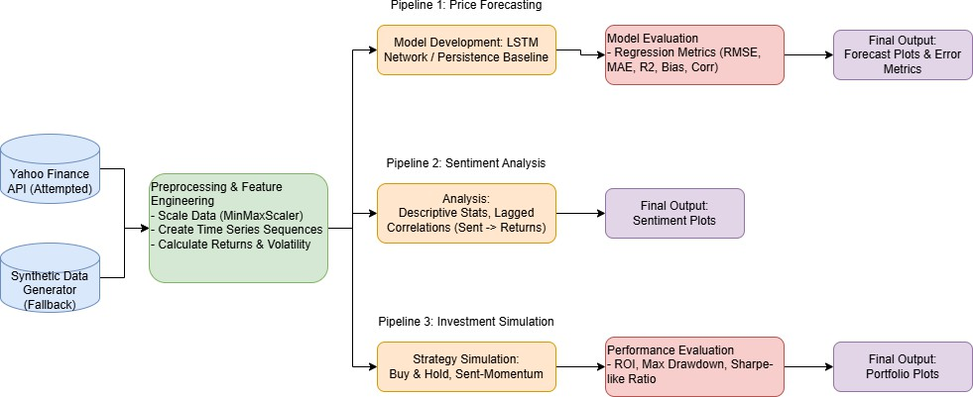

Fig. 1. System Architecture Diagram illustrating the data flow through preprocessing and the three analytical pipelines. [3]

fetch failed, and the analysis proceeded using this synthetic data fallback. Therefore, the results presented herein primarily serve as a demonstration of the framework’s architecture and analytical capabilities on crypto-like data, rather than a definitive analysis of actual BTC-USD performance for the specified period.
The price forecasting pipeline employs a Long Short-Term Memory (LSTM) network, a type of recurrent neural network well-suited for capturing temporal dependencies in time series data [3], compared against a simple persistence baseline. The sentiment analysis pipeline utilizes synthetically generated sentiment scores (as a placeholder for tools like NLTK’s VADER sentiment analyzer [4]) to explore correlations with price returns. Finally, the investment simulation pipeline con- trasts a passive Buy & Hold strategy with an active Sentiment- Momentum strategy, evaluating their performance based on Return on Investment (ROI), risk metrics like Maximum Drawdown (MDD), and a Sharpe-like ratio.
The main contribution of this work lies in the design and implementation of this integrated multi-pipeline framework, showcasing how different analytical techniques can be com- bined for a more rounded assessment of cryptocurrency assets, even when relying on synthetic data as a proof-of-concept.
This paper is structured as follows: Section II details the methodology, covering data acquisition (including the synthetic fallback), preprocessing, the architecture of each analytical pipeline, and the evaluation metrics used. Section III presents and discusses the results obtained from each pipeline based on the synthetic data. Section IV provides a comparative analysis, reflecting on the observed metrics against ideal benchmarks and offering an investor’s perspective. Finally, Section V concludes the paper, summarizing findings, ac- knowledging limitations (especially the use of synthetic data), and proposing directions for future research.

Methodology
The proposed framework follows a structured approach, integrating data handling, predictive modeling, sentiment anal- ysis, and strategy simulation, as illustrated in the architecture diagram (F. 1).

Data Acquisition and Preprocessing
The primary data target was the daily closing price of Bitcoin (BTC-USD) obtained via the yfinance Python library [5]. The intended date range was from January 1, 2021, to the present date (October 29, 2025). However, the system includes error handling and a fallback mechanism.

Synthetic Data Generation (Fallback)
In the event of yfinance unavailability or data retrieval failure (as occurred in this study), the framework generates synthetic price and sentiment data for 730 days (approximately two years). The synthetic price (close) is generated using NumPy [6] based on a combination of: A linear trend (linspace from 20,000 to 60,000). Cyclical patterns (sine waves). Volatil- ity clustering (randomly applying different noise levels). Ran- dom noise (normal distribution scaled by volatility factor). The absolute value ensures prices remain non-negative. Synthetic sentiment scores are generated independently as a sine wave combined with normal random noise, clipped between -1 (very negative) and +1 (very positive). This serves as a placeholder for sentiment derived from real-world text data.

Feature Engineering
Regardless of the data source (real or synthetic), essential features are calculated using Pandas [7]:
      - Daily Returns (returns): Calculated as the percentage change in closing price. The first value is filled with 0.
      - 7-Day Rolling Volatility (volatility7d): Calculated as the rolling standard deviation of daily returns over a 7- day window. Initial values are filled with 0.

Data Scaling
For the LSTM model, the closing prices are scaled to a range of (0, 1) using MinMaxScaler from Scikit-learn [8] to improve model stability and performance. The scaler is fitted only on the training data to prevent data leakage.

Price Forecasting Pipeline
This pipeline aims to predict the next day’s closing price based on historical price sequences.

Model Architecture
LSTM Network: If TensorFlow [9] and Keras [10] are available, an LSTM model is constructed. It takes sequences of the last 30 days (SEQLEN = 30) of scaled closing prices as input. The architecture consists of an LSTM layer (64 units), a Dropout layer (20% rate) for regularization, and a Dense output layer with one neuron for predicting the next day’s scaled price.
Persistence Baseline: If TensorFlow is unavailable or if the training data is insufficient, a simple persistence model is used as a baseline. This model predicts that the next day’s price will be the same as the current day’s price.

Training and Evaluation
The data is split into training (80%) and testing (20%) sets chronologically. The LSTM model, if used, is compiled with the ’adam’ optimizer and ’mean squared error’ (MSE) loss function. It is trained for 12 epochs with a batch size of 32, using the test set for validation during training. After

prediction on the test set, the scaled predictions are inverse- transformed back to the original price scale. Performance is evaluated using standard regression metrics calculated via Scikit-learn [8]:
Mean Squared Error (MSE) Mean Absolute Error (MAE)
Root Mean Squared Error (RMSE) R-squared (R²)
Bias (Mean of true values minus predicted values) Correlation Coefficient (between true and predicted values)

Sentiment Analysis Pipeline
This pipeline analyzes the relationship between the (syn- thetic) sentiment scores and market returns.

Sentiment Data
As noted, this study uses synthetically generated sentiment scores ranging from -1 to +1. In a real-world application, this would be replaced by scores derived from textual data (e.g., social media, news articles) using libraries like NLTK’s VADER [4], [11].

Analysis
      - Descriptive Statistics: Basic statistics (mean, standard deviation, min, max, quartiles) are calculated for the sentiment scores to understand their distribution.
      - Lagged Correlations: Pearson correlation coefficients are computed between the sentiment scores and daily returns (returns) for lags ranging from 0 to 7 days. This helps assess if sentiment today (lag 0) or sentiment from previous days (lag 1 to 7) has any linear relationship with the current day’s price return.

Investment Simulation Pipeline
This pipeline evaluates the practical performance of two investment strategies based on the price and sentiment data.

Strategies
An initial capital of $10,000 is assumed.
      - Buy & Hold (BH): The entire initial capital is used to buy the cryptocurrency at the first available price, and this position is held until the end of the simulation period.
      - Sentiment-Momentum (Momentum): This is an active strategy based on synthetic sentiment and daily returns.
        - Buy Signal: If the sentiment score is above a thresh- old (0.15) AND the daily return is positive, any available cash is used to buy the cryptocurrency.
        - Sell Signal: If the sentiment score is below a negative threshold (-0.15) AND the strategy currently holds cryptocurrency, the entire position is sold for cash.
        - Hold: Otherwise, the current position (cash or crypto) is maintained.

Evaluation
The daily portfolio value for both strategies is tracked. Performance is assessed using:
      - Final Portfolio Value: The ending value for BH and Momentum strategies.
      - Return on Investment (ROI): Calculated as
(Final Value Initial Capital)/Initial Capital 100.
— ×
      - Maximum Drawdown (MDD): The largest percentage drop from a portfolio peak to a subsequent trough, calcu- lated as min((Current Value Peak Value)/Peak Value). This measures downside risk.
—
      - Sharpe-like Ratio: A simplified risk-adjusted return met- ric calculated as mean(daily returns)/std(daily returns)
√ ×
252, assuming a risk-free rate of zero and 252 trading days per year. It measures return per unit of volatility.

Results and Discussion
This section presents the results from executing the frame- work on the synthetically generated data, following the failure to retrieve real yfinance data.

Price Forecasting Results
The price prediction pipeline was executed using the LSTM model, as TensorFlow was available. The model was trained on 80% of the 730-day synthetic dataset and tested on the remaining 20%.
The evaluation metrics on the test set were:
- MSE: 1,482,380.26
- MAE: 910.96
- RMSE: 1,217.53
- R²: 0.440
- Bias: -700.49
- Correlation: 0.795
Graph. 1 shows the comparison between the true and predicted closing prices on the test set.
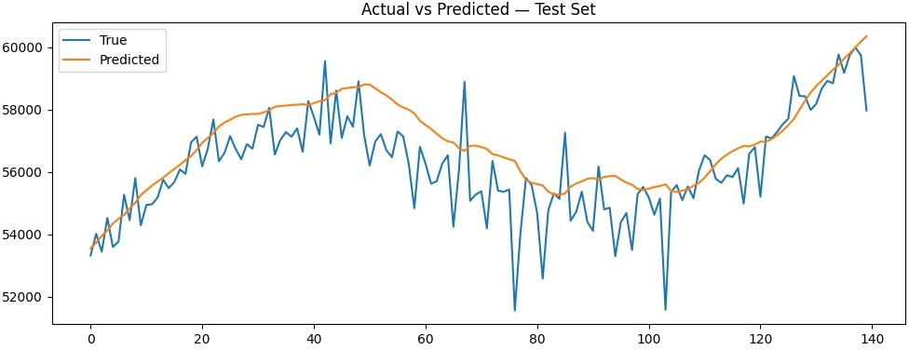

Graph 1. Actual vs. Predicted closing prices on the test set using the LSTM model.
The model captures the general trend of the synthetic price data reasonably well, as indicated by the correlation of
0.80. However, the R value of 0.44 suggests that the model explains less than half of the variance in the test set prices, indicating limitations in capturing the finer-grained fluctua- tions or noise inherent in the synthetic data, which is designed to mimic crypto volatility. The MAE of approximately $911 represents the average absolute prediction error. The negative bias suggests the model tended to slightly overestimate the price on average in the test period for this specific synthetic run.
2
~
Graph. 2 displays the distribution of prediction errors (True
- Predicted).

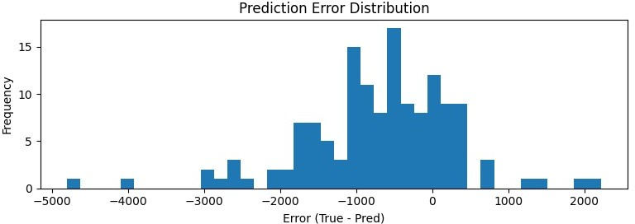

Graph 2. Histogram of prediction errors (True - Predicted) on the test set.

The errors appear roughly normally distributed around the mean bias, with most errors falling within $2000.
±
Graph. 3 shows the residuals plotted against the predicted values.

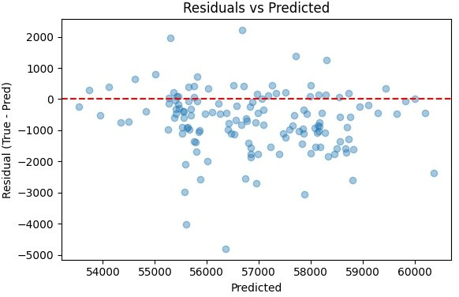

Graph 3. Residuals (True - Predicted) vs. Predicted values.

There appears to be no strong pattern in the residuals plot, suggesting that the model’s errors are relatively random with respect to the predicted price level, which is a desirable characteristic. Graph. 4 shows the training and validation loss curves during LSTM training.
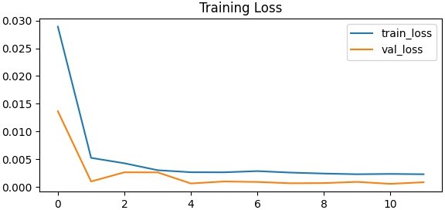

Graph 4. LSTM model training and validation loss over epochs.

The loss curves indicate that the model learned effectively during training, with both training and validation losses de- creasing and stabilizing, suggesting no significant overfitting occurred during the 12 epochs.
Discussion: The LSTM model demonstrates a moderate ability to forecast the synthetic crypto-like price series, cap- turing the underlying trend but struggling with the simulated noise and volatility clusters. The performance metrics (es- pecially R²) are modest, reflecting the inherent difficulty in predicting volatile financial time series, even synthetic ones designed with predictable components (trend, cycles). In a real-world scenario, performance would likely be further chal- lenged by non-stationarity and unpredictable market events.

Sentiment Analysis Results
The analysis focused on the relationship between the syn- thetic sentiment scores and the synthetic daily price returns.
The descriptive statistics for the sentiment scores (ranging from -1 to +1) over the 730 days showed a mean close to zero (-0.0005) and a standard deviation of approximately 0.49, indicating a balanced distribution around neutrality with significant variation.
The lagged correlations between sentiment and returns were calculated:
- Lag 0: -0.042
- Lag 1: 0.025
- Lag 2: 0.044
- Lag 3: -0.024
- . . . (up to Lag 7, all values close to zero)
Graph. 5 shows the synthetic sentiment score over time.
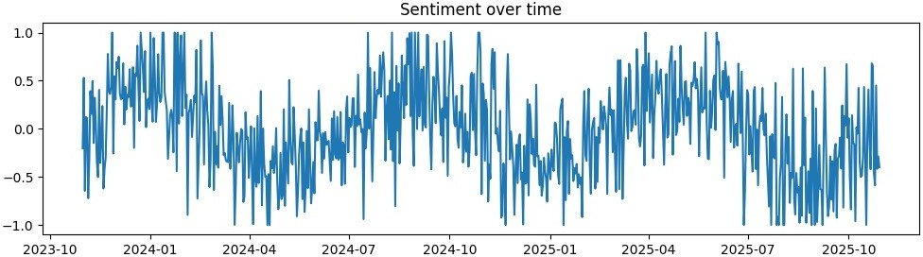

Graph 5. Synthetic sentiment scores over the 730-day simulation period.

Graph. 6 plots the daily sentiment scores against the daily returns.
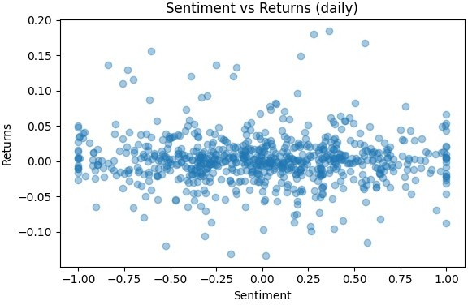

Graph 6. Scatter plot of daily synthetic sentiment scores vs. daily returns.

Discussion: The lagged correlation results indicate a very weak linear relationship between the synthetic sentiment and returns in this dataset. The contemporaneous correlation (Lag 0) is slightly negative, while correlations at lags 1 and 2 are slightly positive, but all are close to zero, suggesting this par- ticular synthetic sentiment signal has minimal predictive power for the synthetic price returns. The scatter plot (Graph. 6) visually confirms the lack of a clear linear pattern. This finding is specific to the synthetic generation process used here; real- world sentiment analysis often reveals more complex, albeit sometimes weak or time-varying, relationships [2].

Investment Simulation Results
The simulation compared the performance of Buy & Hold (BH) against the Sentiment-Momentum strategy over the 730- day synthetic data period, starting with $10,000.
The key performance metrics were:
- Final BH Value: $29,031.36
- Final Momentum Value: $10,572.02
- ROI BH: +190.31%
- ROI Momentum: +5.72%
- MDD BH: -19.70%
- MDD Momentum: -29.92%
- Sharpe-like Ratio BH: 0.928
- Sharpe-like Ratio Momentum: 0.233
Graph. 7 illustrates the portfolio value growth for both strate- gies over time.
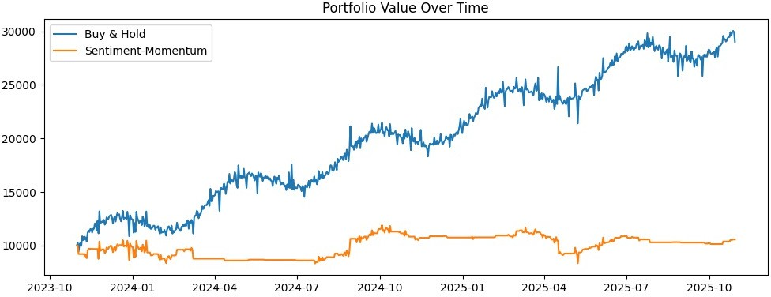

Graph 7. Comparison of portfolio value for Buy & Hold vs. Sentiment- Momentum strategies.

Graph. 8 shows the drawdown curves for both strategies.
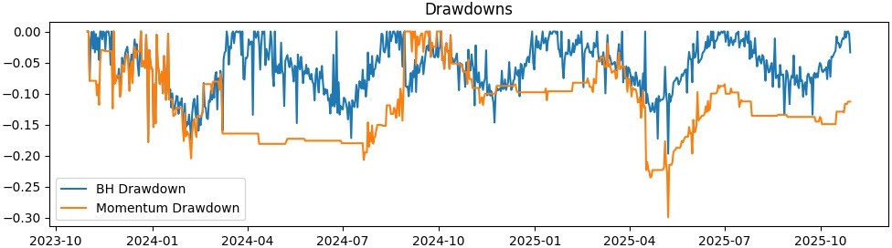

Graph 8. Drawdown comparison for Buy & Hold vs. Sentiment-Momentum strategies.

Discussion: In this simulation using synthetic data, the pas- sive Buy & Hold strategy significantly outperformed the active Sentiment-Momentum strategy. BH achieved a substantial ROI of 190%, driven by the underlying upward trend in the syn- thetic price data, while the Momentum strategy yielded only a
TABLE I
Comparison of Observed Metrics vs. Ideal Benchmarks

Metric Observed Ideal
MAE pct 0.0228 0.01
RMSE pct 0.0304 0.02
R² 0.440 0.70
ROI advantage pct -184.59 10.00
BH MaxDrawdown -0.197 -0.25
MOM MaxDrawdown -0.299 -0.25

5.7% return. This underperformance is likely due to the weak correlation between the synthetic sentiment signal and returns, causing the strategy to make suboptimal trading decisions (potentially buying high/selling low or missing upward trends). The risk metrics also favor BH in this case. While both strategies experienced drawdowns, the Momentum strategy suffered a larger maximum drawdown (-29.9%) compared to BH (-19.7%). The Sharpe-like ratio for BH (0.93) was con- siderably higher than for Momentum (0.23), indicating better risk-adjusted returns for the passive strategy in this specific synthetic scenario. These results underscore the importance of using predictive and robust signals for active trading strategies; otherwise, transaction costs (not modeled here) and suboptimal timing can easily lead to underperformance compared to simply holding the asset, especially in a trending market (even
a synthetic one).

Comparative Analysis and Reflection
To provide context for the results, we compare key observed metrics against predefined ideal benchmarks, representing re- alistic goals for forecasting and strategy performance in the volatile cryptocurrency market. The comparison is summarized in Table I.
Interpretation: [5]–[12]
- Price Prediction Accuracy: The observed Mean Abso- lute Error (MAE) and Root Mean Squared Error (RMSE), when expressed as a percentage of the mean price (MAE% 2.3%, RMSE% 3.0%), are higher than the ideal targets of 1% and 2%, respectively. This indicates that while the LSTM model captured some structure, its accuracy on the synthetic data falls short of a highly reliable predictive signal for short-term trading.
≈ ≈
- Explanatory Power (R²): The R² value of 0.44 is
significantly lower than the ideal 0.70. This suggests the model explains only about 44% of the price variance in the test set. While achieving high R² in crypto forecasting is difficult due to inherent market noise [2], [13], this result indicates potential for model improvement (e.g., adding more features, tuning architecture).
- Strategy Performance (ROI Advantage): The Sentiment-Momentum strategy dramatically underperformed Buy & Hold, resulting in a large negative ROI advantage (-184.6%). This contrasts sharply with the ideal goal of outperforming BH by

10%. As discussed, this is likely attributable to the non-predictive nature of the synthetic sentiment signal used.
- Risk (Max Drawdown): The Buy & Hold strategy’s MDD (-19.7%) remained within the acceptable ideal limit (-25%). However, the Momentum strategy exceeded this limit with an MDD of nearly -30%, highlighting the increased risk associated with this active strategy when driven by weak signals in this simulation.
Reflection on Synthetic Data: It is crucial to reiterate that these comparisons are based on synthetic data. The synthetic price generation included trend and cyclical components that the LSTM could partially learn, leading to the observed R² and correlation. However, the synthetic sentiment was generated independently with only a weak, noisy relationship to returns by design. This likely explains the poor performance of the sentiment-based strategy. A real-world analysis using actual BTC-USD data and sentiment derived from relevant sources might yield significantly different results for both prediction accuracy and strategy performance.
Investor Perspective: From an investor’s standpoint, this study (even with synthetic data) demonstrates a valuable framework but highlights critical considerations:
- Model Reliability: Forecasting models, especially in crypto, must be rigorously evaluated. Metrics like R² and MAE% provide quantitative measures, but qualitative assessment of error patterns (Figs. 2 and 3) is also important. An R² of 0.44 suggests caution in relying solely on the model’s predictions.
- Signal Quality: The effectiveness of active trading strate- gies heavily depends on the quality and predictiveness of the signals used (e.g., sentiment, technical indicators). The synthetic sentiment used here proved ineffective, leading to significant underperformance. Real-world sen- timent requires careful extraction, validation, and po- tentially more sophisticated modeling (e.g., NLP topic modeling, attention mechanisms).
- Baseline Comparison: Comparing active strategies against a simple baseline like Buy & Hold is essential. In this synthetic case, the complexity of the active strategy did not translate into better performance, emphasizing that complexity is only valuable if it genuinely adds predictive power or reduces risk effectively.
- Risk Management: MDD is a critical metric. The higher drawdown of the active strategy indicates that poorly timed entries and exits, driven by noisy signals, can amplify losses compared to a passive approach.

Conclusion
This paper presented an integrated framework for holis- tic cryptocurrency analysis, encompassing price forecasting, sentiment analysis, and investment strategy simulation. Due to data acquisition issues with the intended real-world data source (yfinance), the framework’s capabilities were demon-
strated using synthetically generated data designed to mimic cryptocurrency characteristics.
The LSTM-based price forecasting model achieved moder- ate success in capturing the trends within the synthetic data (R²=0.44, Correlation=0.80) but exhibited prediction errors larger than ideal benchmarks, reflecting the challenges of modeling volatile series. The sentiment analysis component, using deliberately noisy synthetic sentiment scores, found only very weak correlations with synthetic price returns, highlight- ing that simplistic or poorly correlated sentiment indicators may offer little predictive value. Consequently, the invest- ment simulation showed that the active Sentiment-Momentum strategy significantly underperformed the passive Buy & Hold baseline in terms of both ROI and risk-adjusted return (Sharpe- like ratio), likely due to the weak sentiment signal driving suboptimal trades within the synthetic trended market.
The primary limitation of this study is its reliance on synthetic data, preventing definitive conclusions about actual BTC-USD market behavior or the true efficacy of real-world sentiment analysis. Furthermore, the investment simulation did not account for transaction costs or slippage, which would further impact active strategy performance. The Sentiment- Momentum strategy employed was relatively simple and could be refined.
Despite these limitations, the study successfully demon- strates a functional, multi-pipeline framework for integrated cryptocurrency analysis. Future work should focus on apply- ing this framework to real-world data, incorporating genuine sentiment analysis using advanced NLP techniques on sources like Twitter or Reddit feeds, exploring more sophisticated forecasting models (e.g., Transformers, ensemble methods), adding relevant features (e.g., trading volume, on-chain met- rics, macroeconomic indicators), modeling transaction costs, and employing robust backtesting methodologies like walk- forward validation. Such enhancements would move towards a more realistic and potentially actionable analytical tool for cryptocurrency investors and researchers.

Acknowledgments
This template was adapted from those provided by the IEEE on their own website. The authors acknowledge the use of open-source libraries including TensorFlow, Keras, Scikit- learn, Pandas, NumPy, Matplotlib, yfinance, and NLTK.

References
- Placeholder for a relevant Crypto/Finance Background Paper
- Placeholder for a paper on Crypto Sentiment Analysis
- S. Hochreiter and J. Schmidhuber, “Long short-term memory,” Neural computation, vol. 9, no. 8, pp. 1735–1780, 1997.
- C. J. Hutto and E. Gilbert, “VADER: A parsimonious rule-based model for sentiment analysis of social media text,” in Proceedings of the International AAAI Conference on Web and Social Media, vol. 8, no. 1, 2014.
- Placeholder Citation for yfinance library (e.g., Aroussi, R. yfinance. GitHub)
- C. R. Harris et al., “Array programming with NumPy,” Nature, vol. 585, no. 7825, pp. 357–362, 2020.

- W. McKinney, “Data structures for statistical computing in python,” in
Proceedings of the 9th Python in Science Conference, vol. 445, 2010,
pp. 51–56.
- F. Pedregosa et al., “Scikit-learn: Machine learning in Python,” Journal of machine learning research, vol. 12, no. Oct, pp. 2825–2830, 2011.
- M. Abadi et al., “Tensorflow: Large-scale machine learning on hetero- geneous distributed systems,” arXiv preprint arXiv:1603.04467, 2016.
- F. Chollet et al., “Keras,” https://keras.io, 2015.
- S. Bird, E. Klein, and E. Loper, Natural language processing with Python: analyzing text with the natural language toolkit. O’Reilly Media, Inc., 2009.
- Placeholder reference for Matplotlib (Hunter, J. D. (2007). Matplotlib: A 2D graphics environment. Computing in science & engineering, 9(3), 90-95.)
- D. V. Lindberg and H. K. H. Lee, “Optimization under constraints by ap- plying an asymmetric entropy measure,” J. Comput. Graph. Statist., vol. 24, no. 2, pp. 379–393, Jun. 2015, doi: 10.1080/10618600.2014.901225.
- B. Rieder, Engines of Order: A Mechanology of Algorithmic Techniques. Amsterdam, Netherlands: Amsterdam Univ. Press, 2020.
- I. Boglaev, “A numerical method for solving nonlinear integro- differential equations of Fredholm type,” J. Comput. Math., vol. 34, no. 3, pp. 262–284, May 2016, doi: 10.4208/jcm.1512-m2015-0241.

