**This is the design of the simulated circuit:**

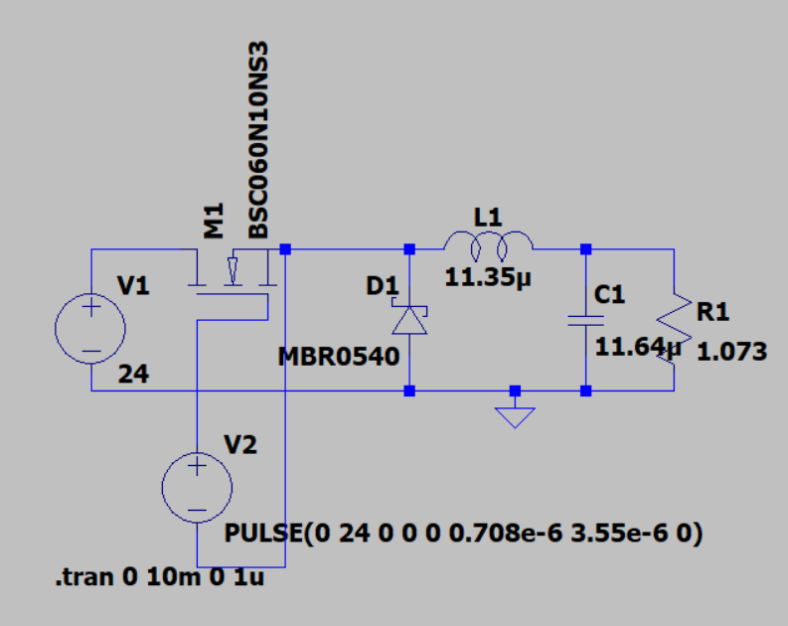

**The values of the components are obtained by the formulas:  
  
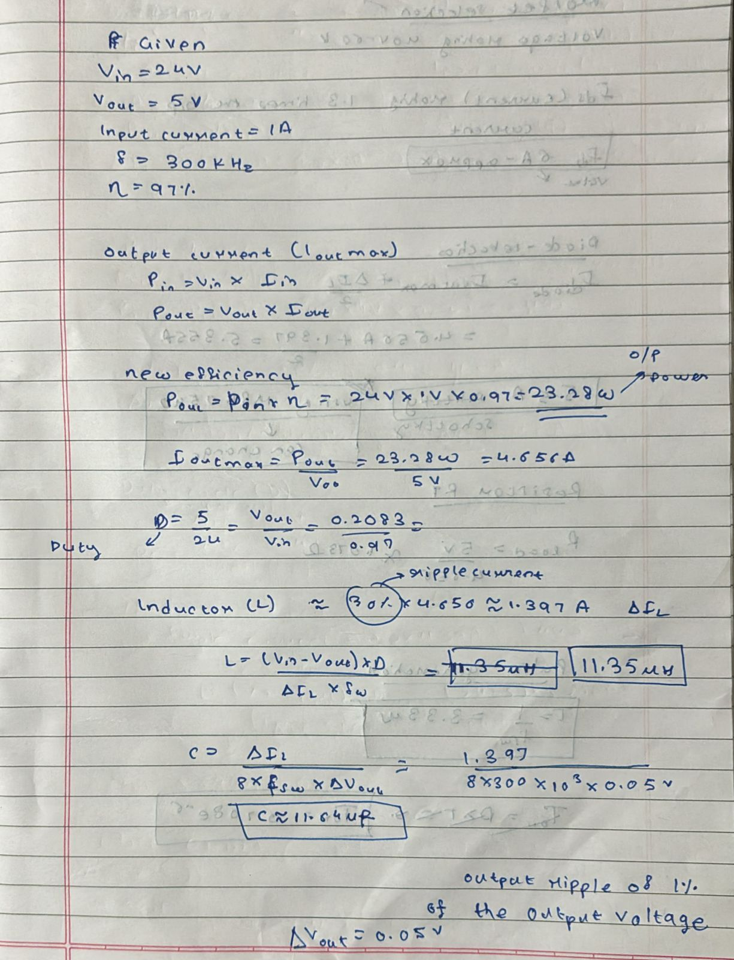**



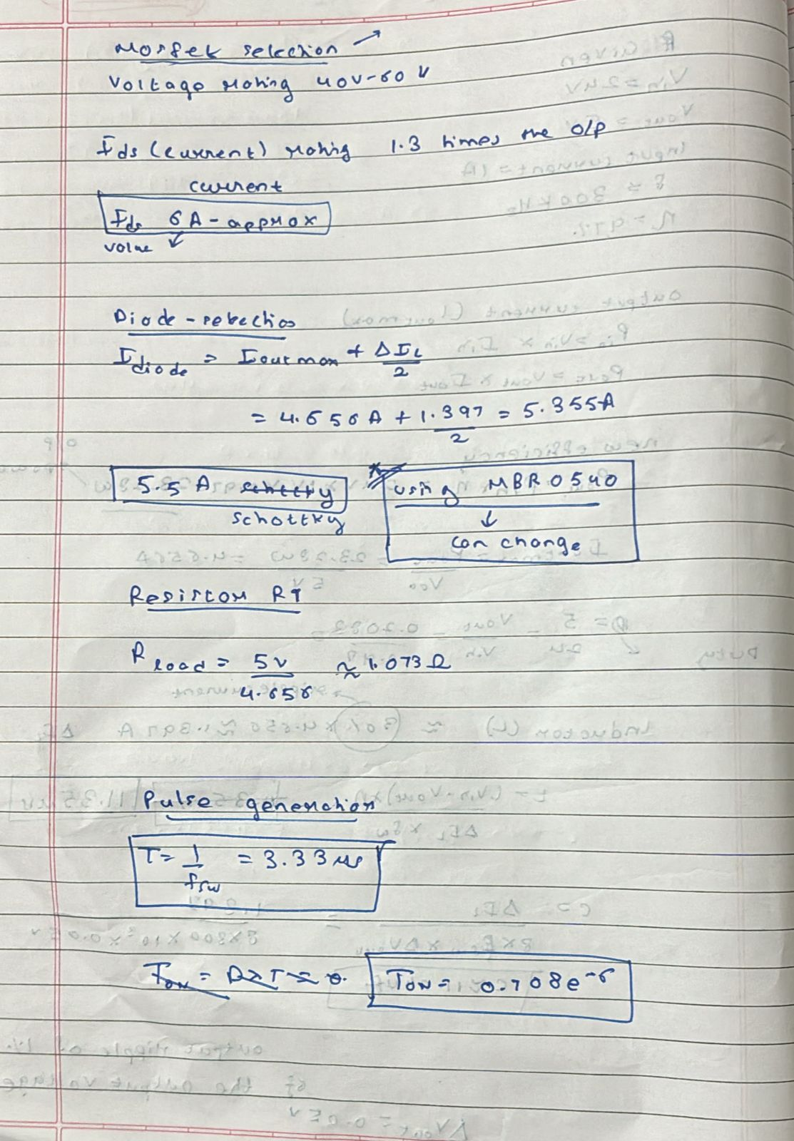



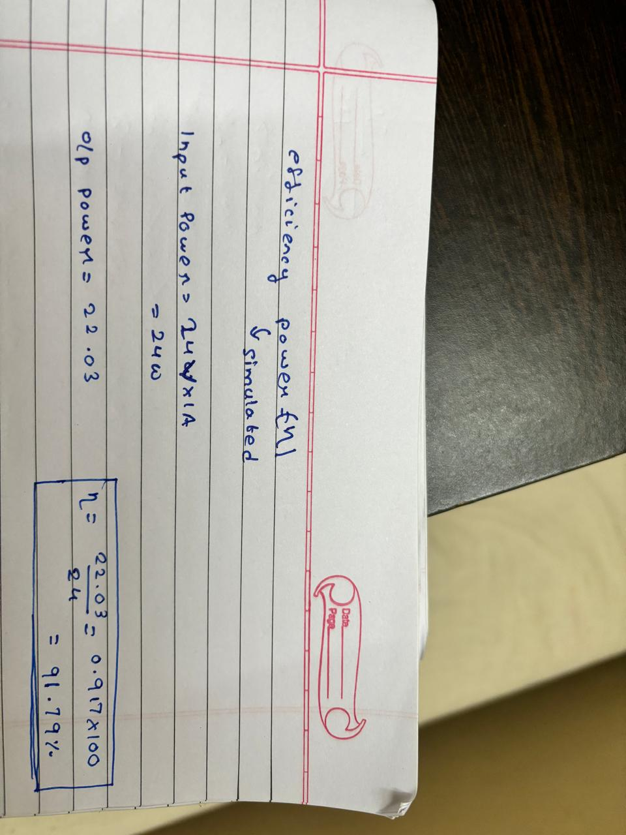

**We can see the efficiency is 91.79%**

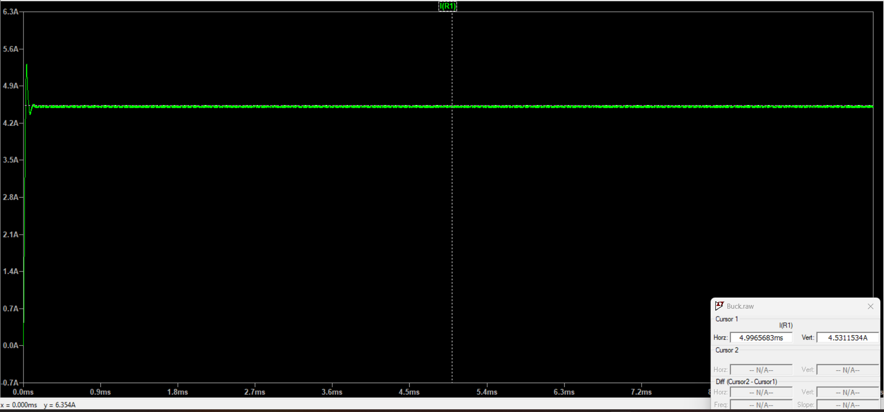

**Output current: 4.5311534A**

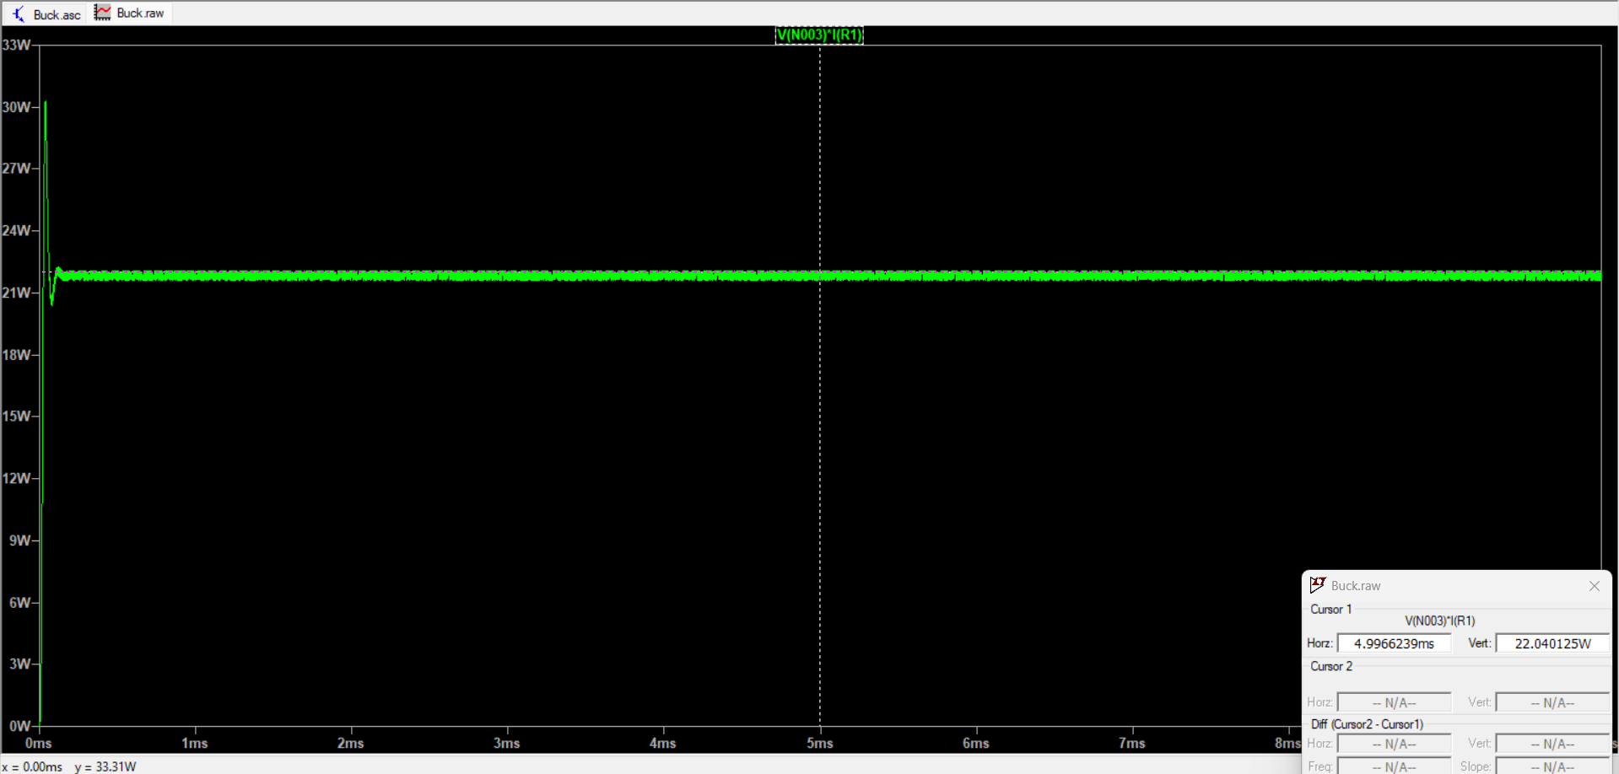

**Output Power: 22.040125W**

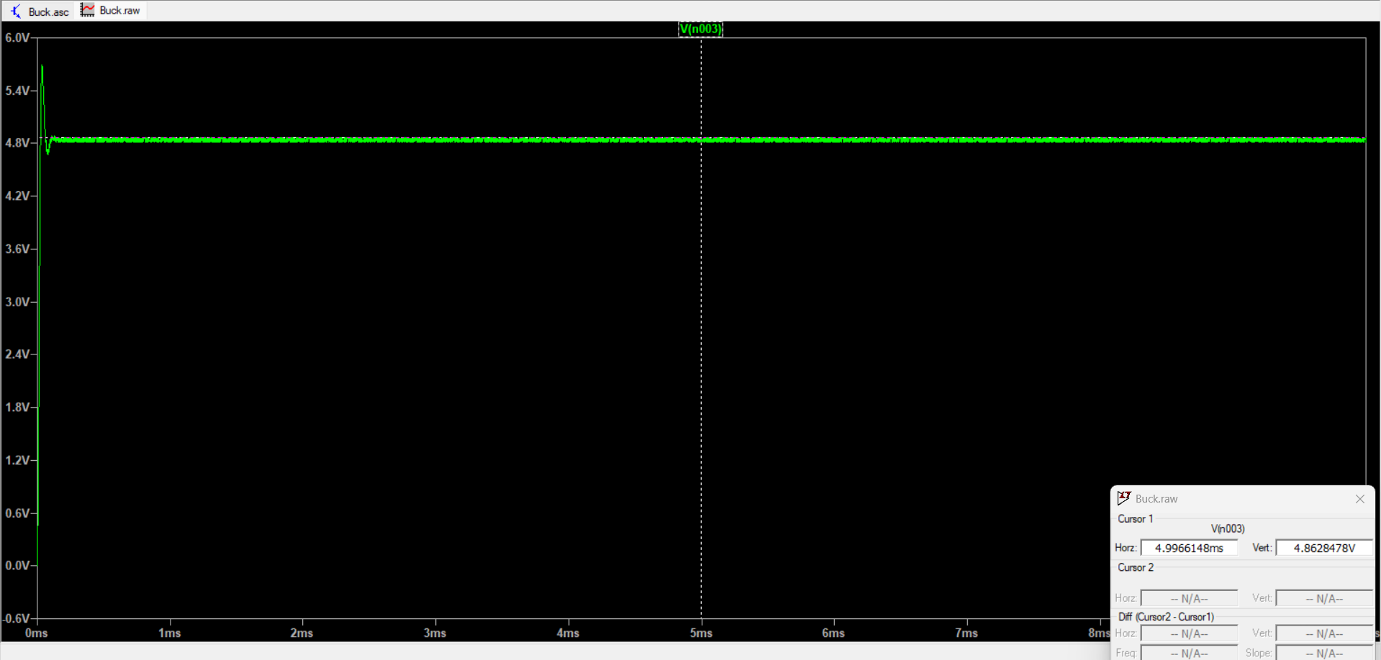

**Output Voltage: 4.8628478V**

**Schematic:  
 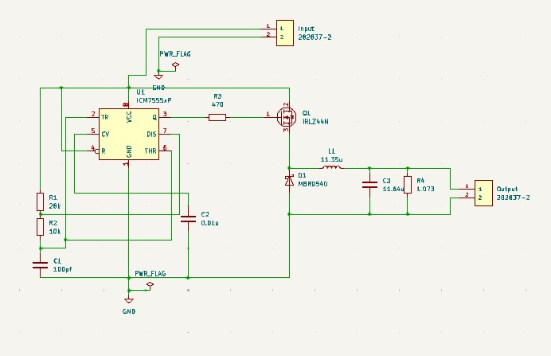**

**PCB (3D view):  
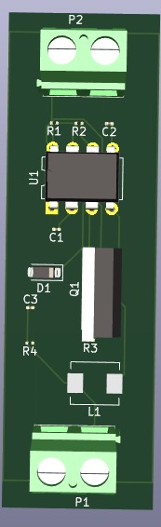**

**PCB (2D view):  
