Progressive Education Society’s
Modern College of Arts, Science and Commerce (Autonomous), Ganeshkhind, Pune-16.

ON-JOB TRAINING (OJT) REPORT

ON
PORTLIFY
Training Context: Portlify Product Development Project

Submitted By
Soham Bhutkar : 253341038
Vishal Vishwakarma : 253341029
Krushna Thombre : 253341013
Onkar Naik : 253341012

Project Guide / Mentor: Sonal Kulkarni Madam
Department of Computer Science
M.Sc. (Computer Science)-I NEP-I Academic Year: 2025-2026

CERTIFICATE
This is to certify that Mr. Soham Bhutkar (Roll No. 253341038), along with the project group members Vishal Vishwakarma (253341029), Krushna Thombre (253341013), and Onkar Naik (253341012), has successfully completed the On-Job Training work through the development of the project titled “Portlify”.
The work was carried out under the guidance of Sonal Kulkarni Madam in the Department of Computer Science, Modern College of Arts, Science and Commerce (Autonomous), Ganeshkhind, Pune-16. as part of the M.Sc. (Computer Science)-I NEP-I curriculum for the academic year 2025-2026.
During this period, the group worked on requirement analysis, interface design, frontend development, backend integration, AI-assisted features, testing, documentation, and presentation preparation related to the Portlify platform.
To the best of our knowledge, the work carried out by the group is genuine and satisfactory.

Place: Pune
Date: ____________________

Project Guide / Mentor | Head of Department
Sonal Kulkarni Madam | ________________________

Internal Examiner | External Examiner
________________________ | ________________________

ACKNOWLEDGEMENT
We express our sincere gratitude to Sonal Kulkarni Madam for her guidance, encouragement, and timely feedback throughout the development of Portlify. Her support helped us shape the project into a complete and presentable OJT submission.
We are thankful to the Department of Computer Science and the faculty members of Modern College of Arts, Science and Commerce (Autonomous), Ganeshkhind, Pune-16. for providing the academic environment, technical direction, and motivation required to complete this work.
We also acknowledge the contribution of all team members. Soham Bhutkar led the project end-to-end, Vishal Vishwakarma supported UI creation and motion graphics, Krushna Thombre supported backend-related features such as GitHub fetching and onboarding, and Onkar Naik contributed to documentation and report structuring.
Finally, we thank the maintainers of React, Supabase, Tailwind CSS, GitHub, Google Gemini, OpenAI, and other tools and libraries that supported the implementation and verification of Portlify.

INDEX
Sr. No. | Title | Page No.
1 | CERTIFICATE | I
2 | CERTIFICATE FROM ORGANIZATION | II
3 | ACKNOWLEDGEMENT | III
4 | INDEX | IV
5 | 1. Abstract | 1
6 | 2. Introduction of Organization / Training Context | 1
7 | 3. Objectives of Training | 1
8 | 4. Technologies / Tools Used | 2
9 | 5. Work Done During Training | 2
10 | 6. Weekly Progress | 4
11 | 7. Skills Learned | 4
12 | 8. Challenges Faced and Solutions | 4
13 | 9. Results / Output Screenshots | 5
14 | 10. Testing and Validation | 8
15 | 11. Advantages and Limitations | 9
16 | 12. Future Enhancements | 9
17 | 13. Conclusion | 9
18 | 14. References / Bibliography | 10
19 | 15. Appendix | 10

The index is kept in table form to match the preferred college submission style. Page numbers are populated automatically after generation.

1. Abstract
Portlify is a full-stack portfolio-building web application developed as the practical OJT work for this report. The system helps students, freshers, job seekers, and professionals create structured online portfolios without manually coding a personal website. It combines guided onboarding, project import, AI-assisted content improvement, public sharing, analytics, and export in a single platform.
The application is built with React, TypeScript, and Vite on the frontend, while Supabase provides authentication, database storage, and serverless edge functions. The completed project demonstrates requirement analysis, UI implementation, backend integration, external API usage, testing, and technical documentation in one end-to-end workflow.

2. Introduction of Organization / Training Context
This OJT work was centered on the development of Portlify as a product-oriented software project in the academic environment. Since the work focused on building a complete application rather than working within a separate external company system, the training context is represented through the project itself and the software engineering workflow followed during implementation.
Portlify addresses a practical need in the career and portfolio space. Many students and early-career professionals have strong projects and skills but do not have the time, design support, or technical knowledge required to build a polished portfolio site. Portlify reduces that barrier by guiding users from account creation to publishing.
The training work involved problem understanding, interface design, frontend development, Supabase integration, AI-backed parsing and writing support, dashboard and preview flows, documentation, and result validation. This made the project a suitable OJT-style implementation with both technical depth and practical relevance.

3. Objectives of Training
- To understand the complete workflow of building and delivering a modern web application.
- To create a guided portfolio-building platform for students, freshers, and job seekers.
- To implement secure authentication, structured content management, and public portfolio publishing.
- To integrate GitHub import, LinkedIn PDF parsing, AI-assisted writing, and SOP generation.
- To practice real project activities such as requirement analysis, UI creation, debugging, testing, and report preparation.

4. Technologies / Tools Used
Layer / Tool | Technology | Purpose
Frontend | React + TypeScript + Vite | Single-page application development
Routing | React Router | Public and protected route navigation
UI and Styling | Tailwind CSS + shadcn/ui + Framer Motion | Design, components, and motion
Backend Platform | Supabase | Authentication, database, and edge functions
Database | Supabase Postgres | Structured storage for profiles, portfolios, and related entities
Data Fetching | TanStack React Query + custom hooks | Fetching, caching, and updates
PDF Text Extraction | pdfjs-dist | Reads LinkedIn PDF text in the client
AI Services | Google Gemini and OpenAI | LinkedIn parsing, content polishing, and SOP generation
Testing | Vitest + Testing Library | Unit and component verification
Version Control | Git and GitHub | Source code management

5. Work Done During Training

5.1 Requirement Analysis and Project Planning
The initial phase focused on understanding the problem faced by students and job seekers when trying to present their work online. Based on this, the workflow was planned around signup, guided onboarding, structured editing, preview, publishing, and export.

5.2 Frontend and User Experience Development
The frontend was developed using React and TypeScript. Core pages such as the landing page, login, signup, onboarding, dashboard, builder, preview, templates, export, and SOP generator were created and connected through route-based navigation.

5.3 Backend Integration and Data Modeling
Supabase was used for authentication, user profiles, portfolio storage, contact information, projects, skills, education, experience, certifications, portfolio views, and landing feedback. The data model supports both structured sections and flexible custom sections.

5.4 Feature Implementation
- Guided onboarding for user type, career field, goals, starter content, and template preference.
- Builder support for bio, projects, skills, education, experience, certifications, contact, and custom sections.
- Five templates: Glass, Night Owl, Vibrant, Editorial, and Brutalist.
- GitHub repository fetching to seed project entries.
- LinkedIn PDF parsing using client-side extraction and AI-backed structuring.
- AI content polishing and SOP generation from portfolio data.
- Public portfolio route, unlisted sharing, analytics logging, and print-friendly export.
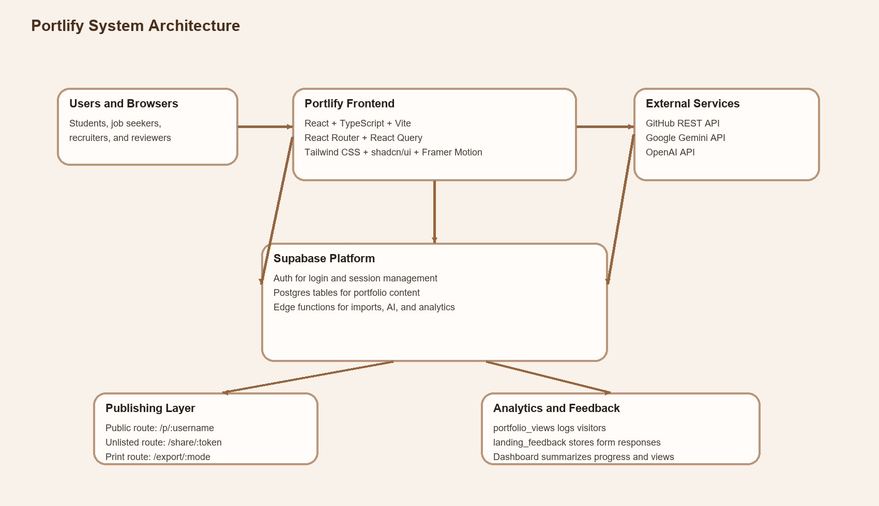
Figure 1. High-level system architecture of Portlify.

6. Weekly Progress
Week / Phase | Focus Area | Activities Completed
Week 1 | Planning and study | Studied portfolio platform requirements, analyzed workflow, and finalized the Portlify project direction.
Week 2 | UI and core flow | Built foundational UI, route structure, authentication flow, and onboarding screens.
Week 3 | Builder and templates | Implemented dashboard, builder modules, preview flow, template selection, and structured portfolio sections.
Week 4 | Integration and validation | Added GitHub fetching, LinkedIn PDF parsing, AI support, screenshots, testing, documentation, and presentation preparation.

7. Skills Learned
- React and TypeScript based application development
- Supabase authentication and database integration
- UI design and structured component-based development
- Handling external APIs and AI-backed workflows
- Testing, debugging, and feature verification
- Documentation, report writing, and presentation preparation
- Team coordination and module-wise contribution management

8. Challenges Faced and Solutions
Challenge | Observed Issue | Solution Followed
Content structure | Users needed guidance, not just blank fields. | Introduced onboarding, starter content, and structured section ordering.
LinkedIn import | LinkedIn data was available only through PDF export. | Used pdfjs-dist for text extraction and an edge function with Gemini for structured parsing.
Portfolio flexibility | Different users needed different section priorities. | Added user-type and goal-based starter section order logic.
Preview personalization | Users needed layout control without breaking templates. | Implemented section layout selection and reusable template rendering logic.
Verification | The documentation had to match the real repository features. | Validated routes, tables, edge functions, screenshots, build output, and tests before finalizing the report.

9. Results / Output Screenshots
The final application provides a working flow from onboarding to portfolio publishing. Screenshots below show the actual implemented pages used in the project.
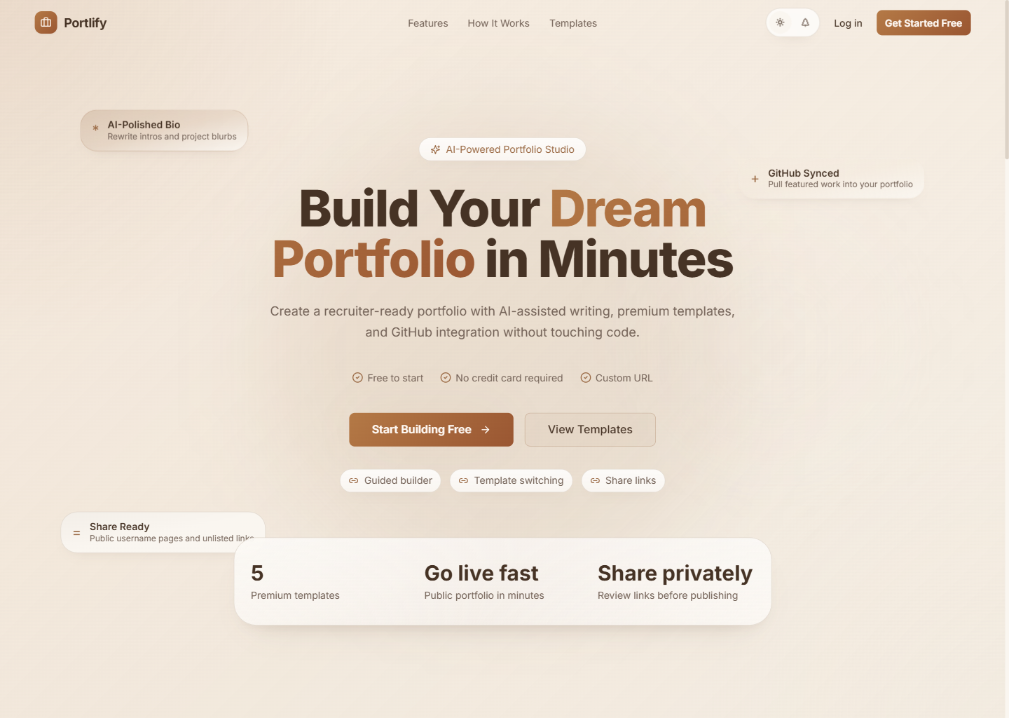
Figure 2. Landing page of the Portlify application.
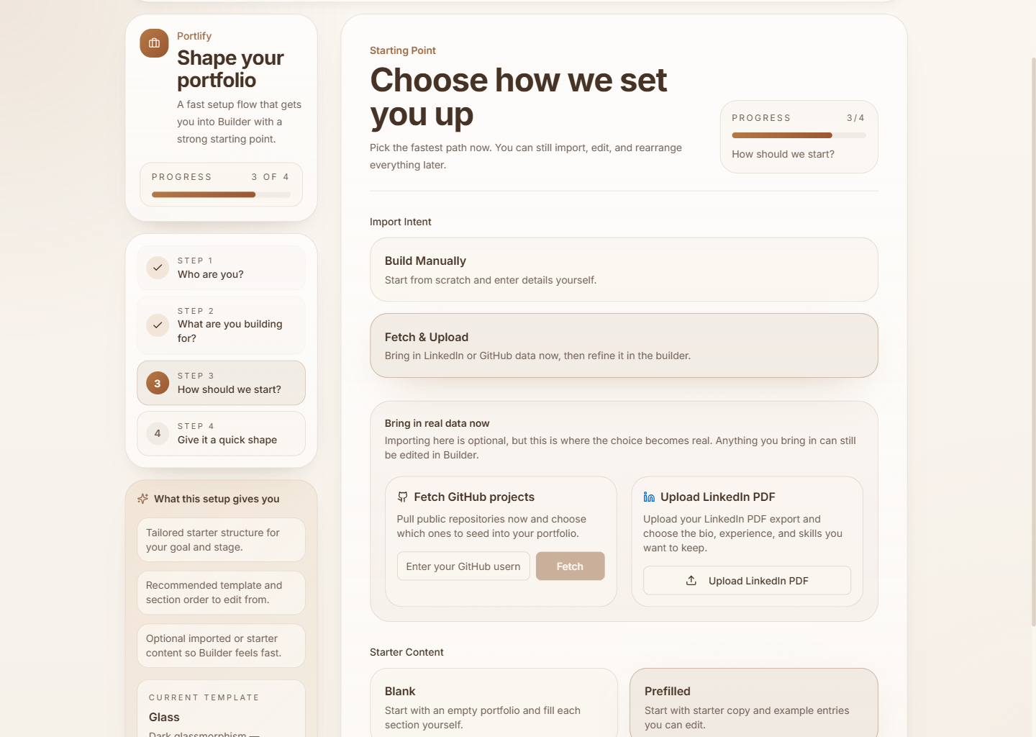
Figure 3. Guided onboarding with GitHub and LinkedIn import choices.
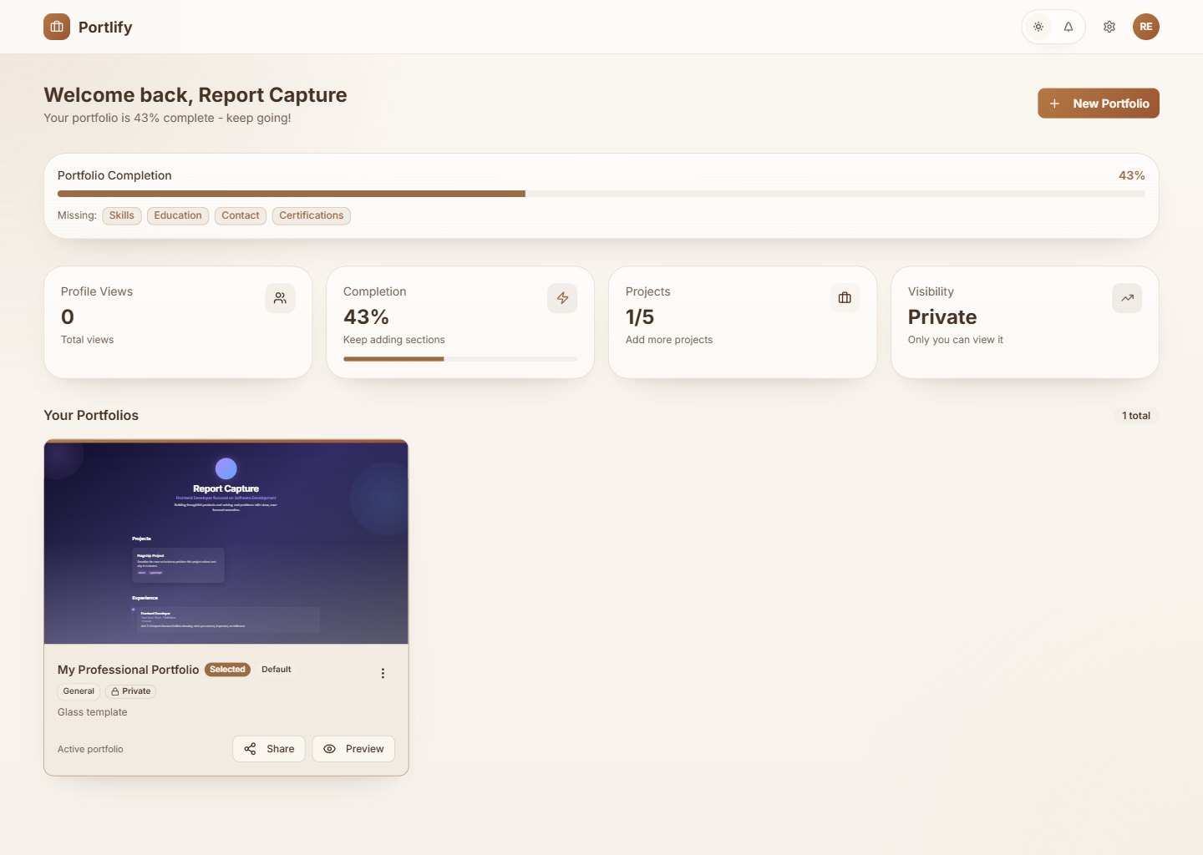
Figure 4. Dashboard after guided setup.
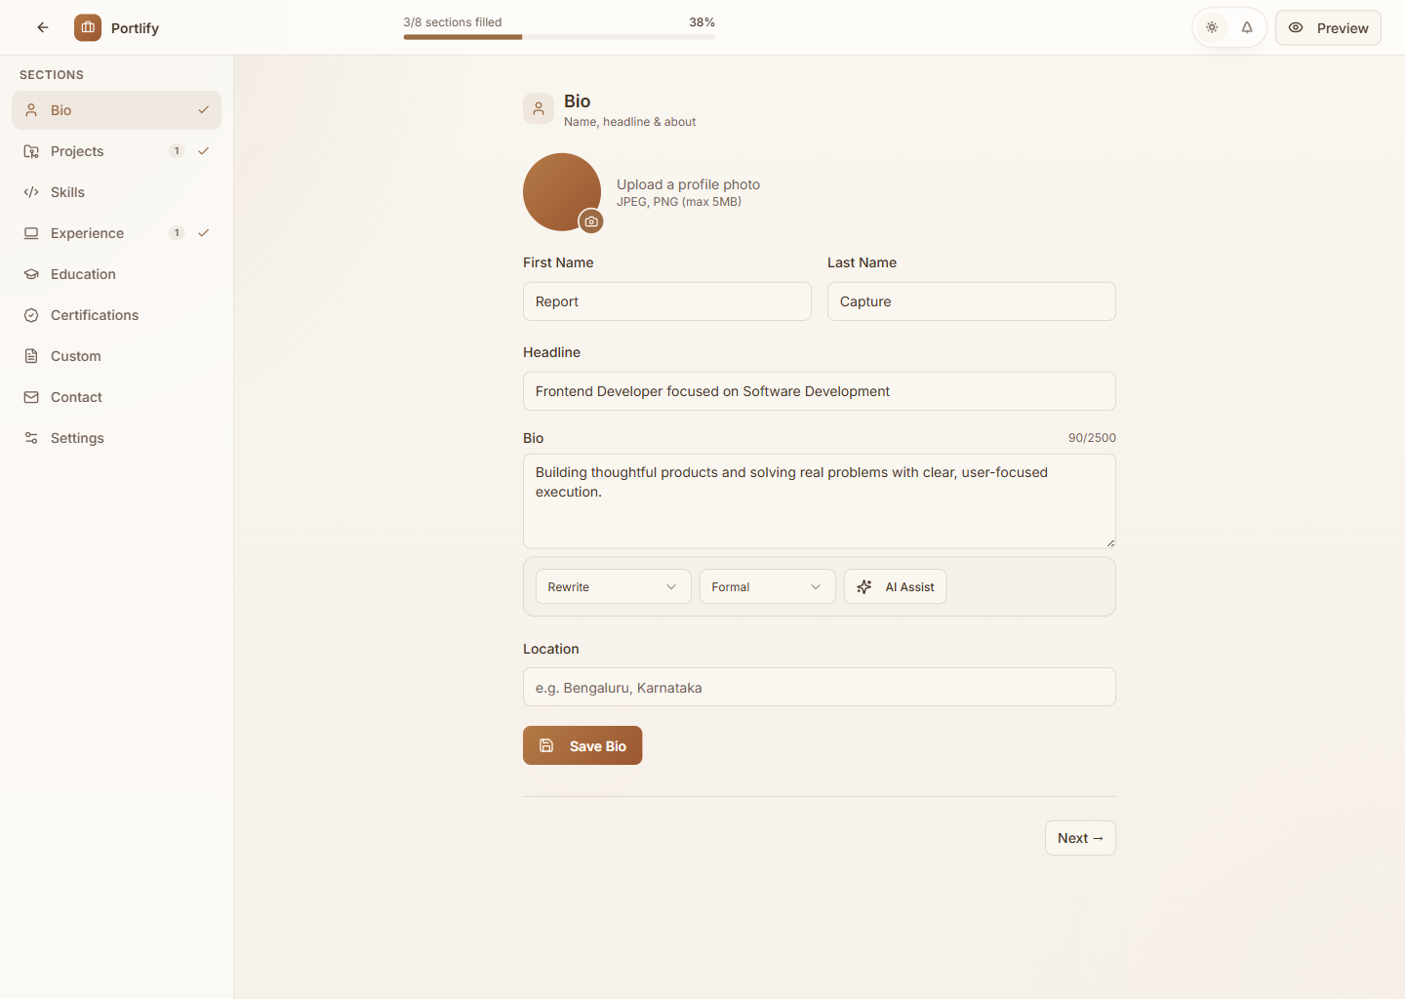
Figure 5. Builder page for editing portfolio content.
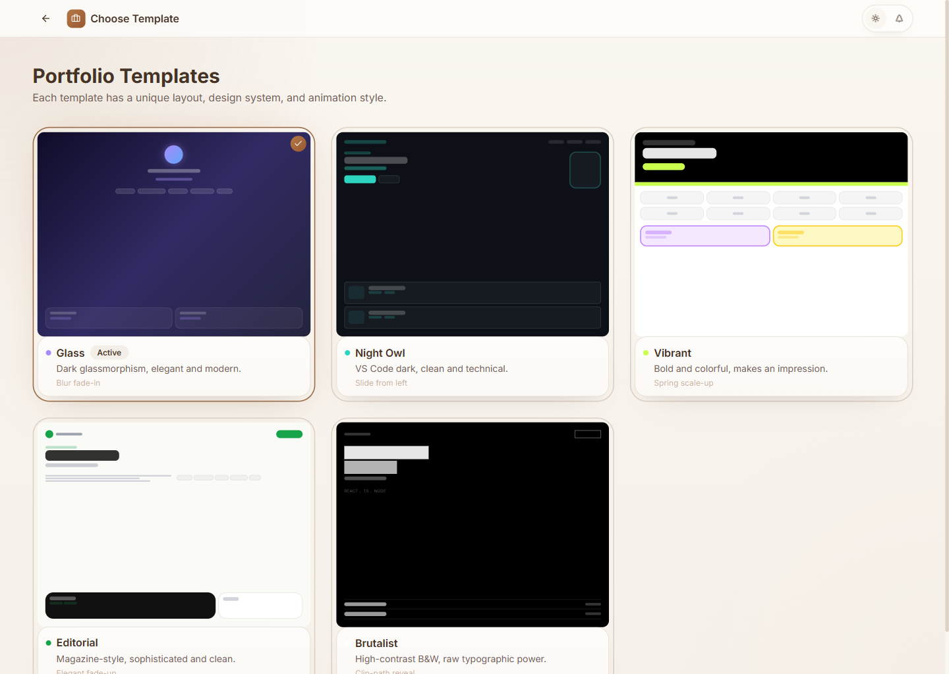
Figure 6. Template selection page.
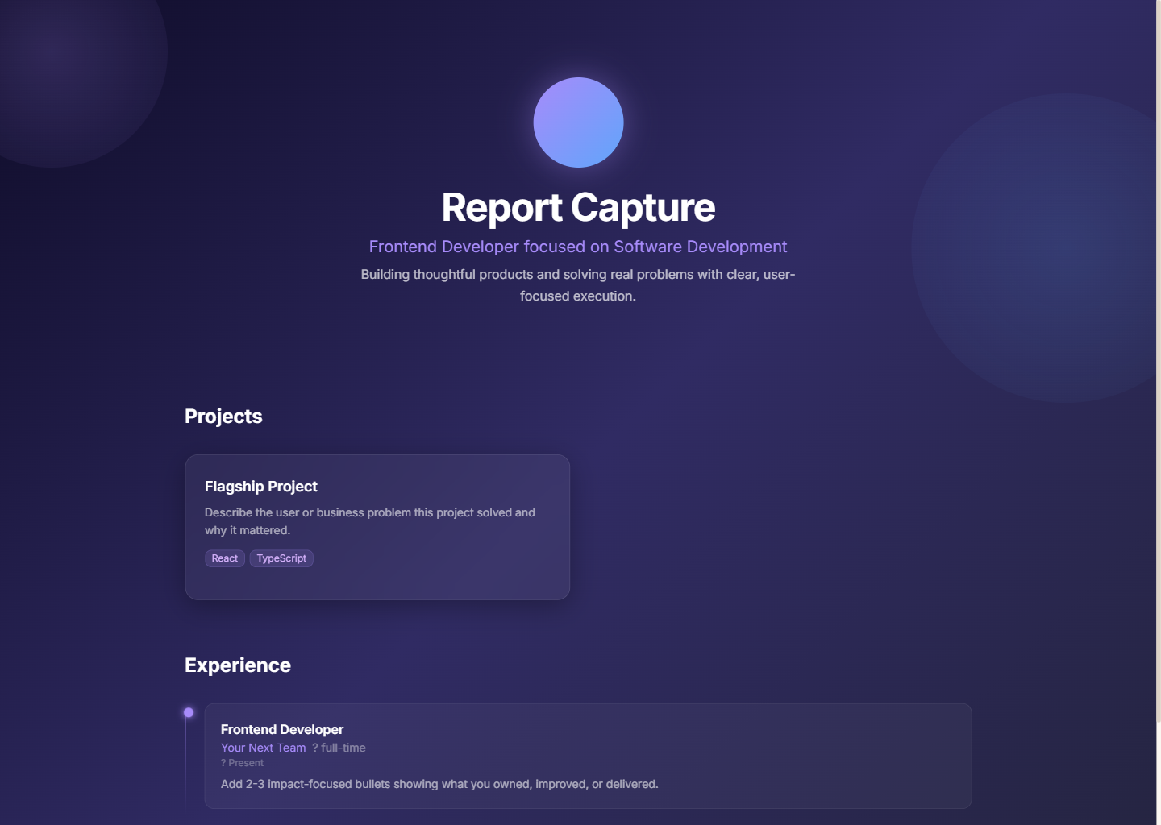
Figure 7. Public portfolio output.

10. Testing and Validation

10.1 Automated Verification
Verification | Result
Production build | Passed using npm run build
Unit and component tests | Passed: 9 files and 20 tests
Route and feature validation | Confirmed against the actual repository and screenshots

10.2 Manual Functional Checks
Area | Status | Observation
Authentication | Passed | Login, signup, and protected routing are implemented.
Onboarding | Passed | User type, goals, import intent, and template selection work in a guided flow.
Builder and preview | Passed | Structured editing and preview flows are present.
Sharing | Passed | Public and unlisted portfolio routes are implemented.
Export | Verified | Protected export route and printable output are available.

11. Advantages and Limitations

11.1 Advantages
- Reduces the effort required to create a professional online portfolio.
- Combines structured content editing, templates, sharing, and export in one platform.
- Supports real integrations such as GitHub import and LinkedIn PDF parsing.
- Provides AI-assisted writing support and SOP generation.

11.2 Limitations
- Some advanced customization features are still limited to the current template system.
- External AI-backed features depend on service availability and configured API access.
- Analytics are currently summary-oriented and can be expanded further in future versions.

12. Future Enhancements
- Custom domain support for live portfolios
- More advanced analytics and trend reporting
- Richer media galleries and personalization options
- Expanded AI assistance across more editable sections
- Additional export styles and downloadable resume formats

13. Conclusion
The OJT work carried out through Portlify demonstrates the end-to-end development of a practical web application that solves a real presentation problem for students and job seekers. The project integrates frontend design, backend services, AI support, and public portfolio delivery into one system.
This report presents the work in the college’s official structure while keeping the technical content aligned with the actual implementation. The final result is both academically presentable and technically credible.

14. References / Bibliography
- Project source repository for Portlify.
- React Documentation - https://react.dev/
- Vite Documentation - https://vite.dev/
- Supabase Documentation - https://supabase.com/docs
- Tailwind CSS Documentation - https://tailwindcss.com/docs
- shadcn/ui Documentation - https://ui.shadcn.com/
- TanStack React Query Documentation - https://tanstack.com/query/latest
- Framer Motion Documentation - https://www.framer.com/motion/
- GitHub REST API Documentation - https://docs.github.com/en/rest
- Google Gemini API Documentation - https://ai.google.dev/
- OpenAI API Documentation - https://platform.openai.com/docs

15. Appendix

15.1 ER-Style Data Model
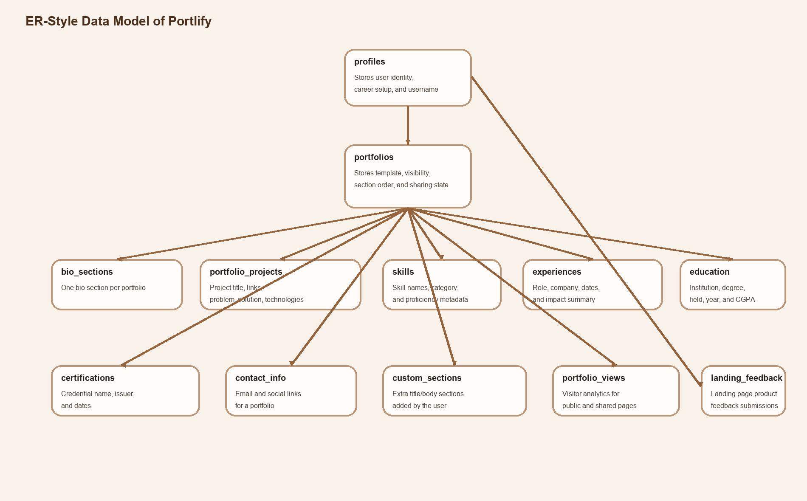
Figure 8. ER-style data model used by Portlify.

15.2 Team Contribution Note
Member | Roll Number | Contribution
Soham Bhutkar | 253341038 | Led the project end-to-end, including planning, UI development, core implementation, integration, testing, report review, and presentation preparation
Vishal Vishwakarma | 253341029 | Assisted in UI creation and motion graphics for marketing and presentation support
Krushna Thombre | 253341013 | Assisted in backend-related work and selected features such as GitHub fetching and onboarding support
Onkar Naik | 253341012 | Assisted in documentation, report structuring, and report writing with AI-assisted drafting support

