UAC Care Transition Efficiency
Executive Summary for Government Stakeholders
Data period: January 12, 2023 – December 21, 2025 | 720 reporting sessions

Why This Matters
Current public reporting on the Unaccompanied Alien Children (UAC) program tracks how many children are in custody at a given time. It does not directly measure how quickly children move through the system — from apprehension, to transfer into HHS care, to reunification with a sponsor. This summary presents findings from an analysis that fills that gap, using the program's own daily reporting data.

Headline Finding
Total volume moving through the system fell sharply in 2025, but the estimated time children spent in HHS care rose at the same time — from roughly 31–34 days on average in 2023–2024 to an estimated 156 days in 2025, more than four times longer.
In plain terms: a smaller population in the system in 2025 did not mean a faster-moving system. The children who remained appear to have stayed substantially longer, on average, than in prior years. This would not be visible from custody counts alone — it only emerges when discharges are measured against the size of the population still in care.

Key Numbers
Metric | 2023 | 2024 | 2025
Children entering CBP custody | 27,056 | 37,166 | 3,115
Children transferred to HHS | 36,124 | 52,552 | 3,965
Children discharged to sponsors | 66,244 | 51,689 | 6,920
Est. average days in HHS care | 30.9 | 33.6 | 156.3

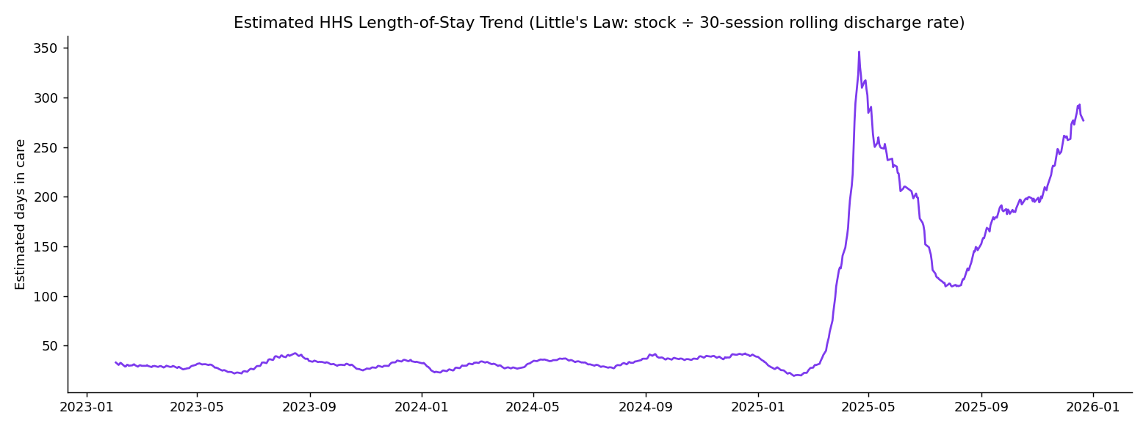
Estimated length of stay in care, 2023–2025.

Where the System Is Under Strain
- 18.3% of all reporting sessions (132 of 720) showed sustained, below-normal discharge performance — a signal of ongoing slowdown, not just occasional dips.
- This is roughly three times more sessions than were flagged by simply watching for oversized custody counts (41 sessions, 5.7%) — meaning a count-only view would have missed most of the strain in the system.
- As of the most recent data (December 21, 2025), fewer than 1 in 200 children in HHS care were being discharged per reporting session on average — directly consistent with the longer average stay noted above.

What Is Working
- The current backlog is shrinking, not growing: recent data shows more children exiting the system than entering it, on average.
- This is a genuinely positive signal — but it is happening from a much smaller and slower base than in 2023–2024, so it should not be read as a full recovery in pipeline speed.

Recommendations
- Track and report the discharge rate relative to the number of children currently in care — not just the raw number discharged — since this is what revealed the 2025 slowdown that raw counts concealed.
- Prioritize investigating the operational cause of the 2025 increase in estimated time-in-care, as it is the most significant change identified in this analysis.
- Add a sustained-slowdown alert (5 or more consecutive reporting periods of below-average discharge performance) alongside existing custody-count monitoring, since the two signals capture different — and only partly overlapping — types of strain.
- Extend daily reporting to consistently cover all seven days of the week; the current data has almost no Friday/Saturday entries, which limits confidence in any weekday-versus-weekend comparisons.

A Note on Confidence
Time-in-care figures in this summary are estimates derived from daily custody and discharge counts (using a standard queuing-theory approximation), not directly measured per-child durations. They are considered directionally reliable and are based on the program's own reported data, but should be treated as estimates rather than exact figures when used in further decision-making.

