Care Transition Efficiency in the
Unaccompanied Alien Children (UAC) Program
A Process-Efficiency and Outcome Evaluation Analysis
Research Paper — Exploratory Data Analysis, Insights & Recommendations
Prepared for: Unified Mentor — in the context of a U.S. Department of Health and Human Services (HHS) dataset
Prepared by: Soham Deolalikar
Data period analyzed: January 12, 2023 – December 21, 2025 (720 reporting sessions)

Abstract
Public reporting on the U.S. Unaccompanied Alien Children (UAC) program has historically emphasized point-in-time custody counts — how many children are currently in Customs and Border Protection (CBP) custody or Department of Health and Human Services (HHS) care. These counts describe capacity but say little about how efficiently children move through the pipeline: from apprehension, to transfer into HHS care, to eventual discharge and reunification with a vetted sponsor.
This paper reframes the publicly available HHS UAC daily reporting dataset (720 sessions, January 2023 – December 2025) through a process-efficiency and outcome-evaluation lens. Five original KPIs — Transfer Efficiency Ratio, Discharge Effectiveness Index, Pipeline Throughput Rate, Backlog Accumulation Rate, and Outcome Stability Score — are constructed from the raw daily counts to quantify how well the system converts inflow into completed placements, where and when the pipeline slows down, and how consistent outcomes have been over time.
The analysis finds that while total volumes moving through the system fell sharply from 2023 to 2025, the estimated length of stay in HHS care rose substantially over the same period, indicating that the slowdown in absolute numbers has not translated into a faster pipeline on a per-child basis. The paper documents this and other findings, flags data-quality caveats (notably sparse Friday/Saturday reporting), and closes with a set of operationally-scoped recommendations.

1. Background and Context
The UAC program operates as a multi-stage care and reunification pipeline rather than a single-point healthcare or custody system. Children who are apprehended are first held in CBP custody, then transferred into HHS care for medical screening, sheltering, and case management, and finally discharged to a vetted sponsor (typically a family member) in the United States.
From a policy and humanitarian standpoint, the speed, continuity, and reliability of this pipeline matter as much as its raw capacity. A child held longer than necessary at any stage represents both a welfare concern and a resource-utilization inefficiency. Yet standard public reporting on the program has concentrated on stock counts (how many children are in custody today) rather than flow metrics (how quickly children are moving through the system, and where they are getting stuck).

2. Problem Statement
While aggregate counts of children in custody are routinely monitored, process-efficiency metrics are largely absent from public reporting. This creates several unanswered questions that this paper aims to address:
- How efficiently are children transferred from CBP custody into HHS care?
- Are HHS discharges keeping pace with the volume of children entering care?
- When and where do care backlogs accumulate, and how large are they?
- Are placement outcomes improving, deteriorating, or holding steady over time?
Without structured transition analytics, bottlenecks in the system remain hidden inside otherwise-stable-looking custody counts.

3. Data and Methodology

3.1 Dataset Description
The dataset is the HHS UAC Program daily reporting series, covering January 12, 2023 through December 21, 2025 — 720 valid reporting sessions after removing trailing blank rows. Each row reports, for a single day:
Column | Description
Date | Reporting date
Children apprehended / placed in CBP custody | Daily intake volume (CBP inflow)
Children in CBP custody | Active CBP custody load (stock)
Children transferred out of CBP custody | Flow into the HHS system
Children in HHS Care | Active HHS care load (stock)
Children discharged from HHS Care | Successful sponsor placements

3.2 Derived KPIs
Five KPIs were derived directly from the raw daily counts, following the methodology specified for this analysis:
KPI | Formula | What it measures
Transfer Efficiency Ratio | Transfers ÷ CBP Custody (stock) | Speed of CBP → HHS movement
Discharge Effectiveness Index | Discharges ÷ HHS Care (stock) | Placement / discharge success rate
Pipeline Throughput Rate | 30-session rolling: total exits ÷ total entries | Overall system movement
Backlog Accumulation Rate | 14-session rolling avg net inflow | Severity of delay / backlog build-up
Outcome Stability Score | 1 − coefficient of variation of Discharge Effectiveness (30-session rolling) | Consistency of placement outcomes

Two supporting estimates were also derived using Little's Law (stock ÷ rolling outflow rate) to approximate length of stay (LOS) in each stage: cbp_los_days_est and hhs_los_days_est. These are model-based estimates, not directly reported figures, and should be read as directional rather than exact.

3.3 Bottleneck and Stagnation Detection
Two distinct signals were built to flag pipeline stress, deliberately kept separate because they capture different failure modes:
- Bottleneck (level-based): a stage's stock is more than 1.5 standard deviations above its 60-session rolling average and is still net-accumulating. This flags unusually large backlogs.
- Stagnation (flow-based): Discharge Effectiveness has been below its own trailing 90-session median for 5 or more consecutive sessions. This flags a persistent slowdown in throughput, even if the stock level itself isn't unusually large.

3.4 Data Quality Note
The dataset contains almost no Friday or Saturday reporting sessions (2 Friday sessions, 0 Saturday sessions, out of 720). As a result, weekday-vs-weekend comparisons in this analysis are effectively driven by Sunday reporting and should be interpreted with that caveat in mind rather than as a full 7-day comparison.
Additionally, the first ~10 sessions of the series produce missing values for 30-session rolling KPIs by construction (insufficient trailing history); these warm-up rows were excluded from era-comparison analysis rather than reported as zero or default values.

4. Exploratory Data Analysis and Key Findings

4.1 Overall Volume, 2023–2025
Across the full 720-session period, the system processed:
Metric | Total (Jan 2023 – Dec 2025)
CBP intake (apprehensions) | 67,337 children
CBP → HHS transfers | 92,641 children
HHS discharges (sponsor placements) | 124,853 children
Transfers and discharges exceeding the same-period intake figure is expected and consistent with a pipeline that was also clearing pre-existing stock carried over from before the reporting window — not a data error.
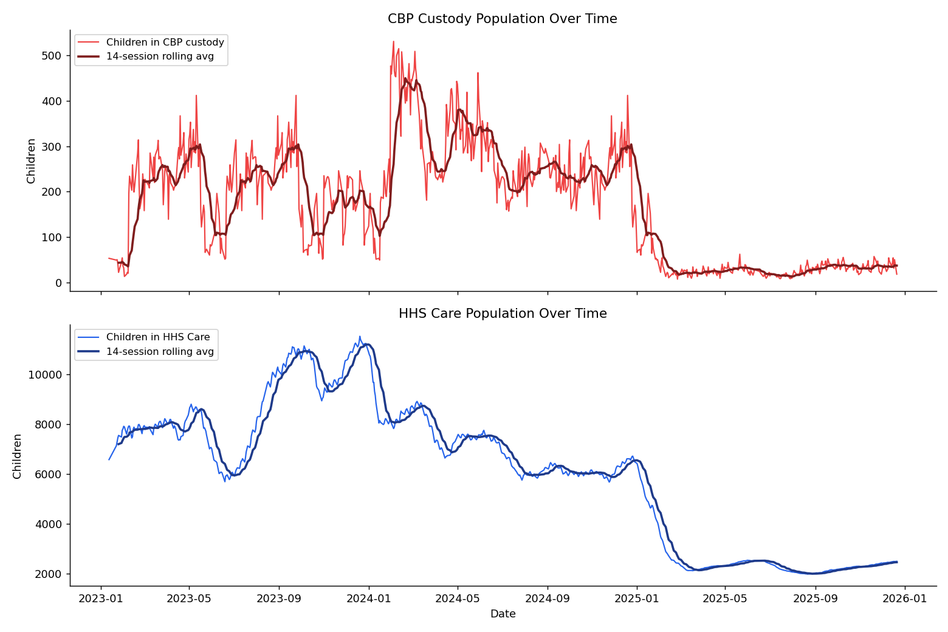
Figure 1. CBP and HHS stock/flow over the full reporting period.

4.2 A Sharp Volume Decline Alongside a Slower Pipeline
Breaking the totals down by year reveals the most significant finding of this analysis:
Year | CBP inflow | Transfers | Discharges | Avg. HHS stock | Avg. HHS LOS (est., days)
2023 | 27,056 | 36,124 | 66,244 | 8,646 | 30.9
2024 | 37,166 | 52,552 | 51,689 | 7,043 | 33.6
2025 | 3,115 | 3,965 | 6,920 | 2,543 | 156.3
Total volume collapsed in 2025 relative to 2023–2024 — intake alone fell roughly 92% versus 2024. On its own, this could be read as the system successfully working down its caseload. But the estimated average length of stay in HHS care rose from roughly 31–34 days in 2023–2024 to an estimated 156 days in 2025 — a more than four-fold increase.
This means the smaller 2025 caseload has not moved through the pipeline meaningfully faster; if anything, the children remaining in the system in 2025 appear to be staying substantially longer, on average, than those processed in the higher-volume years. Falling headline custody counts alone would not surface this — it only becomes visible when discharge rate is measured relative to stock, which is precisely the gap this analysis was designed to close.
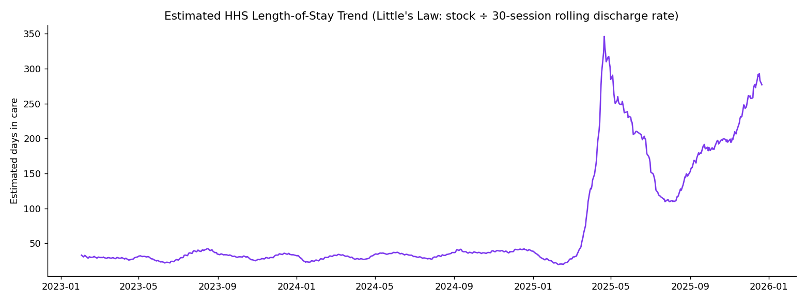
Figure 2. Estimated length-of-stay trend, CBP and HHS (Little's Law approximation).

4.3 Recent Efficiency Snapshot (as of December 21, 2025)
KPI | 30-session avg. | 90-session avg.
Transfer Efficiency Ratio | 0.275 | 0.323
Discharge Effectiveness Index | 0.004 | 0.005
Pipeline Throughput Rate | 1.35 | —
Backlog Accumulation Rate | -2.06 children/session | —
Outcome Stability Score | 0.556 | —
The Discharge Effectiveness Index sitting at roughly 0.004–0.005 means that, in recent sessions, well under 1% of the standing HHS population is being discharged per session on average — directly consistent with the elongated length-of-stay finding above. Pipeline Throughput above 1.0 and a negative Backlog Accumulation Rate both indicate the backlog is currently shrinking, but from a much smaller and much slower-moving base than in 2023–2024.

4.4 Bottlenecks and Stagnation
Signal | Sessions flagged (of 720) | Share of period
CBP-side bottleneck (level-based) | 26 | 3.6%
HHS-side bottleneck (level-based) | 41 | 5.7%
Stagnation (flow-based, HHS) | 132 | 18.3%
The gap between the bottleneck signal (5.7% of sessions) and the stagnation signal (18.3% of sessions) on the HHS side is itself informative: the system spent much more time in a state of persistently slow discharge performance than it did in a state of visibly oversized backlog. A dashboard or reporting process that only tracks raw custody counts would miss roughly three-quarters of the sessions flagged here as under sustained strain, because the population size in those sessions wasn't unusually large — the throughput was.
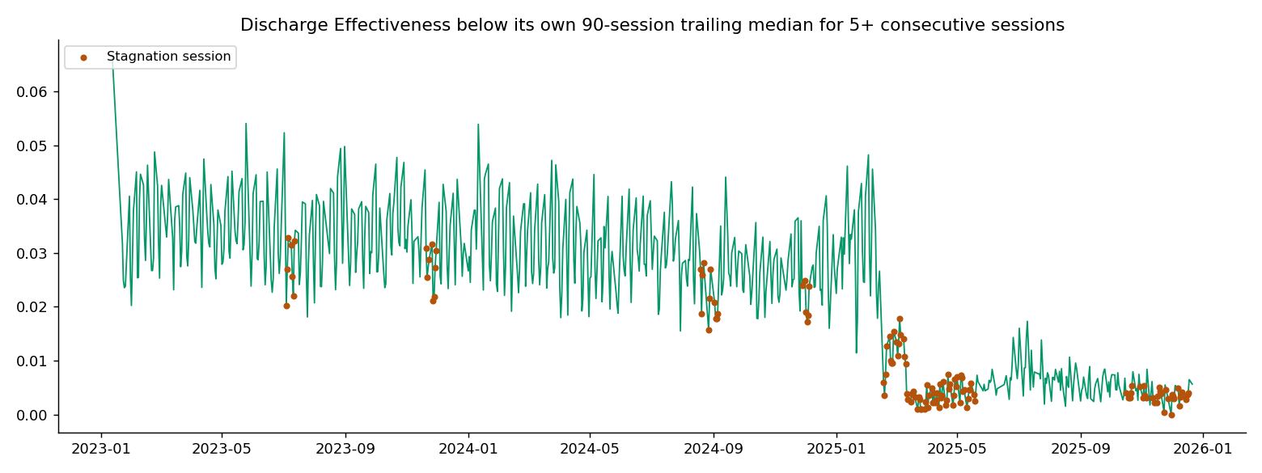
Figure 3. Stagnation periods (flow-based) versus custody stock over time.

4.5 Weekday vs. Weekend Patterns
 | Avg. Transfer Efficiency | Avg. Discharge Effectiveness | Avg. CBP inflow | Avg. transfers | Avg. discharges | Sessions
Weekday | 0.689 | 0.023 | 94.7 | 128.4 | 166.2 | 590
Weekend* | 0.700 | 0.028 | 88.2 | 130.1 | 206.1 | 130
*Weekend figures are driven almost entirely by Sunday reporting, given the near-total absence of Friday/Saturday sessions noted in Section 3.4. Within that caveat, weekend sessions show modestly higher transfer and discharge effectiveness and a notably higher average discharge count, which may reflect operational patterns around Sunday processing or simply a smaller, less representative sample — this should be validated against a more complete 7-day dataset before being treated as a real operational pattern.

4.6 Recent Monthly Trend (2025)
Month | Total discharged | Total transferred | Avg. outcome stability
May 2025 | 205 | 252 | 0.534
Jun 2025 | 281 | 138 | 0.632
Jul 2025 | 396 | 88 | 0.527
Aug 2025 | 254 | 147 | 0.556
Sep 2025 | 237 | 260 | 0.590
Oct 2025 | 242 | 263 | 0.636
Nov 2025 | 159 | 182 | 0.602
Dec 2025* | 144 | 124 | 0.522
*December 2025 reflects a partial month (data ends December 21). Discharge and transfer volumes both trend downward across the second half of 2025, consistent with the broader 2025 slowdown documented in Section 4.2. Outcome stability fluctuates in a moderate band (0.52–0.64) without a clear sustained improvement or decline, suggesting placement consistency has neither meaningfully worsened nor recovered through this window.
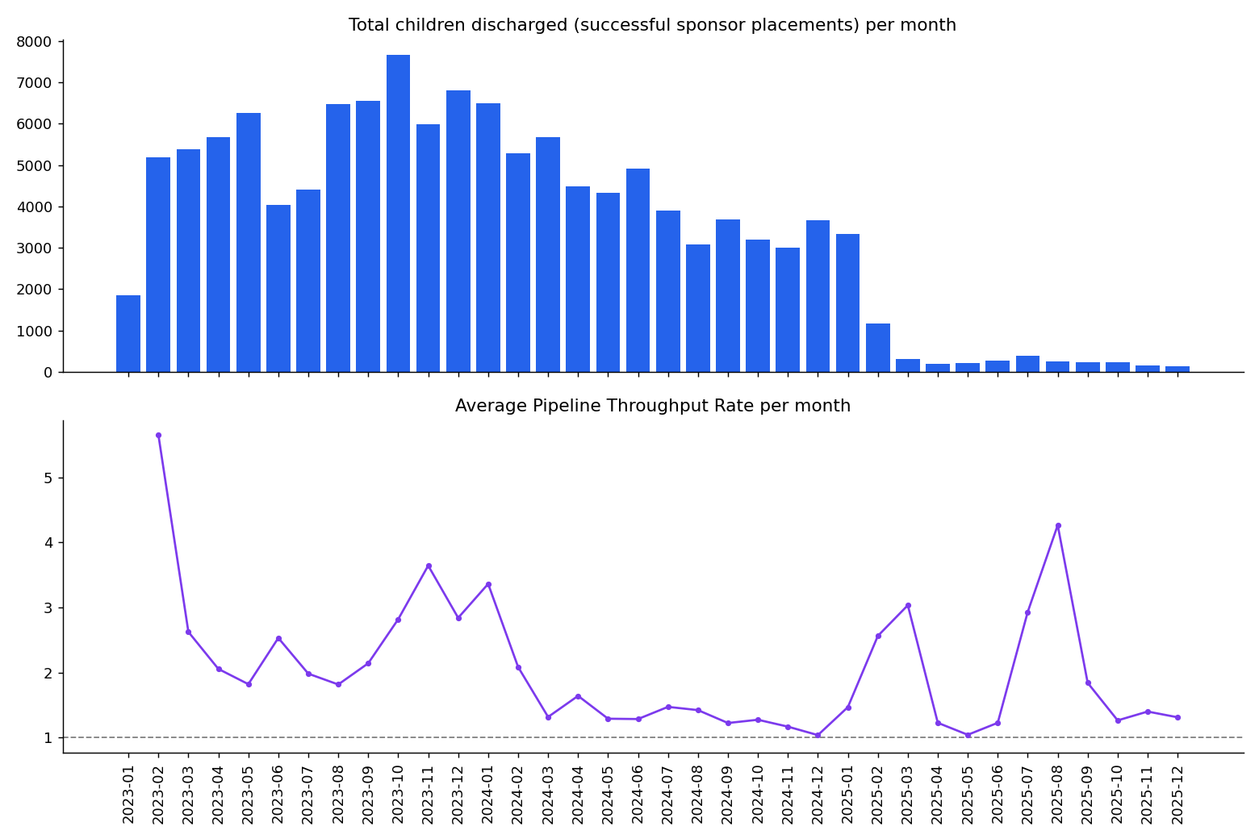
Figure 4. Month-over-month discharge and transfer volumes, 2025.
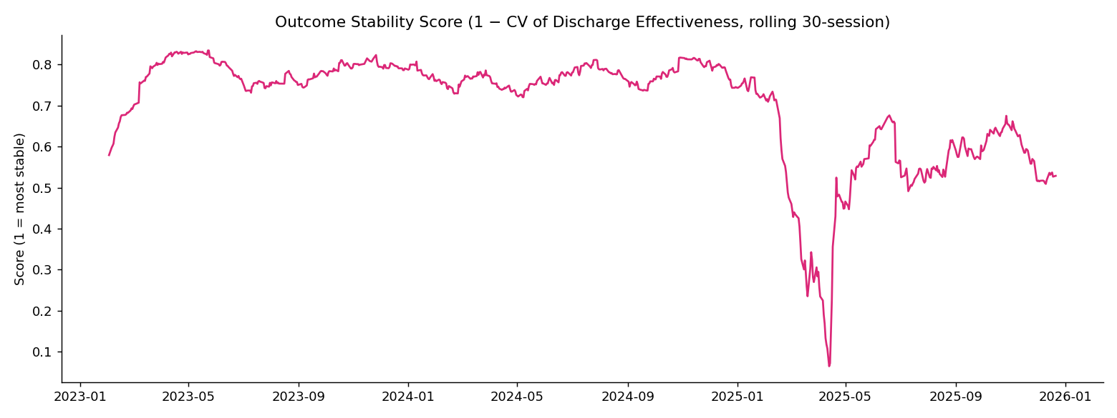
Figure 5. Outcome Stability Score over time.

5. Insights and Interpretation
- Falling custody counts are not, by themselves, evidence of a healthier pipeline. The 2025 data shows the opposite of what headline counts alone would suggest: fewer children in the system, but each one moving through markedly slower.
- Flow-based signals (stagnation, Discharge Effectiveness) surface strain earlier and more often than level-based signals (bottleneck, raw stock size). Relying on stock counts alone would have understated the extent of sustained slowdown by roughly a factor of three in this dataset.
- The system's throughput and backlog trend (Section 4.3) show the current backlog is shrinking — but off a much smaller and slower base, which is a different situation operationally from a genuinely fast-clearing pipeline.
- Weekend patterns (Section 4.5) are suggestive but not conclusive, given the data-quality caveat around missing Friday/Saturday sessions; this is flagged as a direction for further validation rather than a firm finding.

6. Recommendations
- Report discharge rate relative to standing HHS population (Discharge Effectiveness), not just absolute discharge counts, in public and internal dashboards — absolute counts alone concealed the 2025 slowdown documented in this paper.
- Adopt a flow-based stagnation alert (5+ consecutive sessions of below-median discharge effectiveness) alongside the existing level-based bottleneck threshold, since the two signals captured materially different — and only partially overlapping — periods of strain in this data.
- Investigate the specific operational cause of the 2025 length-of-stay increase (estimated ~156 days vs. ~31–34 days in 2023–2024) as a priority item, since it represents the single largest change in system performance found in this analysis.
- Extend reporting to include complete 7-day coverage, particularly Friday and Saturday, to allow weekday/weekend operational differences to be assessed with confidence rather than inferred from a Sunday-heavy sample.
- Use Pipeline Throughput Rate and Backlog Accumulation Rate together as a standing operational pair — throughput alone can look healthy (>1.0) even while the underlying base has shrunk to a fraction of its prior size, as seen in late 2025.

7. Limitations
- Length-of-stay figures (cbp_los_days_est, hhs_los_days_est) are Little's Law approximations derived from stock ÷ rolling outflow, not directly measured per-child durations. They are directionally reliable but should not be quoted as exact individual-level averages.
- The near-absence of Friday/Saturday reporting sessions limits confidence in weekday/weekend comparisons, as detailed in Section 3.4 and 4.5.
- This analysis is based on aggregate daily counts only; it cannot account for case-level factors (sponsor vetting delays, medical holds, legal proceedings) that may explain individual variation within the trends reported here.
- The dataset ends December 21, 2025; conclusions about the 2025 slowdown reflect the period observed and may not extend to more recent activity outside this window.

8. Conclusion
This paper reframes the UAC dataset from a capacity-monitoring lens to a process-efficiency and outcome-evaluation lens. The central finding — that a sharply smaller 2025 caseload has coincided with a substantially longer estimated length of stay — illustrates why flow-based KPIs are a necessary complement to standard custody counts. Measuring how effectively children move through the care pipeline, rather than only how many are present at a given moment, surfaces operational strain that would otherwise remain hidden inside an outwardly shrinking, apparently improving set of numbers. The KPIs, bottleneck/stagnation signals, and recommendations presented here are offered as a starting framework for that kind of ongoing process monitoring.

