horizontal line

**NAME : SOHAM PALEKAR**

**ROLL (old) : 31010921033**

**SUBJECT : PHP and MySQL**

**TITLE : MINIMALIST GROCER**

PHP PROJECT

Minimalist Grocer

**9th November, 2022**

# INTRODUCTION

The website MINIMALIST GROCER is made to make ordering daily groceries a hasslefree task.

This website has a user-friendly interface which makes it easy to navigate through the website.

The website has all the basic functionalities such as a login page, signup page, cart facility, checkout page, log out option, etc.

# SOFTWARE AND HARDWARE REQUIREMENTS

To run this website you will need the following:

1. Install PHP
2. Install XAMPP server
3. Browser eg: Edge, Chrome
4. Database eg: MySQL

Technical knowledge used to make the website

1. Basic knowledge of PHP
2. Basic knowledge of HTML AND CSS
3. SQL commands
4. Database and table creation
5. Code editor like Visual Studio Code

# WORKING OF PROJECT

This website is made with the help of PHP which is a server side scripting language. The backend of the website is handled by PHP. Database and frontend is connected with the help of PHP.

The frontend of the website is done using HTML and CSS.

The XAMPP server helps in locally hosting the website.

All the details of the user are saved on the database using phpmyadmin.

The website contains forms which help take input from the user and save in the database.

WALKTHROUGH OF THE WEBSITE :

The website starts with a signup page where you are required to register and create a new account. The account details are stored in the database.

Next is the login page. Fill in your details and there will be an authentication process which will verify if your account details are correct and if your account exists.

After successful login, you will be redirected to the homepage of the website. The homepage contains various categories choices which you can select and start adding them to the cart.

There are 4 sections: fruits and vegetables, milk products, grains and drinks.

Select any one option and will be redirected to that page.

Add to cart all the necessary items you want and then look at the cart if you want to increase or decrease the quantity of the products.

After selecting all the desired products you can check out from the cart.

After clicking on the checkout option you will have to fill in your details like your address and your preferred payment method.

After filling the checkout page your order will be placed and will be delivered to your doorstep within 2 hours.

After ordering, you can log out of your account.

After logging out from your account the cart items will be cleared off and you will be redirected back to the login page.

# 

# FORMS USED IN THIS WEBSITE (screenshots)

1 ] The first form used is the sign up form.

Use : Takes the user input and helps save it to the database.

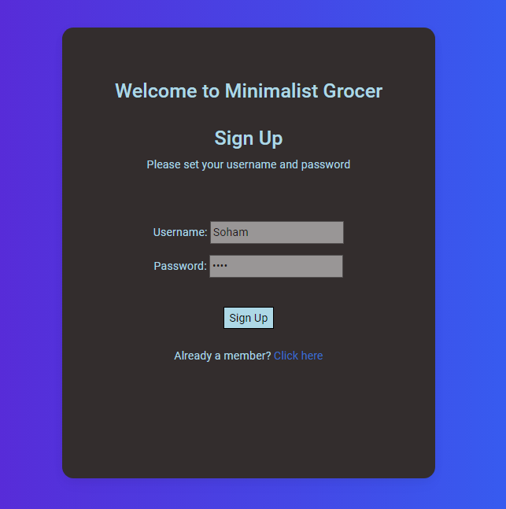

2 ] Login form

Use : To take input from the user and verify their account details.

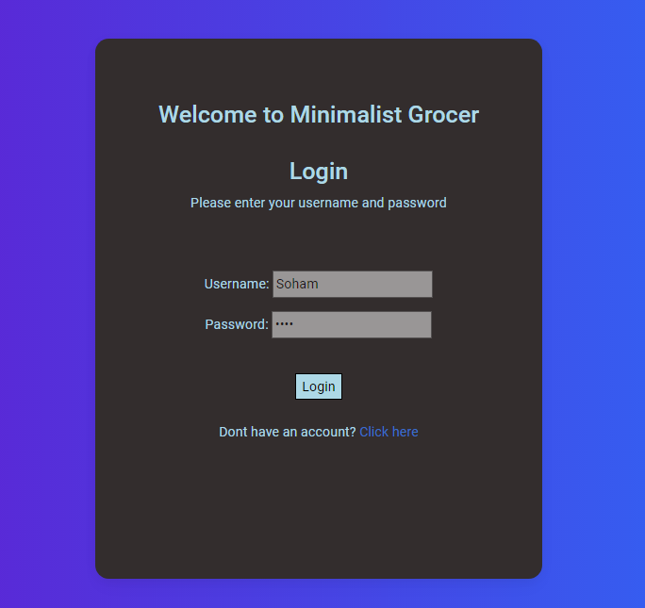

3 ] Cart form in navbar

Use : To view items added to cart



4 ] All the options on homepage

Use : Every button is a form, which helps in going to a particular page.

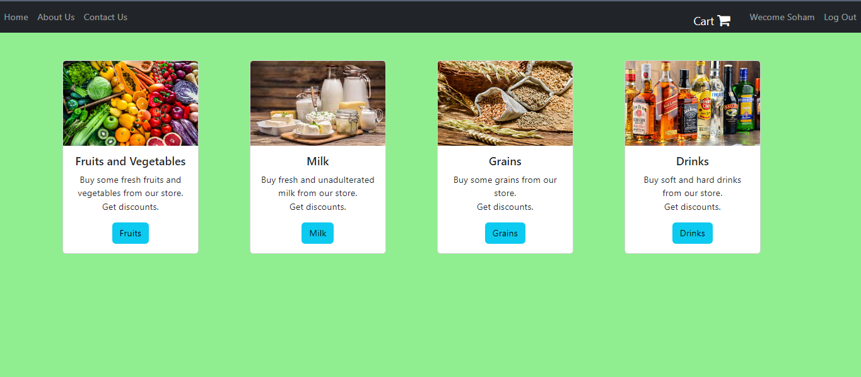

5 ] All add to cart buttons are a form.

Use : Every button has an hidden input value which gives the information about the product in which the form is placed.

Values like their name and price.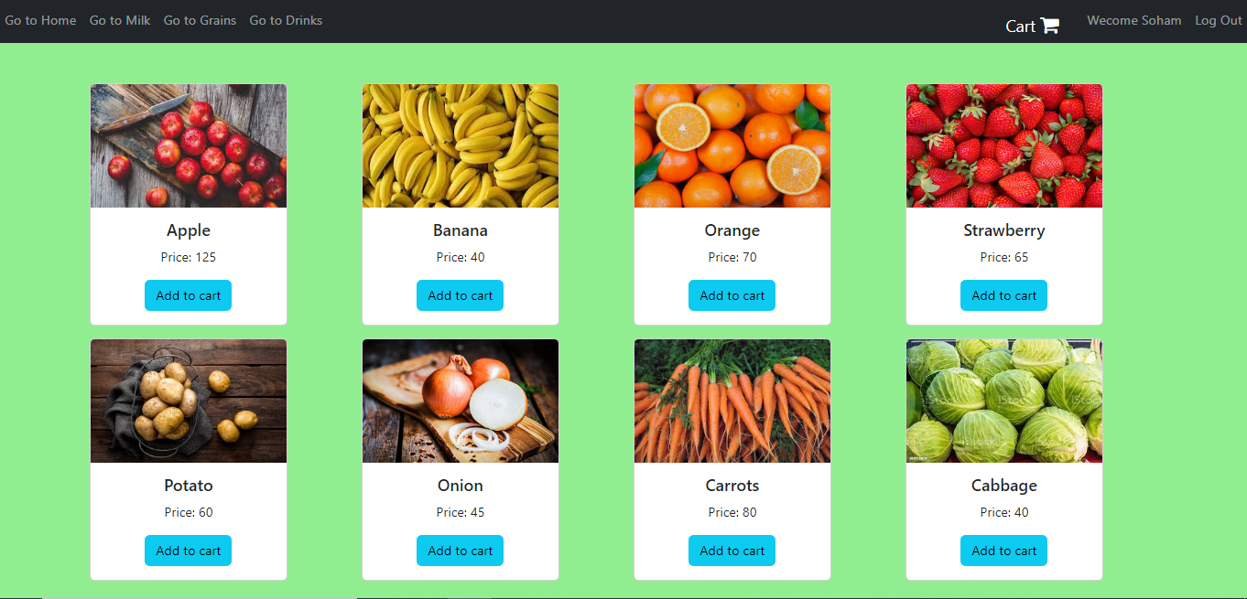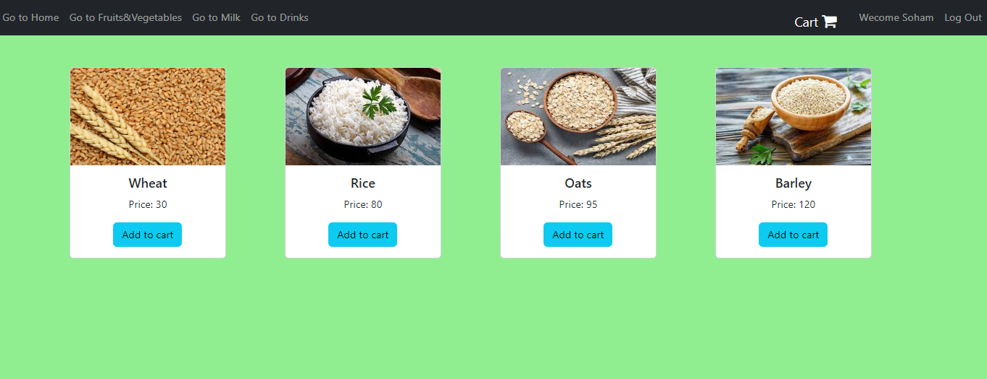

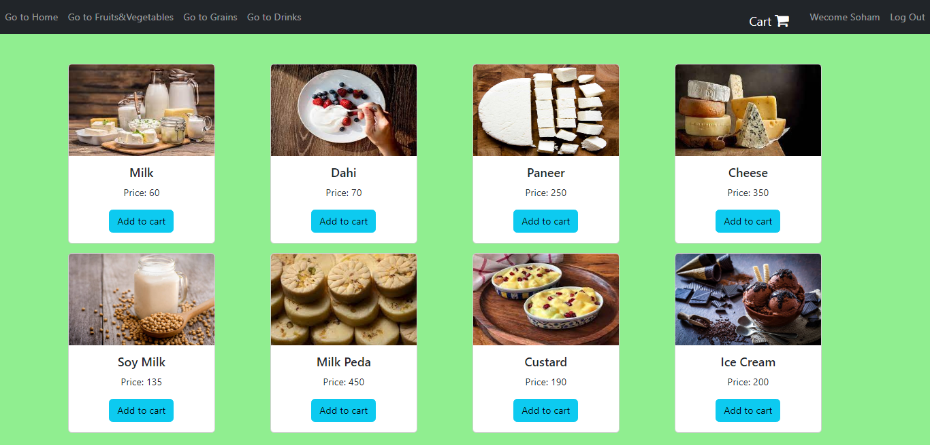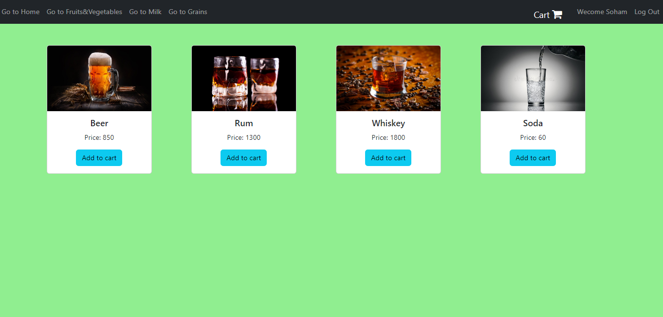

6 ] Change form

Use :

The change button/form is there to help to increase or decrease the quantity of the product.

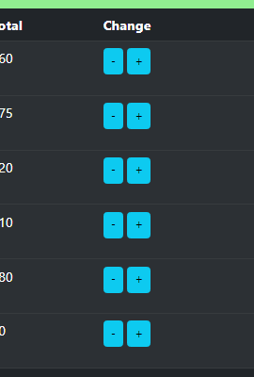

7 ] Remove form

Use : The remove form is used when the product added to cart is not wanted, so it is removed from the cart.

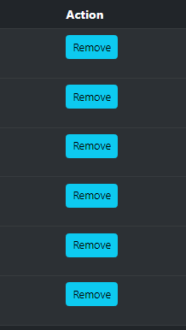

8 ] Empty cart form : This helps when you need to empty the cart. If all items in the cart are wrong then use the empty cart option.

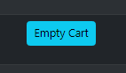

9 ] Checkout form : After all the items in the cart are ready to be ordered, use the checkout option to order all of your items.

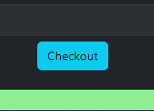

All the cart buttons are forms.

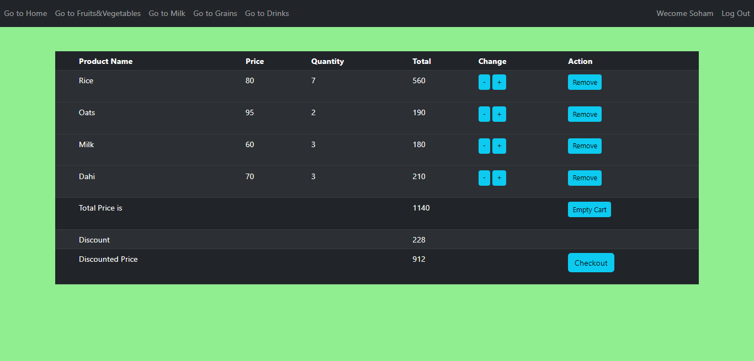

10 ] Checkout page form

Use : Take input from the user about address and payment method.

