1)Explain basic concepts of divide and conquer.

**Divide And Conquer**   
This technique can be divided into the following three parts:

1. **Divide:**This involves dividing the problem into smaller sub-problems.
2. **Conquer:**Solve sub-problems by calling recursively until solved.
3. **Combine:**Combine the sub-problems to get the final solution of the whole problem.

**Divide And Conquer algorithm :**

DAC(a, i, j)

{

if(small(a, i, j))

return(Solution(a, i, j))

else

m = divide(a, i, j) // f1(n)

b = DAC(a, i, mid) // T(n/2)

c = DAC(a, mid+1, j) // T(n/2)

d = combine(b, c) // f2(n)

return(d)

}

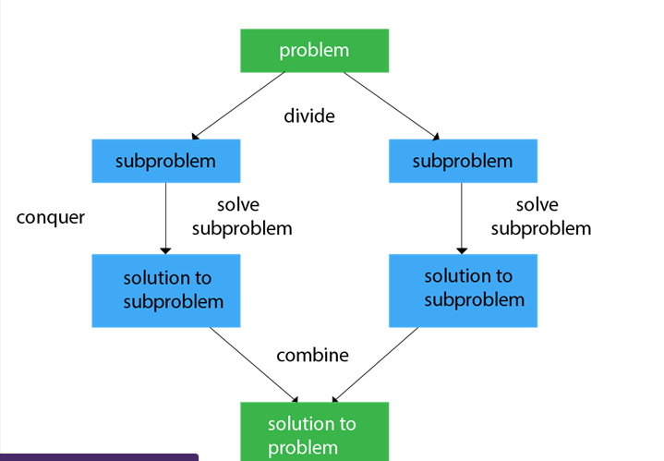

Applications of Divide and Conquer Approach:

Following algorithms are based on the concept of the Divide and Conquer Technique:

1. **Binary Search:** The binary search algorithm is a searching algorithm, which is also called a half-interval search or logarithmic search. It works by comparing the target value with the middle element existing in a sorted array. After making the comparison, if the value differs, then the half that cannot contain the target will eventually eliminate, followed by continuing the search on the other half. We will again consider the middle element and compare it with the target value. The process keeps on repeating until the target value is met. If we found the other half to be empty after ending the search, then it can be concluded that the target is not present in the array.
2. **Quicksort:** It is the most efficient sorting algorithm, which is also known as partition-exchange sort. It starts by selecting a pivot value from an array followed by dividing the rest of the array elements into two sub-arrays. The partition is made by comparing each of the elements with the pivot value. It compares whether the element holds a greater value or lesser value than the pivot and then sort the arrays recursively.

**3)Explain QuickSort using Random Pivoting(Randomized Quick Sort)**

Using random pivoting we improve the expected or average time complexity to O (N log N). The Worst-Case complexity is still O ( N^2 ).

Run the Quicksort algorithm. Each time picking a random element in the array as the pivot.