Hertzsprung–Russell Diagram Analysis Using Gaia DR3
This report presents the construction and analysis of a Hertzsprung–Russell (HR) diagram using high-quality astrometric and photometric data from Gaia Data Release 3 (DR3). The objective is to visualize the stellar population within 100 parsecs of the Sun and identify major stellar evolutionary features.

1. Data Source
The data were obtained from Gaia DR3 using the astroquery.gaia interface. Only stars with parallaxes greater than 10 milliarcseconds were selected, corresponding to distances less than 100 pc. This nearby sample minimizes interstellar extinction effects.

2. Data Selection Criteria
To ensure reliable astrometric measurements, the following quality cuts were applied:
- Parallax over error > 10
- Renormalized Unit Weight Error (RUWE) < 1.4
- Valid G, BP, and RP photometric magnitudes
These criteria reduce contamination from poor astrometric solutions and unresolved binaries.

3. Computation of Physical Parameters
The color index was defined as BP − RP. The absolute G-band magnitude was computed using the Gaia-specific relation:
M_G = G + 5 log10(ϖ) − 10,
where ϖ is the parallax in milliarcseconds. Non-finite values were removed prior to analysis.

4. Hertzsprung–Russell Diagram
The HR diagram was constructed by plotting absolute G magnitude against BP − RP color. The magnitude axis was inverted to follow astronomical convention, placing brighter stars at the top of the diagram.
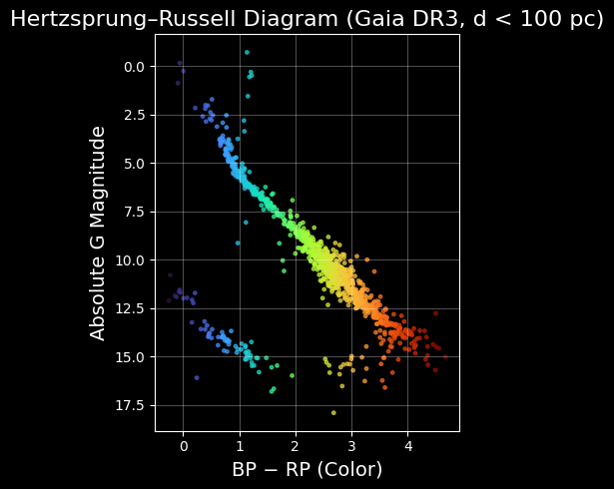

5. Results and Interpretation
The HR diagram clearly shows the main sequence extending diagonally from hot, luminous stars to cooler, fainter ones. A concentration of stars above the main sequence corresponds to red giants, while a sparse population of faint blue stars indicates the presence of white dwarfs. These features are consistent with expectations for a volume-limited sample of nearby stars.

6. Conclusion
This analysis demonstrates the effectiveness of Gaia DR3 data in studying stellar populations. Even a relatively small, well-filtered sample reveals the fundamental structure of the HR diagram, highlighting Gaia’s importance for observational astrophysics and Galactic studies.

