Identification of Open Star Cluster Membership Using Gaia DR3
This report presents a study on the identification of genuine members of an open star cluster using high-precision astrometric and photometric data from Gaia Data Release 3 (DR3). The Pleiades cluster is used as a case study to demonstrate how parallaxes, proper motions, and color–magnitude diagrams can be combined to distinguish cluster members from field stars.

1. Data Source and Cluster Selection
Gaia DR3 data were queried for a circular region of radius 3 degrees centered on the Pleiades open cluster (RA = 56.75°, Dec = 24.12°). This region includes both cluster members and surrounding field stars, enabling robust membership determination.

2. Quality Filtering
The following selection criteria were applied to ensure reliable astrometric measurements:
- Positive parallaxes
- Parallax signal-to-noise ratio > 10
- RUWE < 1.4
These cuts remove sources with unreliable distance or astrometric solutions.

3. Derived Parameters
Distances were computed from parallaxes using d = 1000 / ϖ. Absolute G-band magnitudes were calculated using the distance modulus. The BP − RP color index was used as a temperature proxy.

4. Membership Determination
Initial membership selection was performed in parallax space by identifying stars within two standard deviations of the mean cluster parallax. This was followed by proper motion filtering, selecting stars with pmRA and pmDEC values consistent with the cluster mean within a 2σ threshold.
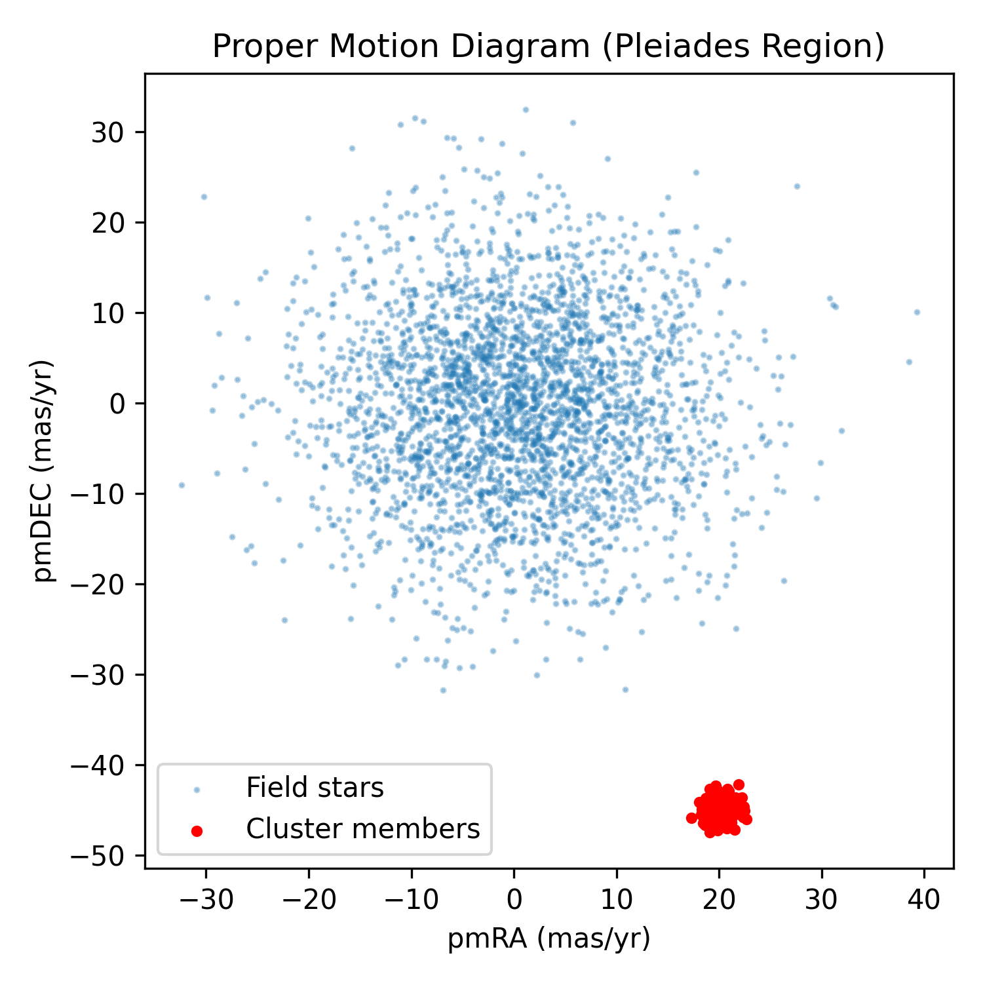

5. HR Diagram Validation
The Hertzsprung–Russell diagram was constructed to validate the astrometric membership selection. Confirmed members form a narrow and well-defined main sequence, while field stars populate a broader region of the diagram.
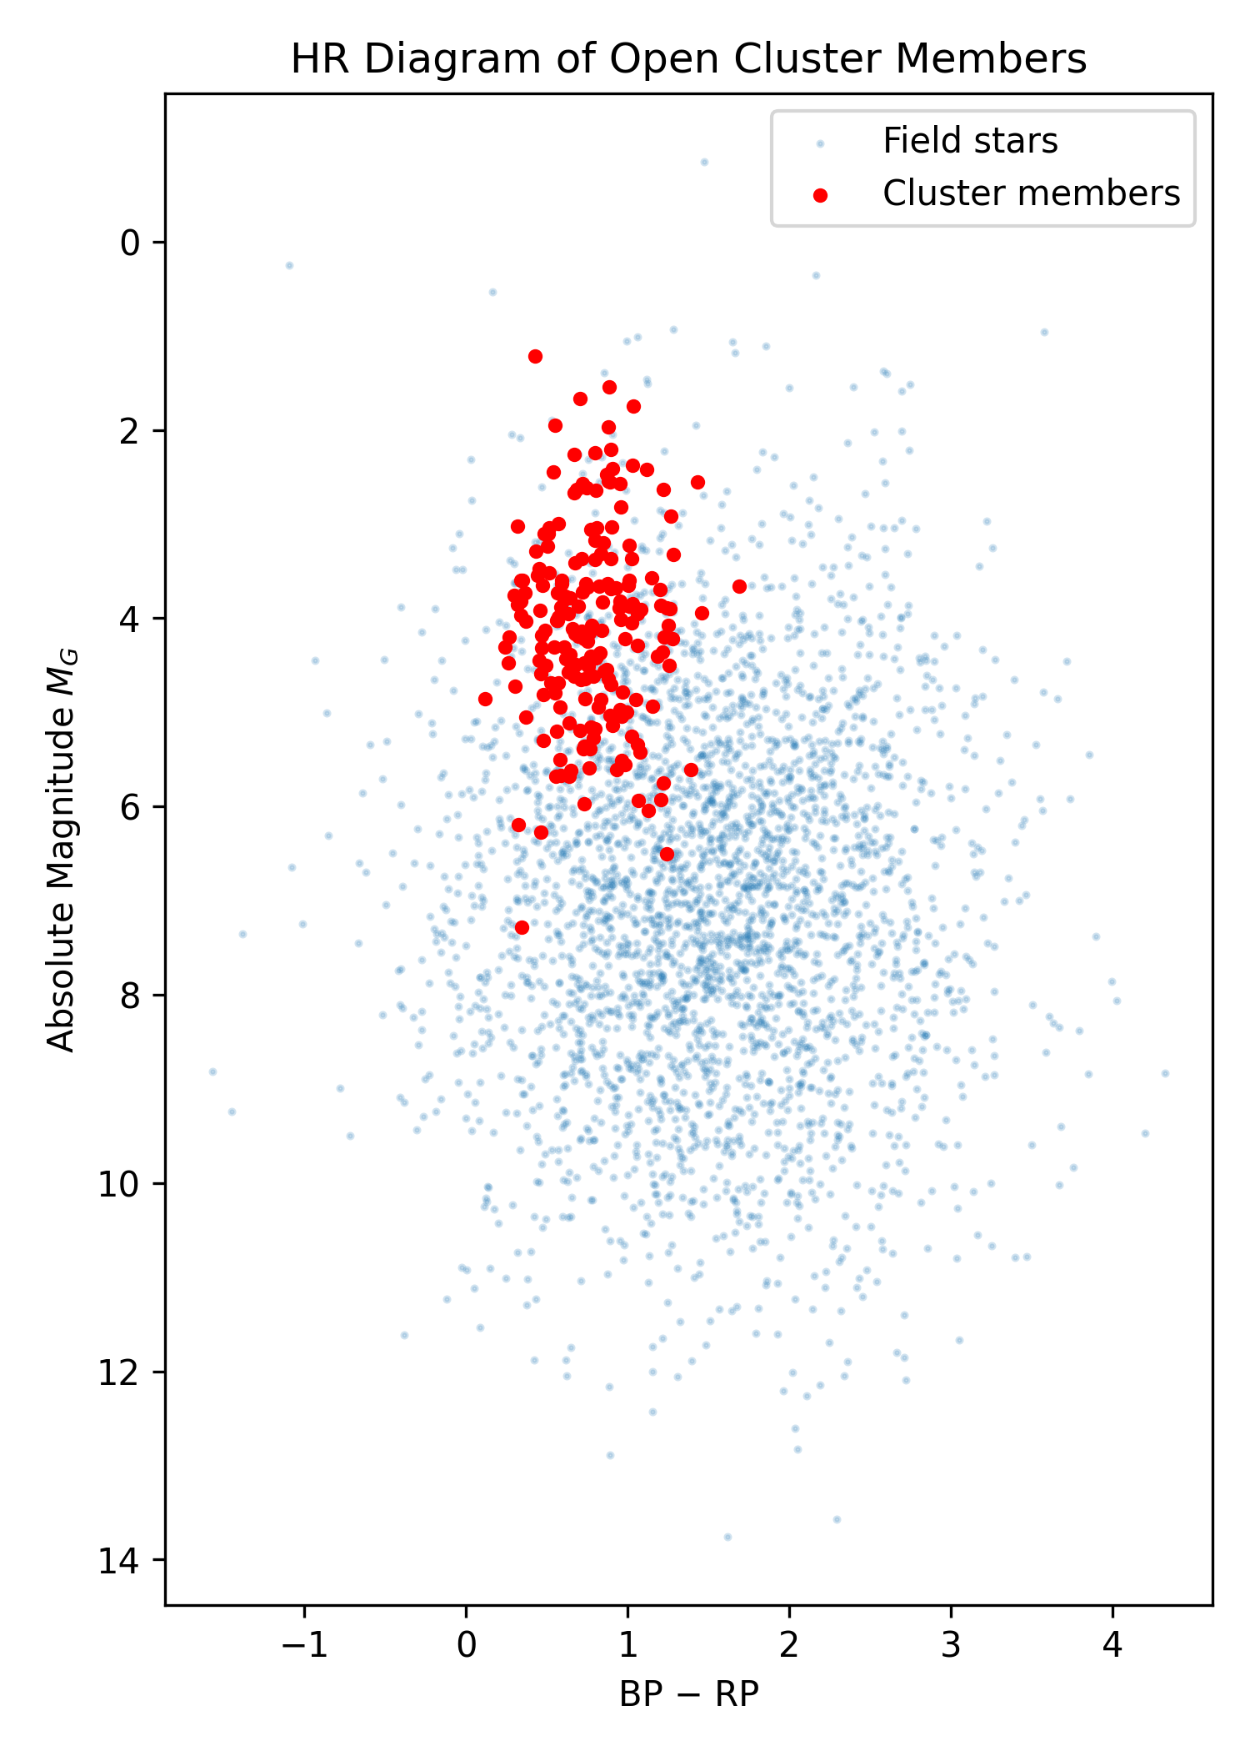

6. Results and Discussion
The combined astrometric selection yields a clean sample of cluster members. The resulting HR diagram confirms the physical coherence of the selected population. The mean distance derived from the members provides a robust estimate of the cluster distance.

7. Conclusion
This project demonstrates the effectiveness of Gaia DR3 astrometry for open cluster membership determination. The methodology is scalable to other clusters and forms a strong foundation for future studies of stellar evolution and Galactic structure.

