

**School of Computing**

**SRM IST, Kattankulathur – 603 203**

**Course Code: 18CSC206J**

**Course Name: Software Engineering and Project Management**

| **Experiment No** | 13 |
| --- | --- |
| **Title of Experiment** | Provide the details of Architecture Design/Framework/Implementation |
| **Name of the candidate** | Soham Ghosh |
| **Team Members** | Ayush Abhigyan, Abhishri Joshi |
| **Register Numbers** | RA2011003010504, RA2011003010493, RA2011003010475 |
| **Date of Experiment** | 8/6/22 |

**Mark Split Up**

| **S. No** | **Description** | **Maximum Mark** | **Mark Obtained** |
| --- | --- | --- | --- |
| 1 | Exercise | 5 |  |
| 2 | Viva | 5 |  |
| **Total** | | **10** |  |

**Staff Signature with date**

**Aim**

To provide the details of architectural design/framework/implementation

**Team Members:**

| **S No** | **Register No** | **Name** | **Role** |
| --- | --- | --- | --- |
| **1** | **RA2011003010504** | **Soham Ghosh** | **Rep/Member** |
| **2** | **RA2011003010493** | **Ayush Abhigyan** | **Member** |
| **3** | **RA2011003010475** | **Abhishri Joshi** | **Member** |

Website architecture refers to the planning and design of a site's information architecture (IA) to establish structure and enhance usability. All websites have an IA but the overall picture of a website’s architecture also includes:

* usability
* interaction design
* user interface design
* information design
* web design
* graphic design
* content strategy

**Web Architectural design - Meloxxy (an Online Music Player)**

1. **Home Page**

The Home page (excluding the Login page) of our website comprises the *About* section at the top. It contains a list of playable songs which further contain details like Artist Name, Length of the Track and the Play button beside the Track.

**Visual Representation**

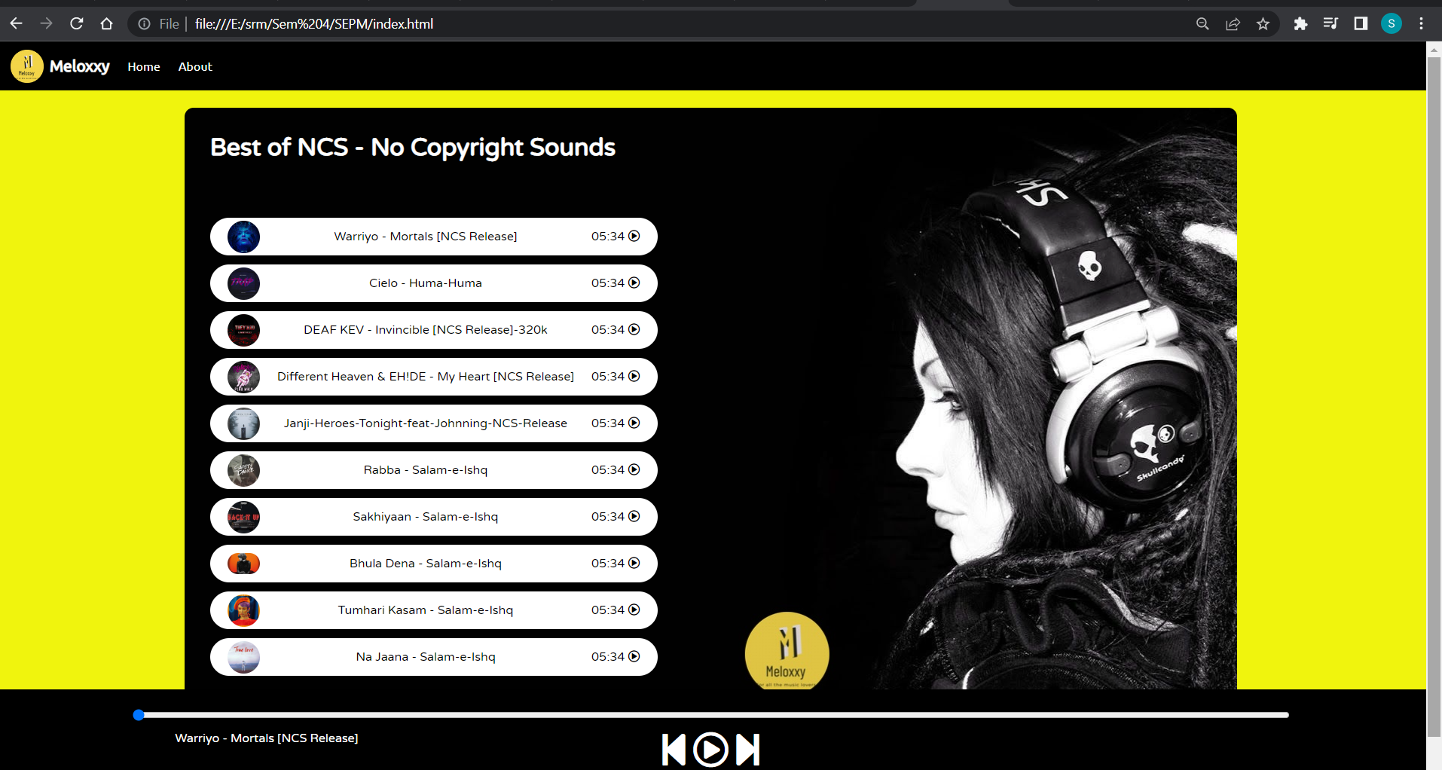

**Source code (index.html) - List of songs**

<div class="container">

<div class="songList">

<h1>Best of NCS - No Copyright Sounds</h1>

<div class="songItemContainer">

<div class="songItem">

<img alt="1">

<span class="songName">Let me Love You</span>

<span class="songlistplay"><span class="timestamp">05:34 <i id="0" class="far songItemPlay fa-play-circle"></i> </span></span>

</div>

<div class="songItem">

<img alt="1">

<span class="songName">Let me Love You</span>

<span class="songlistplay"><span class="timestamp">05:34 <i id="1" class="far songItemPlay fa-play-circle"></i> </span></span>

1. **Setting up an Equalizer using GIF**

A GIF of an Equalizer has been implemented in the code. This GIF starts moving only when the song is being played. In other cases, where the song is not being played, this GIF does not show up.

**Visual Representation**

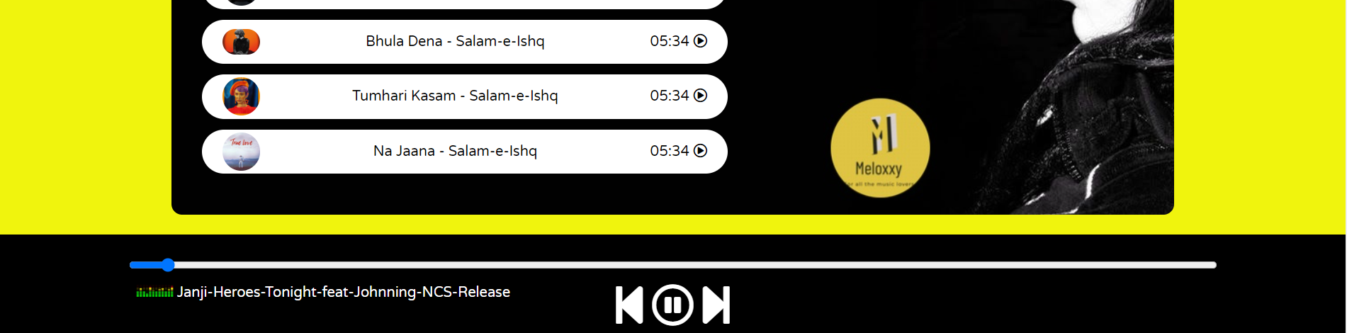

**Source Code - Setting up GIF**

<div class="songInfo">

<img src="playing.gif" width="42px" alt="" id="gif">

</div>

</div>

1. **Details of the artist using href**

A simple href attribute has been implemented in the code which helps to link the Artist Name with its respective Wikipedia page.

**Visual Representation**

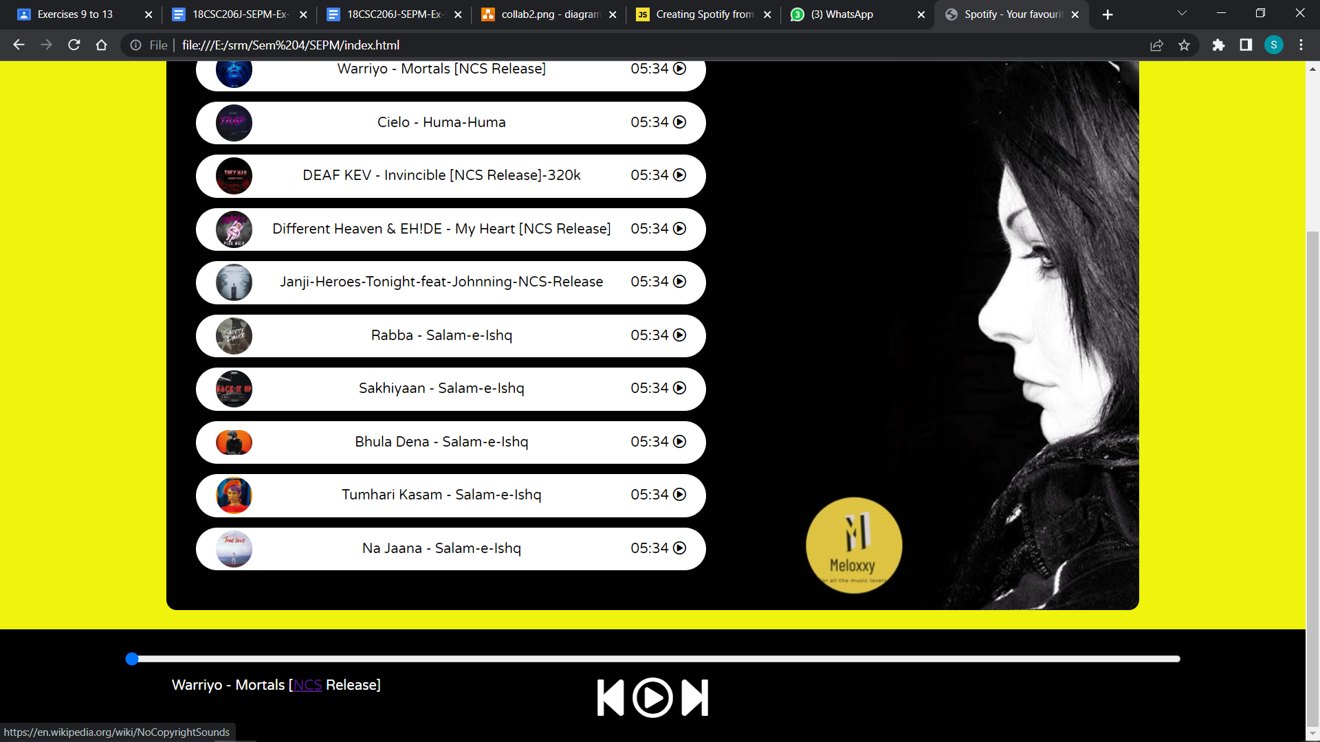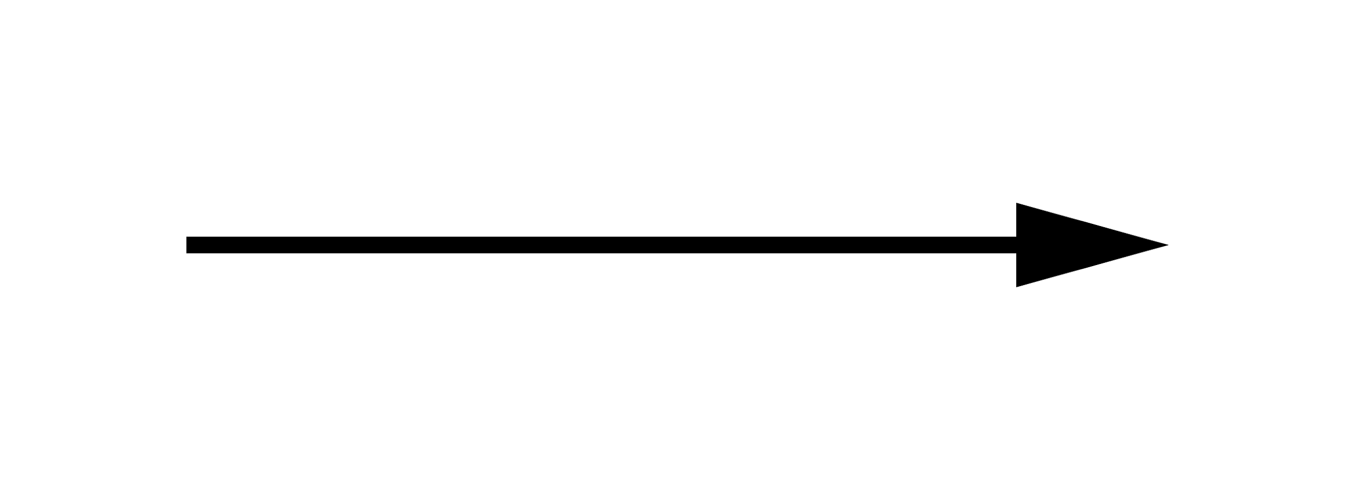

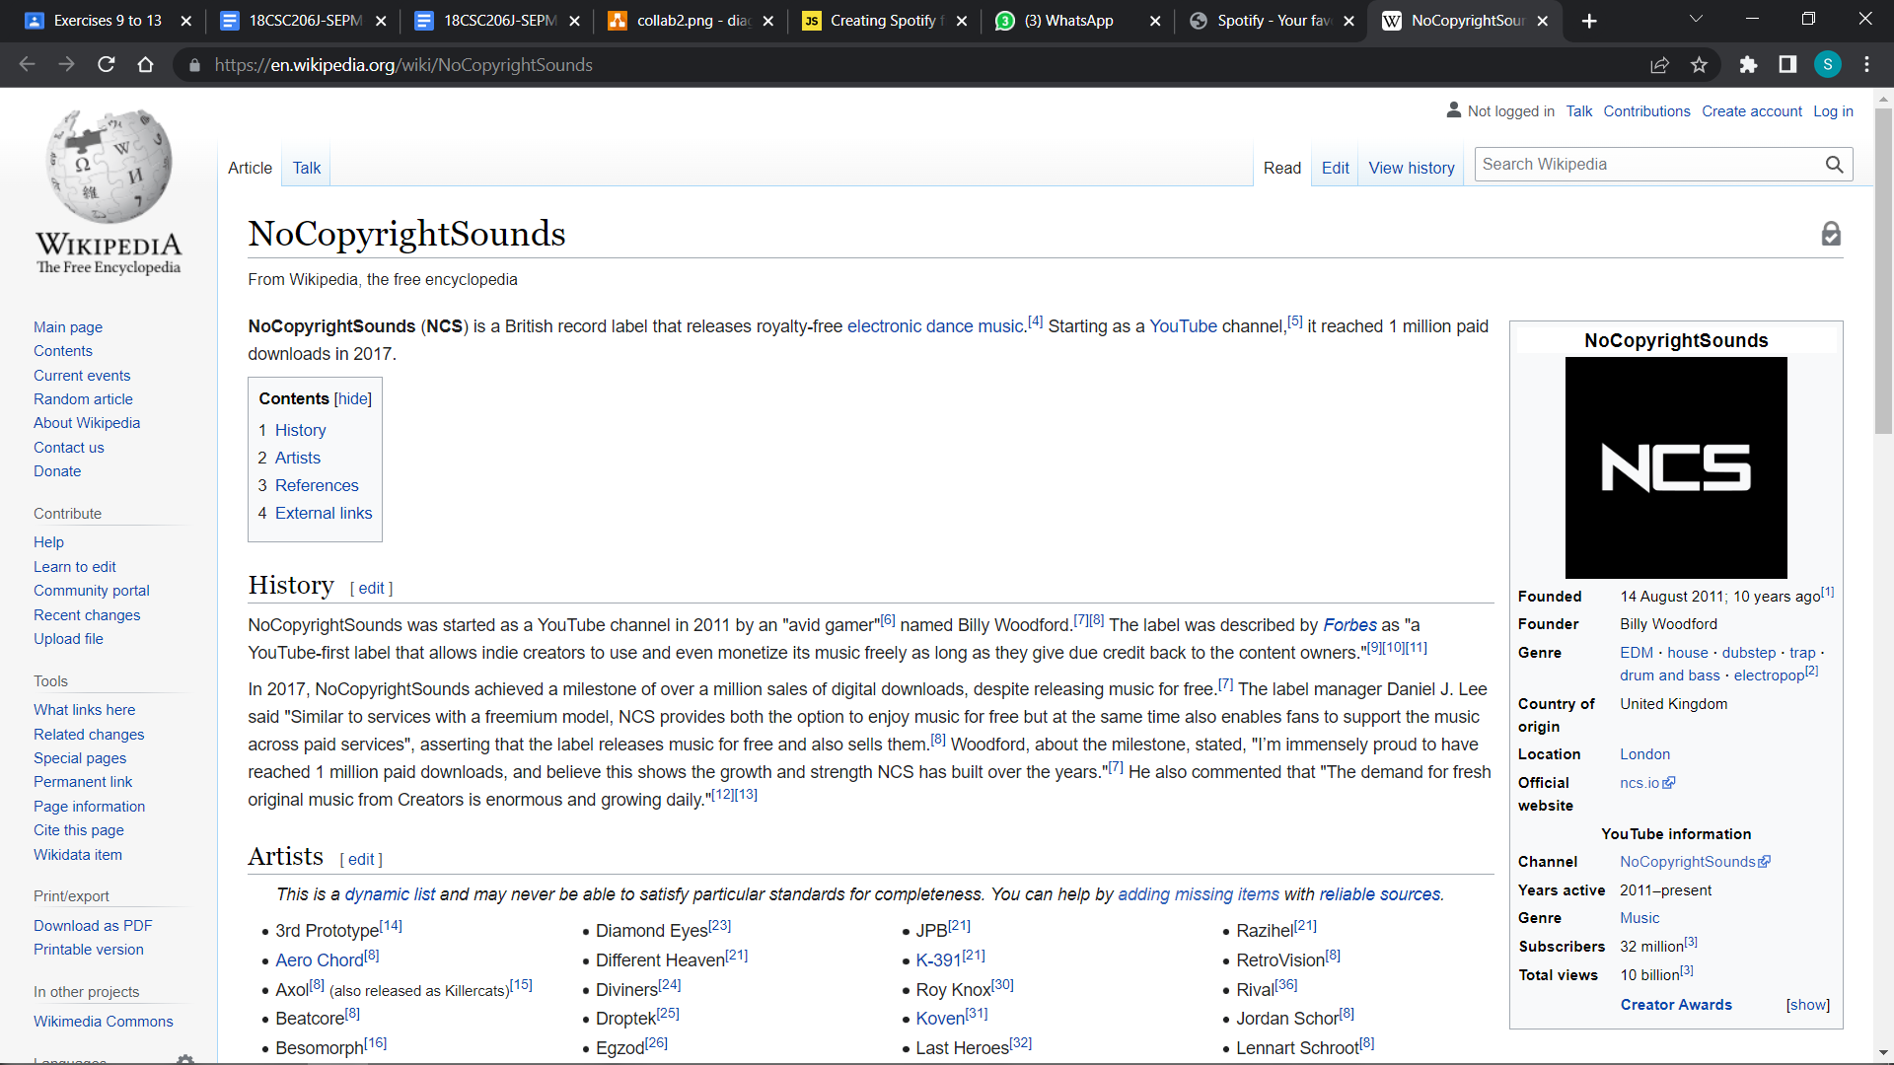

**Source Code - href**

<div class="songInfo">

<span id="masterSongName">Warriyo - Mortals [<a href="https://en.wikipedia.org/wiki/NoCopyrightSounds"target="_blank">NCS</a> Release]</span>

</div>

Result:

Thus, the details of architectural design/framework/implementation along with the screenshots were provided.