

**Department of Networking and Communications**

**SRM IST, Kattankulathur – 603 203**

**Course Code: 18CSC206J**

**Course Name: Software Engineering and Project Management**

|  |  |
| --- | --- |
| **Experiment No** | 5 |
| **Title of Experiment** | Prepare Work breakdown structure, Timeline chart, Risk identification table |
| **Name of the candidate** | Soham Ghosh |
| **Team Members** | Abhishri Joshi, Ayush Abhigyan |
| **Register Number** | RA2011003010504, RA2011003010475, RA2011003010493 |
| **Date of Experiment** | 19/4/22 |

**Mark Split Up**

|  |  |  |  |
| --- | --- | --- | --- |
| **S.No** | **Description** | **Maximum Mark** | **Mark Obtained** |
| 1 | Exercise | 5 |  |
| 2 | Viva | 5 |  |
| **Total** | | **10** |  |

**Staff Signature with date**

**Aim**

To Prepare Work breakdown structure, Timeline chart and Risk identification table

**Team Members:**

|  |  |  |  |
| --- | --- | --- | --- |
| **Sl No** | **Register No** | **Name** | **Role** |
| **1** | **RA2011003010504** | **Soham Ghosh** | **Rep** |
| **2** | **RA2011003010475** | **Abhishri Joshi** | **Member** |
| **3** | **RA2011003010493** | **Ayush Abhigyan** | **Member** |

**WBS for the project**

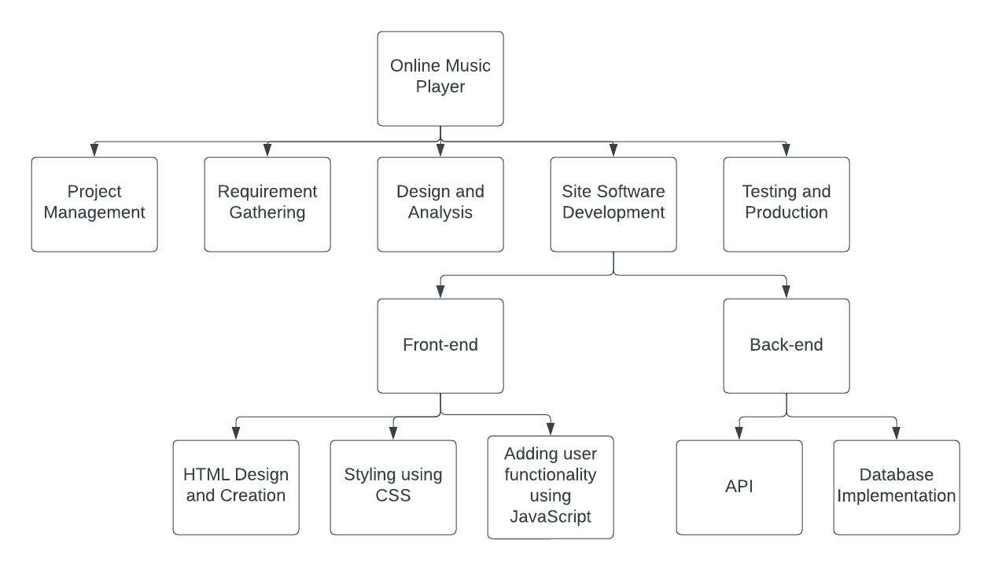

* Online Music Player
* Project Management
* Requirements Gathering
* Analysis & Design
* Site Software Development
* Front-end
* HTML Design and Creation
* Styling using CSS
* Adding user functionality using JavaScript
* Back-end
* API
* Database Implementation
* Testing and Production

**Timeline – Gantt Chart**

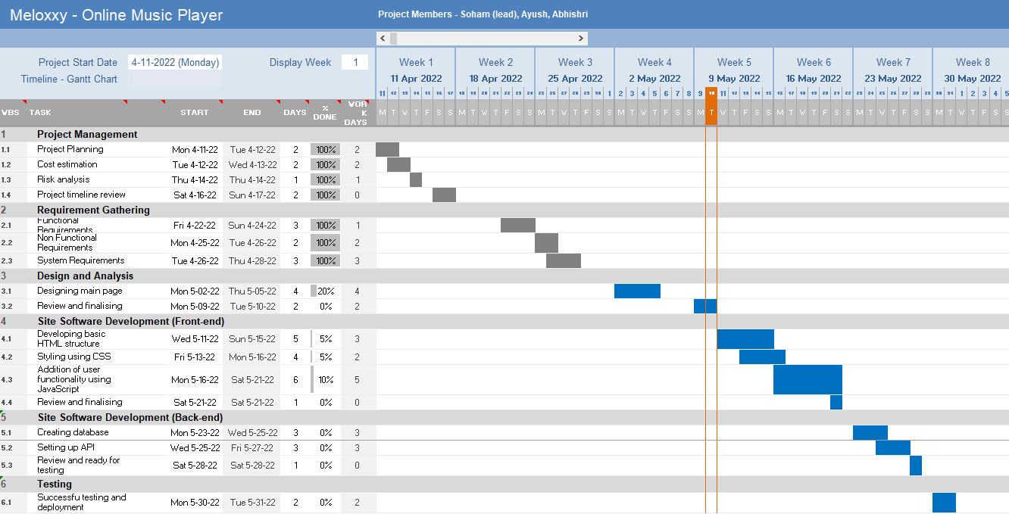

**Risk Analysis – SWOT and RMMM**

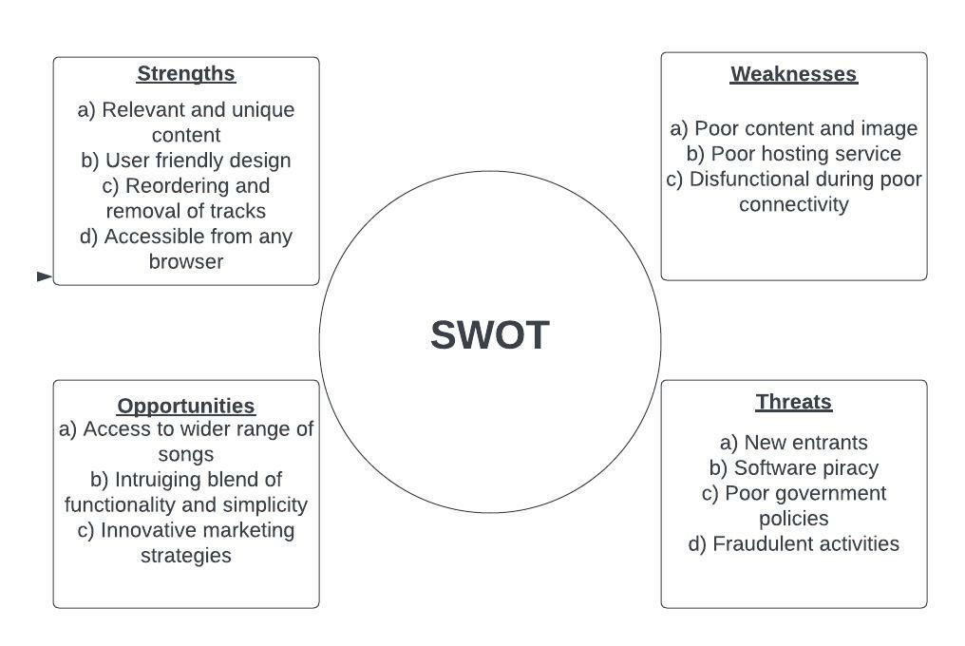

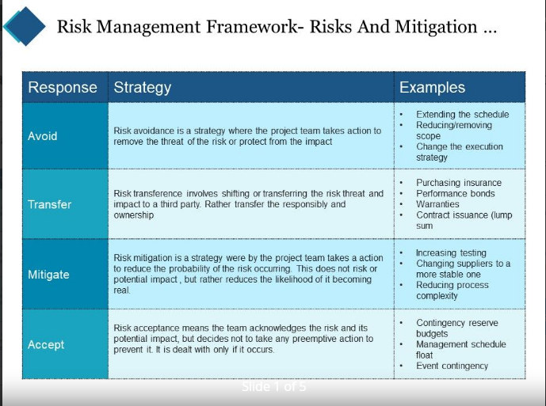

**Result:**

Thus, the work breakdown structure with timeline chart and risk table were formulated successfully.