

**School of Computing**

**SRM IST, Kattankulathur – 603 203**

**Course Code: 18CSC206J**

**Course Name: Software Engineering and Project Management**

| **Experiment No** | 8 |
| --- | --- |
| **Title of Experiment** | Develop a Data Flow Diagram (Process-Up to Level 1) |
| **Name of the candidate** | Soham Ghosh |
| **Team Members** | Ayush Abhigyan, Abhishri Joshi |
| **Register Number** | RA2011003010504, RA2011003010493, RA2011003020475 |
| **Date of Experiment** | 16/05/2022 |

**Mark Split Up**

| **S. No** | **Description** | **Maximum Mark** | **Mark Obtained** |
| --- | --- | --- | --- |
| 1 | Exercise | 5 |  |
| 2 | Viva | 5 |  |
| **Total** | | **10** |  |

**Staff Signature with date**

**Aim**

To develop the data flow diagram up to level 1 for the <project name>

**Team Members:**

| **S No** | **Register No** | **Name** | **Role** |
| --- | --- | --- | --- |
| **1** | **RA2011003010504** | **Soham Ghosh** | **Rep** |
| **2** | **RA2011003010493** | **Ayush Abhigyan** | **Member** |
| **3** | **RA2011003010475** | **Abhishri Joshi** | **Member** |

**Data Flow Diagram**

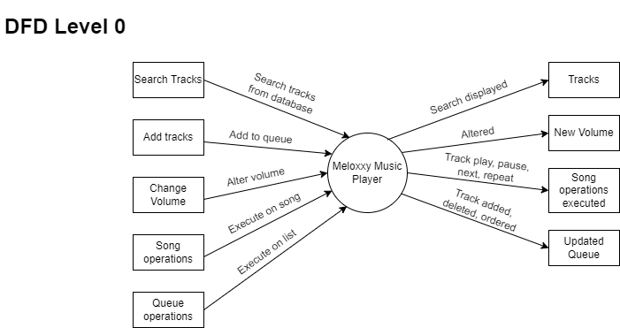

Result:

Thus, the data flow diagrams have been created for the <project name>.