

**School of Computing**

**SRM IST, Kattankulathur – 603 203**

**Course Code: 18CSC206J**

**Course Name: Software Engineering and Project Management**

| **Experiment No** | 9 |
| --- | --- |
| **Title of Experiment** | Design a Sequence and Collaboration Diagram |
| **Name of the candidate** | Soham Ghosh |
| **Team Members** | Ayush Abhigyan, Abhishri Joshi |
| **Register Number** | RA2011003010504, RA2011003010493, RA2011003010475 |
| **Date of Experiment** | 8/6/22 |

**Mark Split Up**

| **S. No** | **Description** | **Maximum Mark** | **Mark Obtained** |
| --- | --- | --- | --- |
| 1 | Exercise | 5 |  |
| 2 | Viva | 5 |  |
| **Total** | | **10** |  |

**Staff Signature with date**

**Aim**

To create the sequence and collaboration diagram for the <project name>

**Team Members:**

| **S No** | **Register No** | **Name** | **Role** |
| --- | --- | --- | --- |
| **1** | **RA2011003010504** | **Soham Ghosh** | **Rep/Member** |
| **2** | **RA2011003010493** | **Ayush Abhigyan** | **Member** |
| **3** | **RA2011003010475** | **Abhishri Joshi** | **Member** |

**Collaboration Diagram**

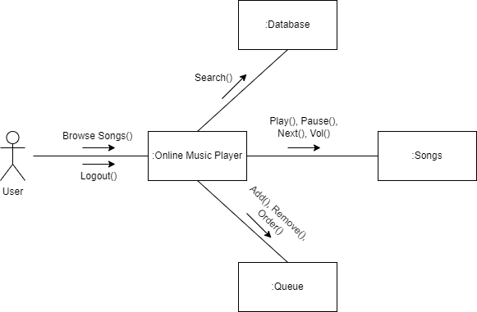

Result:

Thus, the sequence and collaboration diagrams were created for the <project name>.

**\*/ For Example**

**Sequence Diagram**

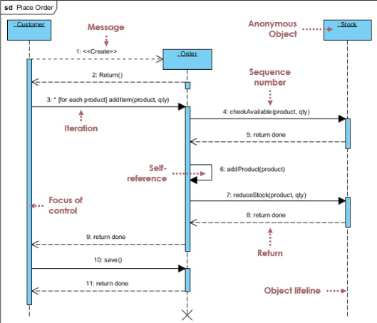

**Collaboration Diagram**

