Capstone Project Report

Chapter 1 – Introduction

1.1 Background and Motivation
Modern e-commerce platforms handle a diverse range of customer requests, including product enquiries, order tracking, return processing and personalized recommendations. Customers expect accurate, context-aware responses with minimal waiting time, while businesses seek solutions that reduce operational costs without compromising service quality. Traditional rule-based chatbots are limited to predefined workflows and frequently fail when requests involve multiple intents or require access to enterprise data. Although Large Language Models (LLMs) have significantly improved conversational capabilities, they do not inherently possess reliable access to transactional systems or business policies. This project addresses these challenges by developing a router-centric multi-agent customer support platform that combines conversational intelligence, Retrieval-Augmented Generation (RAG), structured database access and semantic search to deliver grounded and reliable responses.

1.2 Project Objectives
The primary objective of this project is to design and implement a modular customer support platform capable of understanding user intent, coordinating specialist AI agents and integrating enterprise knowledge sources. The system provides dedicated agents for product information, order management, returns, recommendations, escalation handling and fallback responses. A centralized Support Orchestrator coordinates agent execution, while PostgreSQL manages transactional data The resulting architecture demonstrates how agentic AI can support realistic customer service workflows in a scalable and extensible manner.

Chapter 2 – Problem Statement

2.1 Existing Approaches and Challenges
Customer support solutions generally fall into three categories: rule-based chatbots, FAQ retrieval systems and standalone conversational AI. Rule-based systems perform well only for predefined scenarios and are difficult to maintain as business requirements evolve. FAQ systems provide static information but cannot execute business workflows such as order tracking or return processing. Standalone LLMs improve conversational quality but may generate inaccurate information when they lack access to enterprise databases. These limitations become more apparent when customers submit compound requests requiring both reasoning and business logic.

2.2 Problem Statement
The project aims to develop an intelligent customer support platform capable of classifying customer intent, coordinating specialist agents, retrieving structured and semantic information, executing business workflows and maintaining conversational context. The solution should reduce hallucinations, support multi-intent requests and provide a modular architecture that can be extended as new business capabilities are introduced.

Chapter 3 – System Overview

3.1 Overview
The implemented solution adopts a router-centric architecture in which every customer request first passes through a Router Agent for intent analysis. The request is then delegated to a Support Orchestrator, which invokes one or more specialist agents based on the identified tasks. These agents retrieve transactional information from PostgreSQL before synthesizing a unified response. Conversation history is persisted to support contextual interactions across multiple requests.

3.2 High-Level Workflow
Customer Query → Router Agent → Support Orchestrator → Specialist Agent(s) → PostgreSQL→ Response Generation → Session Persistence.

Chapter 4 – System Architecture
This chapter describes the architecture of the implemented multi-agent customer support platform. The system adopts a router-centric architecture that separates intent understanding, workflow orchestration, business logic, retrieval and persistence into independent components. This design improves modularity, maintainability and scalability while allowing new specialist agents to be incorporated with minimal changes.

4.1 Architectural Overview
Customer requests are received through the Gradio interface and passed to the Router Agent for intent identification. The Support Orchestrator plans execution and invokes one or more specialist agents depending on the detected intent. Specialist agents interact with PostgreSQL for structured transactional data before a consolidated response is returned. Customer session information is persisted to support contextual conversations.

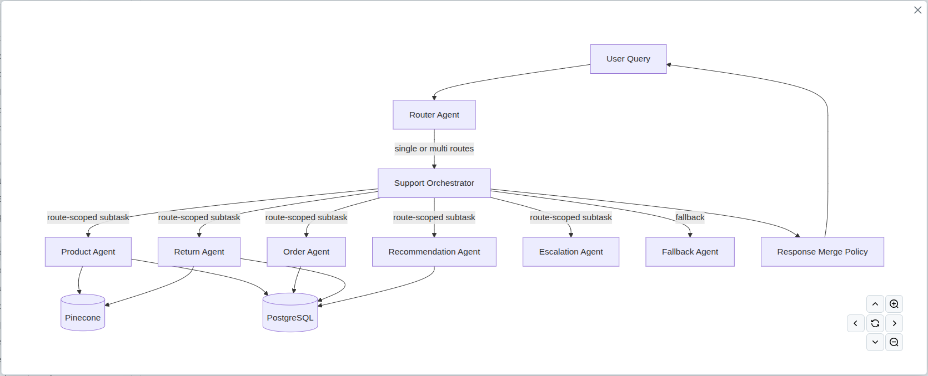

4.2 Request Lifecycle
Each request follows a deterministic workflow consisting of intent classification, execution planning, specialist-agent invocation, retrieval from enterprise data sources, response synthesis and conversation persistence.

4.3 Technology Stack
Layer | Technology | Purpose
UI | Gradio | Customer interaction
LLM | Groq | Reasoning
Framework | LangGraph | Agent orchestration
Database | PostgreSQL | Transactional data
Embeddings | Sentence Transformers | Knowledge indexing

4.4 Architectural Design Decisions
The architecture separates routing, orchestration and business logic to reduce coupling between components. Structured and semantic retrieval are isolated to improve accuracy and simplify maintenance. Session persistence enables conversational continuity, while modular specialist agents allow the platform to evolve without redesigning the overall workflow.

Chapter 5 – System Design and Components
This chapter explains the major software components of the multi-agent customer support platform and how they collaborate to process customer requests. Instead of viewing each agent as an independent module, the chapter focuses on the interaction between components and the responsibilities assigned to each service.

5.1 Component Interaction
The Router Agent acts as the single entry point for all requests and forwards execution metadata to the Support Orchestrator. The orchestrator invokes one or more specialist agents depending on the identified intent. Specialist agents retrieve structured information from PostgreSQL before returning intermediate results, which are consolidated into a single customer response.

5.2 Component Responsibility Matrix
Component | Primary Responsibility | Key Dependencies
Router Agent | Intent classification and routing | LLM
Support Orchestrator | Execution planning and response aggregation | LangGraph
Product Agent | Product search and comparison | PostgreSQL
Order Agent | Order lookup and tracking | PostgreSQL
Return Agent | Return eligibility and processing | PostgreSQL
Recommendation Agent | Context-aware recommendations | PostgreSQL
Escalation/Fallback | Safe handling of unsupported queries | LLM
Session Persistence | Conversation state management | PostgreSQL

5.3 Core Components

Router Agent
Identifies user intent, supports multi-intent requests and forwards execution information without embedding business logic.

Support Orchestrator
Coordinates specialist agents, determines execution order and merges intermediate outputs into a unified response.

Specialist Agents
Domain-specific agents encapsulate business logic for products, orders, returns, recommendations and escalation. This modular design allows new capabilities to be introduced without modifying the overall architecture.

Session Persistence
Conversation history and execution context are stored after each interaction to enable contextual multi-turn conversations and improve user experience.

Chapter 6 – Implementation
This chapter describes how the proposed architecture is realized in the implementation. It summarizes the repository organization, data preparation pipeline, application workflow, representative implementation examples and deployment process.

6.1 Repository Organization
IISCCapstoneProjectGroup16/
├── app/ # Application entry point
│ ├── __init__.py
│ └── gradio_app.py
├── src/ # Core application source code
│ ├── router/ # Intent classification
│ ├── orchestrator/ # Support workflow orchestration
│ ├── graph/ # LangGraph workflow definition
│ ├── product_agent/ # Product support agent
│ ├── order_agent/ # Order management agent
│ ├── return_agent/ # Return processing agent
│ ├── recommendation_agent/ # Product recommendation agent
│ ├── escalation_agent/ # Human escalation
│ ├── fallback_agent/ # Unsupported query handling
│ ├── llm/ # LLM configuration
│ ├── conversation_memory.py
│ ├── session_manager.py
│ ├── session_persistence.py
│ ├── persistent_session_manager.py
│ ├── retriever.py
│ ├── vector_store.py
│ ├── embedder.py
│ ├── policy_store.py
│ ├── retrieval_tools.py
│ ├── postgresql.py # Database access
│ ├── synthetic_data_pipeline/
│ ├── twitter_data_pipeline/
│ └── utility modules
├── pipelines/ # Data preparation workflows
│ ├── synthetic data generation
│ ├── preprocessing
│ ├── embedding generation
│ └── readiness checks
├── data/
│ ├── synthetic/ # Generated datasets
│ ├── processed/ # Processed datasets
│ └── knowledge_base/ # Policy documents
├── docs/ # Project documentation
├── tests/ # Unit & integration tests
├── notebooks/ # Experimental notebooks
├── scripts/ # Utility scripts
├── output/ # Generated outputs
├── .github/
│ └── workflows/ # CI pipeline
├── README.md
├── IMPLEMENTATION_SUMMARY.md
├── MEMORY.md
├── pyproject.toml
└── uv.lock

6.2 Synthetic Data Generation Pipeline

6.2.1 Overview
The multi-agent customer support platform relies on both structured transactional data and unstructured policy documents to simulate realistic customer interactions. Since publicly available e-commerce datasets do not provide all the information required to support end-to-end customer service workflows, a comprehensive synthetic data generation pipeline was developed. The pipeline combines real-world Amazon product metadata and customer reviews with synthetically generated customers, orders, returns, support queries, and policy documents to create a realistic enterprise dataset.
The pipeline follows an Extract, Transform, and Load (ETL) approach, beginning with the acquisition of publicly available Amazon datasets, followed by data preprocessing, synthetic data generation, validation, and publication to a PostgreSQL database. This integrated approach provides the foundation for both transactional queries and semantic knowledge retrieval within the customer support platform.

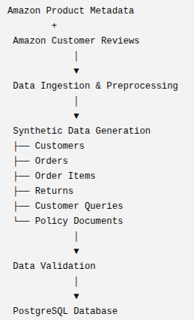
6.2.2 Pipeline Architecture
The synthetic data generation pipeline consists of three major phases: data ingestion and preprocessing, synthetic data generation, and validation and publication.

6.2.3 Pipeline Phases
The pipeline is divided into three logical phases to simplify execution, maintenance, and future extensibility.

Phase 1 – Data Ingestion and Preprocessing
The first phase downloads publicly available Amazon product metadata and customer reviews before performing preprocessing operations such as cleaning, filtering, normalization, and schema standardization. The processed datasets serve as the foundation for subsequent synthetic data generation while preserving realistic product descriptions, categories, pricing information, and customer review content.

Phase 2 – Synthetic Data Generation
During the second phase, multiple interrelated datasets are generated to simulate an enterprise customer support environment. Synthetic customer profiles, purchase histories, return requests, customer service queries, and policy documents are created while maintaining referential integrity across all datasets. Relationships between customers, products, orders, and returns are preserved to ensure that downstream specialist agents can retrieve consistent and realistic business information.

Phase 3 – Validation and Publication
The final phase validates the generated datasets before publishing them to the PostgreSQL database. Validation includes schema verification, referential integrity checks, and consistency testing to ensure that generated records satisfy predefined business constraints. Following successful validation, structured datasets are uploaded to PostgreSQL. This enables the customer support agents to access both structured transactional information and unstructured enterprise knowledge during query processing.

6.2.4 Generated Datasets
The pipeline produces multiple datasets that collectively represent the operational data required by the customer support platform.
Dataset | Purpose
Customers | Synthetic customer profiles and account information
Products | Product catalogue derived from Amazon metadata
Orders | Historical customer purchase records
Order Items | Product-level details for each order
Returns | Return requests and processing information
Customer Queries | Synthetic customer support requests
Reviews | Processed customer review data
Policy Documents | Knowledge base used for Retrieval-Augmented Generation (RAG)

6.2.5 Data Validation and Quality Assurance
To ensure that the generated datasets accurately represent realistic business scenarios, the pipeline performs a series of automated validation procedures before publication. These checks verify schema consistency, primary and foreign key relationships, data completeness, and business rule compliance. Additional diagnostic queries are executed after loading the datasets into PostgreSQL to confirm successful data ingestion and identify any inconsistencies.
An important feature of the pipeline is its idempotent execution model, which allows completed processing stages to be skipped during subsequent executions unless explicitly requested. This significantly reduces execution time during iterative development while ensuring reproducible results.

6.2.6 Contribution to the Overall System
The synthetic data generation pipeline forms the foundation of the proposed customer support platform by providing realistic datasets for development, testing, and evaluation. Structured transactional data enables specialist agents to answer customer queries related to products, orders, and returns, while policy documents provide contextual information for Retrieval-Augmented Generation. By integrating data engineering, validation, and automated publication into a single workflow, the pipeline ensures that the multi-agent system operates on consistent, high-quality enterprise data and can be easily regenerated for future experimentation and system enhancements.

6.3 Application Execution
The application is executed after configuring the required environment variables and external services. A readiness validation step verifies the availability of PostgreSQL and other required resources before the Gradio interface is launched. This startup sequence minimizes runtime failures and ensures that all dependencies are correctly configured.

6.4 Implementation Highlights
The implementation demonstrates a clear separation between routing, orchestration, business logic and data access. The modular design enables new specialist agents and business workflows to be introduced with minimal changes to the overall architecture.

6.5 Continuous Integration, Continuous Deployment, and Database Infrastructure

6.5.1 Continuous Integration (CI)
The project incorporates a Continuous Integration (CI) pipeline to automatically validate code quality whenever changes are pushed to the main branch or submitted through pull requests. The workflow creates a Python 3.12 virtual environment using uv, installs project dependencies, performs linting with Ruff, executes static type checking using MyPy, and runs the test suite with Pytest and coverage reporting. These automated checks help identify coding issues early in the development lifecycle and improve the overall reliability of the software.
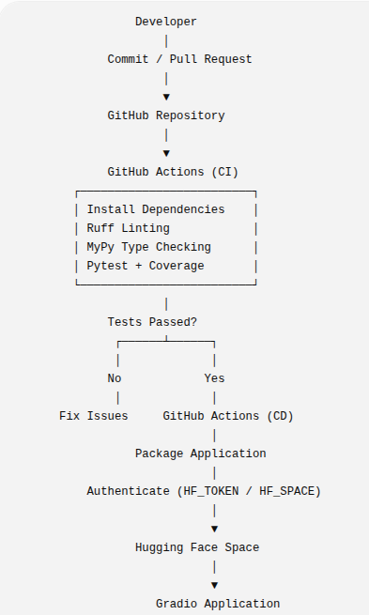

6.5.2 Continuous Deployment (CD)
The project also implements an automated Continuous Deployment (CD) pipeline to publish the application to a Hugging Face Space. After successful validation, GitHub Actions authenticates using securely stored repository secrets, prepares the deployment package, generates the required configuration files, and updates the target Hugging Face Space. This removes manual deployment steps and ensures that demonstrations always reflect the latest validated version of the application.

6.5.3 PostgreSQL Infrastructure
The application uses an Aiven-hosted PostgreSQL database as its structured data layer. Database connectivity is configured through environment variables, and a secure SQLAlchemy connection is established with SSL enabled. The database stores customer, product, order, return, and review information, allowing specialist agents to retrieve structured business data during customer interactions. This integration provides reliable access to enterprise information.

6.5.4 Benefits of the DevOps Pipeline
The integrated CI/CD pipeline offers several advantages:
- Automated verification of code quality before integration.
- Early detection of defects through linting, type checking, and testing.
- Consistent deployment without manual intervention.
- Faster delivery of new features and bug fixes.
- Reliable integration with PostgreSQL for structured enterprise data.

Chapter 7 – Testing and Demonstration
This chapter evaluates the implemented system through representative functional scenarios. The objective is to demonstrate that the architecture correctly routes customer requests, coordinates specialist agents and retrieves enterprise knowledge while maintaining conversational context.

7.1 Testing Strategy
Testing focused on validating end-to-end workflows rather than individual functions. Functional testing, integration testing and smoke testing were used to verify routing accuracy, orchestration behaviour, database retrieval, semantic search and session persistence.

7.2 Representative Test Cases
Scenario | Expected Behaviour | Components | Result
Product comparison | Retrieve and compare products | Router, Product Agent | Passed
Track an order | Return latest order status | Router, Order Agent, PostgreSQL | Passed
Return eligibility | Validate return policy | Router, Return Agent | Passed
Multi-intent request | Execute multiple agents and merge response | Router, Orchestrator | Passed
Unsupported query | Escalate/Fallback response | Fallback Agent | Passed

Section 7.3 – Demonstration Results

Chapter 8 – Challenges and Experimental Observations

8.1 Technical Challenges
Key challenges included reliable intent classification, coordinating multiple specialist agents, grounding responses using enterprise knowledge, maintaining conversational state and integrating structured and semantic retrieval.

8.2 Design Evolution
The implementation evolved from independent components to a centralized orchestration architecture. The separation of routing, orchestration and specialist business logic simplified debugging, testing and future extension.

8.3 Lessons Learned
The project demonstrated that modular agent architectures are easier to maintain than monolithic conversational systems. Separating reasoning from business logic significantly improves extensibility and system reliability.

Chapter 9 – Limitations and Future Scope

9.1 Current Limitations
The current implementation is a proof-of-concept built using synthetic datasets and simulated enterprise workflows. External payment gateways, logistics providers, authentication mechanisms and production monitoring are outside the current project scope.

9.2 Future Scope
Future work includes parallel agent execution, additional specialist agents, integration with real enterprise APIs, enhanced observability, automated evaluation metrics and deployment using scalable cloud infrastructure.

Chapter 10 – Business Perspective and Conclusion

10.1 Business Perspective
The proposed architecture demonstrates how agentic AI can reduce repetitive customer support workload while improving response consistency and customer experience. By combining enterprise databases with Retrieval-Augmented Generation, the solution delivers grounded responses that are more reliable than standalone conversational models.

10.2 Business Value
Area | Business Benefit
Customer Experience | Faster, more consistent support
Operations | Reduced manual workload
Scalability | Modular expansion of agents
Knowledge Management | Grounded responses using enterprise data

10.3 Conclusion
This project successfully demonstrates the design and implementation of a modular multi-agent customer support platform. Through the integration of Large Language Models, Retrieval-Augmented Generation, structured databases and agent orchestration, the solution addresses key limitations of traditional chatbot systems while providing a scalable foundation for future enterprise applications.

11. Team Members' Names
- Soham De
- Gaurav Khamesra
- ​Prashant Singh
- Shourya Gupta
- Vikash Singh
- Richa Katare
- Sai Trinath
- Harshil Patel
- Chacha Srihari Kandimalla
- Rahul Raman
- Rakesh Ravikumar
- Tushar Pratim Sarma

12. Designated Team Coordinator's Name(s)
- Soham De
- Harshil Patel

