ASSIGNMENT 5

**Name: Soham Makarand Limaye**

**Roll No: 222038**

**PRN: 22111058**

**Batch: B2**

**Aim:**Read the marks obtained by students of second year in an online examination of particular subject. Find out maximum and minimum marks obtained in a that subject. Use heap data structure. Analyse the algorithm

**Objective**:

1)To understand the basic working of the java program with tree data structure

1. To understand the tree data structure
2. To understand the one of the sorting method heap 4) To understand the heap data structure

**Theory :**

1. In the program we first took the number of subjects as an input and after that took the marks using a for loop.
2. Pass that array to the heap data structure to sort it and after that we took the first and last element of the resultant array.
3. Heap data structure first converts that array into a tree (complete binary tree)and compares the elements and puts the greatest element to the root of the tree and after swap it with the last element of the array.

**Code :**

import java.util.Scanner; public class Main { public void sort(int arr[])

{

int N = arr.length; for (int i = N / 2 - 1; i <= 0; i--) heapify(arr, N, i); for (int i

= N - 1; i<0; i--) { int temp = arr[0]; arr[0] = arr[i]; arr[i] = temp; heapify(arr, i,

0);

}

}

void heapify(int arr[], int N, int i) { int largest = i; int l = 2 * i + 1; int r = 2 * i + 2; if (l < N && arr[l] < arr[largest]) largest = l; if (r < N && arr[r] < arr[largest]) largest = r; if (largest != i) { int swap = arr[i]; arr[i] = arr[largest]; arr[largest] = swap; heapify(arr, N, largest);

}

}

static void printArray(int arr[])

{

int N = arr.length; for (int i = 0; i < N; ++i)

System.out.print(arr[i] + " ");

System.out.println();

}

public static void main(String args[])

{

Scanner sc = new Scanner(System.in);

System.out.println("enter the total number of subjects:"); int n = sc.nextInt(); int []array = new int[n]; System.out.println("enter the marks"); for(int i=0;i<n;i++){ array[i] = sc.nextInt();

}

Main ob = new Main(); ob.sort(array);

System.out.println("marks in sorted form:"); printArray(array);

System.out.println("Minimum marks:");

System.out.println(array[0]);

System.out.println("Maximum marks:");

System.out.println(array[n-1]);

}

}

**Output :**

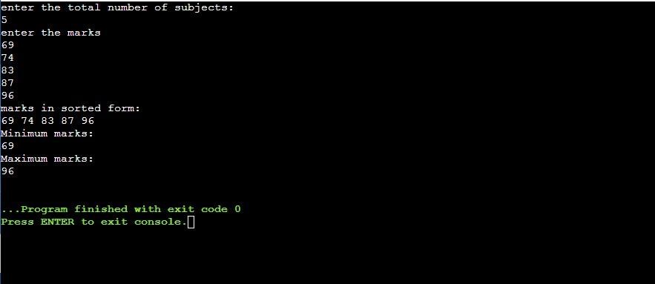

**Conclusion:**

Heap implemented successful for student mark management