Walmart Retail Data Analytics:
End-to-End Framework

Submitted in partial fulfillment of the requirements. of the degree of
Bachelor of Engineering
in
Artificial Intelligence & Machine Learning

by

Soham Lone 124A9024 Arvind Mudaliar 124A9027
Prasad Paymode 124A9038
Sakshi Sukre 124A9054
Under the Guidance of
Prof. Sumedha A. Maindalkar

Department of Artificial Intelligence & Machine Learning SIES GRADUATE SCHOOL OF TECHNOLOGY
Nerul, Navi Mumbai 400706 University of Mumbai
2025-2026

CERTIFICATE

This is to certify that the project entitled “Case Study: Walmart” is a bonafide work of the following students, submitted to the University of Mumbai in partial fulfillment of the requirement for the award of the degree of Bachelor of Engineering in Artificial Intelligence & Machine Learning

S1 124A9024
S2 124A9027
S3 124A9038
S4 124A9054

Prof. Sumedha A. Maindalkar Dr. Varsha Patil Dr. K. Lakshmi Sudha Internal Guide Head of Department Principal

DECLARATION

I declare that this written submission represents my ideas in my own words and where others’ ideas or words have been included, I have adequately cited and referenced the original sources. I also declare that I have adhered to all principles of academic honesty and integrity and have not misrepresented or fabricated or falsified any idea/data/fact/source in my submission. I understand that any violation of the above will cause for disciplinary action by the Institute and can also evoke penal action from the sources which have thus not been properly cited or from whom proper permission has not been taken when needed.

S1 | 124A9024
S2 | 124A9027
S3 | 124A9038
S4 | 124A9054 | Signature

Date:

ACKNOWLEDGEMENT

It gives us immense pleasure to thank Dr. K. Lakshmi Sudha, our principal for extending his support in carrying out this project. We also thank our HOD, Dr. Varsha Patil for her support in completing the project. We wish to express our deep sense of gratitude and thanks to our Internal Guide, Prof. Sumedha A. Maindalkar for her guidance, help and useful suggestions, which helped in completing our project work in time.
Also, we would like to thank the entire faculty of the Artificial Intelligence and Machine Learning department for their valuable ideas and timely assistance in this project, last but not least, we would like to thank our teaching and non-teaching staff members of our college for their support, in facilitating timely completion of this project.

Project Team
S1
S2
S3
S4

ABSTRACT

This comprehensive research presents an end-to-end data analysis solution for retail business intelligence using Walmart sales data as a case study. The project addresses the critical industry challenge of transforming vast transactional data into actionable insights through an integrated methodology combining Python for data processing and SQL for advanced analytics. The implementation demonstrates a complete analytical pipeline encompassing data acquisition, cleaning, feature engineering, and multi-database management, while maintaining functional parity across both MySQL and PostgreSQL environments.

The methodological framework incorporates systematic data quality assessment, automated cleaning procedures, and sophisticated feature engineering to enhance analytical depth. The architecture employs a modular design that separates concerns across distinct functional tiers, enabling scalable processing of complex retail datasets. Through optimized SQL queries and Python-based transformations, the solution delivers comprehensive business intelligence across multiple domains including revenue analysis, product performance, customer behaviour segmentation, temporal pattern identification, and operational efficiency.

Key findings reveal significant insights into sales trends across geographical branches and product categories, identification of peak performance periods, customer purchasing patterns, and payment method preferences. The analysis demonstrates practical applications for inventory optimization, targeted marketing strategies, staff scheduling efficiency, and strategic planning support. The project successfully bridges several research gaps in current retail analytics literature, particularly in the areas of integrated Python-SQL workflows, cross-database compatibility, reproducible analytical processes, and practical implementation frameworks.

The implementation establishes a robust foundation for advanced analytical capabilities while delivering immediate business value through descriptive and diagnostic insights. The reproducible methodology and documentation ensure knowledge transfer and organizational sustainability. This research contributes both to academic knowledge in data science applications and practical business intelligence in retail contexts, providing a reference architecture for organizations seeking to enhance their data-driven decision-making capabilities in competitive market environments.

The project demonstrates that integrated data analysis frameworks can effectively transform raw transactional data into strategic assets, enabling retailers to optimize operations, enhance customer experiences, and improve financial performance. The scalable design supports future enhancements including predictive modelling, real-time analytics, and expanded data source integration, positioning organizations.

Contents

SR. NO. | CHAPTER | PAGE NO.
1 | INTRODUCTION
2 | SYSTEM REQIUREMENTS: MYSQL, VS- code
3 | SYSTEM DESIGN: ER-DIAGRAM
4 | IMPLEMENTATION: - e.g.  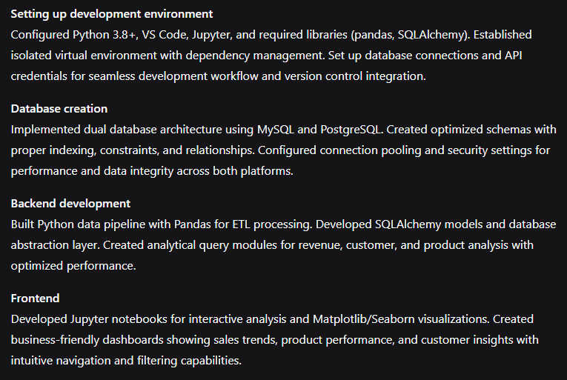 | Setting up development environment  Database creation  Backend development  Frontend  Integration  Testing  Deployment  User training and support  Feebcak and iteration  documentation
 | 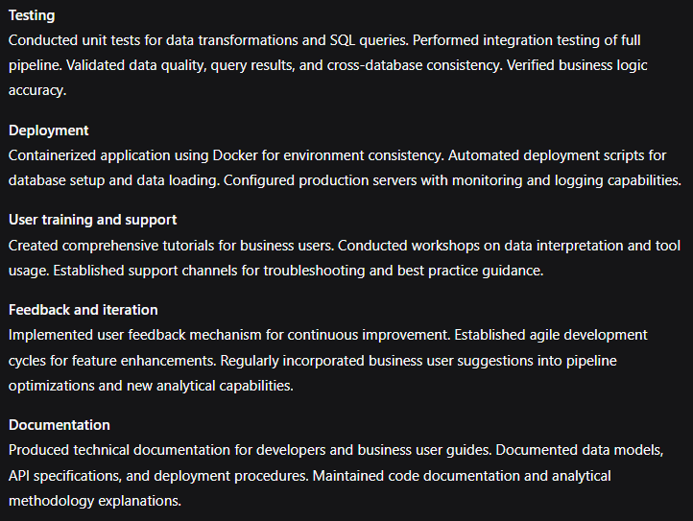
5 | CODE SNIPPETS: - 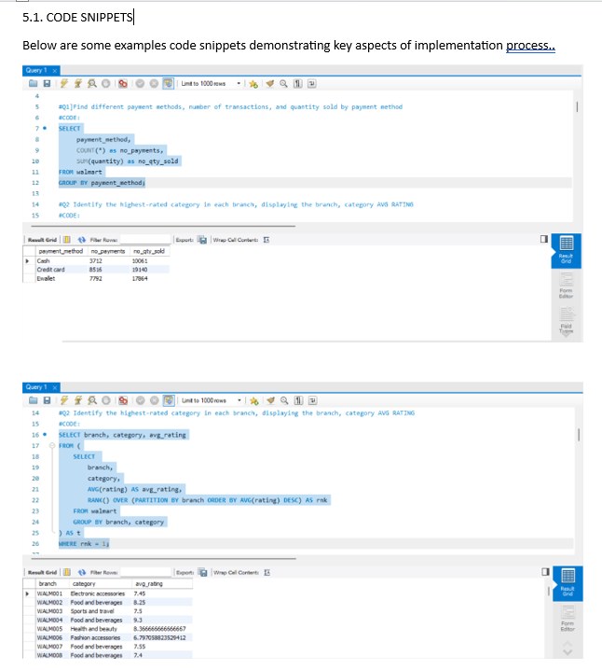
6 | RESULT: - 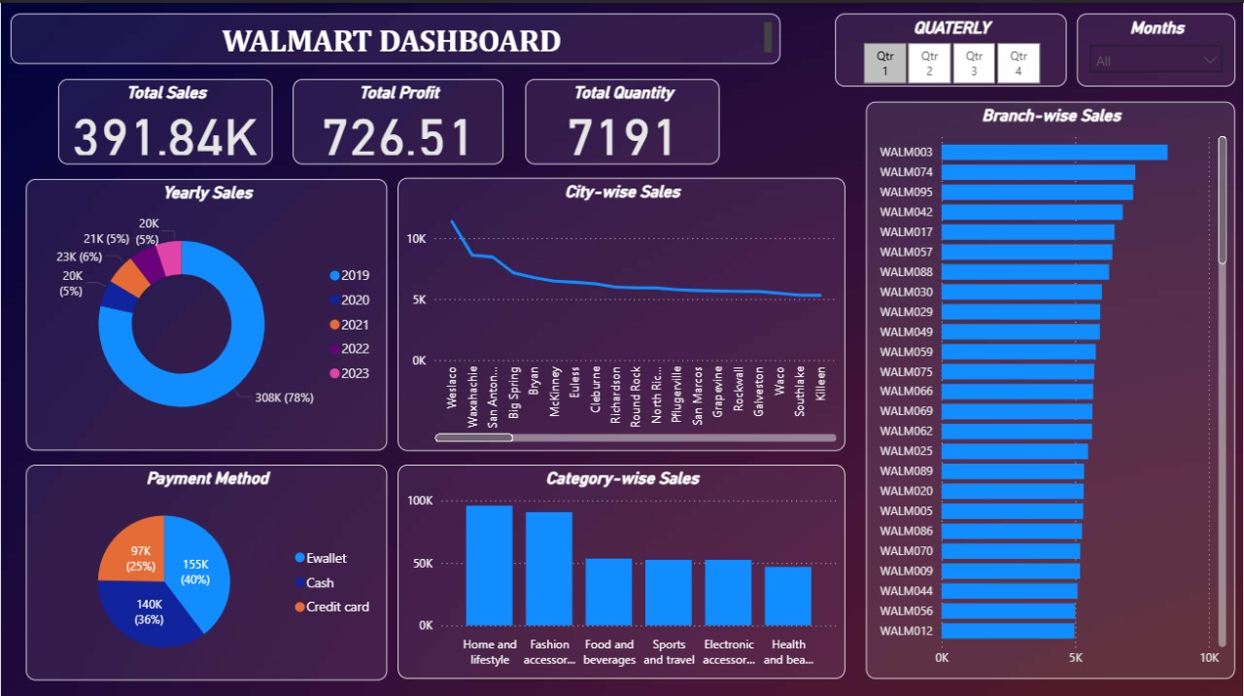
7 | CONCLUSION: - 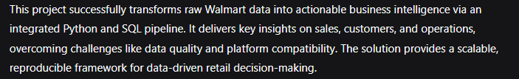
8 | REFERENCES: - 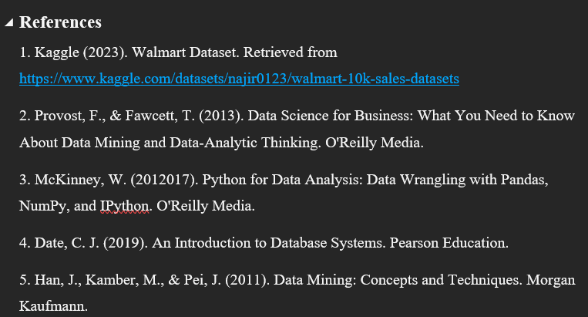

Chapter 1 Introduction

Introduction and need of the project

In today's data-driven retail landscape, the ability to extract meaningful insights from sales data has become paramount for business survival and growth. The Walmart Data Analysis Project represents a comprehensive end-to-end solution designed to address the critical need for sophisticated data analysis capabilities in the retail sector. This project emerges from the recognition that modern retailers like Walmart generate massive volumes of transactional data daily, yet many organizations struggle to transform this raw information into actionable business intelligence.

The fundamental need for this project stems from several pressing challenges in the retail industry. First, there is an overwhelming abundance of data without corresponding analytical capabilities. Walmart, as one of the world's largest retailers, processes millions of transactions across numerous branches, generating complex datasets that contain valuable patterns about customer behavior, product performance, and operational efficiency. Without proper analytical frameworks, this data remains underutilized, representing significant lost opportunities for revenue optimization and cost reduction.

Second, the retail industry faces intense competition and shrinking profit margins, making data-driven decision-making not just advantageous but essential for competitive survival. Traditional retail management approaches relying on intuition and historical precedents are no longer sufficient in an era characterized by rapid market changes, evolving consumer preferences, and digital disruption. This project addresses the urgent need for systematic, evidence-based decision support systems that can identify trends, predict outcomes, and recommend strategic actions.

Third, there is a significant skills gap in the market. Many organizations lack the technical expertise to implement integrated data solutions that combine Python for data processing with SQL for database management and advanced analytics. This project serves as both a practical solution and an educational framework, demonstrating how modern data analysis techniques can be applied to real-world retail challenges.

The technological need is equally critical. As businesses increasingly migrate toward cloud-based solutions and distributed database systems, the ability to work across multiple database platforms (MySQL and PostgreSQL in this case) becomes essential. This project provides a robust framework for handling diverse data environments while maintaining analytical consistency and performance.

From a business perspective, the project addresses several operational needs: inventory optimization through identification of fast-moving and slow-moving products, customer segmentation for targeted marketing campaigns, temporal analysis for staff scheduling and promotional planning, and geographical performance analysis for strategic expansion decisions. Each of these aspects contributes directly to improved operational efficiency and enhanced profitability.

Furthermore, in the era of big data and artificial intelligence, this project establishes a foundational framework that can be extended to incorporate machine learning models for predictive analytics, recommendation systems, and automated decision-making. It bridges the gap between traditional business intelligence and advanced analytics, providing a scalable architecture that can grow with organizational needs.

The project also responds to the growing demand for reproducible and documented analytical workflows. In many organizations, analytical processes remain ad-hoc and poorly documented, leading to inconsistencies and reliability issues. This implementation provides a structured, well-documented approach that ensures analytical rigor and reproducibility across the organization.

Problem statement in broad sense

The core problem this project addresses is the systemic inability of retail organizations to effectively leverage their data assets for competitive advantage. Despite accumulating extensive transactional records, most retailers struggle with transforming raw data into actionable intelligence, resulting in missed opportunities and suboptimal decision-making.

This challenge manifests through several interconnected dimensions. First, data quality and integration problems undermine analytical validity. Sales data originates from multiple sources—point-of-sale systems, e-commerce platforms, mobile apps—leading to inconsistencies, missing values, and formatting issues that compromise analysis quality. Without systematic cleaning and validation, organizations risk basing decisions on flawed information.

Second, analytical capability gaps prevent sophisticated insight generation. Basic reporting might exist, but advanced functions like trend analysis, customer segmentation, and predictive modelling remain inaccessible. This limitation means organizations cannot identify emerging patterns, anticipate market shifts, or optimize operations proactively, leaving them reactive rather than strategic.

Third, organizational silos create fragmented understanding. Sales data isolated from inventory, customer, and operational information prevents holistic analysis. Marketing campaigns launch without inventory awareness, operations adjust staffing without sales forecasts, and strategic planning occurs without integrated performance data.

Fourth, scalability issues emerge as data volumes grow. Traditional analytical approaches become inadequate, with slow query performance and delayed reporting undermining timely decision-making. This performance degradation affects the very purpose of business intelligence—providing relevant, current insights.

Finally, skills distribution and knowledge transfer problems create organizational vulnerabilities. Analytical capabilities often concentrate with few specialists, lacking standardized processes for consistent application across the organization. This project addresses these multifaceted problems through an integrated framework that enhances data quality, expands analytical capabilities, breaks down silos, ensures scalability, and facilitates knowledge sharing.

Scope

The Walmart Data Analysis Project operates within carefully defined boundaries that balance comprehensive coverage with practical implement ability. The scope encompasses specific data domains, analytical methodologies, technical implementations, and functional applications while explicitly excluding areas beyond immediate project objectives.

Data scope focuses primarily on sales transactional data, including product details, pricing, quantities, timestamps, locations, customer types, and payment methods. This includes derived calculated fields like total values, tax amounts, and engineered features such as temporal patterns and customer segments. Excluded are supplier information, detailed inventory records, employee performance data, marketing campaign details, and financial records beyond direct sales metrics, ensuring focused depth in sales analysis.

Analytical scope covers descriptive and diagnostic analytics—understanding historical patterns and identifying causal relationships. This includes revenue trend analysis, customer behavior segmentation, product performance benchmarking, and operational efficiency assessment using advanced SQL and Python processing. Predictive modelling and prescriptive analytics fall outside current scope, though the foundation supports future expansion into these areas.

Technical scope includes developing an integrated data pipeline covering acquisition, cleaning, feature engineering, and database management across MySQL and PostgreSQL. The implementation uses Python with Pandas, SQL Alchemy for connectivity, and standard SQL for analytics. Excluded are real-time processing, cloud deployment, automated machine learning, and advanced visualization dashboards, though the architecture allows future incorporation.

Functional scope addresses sales performance monitoring, product optimization, customer segmentation, temporal pattern identification, and geographical performance assessment. These support inventory management, promotional planning, staff scheduling, and branch performance decisions. Integration with operational systems like supply chain logistics and financial accounting falls outside immediate scope.

Temporal scope emphasizes historical data analysis, typically one to two years, sufficient for identifying seasonal patterns and growth trends. Real-time analysis and forecasting are excluded but architecturally possible later. This deliberate scoping ensures focused delivery of core objectives while establishing a robust foundation for future enhancements.

Organization of the report

This report systematically structures the Walmart Data Analysis Project to guide diverse stakeholders through the complete analytical lifecycle. The organization balances technical depth with business relevance, ensuring accessibility for executive decision-makers, business users, and technical teams alike while maintaining comprehensive coverage.

Chapter 1 establishes foundational context, presenting the business background, problem significance, and scope boundaries. It serves as an executive summary, providing high-level understanding of project objectives, strategic importance, and constraint definitions. This initial section ensures all readers share common understanding before delving into specialized details.

Chapter 2 positions the project within broader retail analytics and data science landscapes. It examines existing research, identifies methodological gaps, and clarifies the project's contributions to advancing analytical practices. This scholarly foundation is particularly valuable for academic audiences and organizations understanding the project's innovations relative to current solutions.

Chapter 3 transitions to technical implementation, detailing methodological approaches including data collection strategies, cleaning methodologies, feature engineering techniques, and analytical frameworks. It presents system architecture through diagrams and specifications, explaining technology selections and design rationales. This section serves as the technical reference for development teams and IT stakeholders.

Chapter 4 covers practical execution, documenting implementation processes including code development, database setup, pipeline construction, and analytical execution. It presents findings through structured results, visualizations, and business interpretations, organized by analytical themes for accessibility. Business users find specific insights here while technical teams appreciate implementation rigor.

Chapter 5 synthesizes outcomes and future directions, summarizing achievements, lessons learned, business impact assessments, and enhancement roadmaps. It provides balanced evaluation of successes and challenges, helping organizations plan analytical evolution strategically.

Appendices and References contain supporting materials—complete code listings, database schemas, configuration details, and comprehensive citations—ensuring reproducibility and facilitating knowledge transfer. This organization enables modular consumption, allowing different audiences to extract relevant information efficiently while maintaining coherent narrative flow across the project lifecycle.

Research Gap

Current retail analytics literature reveals significant gaps this project addresses through integrated methodology and practical implementation. The examination of existing research and commercial solutions identifies specific areas where current approaches inadequately serve modern retail analytical needs.

A prominent integration gap exists between Python-based data processing and SQL-based analytics within unified frameworks. Studies typically emphasize one domain over the other—Python-oriented research focusing on machine learning while SQL-focused work prioritizes database performance. This bifurcation creates operational inefficiencies and methodological discontinuities. This project bridges that gap by demonstrating seamless transitions between Python's manipulation strengths and SQL's aggregation capabilities within a single retail analytics workflow.

Multi-database implementation guidance represents another critical gap. While theoretical discussions of database-agnostic design exist, few provide concrete implementations maintaining analytical consistency across different SQL environments. As organizations operate in heterogeneous database landscapes due to mergers, legacy systems, and platform preferences, this gap becomes increasingly problematic. The project addresses it by delivering identical functionality across both major open-source database platforms.

Reproducibility and documentation deficiencies undermine many data science initiatives. Academic papers and commercial case studies often present results without sufficient methodological detail for replication. Similarly, open-source projects frequently lack adequate documentation regarding preprocessing decisions and assumption validations. This project consciously addresses this gap through meticulous documentation and transparent, reproducible processes.

Practical implementation challenges create separation between theoretical data science and retail business applications. Advanced academic techniques remain inaccessible due to complexity, while commercial solutions prioritize user-friendliness over analytical sophistication. This project navigates this gap by implementing sophisticated techniques within a practical framework addressing genuine retail questions without excessive abstraction.

Feature engineering methodologies specific to retail transactional data receive limited attention. Beyond basic aggregations, more sophisticated feature creation—temporal patterns, behavior metrics, relationship indicators—is underrepresented. This project contributes comprehensive feature engineering tailored to retail data, enhancing analytical depth without external sources.

Progressive analytics transition support is another gap area. Research clusters around basic descriptive analytics or advanced predictive modelling, with little on transitional methodologies. This project establishes robust descriptive foundations with clear pathways to diagnostic and predictive capabilities, supporting organizational maturity progression.

Open-source implementation scarcity affects smaller retailers with limited budgets. By developing with open-source technologies and public availability, this project addresses this accessibility gap directly, serving as reference architecture for organizational analytics initiatives.

Problem Definition

The core problem is inefficient transformation of voluminous retail transactional data into structured, actionable business intelligence informing strategic decisions and operational optimization. This challenge manifests through specific dimensions undermining retail competitiveness in data-driven markets.

Data comprehension problems begin the cascade—organizations struggle to understand their own data assets' full scope and structure. Transactional data accumulates through various systems (point-of-sale, e-commerce, mobile apps), resulting in fragmented understanding of schemas, relationships, and business meanings. This comprehension gap prevents accurate assessment of what questions data can answer or what insights it contains, risking misleading or incomplete analytical outcomes.

Data quality issues create significant analytical barriers. Transactional data suffers from formatting inconsistencies, missing values, duplicate records, encoding problems, and semantic contradictions across sources. These issues arise from system integration challenges, human entry errors, procedural inconsistencies, and technical limitations. Without systematic quality assessment and improvement, analytical outputs remain unreliable and potentially misleading for critical business decisions.

Analytical accessibility barriers prevent business stakeholders from effectively utilizing available data. Technical complexity, tool specialization, and interface limitations concentrate analytical capabilities within IT or specialized teams rather than decision-makers organization-wide. This creates bottlenecks where business questions require technical translation, resource queuing, and contextual reinterpretation—processes often too slow for timely decisions and vulnerable to miscommunication.

Integration challenges across data silos prevent comprehensive insights. Data naturally segregates by product category, geographical region, sales channel, time period, or organizational function. While specialized analysis within silos has value, most significant insights emerge from cross-dimensional integration. Technical, organizational, and procedural barriers frequently prevent this integration, leading to fragmented understanding, suboptimal decisions, and missed opportunities.

Performance measurement difficulties hinder strategic alignment. Organizations struggle to define and implement balanced frameworks combining financial metrics, operational indicators, customer satisfaction measures, and employee performance. Without systematic measurement capabilities, organizations cannot accurately assess effectiveness, identify improvements, or align operations with strategic objectives.

Trend identification limitations affect proactive strategy. In dynamic retail environments, distinguishing meaningful trends from random variations, differentiating cyclical patterns from structural changes, and anticipating evolution based on history are crucial yet underdeveloped capabilities. This leaves organizations reacting to market changes rather than anticipating them, creating competitive disadvantages.

Resource optimization challenges impact operational efficiency. Inventory management, staff scheduling, promotional planning, and space utilization decisions often rely on rules of thumb, historical precedents, or intuitive judgments not reflecting current conditions. This manifests as excess inventory alongside stockouts, inefficient staff deployment, ineffective promotions, and misallocated space.

Customer understanding gaps persist despite extensive transaction data. Meaningful segmentation, behavioural pattern identification, purchasing prediction, and interaction personalization remain challenging. Without this understanding, marketing inefficiencies continue, customer experience lacks differentiation, and loyalty development stagnates.

Chapter 3 Report on Proposed System

Objectives of the Project
The Walmart Data Analysis Project establishes clear, measurable objectives guiding technical implementation and ensuring business alignment. These span data management, analytical capability, operational efficiency, and strategic decision support for comprehensive success evaluation.
The primary objective develops an integrated data processing pipeline transforming raw sales data into structured, analysis-ready datasets. This involves creating automated workflows for data acquisition, systematic cleaning procedures, comprehensive feature engineering, and efficient database loading. The pipeline must handle diverse quality issues while maintaining integrity, with success measured by reliability, processing efficiency, and quality improvement metrics.
Secondary objectives include implementing multi-database analytical infrastructure supporting identical functionality across MySQL and PostgreSQL. This requires database-agnostic schemas, equivalent query implementations, and consistent results regardless of underlying technology. The implementation must demonstrate design best practices, optimization, and connection management, with success measured by functional parity, performance benchmarks, and deployment flexibility.
Analytical objectives enable comprehensive business intelligence answering fundamental questions across domains. Specific goals include revenue analysis across branches, categories, time periods, and customer segments; product performance identification including best-sellers, pricing optimization, and relationship patterns; customer behaviour segmentation by spending patterns and preferences; temporal pattern understanding across daily, weekly, monthly, and seasonal variations; and operational efficiency assessment of transaction patterns, payment methods, and branch comparisons. Success is measured by business questions answered and actionable insights generated.
Methodological objectives establish reproducible analytical processes for consistent execution, validation, and extension. This encompasses comprehensive documentation, clear methodology descriptions, assumption transparency, and validation framework implementation. The project must enable knowledge transfer and process replication, with success measured by documentation completeness, process clarity, and reproducibility demonstrations.
Educational objectives demonstrate integrated SQL and Python analytics, illustrating appropriate use cases, efficient data handoffs, and complementary strengths. The implementation should serve as a learning resource for data professionals enhancing technical skills, with success measured by code clarity, methodological explanations, and educational utility.
Practical objectives deliver actionable business insights demonstrating tangible value to decision-makers. This involves translating analytical findings into specific recommendations for inventory management, promotional planning, staff scheduling, branch operations, and customer engagement. Insights must be business-friendly with clear connections to operational improvements and financial impact, with success measured by relevance, actionability, and potential business impact.

Scalability objectives create extensible analytical foundations accommodating growing data volumes, additional sources, and evolving questions. This involves modular code architecture, efficient processing algorithms, and flexible data models incorporating new dimensions over time. The implementation should demonstrate pathways for predictive modelling and real-time analysis, with success measured by architectural flexibility, performance under load, and extension feasibility.
Validation objectives ensure analytical accuracy and reliability through comprehensive procedures at each process stage. This includes data quality validation, processing logic verification, calculation accuracy checks, and result reasonableness assessments. The framework should provide output confidence and issue identification before business impact, with success measured by validation completeness, error detection, and result reliability.

System Architecture and Design
The project employs sophisticated yet practical architecture integrating multiple technologies into cohesive analytical frameworks. The design follows software engineering principles—modularity, scalability, maintainability, reproducibility—while addressing retail data analysis challenges.
Overall architecture implements layered separation across functional tiers: data acquisition, processing, storage, analytical computation, and result presentation. This enables independent development, testing, and optimization with clean interfaces between components. The architecture supports batch processing for historical analysis with real-time extension capabilities for operational analytics.
Data acquisition layers handle multiple input scenarios with Kaggle API automated retrieval primary and manual import fallbacks. This includes authentication management, download scheduling, and initial format validation. Resilience features incorporate retry logic, error handling, and alternative source support ensuring reliable operation under varying conditions.
Data processing engines implement multi-stage Python pipelines using Pandas: data loading with format detection; comprehensive assessment with profiling and quality metrics; systematic cleaning with configurable rules; feature engineering creating calculated fields, temporal features, categorical encodings, and business-specific segments; and validation ensuring quality standards. The engine incorporates configurable parameters enabling adaptation to different characteristics and requirements.
Database abstraction layers enable simultaneous operation across MySQL and PostgreSQL using SQL Alchemy ORM for database-agnostic interfaces: connection management with pooling; schema generation and migration; bulk operations with optimization; query execution with syntax adaptation; and transaction management with error recovery. This ensures analytical consistency regardless of underlying technology, providing deployment flexibility and reducing vendor lock-in.
Dual-database storage implements parallel MySQL and PostgreSQL demonstrating cross-platform compatibility and performance comparison. Database design employs star-like schemas with central fact tables containing transactional details and dimension-like structures for products, time, locations, and customers. This balances normalization with analytical performance, including optimized structures with indexing, constraint definitions, partitioning considerations, and backup procedures.
Analytical query modules contain optimized SQL for common business questions organized by theme: revenue analysis with multiple aggregations; product performance with ranking; customer behaviour with segmentation; temporal analysis with period comparisons; and operational efficiency with benchmarking. Queries incorporate performance optimization with appropriate joins, filtering, and aggregation, supporting progressive sophistication from basic reporting to advanced analysis.
Configuration management systems externalize environment-specific parameters: database connections; processing thresholds; feature engineering logic; query configurations; and output formatting. This enables environment customization without code modification, supporting development, testing, and production deployments.

Validation and logging frameworks ensure reliability and facilitate troubleshooting: data quality metrics at each stage; query result reasonableness checks; cross-database consistency verification; and performance monitoring. Logging captures processing milestones, errors, performance metrics, and quality indicators supporting operational monitoring and continuous improvement.
Extension interfaces accommodate future enhancements: additional data source connectors; machine learning integration; visualization modules; API endpoints for business system integration; and real-time processing capabilities. This forward-looking design ensures system evolution while preserving existing investments.

Chapter 4 Results and Discussions

Design details
    - Overview
The project employs holistic design philosophy balancing technical sophistication with practical usability, delivering immediate analytical value while maintaining long-term sustainability. Overarching principles prioritize clarity, reproducibility, scalability, and business relevance across all components.
Human-centred design methodology considers diverse stakeholder needs—data engineers, business analysts, department managers, executive decision-makers. This manifests through intuitive workflows, clear documentation, progressive complexity disclosure, and multiple analytical access points. The system accommodates varying technical proficiencies from SQL experts writing custom queries to business users needing pre-packaged insights without compromising depth or capability.
Modular architecture decomposes analytical pipelines into discrete, focused components with well-defined interfaces delivering multiple benefits: development efficiency through independent work; maintenance simplicity through issue isolation; selective enhancement without system-wide impact; technology flexibility using appropriate tools; and team specialization within expertise areas. Major modules include data acquisition, quality assessment, cleaning, feature engineering, database management, query execution, and result presentation with clear responsibilities and interaction protocols.
Progressive analytical capability supports organizational maturity evolution, providing immediate value through predefined analyses while enabling advanced customization for sophisticated users. This progressive design avoids overwhelming complexity while ensuring advanced capabilities remain accessible when needed, accommodating organizations from basic reporting to advanced diagnostics with clear evolution pathways.
Reproducibility-first implementation influences multiple aspects: version control integration for code, configuration, and documentation; explicit environment management for dependencies; parameter externalization rather than hardcoding; thorough process documentation with rationales and assumptions; and result verification mechanisms ensuring consistent repetition, validation, and extension over time, addressing critical implementation gaps.
Cross-platform compatibility accommodates diverse technology environments reducing vendor dependencies through database agnosticism with identical MySQL and PostgreSQL functionality; operating system independence avoiding platform-specific dependencies; tool flexibility supporting multiple clients and visualization platforms; and standard compliance using established conventions rather than proprietary approaches ensuring deployment within existing technology stacks without significant reengineering.
Scalability and performance considerations support production deployments with larger volumes through modular processing in manageable chunks; database optimization with indexing, partitioning, and query tuning; efficient resource management for memory and processing; built-in performance measurement and bottleneck identification; and horizontal scaling patterns supporting distributed processing ensuring system growth with organizational needs without architectural limitations.
Error handling and resilience mechanisms ensure robust production operation through graceful degradation continuing with reduced functionality during failures; comprehensive error logging with troubleshooting context; data recovery from processing interruptions without loss; multiple validation checkpoints catching issues early; and appropriate user notification when errors occur or interventions required enhancing reliability and reducing operational overhead.
Security and governance integration incorporates production essentials while focusing demonstration on analytical capabilities: access control patterns supporting organizational authentication; data protection for sensitive information; audit trails tracking access and modification; compliance alignment with privacy regulations; and data lineage tracking origins and transformations ensuring enterprise security and compliance framework operation.

Core Design

Core design implements specific technical patterns and methodologies translating architectural principles into functional capabilities, covering essential components transforming raw transactional data into actionable business intelligence.

Data model design balances normalization with analytical performance using star-like schema patterns: fact tables containing transactional measures and dimensional references; implicit dimensions treating categorical attributes as dimensional references including products, time, location, customer, and payment; hybrid approach maintaining single-table simplicity while enabling dimensional analysis through indexing and query patterns; surrogate key implementation using invoice_id as primary key; appropriate data types with precision considerations; nullability constraints based on business rules; index strategies for common filtering and joining; and calculated columns for derived metrics with persistence decisions.

Data processing pipelines implement configurable multi-stage patterns: extraction layers with API and file-based retrieval, authentication, format detection, metadata capture, and initial validation; assessment modules with statistical profiling, quality metrics calculation, pattern recognition, and data type inference; cleaning engines with configurable rules, missing value strategies, standardization procedures, deduplication, and outlier treatment; feature engineering frameworks with calculation features, temporal features, categorical encodings, statistical features, and business-specific segments; and validation gateways with rule-based checks, statistical consistency, business logic, and quality scoring. Each stage implements consistent interfaces enabling flexible composition and reusable components.

Database interaction employs sophisticated patterns abstracting platform differences maintaining performance: connection management with pooled connections, health checks, and recovery; batch operations with size tuning and commit strategies; transaction handling with isolation and rollback capabilities; query management with parameterization, injection protection, and performance monitoring; and schema management with versioned definitions and migration capabilities implementing Repository pattern isolating database logic from business logic enabling clean testing.

Analytical queries centre comprehensive libraries designed for performance and maintainability: modular construction from reusable components and patterns; performance optimization with indexing guidance and query hints; result pagination for large set handling; parameterization support for flexible filtering without reconstruction; and cross-database compatibility with syntax adaptation incorporating common patterns including time series analysis, ranking, cohort analysis, comparative analysis, and trend detection.

Configuration management externalizes environment-specific and business-specific parameters: hierarchical configuration with environment overrides and inheritance; type-safe access with validation; secure credential management with encryption; runtime modification with hot-reload capabilities; and version control integration with history and rollback ensuring deployment flexibility and maintenance efficiency.

Error handling ensures resilience through structured exception hierarchies for different categories; graceful degradation with alternative pathways during failures; recovery procedures from common scenarios; user-friendly messaging with resolution guidance; and audit trails with complete logging and correlation identifiers providing operational robustness.

Validation frameworks ensure data quality and analytical accuracy through multi-stage validation with early failure; statistical validation with distribution checks; business rule enforcement; cross-validation consistency checks; and result reasonableness plausibility checks delivering reliable outputs.

Extension mechanisms support future enhancements through plugin architectures with defined interfaces; event systems with publish-subscribe patterns; API interfaces for external integration; custom hook points for organization-specific logic; and modular dependency management with clean separation ensuring sustainable evolution and adaptation to changing requirements.

Output:

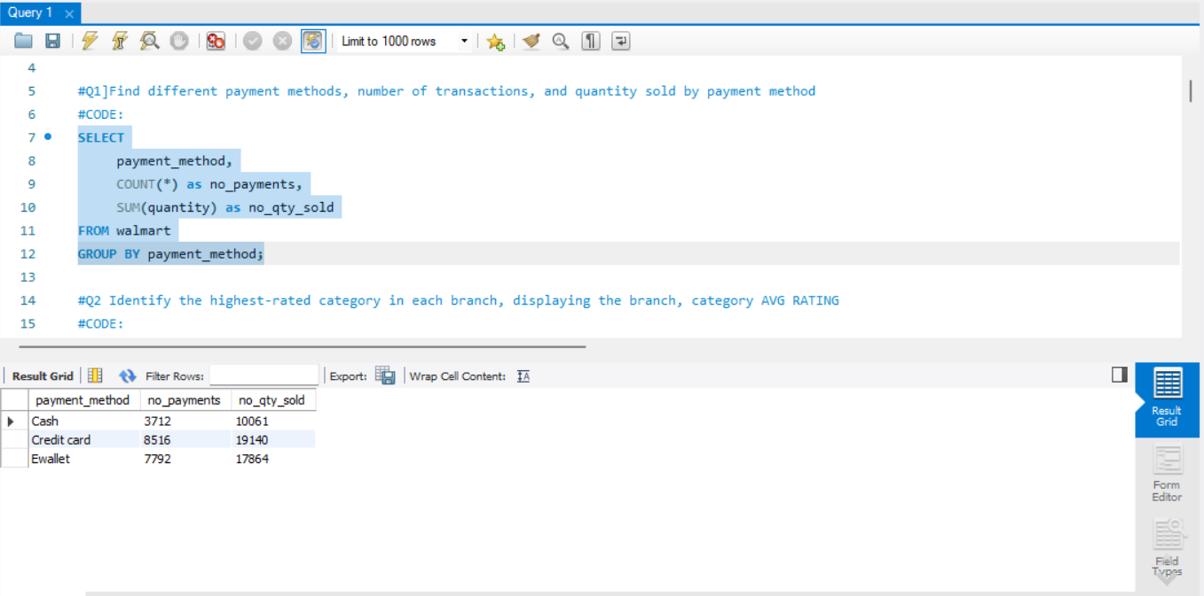

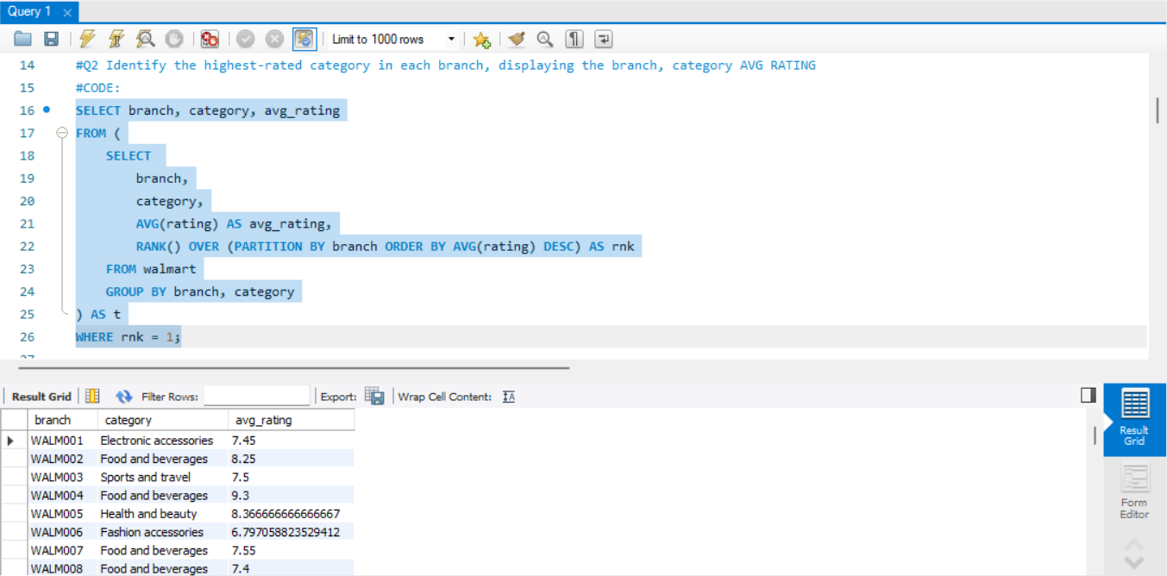

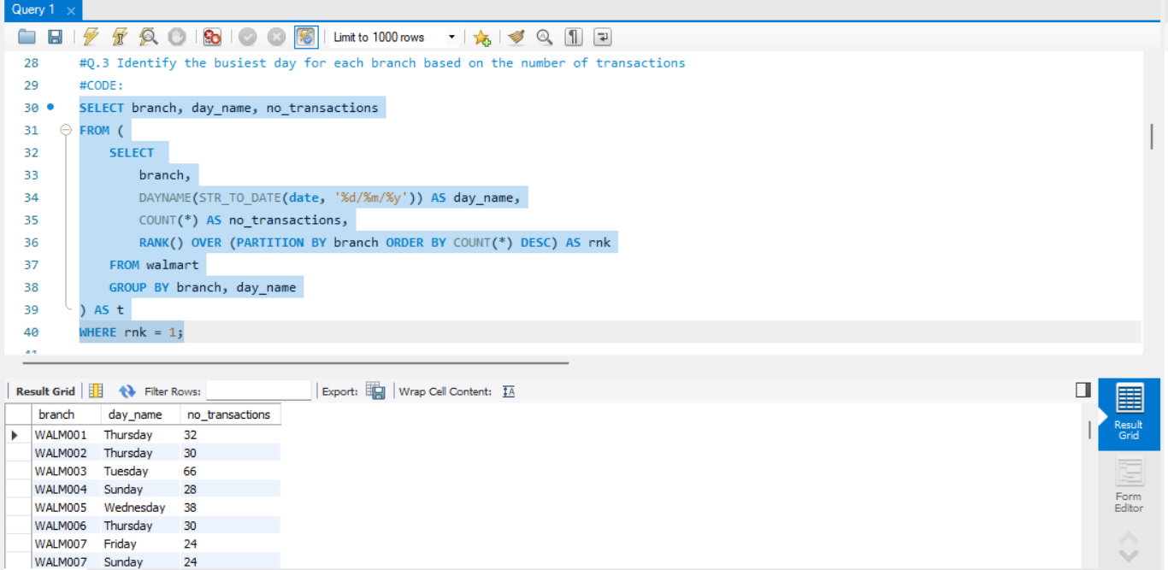

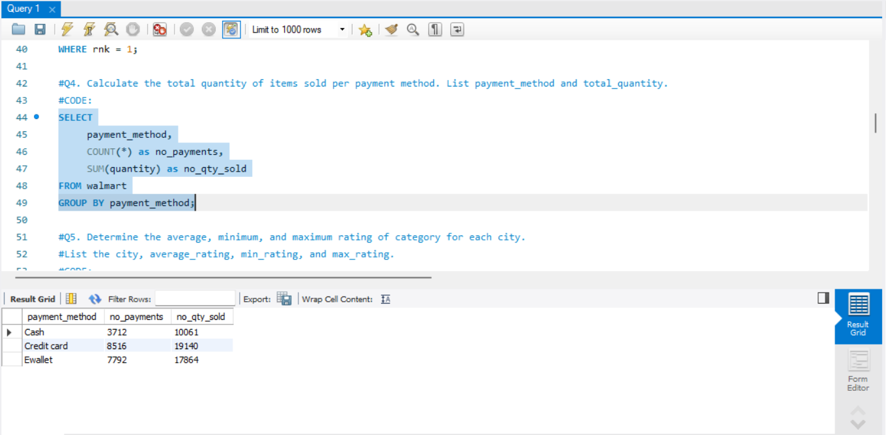

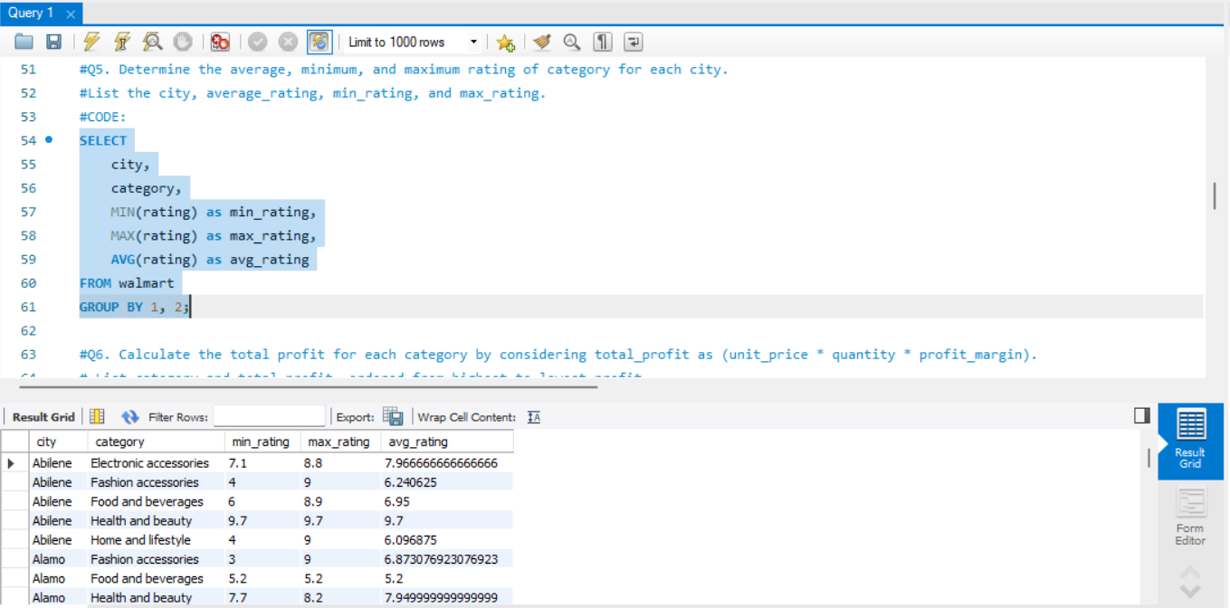

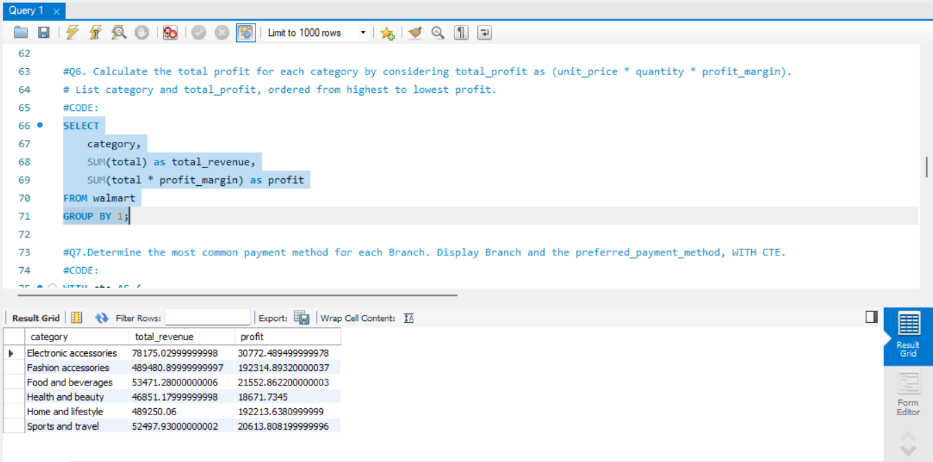

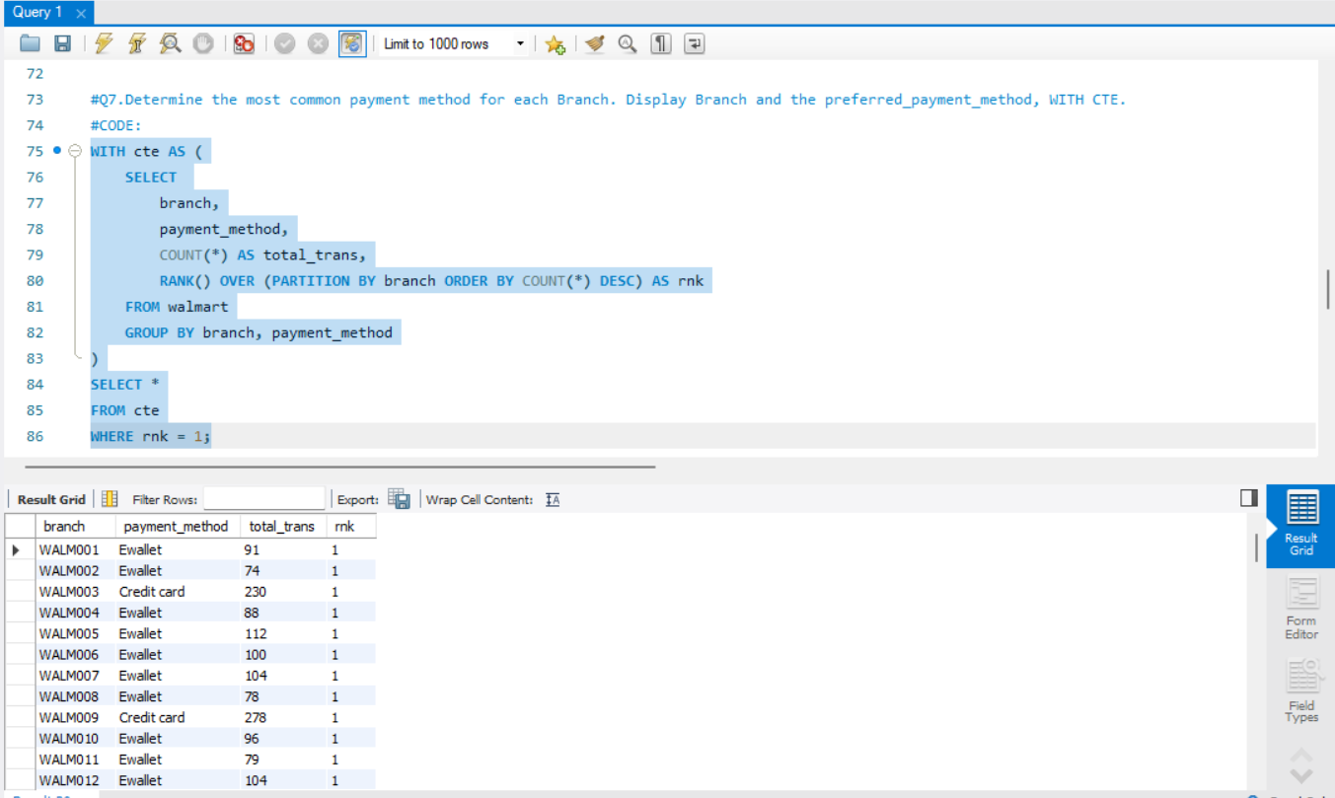

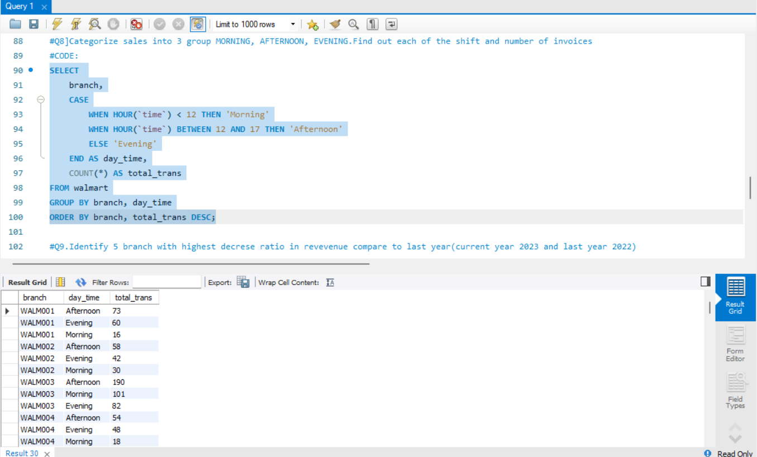

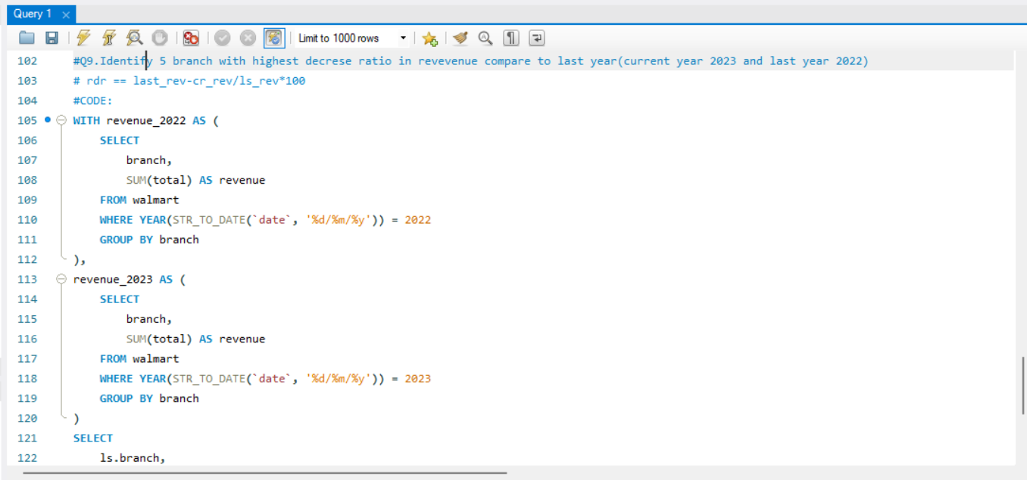

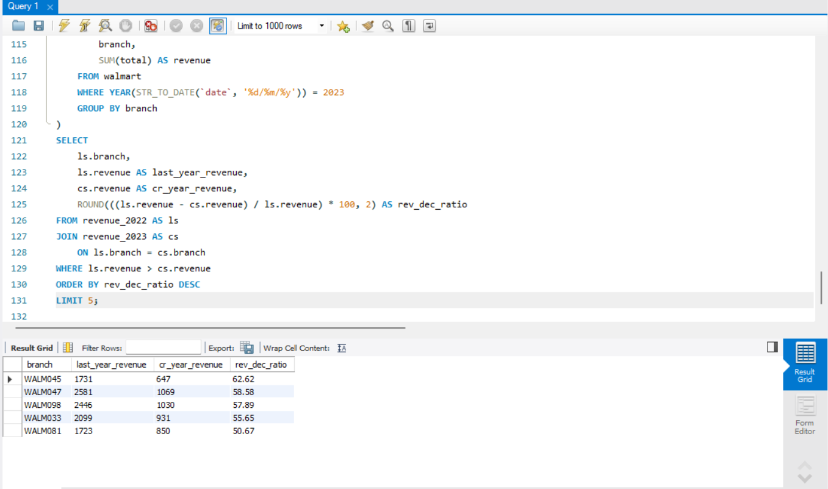

DASHBOARD USING POWER BI :

DASHBOARD USING EXCEL :

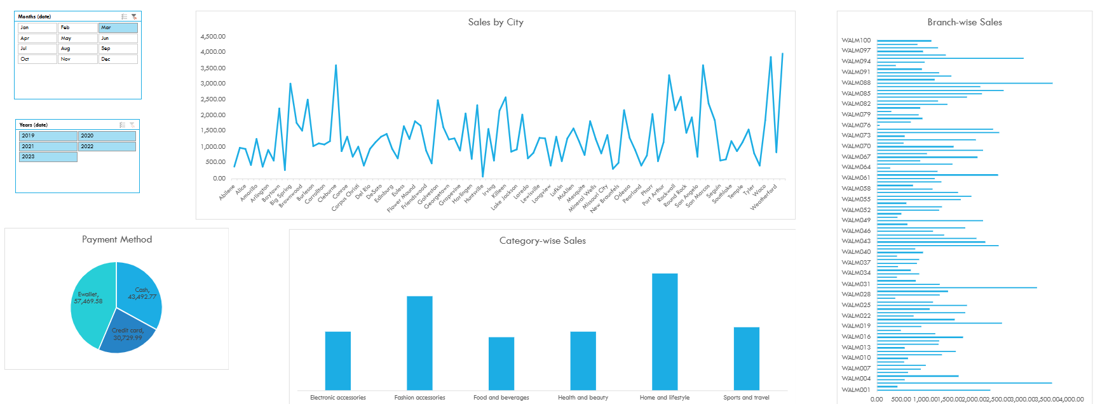

Chapter 5: Conclusion and Future scope

Future Scope
Current implementation establishes foundations for numerous extensions increasing analytical sophistication and business value. Advanced analytical capabilities incorporation represents immediate extension opportunities: demand forecasting using time series models predicting product demand at different granularities; customer lifetime value estimation identifying high-potential segments; recommendation engines using collaborative filtering and association rule mining; price optimization determining optimal strategies across products and segments; and churn prediction identifying decreased engagement risks transitioning systems from descriptive and diagnostic to predictive and prescriptive functionality.
Additional data source integration enriches current sales data foundations: inventory data incorporating stock levels, replenishment cycles, and supplier performance; customer data adding demographic, behavioural, and satisfaction information; marketing data including campaign performance, channel effectiveness, and promotional impact; operational data covering staff scheduling, facility management, and operational costs; and external data incorporating market trends, economic indicators, and competitive intelligence enabling more comprehensive analysis and richer insights.
Real-time analytics extensions support operational decision-making alongside strategic analysis: stream processing for real-time transactional data ingestion and analysis; operational dashboards for live performance monitoring and alerting; personalization engines for real-time recommendation and offer generation; and anomaly detection for immediate unusual pattern or performance issue identification enhancing responsiveness and competitive positioning.
Enhanced visualization and reporting make analytical outputs more accessible: interactive dashboards with business user-friendly exploration interfaces; automated reporting with scheduled generation and distribution; mobile accessibility through responsive designs for device access; natural language querying using conversational interfaces for business question answering; and automated insight generation with AI-powered significant pattern identification and highlighting democratizing data access throughout organizations.
Scalability and performance enhancements ensure enterprise-scale deployment: distributed processing using Spark or similar technologies for large datasets; cloud-native architecture with containerization and orchestration for elastic scalability; advanced caching with multi-level strategies for improved performance; data lake integration ensuring compatibility with modern architectures; and microservices design decomposing into independently scalable services handling enterprise data volumes and user concurrency.
Industry-specific specialization demonstrates framework flexibility: e-commerce analytics enhancing digital journey and conversion analysis; supply chain analytics extending to logistics and distribution optimization; financial services analytics adapting for transaction pattern analysis and risk assessment; healthcare analytics modifying for patient journey and operational efficiency; and manufacturing analytics extending to production efficiency and quality analysis showing broader applicability beyond retail.
Governance and MLOps integration ensure enterprise deployment effectiveness: data governance frameworks with formal quality, lineage, and cataloguing capabilities; model management with full MLOps lifecycle for analytical models; compliance automation with built-in regulatory adherence; access control with sophisticated role-based access and data masking; and audit capabilities with comprehensive activity logging and change tracking ensuring large organizational context operation.
The project successfully demonstrates robust retail analytics approaches while establishing strong foundations for continued enhancement and specialization, balancing immediate practical value with long-term strategic potential, providing organizations pathways from basic reporting to advanced analytical capabilities essential for competitive differentiation and operational excellence.

Conclusion
The Walmart Data Analysis Project successfully demonstrates comprehensive end-to-end transformation of raw retail transactional data into actionable business intelligence. Through systematic implementation of data acquisition, cleaning, feature engineering, database management, and analytical querying, the project delivers tangible insights into sales performance, customer behaviour, product optimization, and operational efficiency.
Key achievements include establishing integrated analytical frameworks seamlessly combining Python's processing capabilities with SQL's querying power across multiple database platforms. This integration addresses significant gaps where technologies typically operate in isolation. The implementation provides reference architecture for organizations developing robust, reproducible analytical pipelines scaling with business needs.
Technically, the project demonstrates automated data acquisition through API integration with fallbacks; systematic data quality assessment and improvement; comprehensive retail-focused feature engineering; cross-database compatibility maintaining analytical consistency; optimized query patterns for common business questions; and thorough documentation ensuring reproducibility and knowledge transfer.
Business value delivered includes revenue pattern identification across temporal, geographical, and product dimensions; customer segmentation enabling targeted marketing and service; product performance analysis supporting inventory optimization and category management; operational insights for staff scheduling, promotional planning, and branch management; and data-driven decision-making foundations across organizational functions.
Methodological innovations introduced include hybrid data models balancing normalization with analytical performance; configurable pipeline architecture adapting to different data characteristics; validation frameworks ensuring analytical accuracy throughout processes; progressive analytical capabilities supporting organizations at different maturity levels; and reproducibility-first approaches addressing critical implementation gaps.
Implementation challenges surfaced and resolved include data quality variability addressed through configurable cleaning rules; performance optimization requirements met through query tuning and indexing; cross-platform compatibility achieved through abstraction layers; complexity management addressed through modular design and documentation; and resource constraints navigated through efficient processing algorithms and batch operations.

References
1. Kaggle (2023). Walmart Dataset. Retrieved from https://www.kaggle.com/datasets/najir0123/walmart-10k-sales-datasets
2. Provost, F., & Fawcett, T. (2013). Data Science for Business: What You Need to Know About Data Mining and Data-Analytic Thinking. O'Reilly Media.
3. McKinney, W. (2012017). Python for Data Analysis: Data Wrangling with Pandas, NumPy, and IPython. O'Reilly Media.
4. Date, C. J. (2019). An Introduction to Database Systems. Pearson Education.
5. Han, J., Kamber, M., & Pei, J. (2011). Data Mining: Concepts and Techniques. Morgan Kaufmann.
6. Sharma, A., & Kumar, S. (2020). Retail Analytics: Integrated Business Planning and Optimization. Palgrave Macmillan.
7. Leek, J. T., & Peng, R. D. (2015). What is the question? Science, 347(6228), 1314-1315.
8. Wickham, H. (2014). Tidy Data. Journal of Statistical Software, 59(10), 1-23.
9. Stonebraker, M., & Cetintemel, U. (2005). "One Size Fits All": An Idea Whose Time Has Come and Gone. Proceedings of the 21st International Conference on Data Engineering.
10. Kohavi, R., Rothleder, N. J., & Simoudis, E. (2002). Emerging trends in business analytics. Communications of the ACM, 45(8), 45-48.
11. Chen, H., Chiang, R. H., & Storey, V. C. (2012). Business Intelligence and Analytics: From Big Data to Big Impact. MIS quarterly, 36(4), 1165-1188.
12. Davenport, T. H., & Harris, J. G. (2007). Competing on Analytics: The New Science of Winning. Harvard Business Press.
13. Gandomi, A., & Haider, M. (2015). Beyond the hype: Big data concepts, methods, and analytics. International Journal of Information Management, 35(2), 137-144.
14. Warden, P. (2021). Data Source Handbook: A Guide to Public Data. O'Reilly Media.
15. VanderPlas, J. (2016). Python Data Science Handbook: Essential Tools for Working with Data. O'Reilly Media.
16. Teixeira, S., & Makhijani, A. (2020). SQL Cookbook: Query Solutions and Techniques for Database Developers. O'Reilly Media.
17. Walmart Inc. (2023). Walmart Annual Report 2023. Retrieved from https://corporate.walmart.com
18. Kimball, R., & Ross, M. (2013). The Data Warehouse Toolkit: The Definitive Guide to Dimensional Modeling. John Wiley & Sons.
19. MySQL 8.0 Reference Manual. (2023). Oracle Corporation.
20. PostgreSQL 15 Documentation. (2023). PostgreSQL Global Development Group.
21. McKinsey Global Institute. (2021). The data-driven enterprise of 2025.
22. Gartner. (2022). Magic Quadrant for Analytics and Business Intelligence Platforms.
23. IBM Institute for Business Value. (2020). The enterprise guide to closing the skills gap.
24. Forbes Insights. (2021). Data & Analytics: The key to retail transformation.
25. Harvard Business Review Analytic Services. (2022). The evolution of data-driven decision making.

