**STEPS TO INSTALL VS CODE**

**Name- Soham**

**PRN-23070123084**

**ENTC B1**

1. Click on the site <https://code.visualstudio.com> and then click on download for windows to get vs code in your.

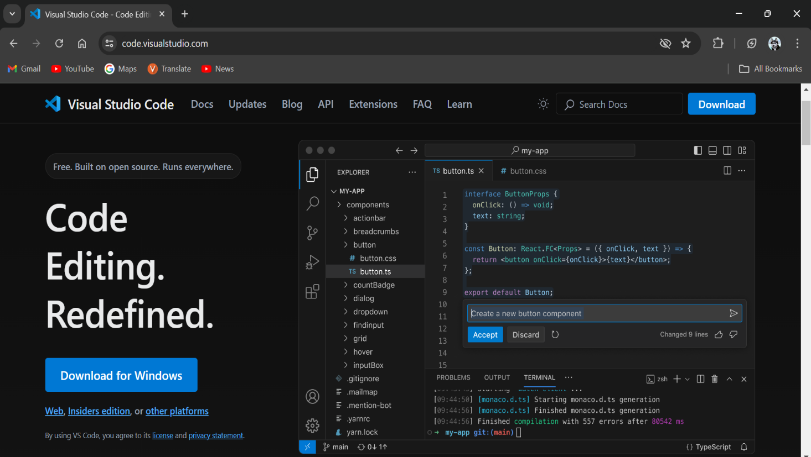

1. Now, in your pc your vs code will start downloading. After that click on the recent downloaded file in downloads tab to open the vs code.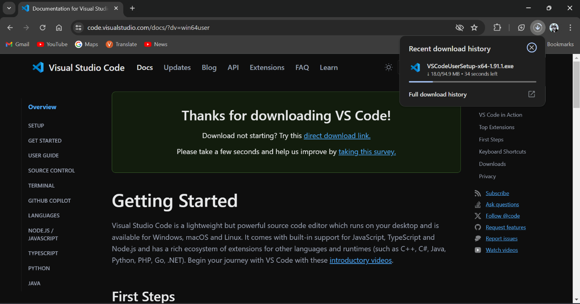
2. Then a Pop up window will appear , after that click on “I accept the agreement”. And click on next to proceed.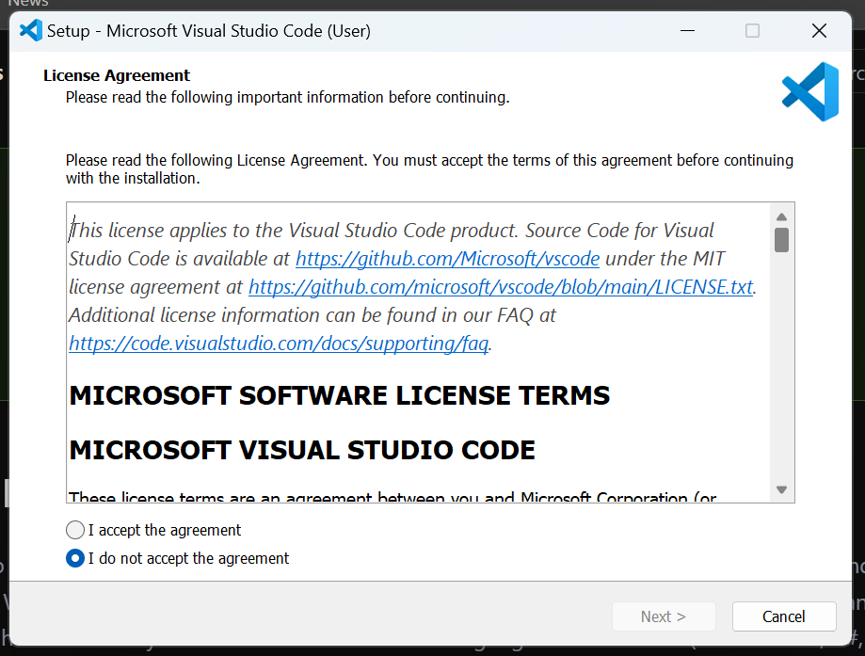
3. Select the location for vs code in your pc.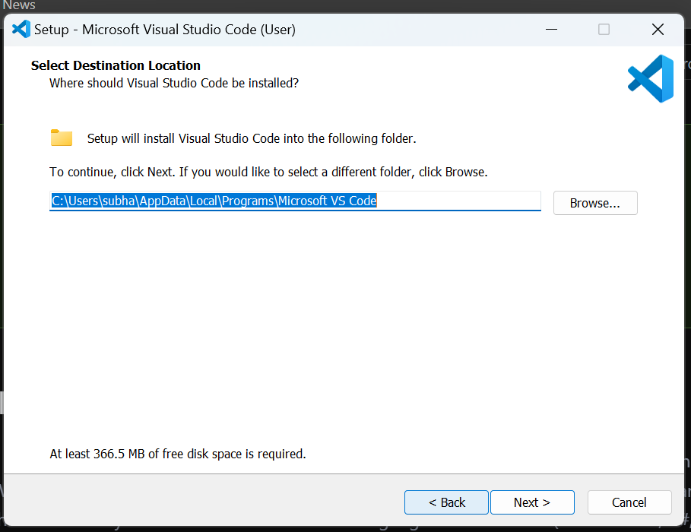
4. Now the setup installs vs code in your pc /computer.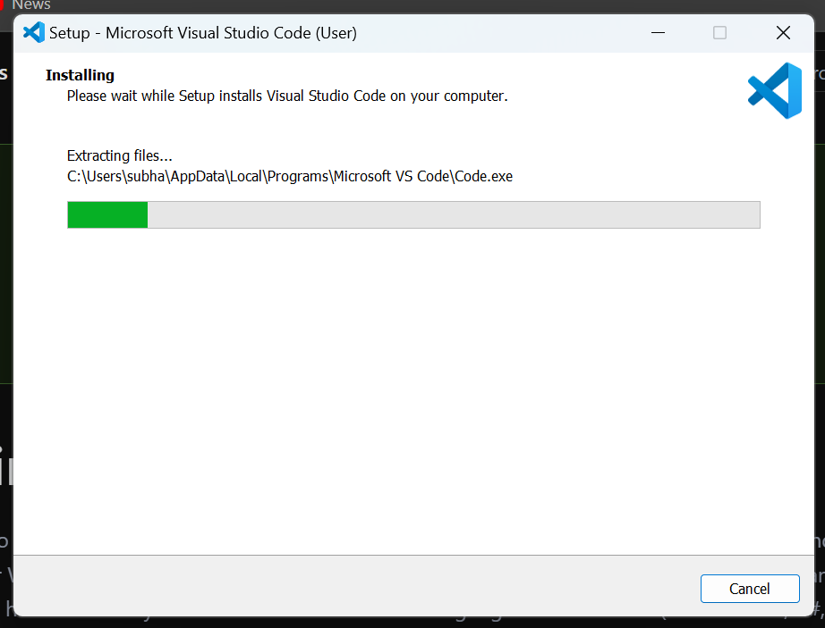
5. Now we get the first interface of the vs code.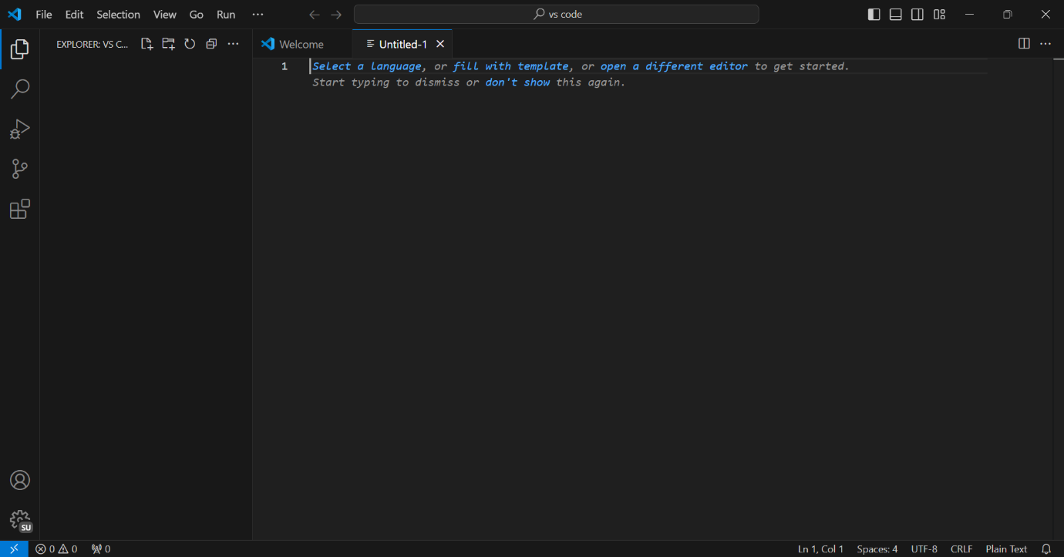
6. After the vs code get installed, we have to install its other extensions like code runner and C/C++ to run the code. 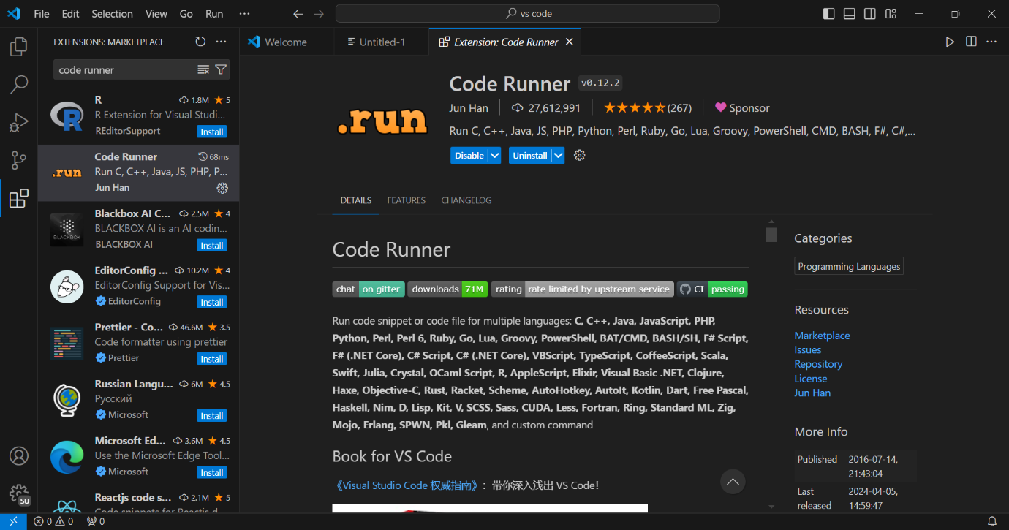
7. Now download the MinGW which will compile your code in vs code. Site- [MinGW - Minimalist GNU for Windows download | SourceForge.net](https://sourceforge.net/projects/mingw/)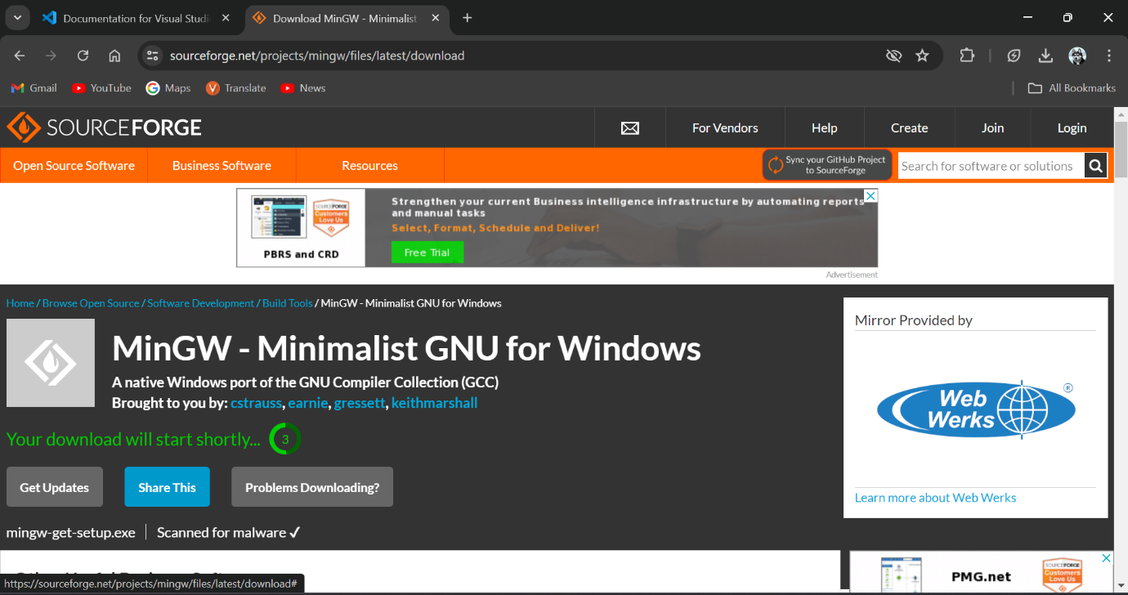
8. Then a pop up window will appear in your pc for the installation of MinGW. Click on install.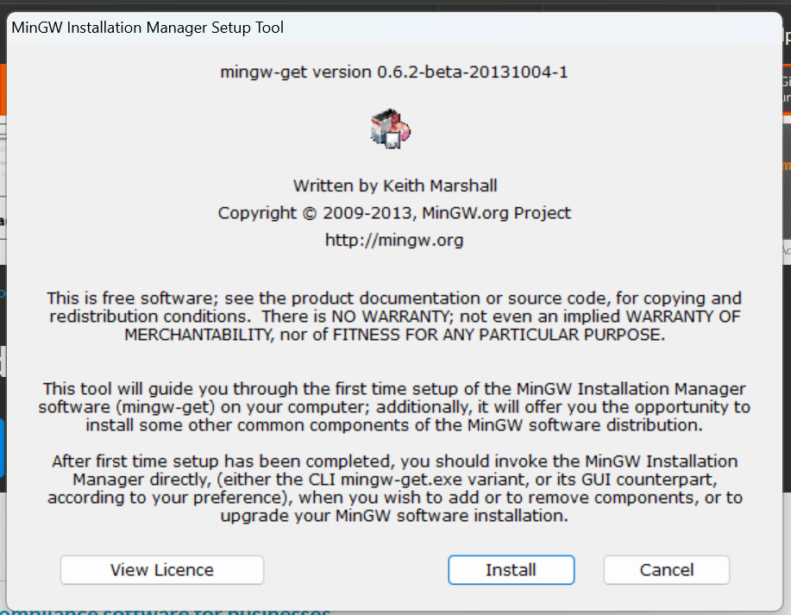
9. Then we see installation of MinGW begins.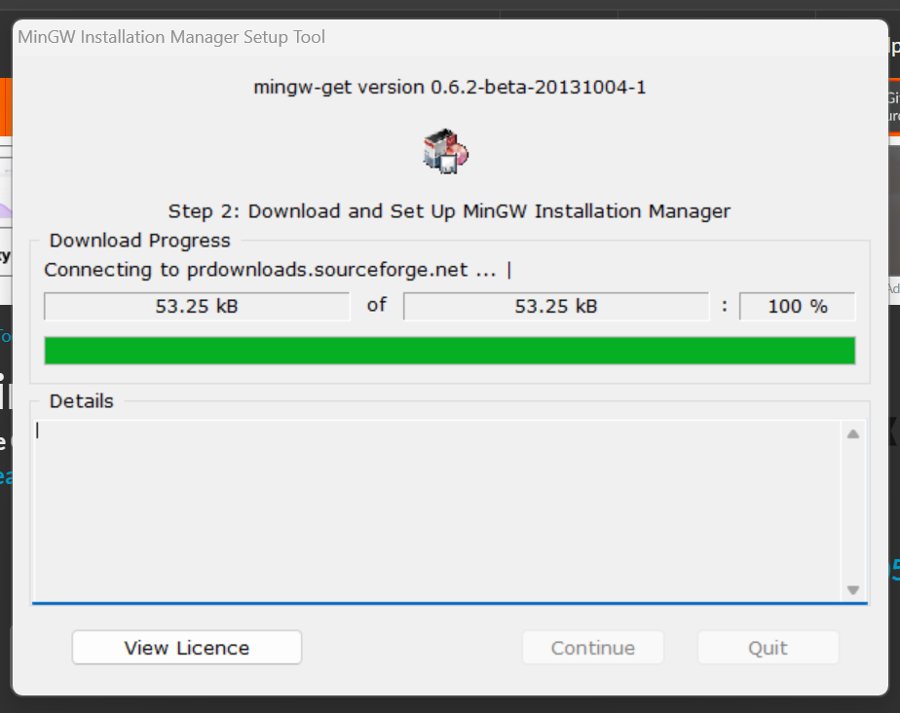
10. After this, various packages will appear. select all the required boxes you need for the c and c++ language.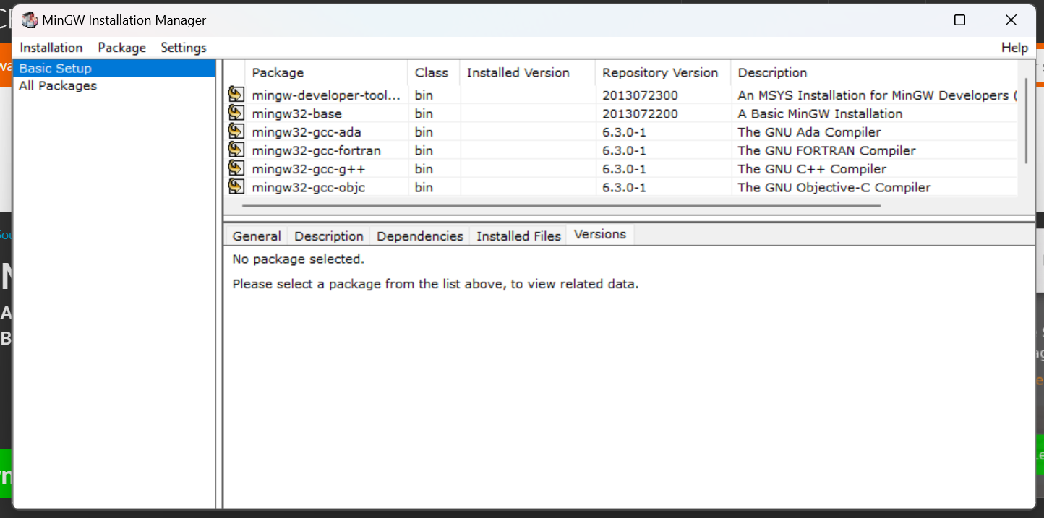
11. Click on apply. Then MinGW gets installed in your pc.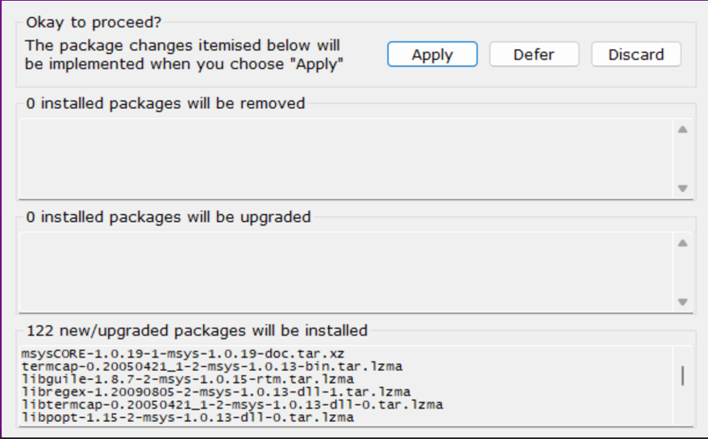
12. .After this go to THIS PC click on ‘ Advanced System Settings’. A pop up window will appear, and then go to ‘Environmental Variables’.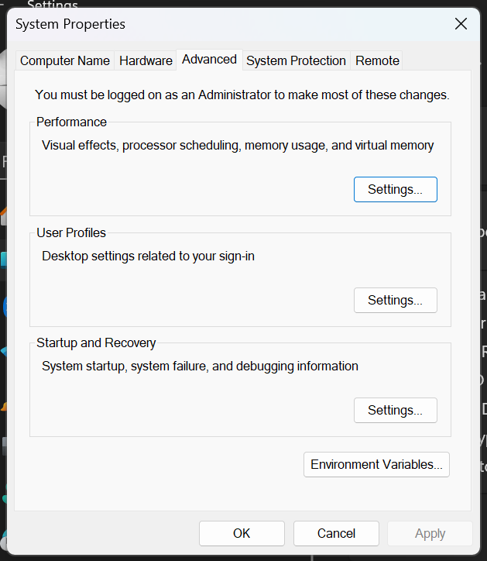
13. Here you have to select the path file and then you have to edit it.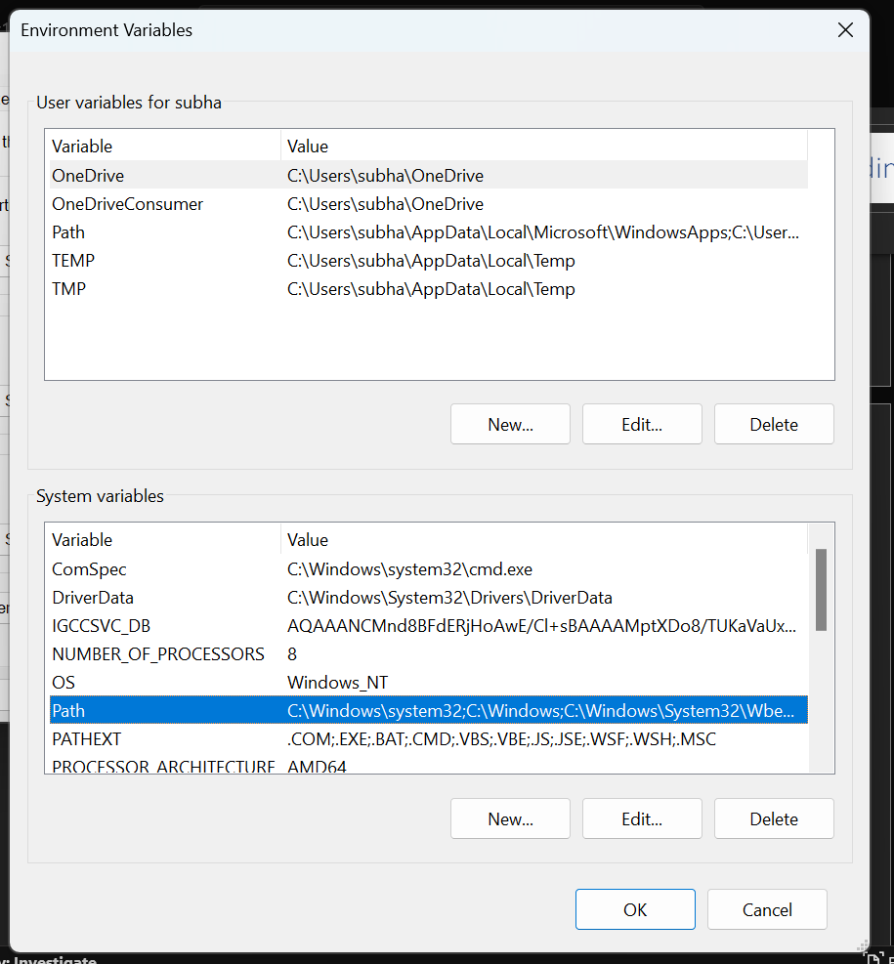
14. A pop-up window will appear. Click on new tab and add the link of the location of MingGW in THIS PC (in bin).And click on OK. Your Visual Studio Code is ready for use. 