**Hive Code:**

beeline

!connect jdbc:hive2://babar.es.its.nyu.edu:10000/

use NetID;

**Create temporary functions and set number of mappers and reducers:**

set hive.input.format=org.apache.hadoop.hive.ql.io.HiveInputFormat;

set mapred.map.tasks = 20;

set mapred.reduce.tasks = 20;

create temporary function st_polygon as 'com.esri.hadoop.hive.ST_Polygon';

create temporary function st_point as 'com.esri.hadoop.hive.ST_Point';

create temporary function st_contains as 'com.esri.hadoop.hive.ST_Contains';

**Creating 311 Data Hive table**

create external table 311_data_1 (unique_key string, created_date timestamp, complaint_type string, latitude double, longitude double) row format delimited fields terminated by ',' location '/user/jl9200/rbda/shareHDFS_project/data2/';

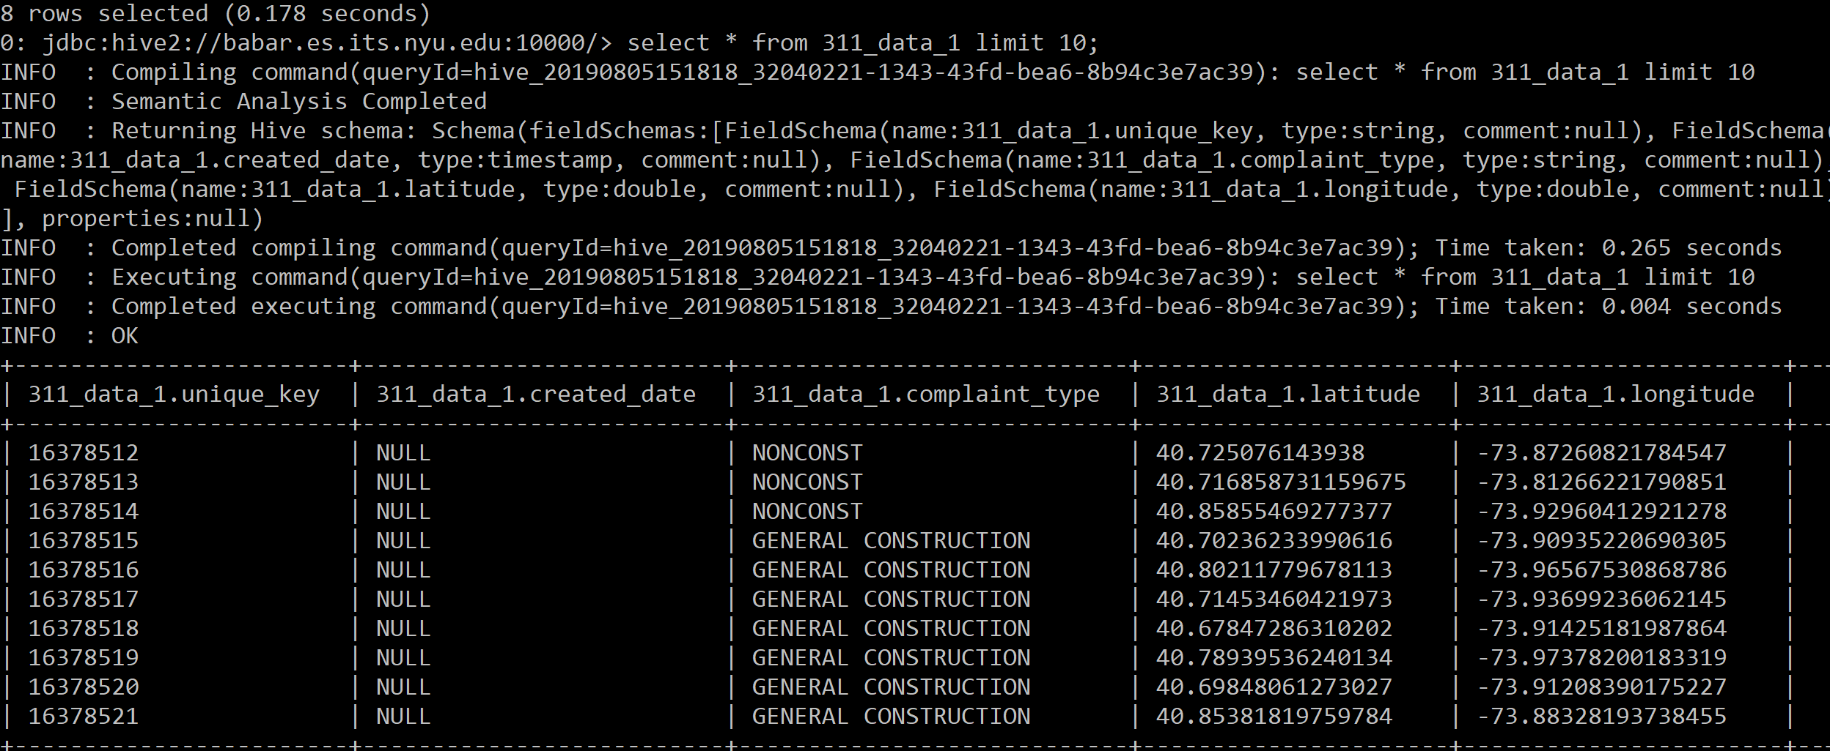

**Taking out only the complaint_types is Graffiti from the 311 Data Hive Table**

CREATE TABLE 311_data_graffiti AS

SELECT * FROM 311_data_1

WHERE complaint_type=’Graffiti’;

**Create Zillow Neighborhoods table in hive**

create external table zillow1 (name string, geometry string) row format delimited fields terminated by '\t' location '/user/jl9200/rbda/shareHDFS_project/zillowtxt';

**Performing spatial join on these two datasets ( zillow1 and 311_data_graffiti)**

CREATE TABLE 311_zillow AS

SELECT zillow1.name, count(*) cnt FROM zillow1

JOIN 311_data_graffiti

WHERE st_contains(st_polygon(zillow1.geometry), st_point(311_data_graffiti.longitude, 311_data_graffiti.latitude))

GROUP BY zillow1.name

ORDER BY cnt desc;

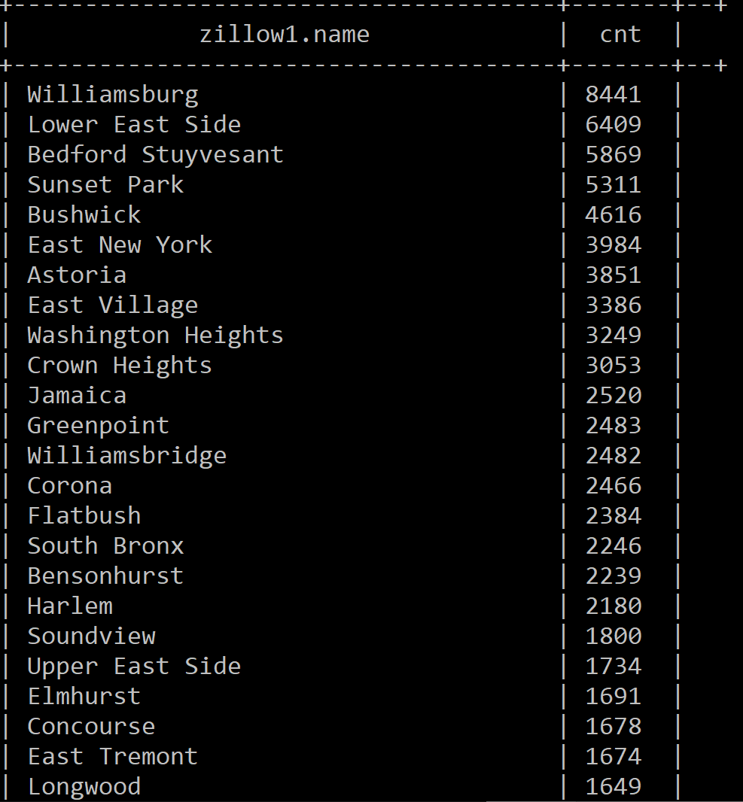

**Export the HIVE TABLE to HDFS**

INSERT OVERWRITE DIRECTORY '/user/jl9200/rbda/shareHDFS_project/output1' SELECT * FROM 311_zillow;

** '/user/jl9200/rbda/shareHDFS_project/output1' should be a new directory that had never been created before!

**Export table from hdfs to dumbo (This Command is run on dumbo not beeline)**

hdfs dfs -cat 311_zillow/000000_0 > 311_zillow.csv

**Clean Output csv on dumbo (This Command is run on dumbo not beeline)**

python clean_output.py 311_zillow.csv 311_zillow_output.csv

* **Also Repeat the process above for the created_date data for 311**

select * from 311_zillow_wtime ORDER BY cnt DESC LIMIT 10;

