SLE-3: Architectural Design (Full C4 Model)
Course: 02AML204 – Introduction to Artificial Intelligence
PRN: 25UAM124
Name: Soham Nanaso Patil
Division: B
Date: 7 October 2026
GitHub: https://github.com/SohamP27

1. System Title & Short Description
System: BFS / DFS Route Finder (continued from SLE-2).
The system takes an unweighted graph, a start node and a goal node, and finds a route using either Breadth-First Search or Depth-First Search. It also records execution time, nodes expanded and path length so the two algorithms can be compared. It solves the problem of choosing between BFS and DFS: BFS guarantees the shortest path in an unweighted graph, while DFS can be faster but may return a much longer route (SLE-2: 4 edges vs 14 edges on the 16-node graph).

2. Context Diagram (Level 1)
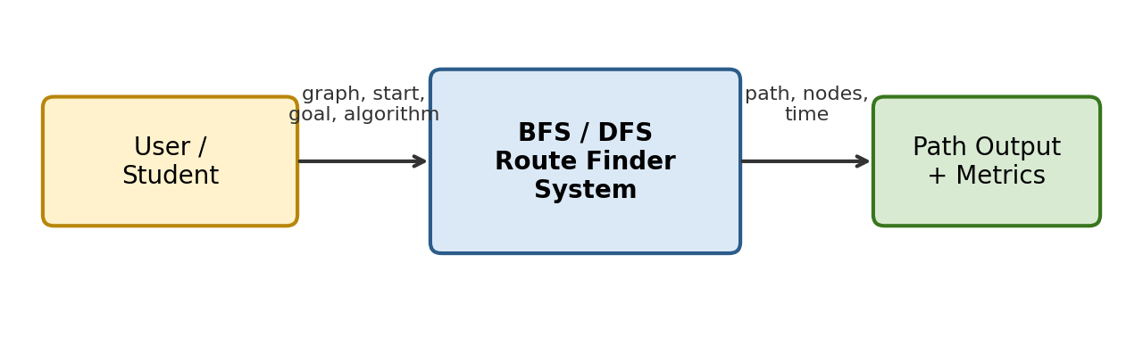
The user supplies a graph, start node, goal node and the chosen algorithm. The system is one box that runs the search and returns the path plus metrics (nodes expanded, time, path length). No external services are used, so only the user and the output appear.

3. Container Diagram (Level 2)
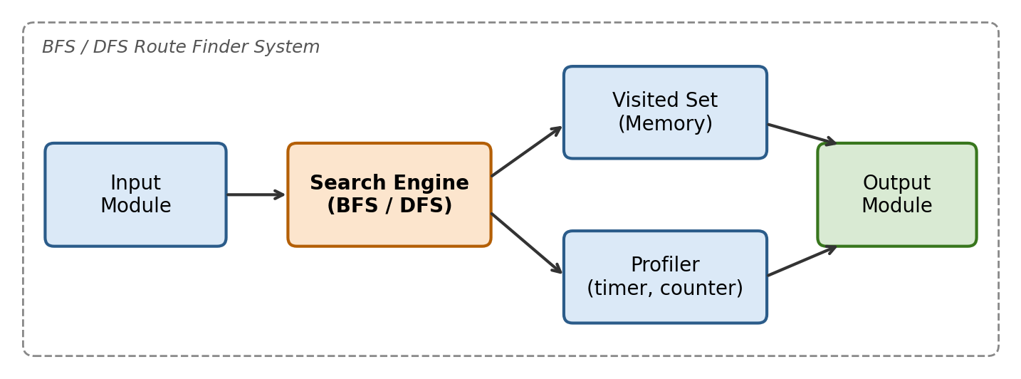
- Input Module: reads the adjacency-list graph, start node, goal node and algorithm choice (BFS or DFS).
- Search Engine: runs BFS (queue) or DFS (stack) on the graph and finds the route to the goal.
- Visited Set (Memory): stores visited nodes so no node is processed twice and loops are avoided.
- Profiler: measures time with time.perf_counter_ns() and counts nodes expanded.
- Output Module: shows the path, path length, nodes expanded and average time.

4. Component Diagram (Level 3) – Search Engine
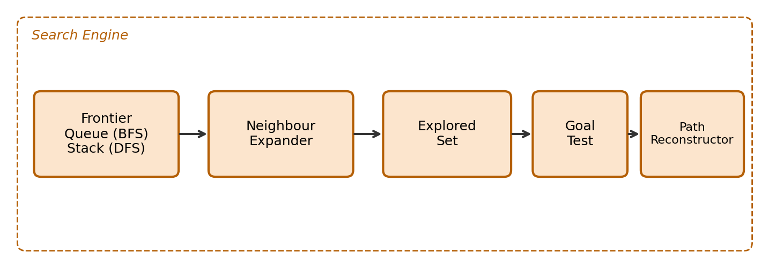
Frontier holds nodes waiting to be explored: a queue for BFS and a stack for DFS, which is the only real difference between the two. The Neighbour Expander gets adjacent nodes in a fixed order, the Explored Set skips repeats, the Goal Test stops the search when the goal is removed from the frontier, and the Path Reconstructor follows parent links back to the start to build the route.

5. Code Level Overview (Level 4)
- class Graph: adjacency list; returns the neighbours of a node.
- def bfs(graph, start, goal): queue-based search; returns path and nodes expanded.
- def dfs(graph, start, goal): stack-based search; returns path and nodes expanded.
- def reconstruct_path(parent, goal): builds the route from the parent map.
- def profile(func, runs=5000): repeats a search and returns the mean time in µs.
- def main(): reads input, calls bfs/dfs, prints the results.

6. Design Decisions
The graph, search and profiling parts are kept in separate containers so BFS and DFS can be swapped without touching input or output code. Both algorithms share the same graph, neighbour order and visited-set logic, so only the frontier structure (queue vs stack) changes. This keeps the SLE-2 comparison fair. The Profiler is separate so timing code does not mix with search logic.

7. AI Contribution Note
- AI tools used: Claude (Anthropic).
- What AI helped with: structuring the C4 levels for the BFS/DFS system, drafting the explanations and the simple diagrams.
- What I did myself: the BFS/DFS code and profiling in SLE-1 and SLE-2, reviewing that the architecture matches my code, and checking the final report.

8. Conclusion
C4 lets a system be described from the big picture down to the code, one level at a time. For this project it showed that BFS and DFS differ only in the frontier component, while the rest of the system stays the same. Separating input, search, memory, profiling and output makes the design easier to understand, test and extend, for example by adding A* later with a Heuristic Module.

