Database Management Systems Lab
Project Phase: 2
Group Members:
Sr.No. | Name | PRN | Branch | Division
1 | Shubham Chitrakar | 24070122195 | CS | C1
2 | Soham Phansalkar | 24070122202 | CS | C1
3 | Talib Jiruwala | 24070122215 | CS | C1
4 | Tanmay Sheware | 24070122216 | CS | C1

Under the Guidance of Dr. Anuradha Pillai
Department of Computer Science
Symbiosis Institute of Technology, Pune
Title of the project:
Trip Itinerary Planner System
About the project:
The tourism industry is booming, but trip planning has become surprisingly complicated. Travelers today juggle countless choices like destinations, transportation modes, hotels, restaurants, and budgets—while trying to coordinate day by day activities and seasonal availability. Without proper organization, this often leads to messy schedules, overspending, and missed opportunities to make everything work together smoothly.
The Itinerary Planner System solves this problem by providing one centralized platform to manage every aspect of your trip. Instead of scattered notes and spreadsheets, you can create personalized itineraries that connect destinations, daily schedules, transport options, accommodations, and dining spots while staying on budget. Everything is stored in one place, making it simple to update plans and keep all your travel details coordinated.
This project is built on solid database design principles, carefully structuring how users, trips, destinations, attractions, and other elements relate to each other. Using proven techniques like entity-relationship modeling, normalization, and integrity constraints, the system ensures data remains organized, accurate, and efficient. The design is also scalable and ready for future integration with a Java application, making it suitable for real-world travel planning needs.

Addressed pain points:
The pain point addressed by the Itinerary Planner System lies in the difficulty and inefficiency of manually planning trips. Travelers often struggle to manage multiple aspects such as destinations, transportation, accommodation, activities, and budget within scattered sources of information. This leads to poor organization, time consumption, and increased chances of errors in planning. The proposed system provides a centralized and structured platform to organize all travel-related data in one place. By integrating itinerary planning, resource selection, and budget management, the system simplifies the entire travel planning process. This enables users to plan trips more efficiently, save time, and make informed decisions with better clarity and control.

EER DIAGRAM

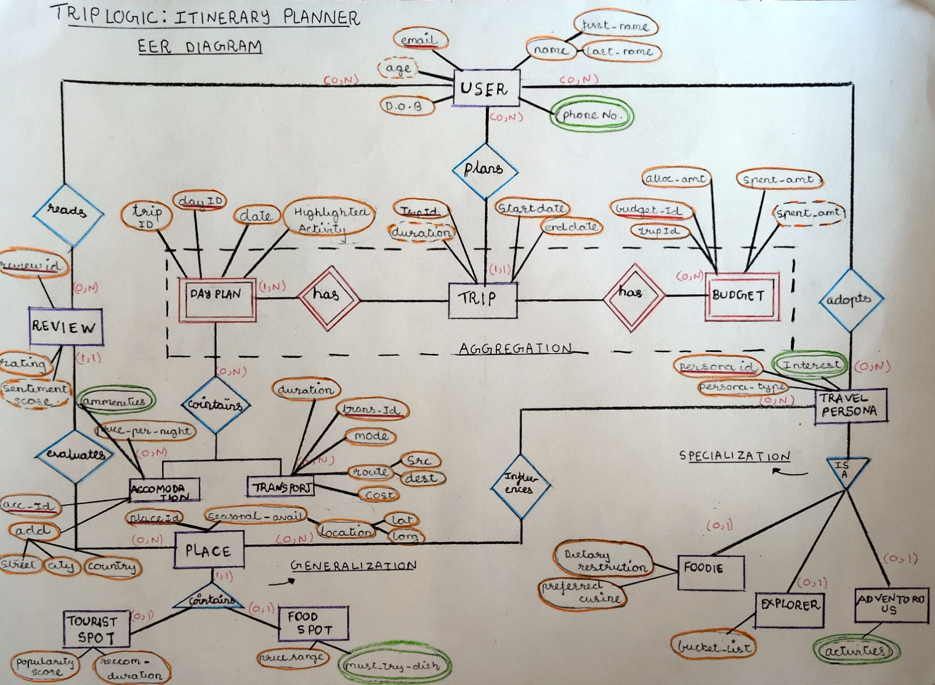

Anomalies:
A database anomaly is a fault within a database, which can occur because of poor planning or when everything is stored in a flat database. Anomalies cause inconsistencies between stored data and the real world. In TripLogic, we identify anamolies in several tables and show how normalization resolves them.
Anomalies occurring in our database:
- First Normal Form (1NF) : Violation in Accommodation
The Accommodation table stored multiple amenity values within a single cell like gym and spa, violating the atomicity requirement of 1NF. AccommodationID = A005 is a clear example of this

Insert Anomaly: To insert AccommodationID A006 with amenities like Rooftop Bar and Concierge, both values must be crammed into one cell. Also If the system later needs to query all accommodations with a Gym, it cannot do so with a simple WHERE clause.
Update Anomaly: If Pool is renamed to Infinity Pool across all records, every row where Pool appears inside the Amenities cell must be individually string replaced. Missing rows creates inconsistency where the same facility carries two different names in the same database.
Delete Anomaly: Deleting a specific amenity associated with an AccommodationID would lead to loss of information about other amenities if they are stored within the same cell, potentially breaking the accommodation entry.

Accomodation Table:
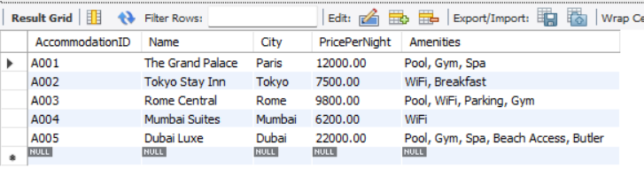

Secondary 1NF Violation: TravelPersona Table:
The TravelPersona table has the same category of violation: the Interests attribute (e.g., Hiking, Street Food, Museums) stores multiple values in a single cell,and updating or deleting one interest risks corrupting others stored in the same cell.

- Second Normal Form (2NF): Violation in TripDaySchedule Table
Attributes like StartDate, EndDate, and Duration depend only on TripID, not on the full composite key (TripID, DayID). This is a partial dependency because trip-level attributes get repeated for every day planned under that trip.
Insert Anomaly: To insert a new daily activity, we must provide all attributes including `TripID` and `StartDate`, which leads to repetition. If we want to create a Trip but haven't planned the days yet, we can't insert it without a `DayID`.
Update Anomaly: Updating information about a trip like EndDate requires updating potentially multiple rows if the trip has multiple DayPlan accounts, leading to inconsistency.
Delete Anomaly: Deleting a DayPlan might result in losing information about the associated Trip entirely (like its Duration), leading to data inconsistency

TripDaySchedule Table:
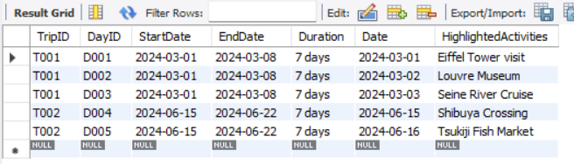

3) Third Normal Form (3NF): Violation in Trip-User Table
Storing personal details inside the trip table creates a roundabout mess. Attributes like FirstName and Age belong to the user's Email, not the TripID. The database shouldn't have to look up a trip just to find out user's age.

Insert Anomaly: If a new user registers on the TripLogic platform but hasn't planned a trip yet, we cannot insert their details (Email, FirstName, Age) into the database because a primary key (TripID) is required. Additionally, if an existing user books a second trip, we are forced to repeatedly enter their FirstName and Age, leading to data redundancy.
Update Anomaly: If a user changes their LastName or their Age updates, we would have to search and update potentially multiple rows if that user has planned multiple trips. Missing updating even one row, the system will show conflicting names or ages for the exact same user.
Delete Anomaly: If a user cancels their only planned trip and we delete that TripID record, we accidentally wipe out all of their user account information (Email, FirstName, Age) from the database losing the user.

TripUser Table:
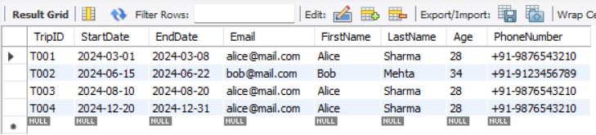

Functional dependencies:
Functional dependency refers to a relationship that is present between attributes of any table that are dependent on each other. It helps in avoiding data redundancy and getting to know more about bad designs.
Functional dependencies of schema occurring in our code:
- User(Email, FirstName, LastName, PhoneNumber, DateOfBirth, Age)
- Trip(TripID, StartDate, EndDate, Duration, Email (FK → User.Email))
- DayPlan(DayID, Date, HighlightedActivities, TripID (FK → Trip.TripID))
- Budget(BudgetID, AllocatedAmount, SpentAmount, RemainingAmount, TripID (FK → Trip.TripID))
- TravelPersona(PersonaID, PersonaName, Interests)
- Foodie(PersonaID (FK → TravelPersona.PersonaID), FavoriteCuisines)
- Explorer(PersonaID (FK → TravelPersona.PersonaID), BucketList)
- Adventurous(PersonaID (FK → TravelPersona.PersonaID), Activities, RiskLevel)
- Review(ReviewID, Rating, Comment, ReviewDate, SentimentScore, UserID (FK → User.Email),
- PlaceID (FK → Place.PlaceID))
- Place(PlaceID, SeasonalAvailability, Latitude, Longitude)
- TouristSpot(PlaceID (FK → Place.PlaceID), PopularityScore, RecommendedDuration)
- FoodSpot(PlaceID (FK → Place.PlaceID), PriceRange, MustTryDishes)
- Accommodation(AccommodationID, Name, Street, City, Country, Amenities, PricePerNight)
- Transport(TransportID, Mode, Source, Destination, Cost, Duration)

Normalization:
A normalization procedure, which combines and splits tables, is usually sufficient to remove this. By normalizing the database, we reduce the likelihood of creating tables that generate anomalies. Normalization is necessary if you do not do it then the overall integrity of the data stored in the database will eventually degrade. Specifically, this is due to data anomalies.
Types of normalization
- Unnormalized form or UNF:
It is the simplest database model also known as non-first normal form (NF2).A UNF model will suffer problems like data redundancy thus it lacks the efficiency of database normalization.
- First Normal Form or 1NF:
A relation is in first normal form only if the relational table doesn’t contain any multivalued attribute but contains only single-valued attributes.
3. Second Normal Form or 2NF:
A relation is in second normal form if:
- It is in first normal form or 1NF
- It doesn’t contain any partial dependencies. (It shouldn’t have any non-prime attribute which is functionally dependent on any proper subset of the candidate key of the relation.).
4. Third Normal Form or 3NF:
Let R be the relational schema, X->Y any non-trivial functional dependency over R is in 3NF if:
- R should be in 2NF
- X should be candidate key or superkey, or
- Y should be prime attribute

Normalization occurring in our code:
  - 1NF:
Violation: The Amenities attribute held multiple comma separated values in a single cell, violating 1NF atomicity.
Solution: Create a separate AccommodationAmenity mapping table. Each row holds exactly one amenity for one accommodation.
Before: Accomodation Table
After Accommodation_new:
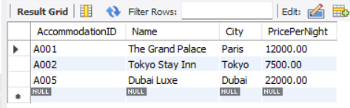

AccommodationAmeinity Table:
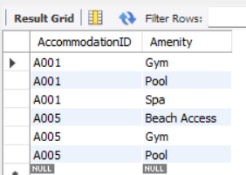
  - 2NF:
Violation: In the initial design StartDate, EndDate, and Duration depended only on TripID , a partial dependency on part of the composite primary key (TripID + DayID).

Solution: Separate trip level attributes into the standalone Trip table and keep daily activity data in DayPlan, referencing TripID as a foreign key.

Before:

To remove partial dependency and achieve 2NF, we need to separate trip attributes into a separate table.
Trip Table:
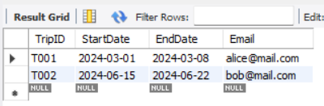

DayPlan Table:
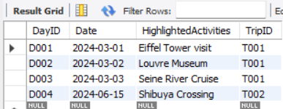

Trip data is stored exactly once per trip. Updating T001's EndDate requires changing one row , no repetition, no risk of inconsistency across multiple day plan rows.

  - 3NF
Violation: In the flat design, user attributes (FirstName, LastName, Age, PhoneNumber) stored inside Trip created the transitive dependency TripID -> Email -> user attributes.
Solution: Extract all user attributes into a separate User table keyed on Email. Trip retains only Email as a foreign key. User data is stored exactly once, independent of any trip.
Before:

To remove the transitive dependency and achieve 3NF, we need to separate the attributes related to user into a separate table.

User Table:
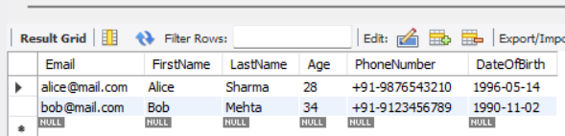
Trip Table:
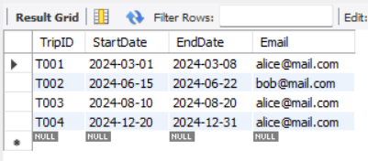
What is MySQL:
MySQL is a relational database management system (RDBMS) developed by Oracle that is based on structured query language (SQL).
Implementation of the tables in MySQL:
create database dbmsReport; use dbmsReport;

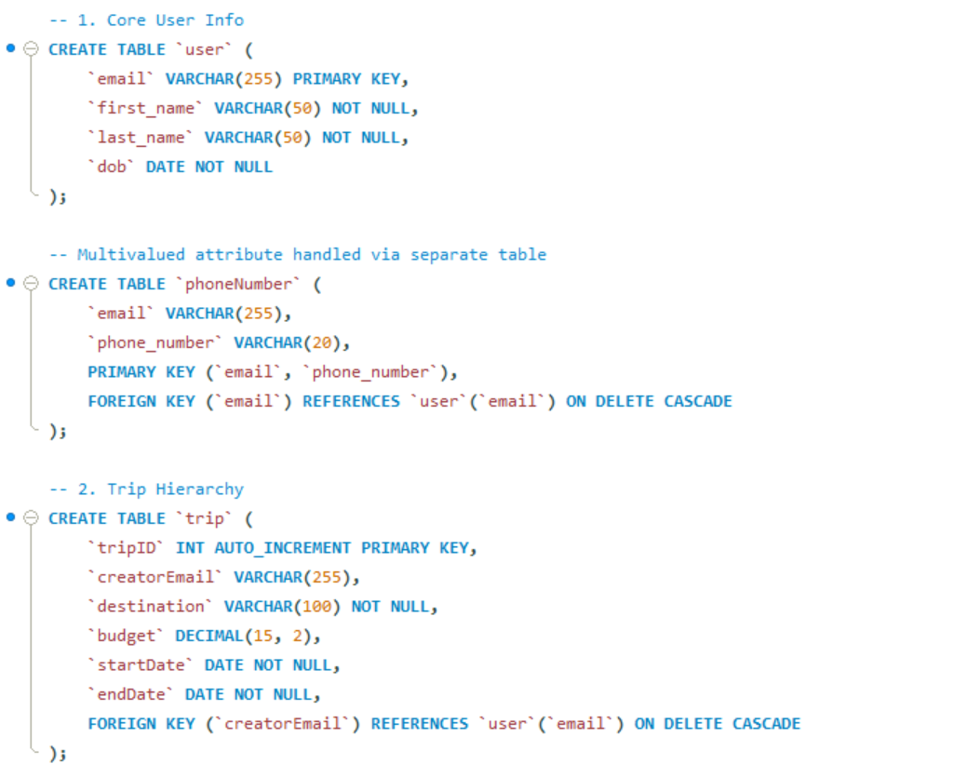

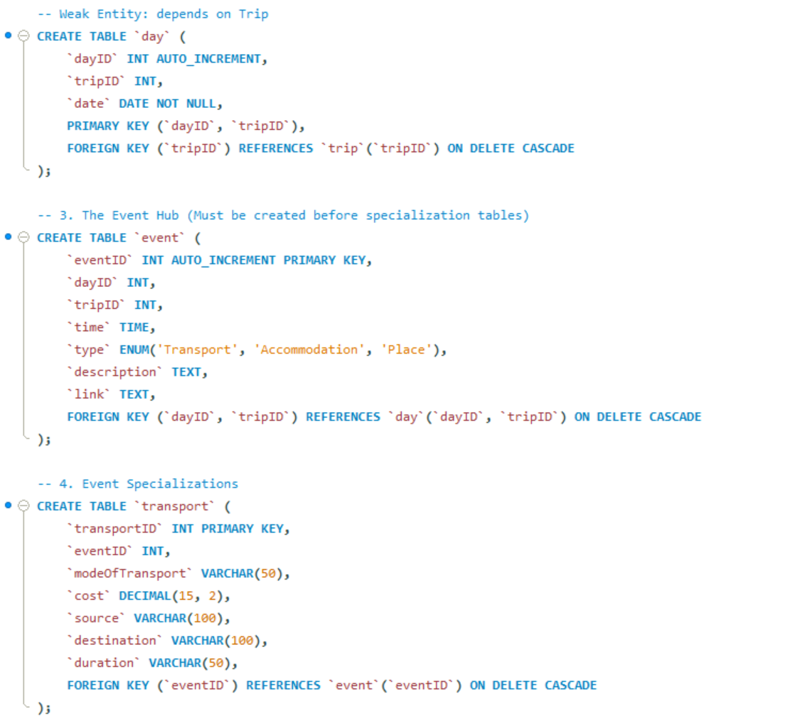

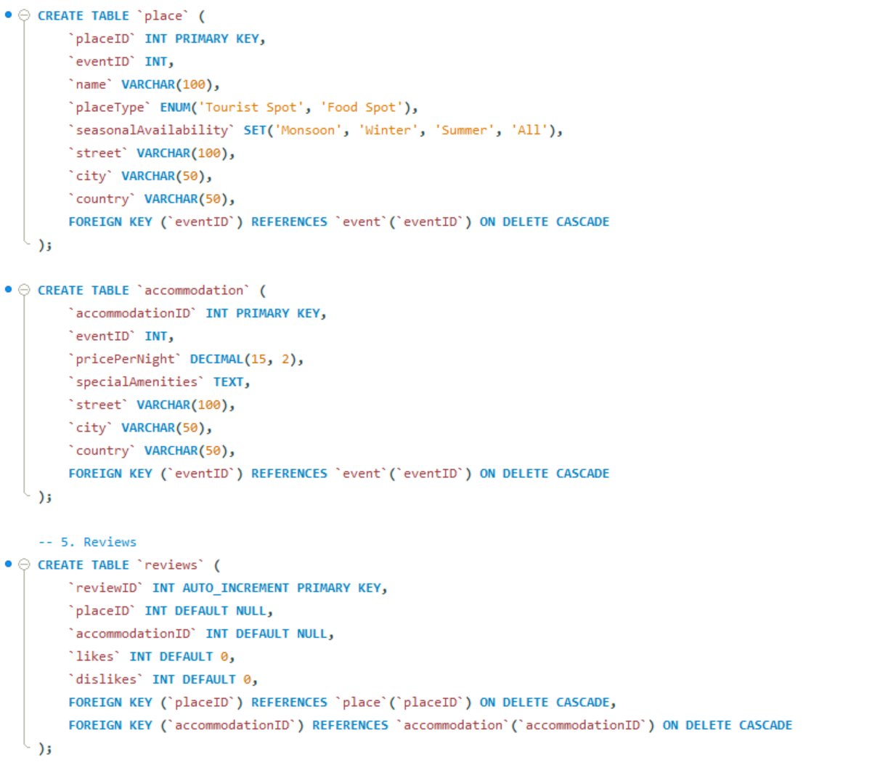

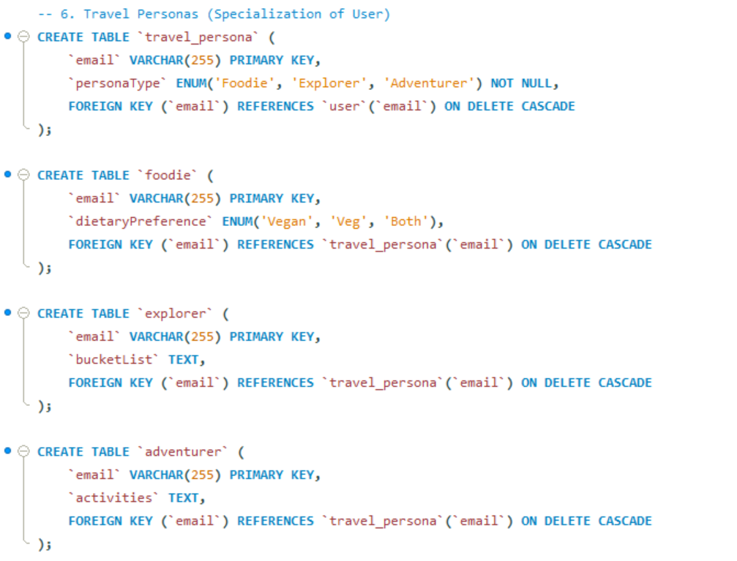

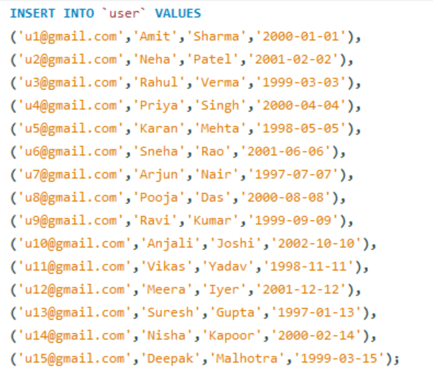
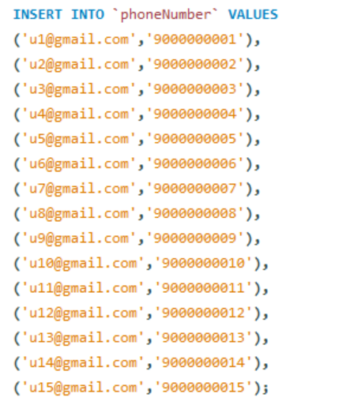

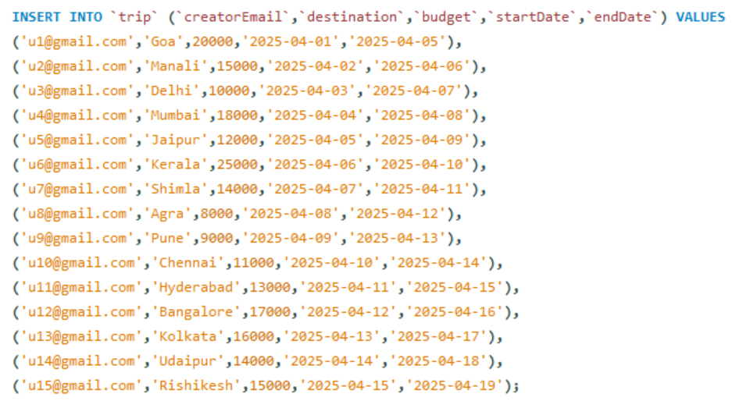

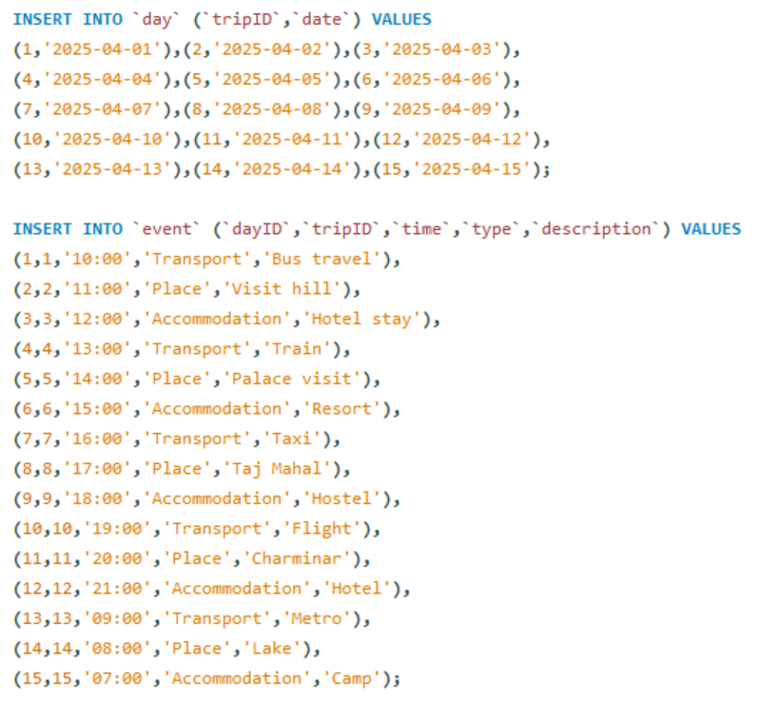

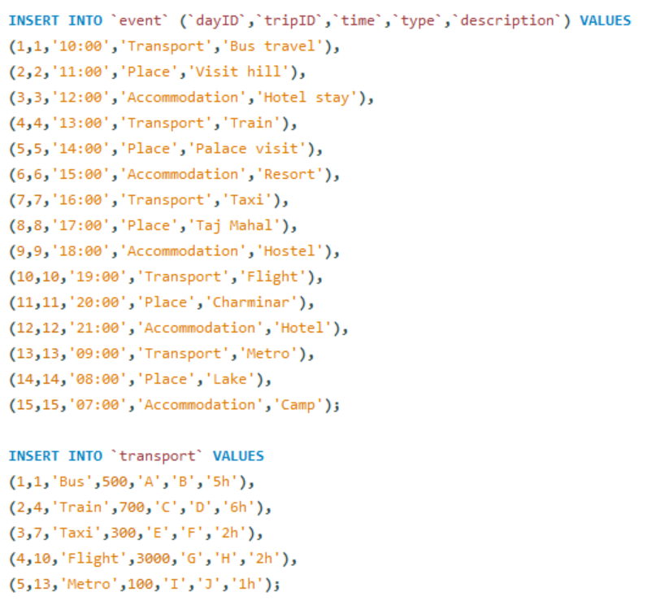
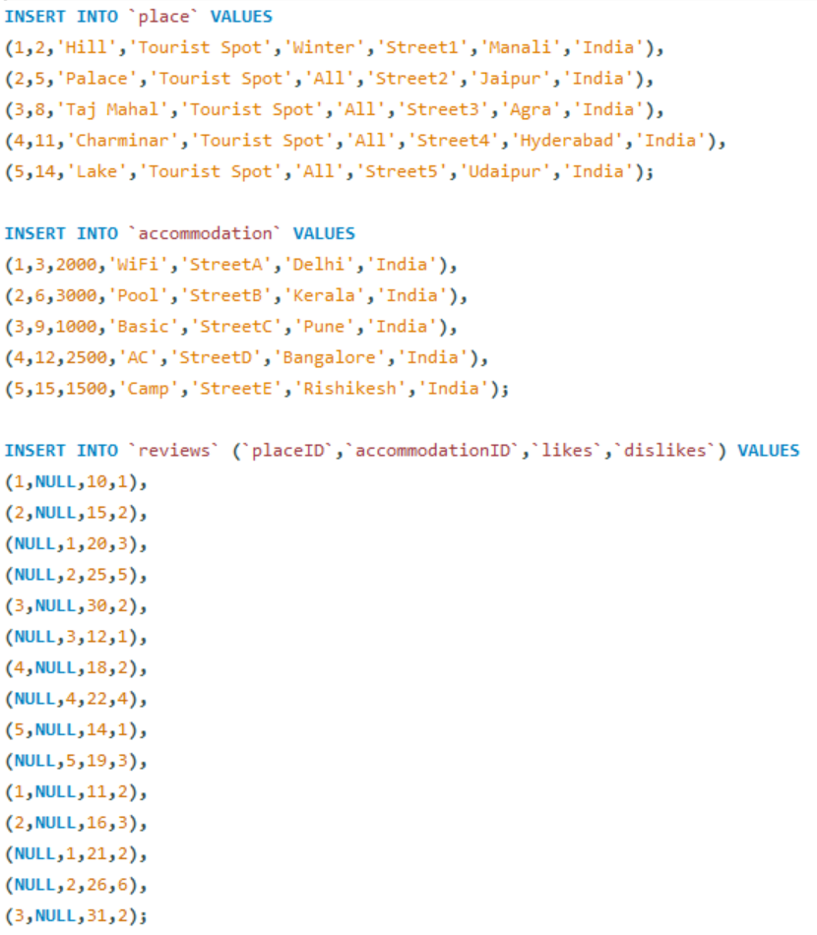

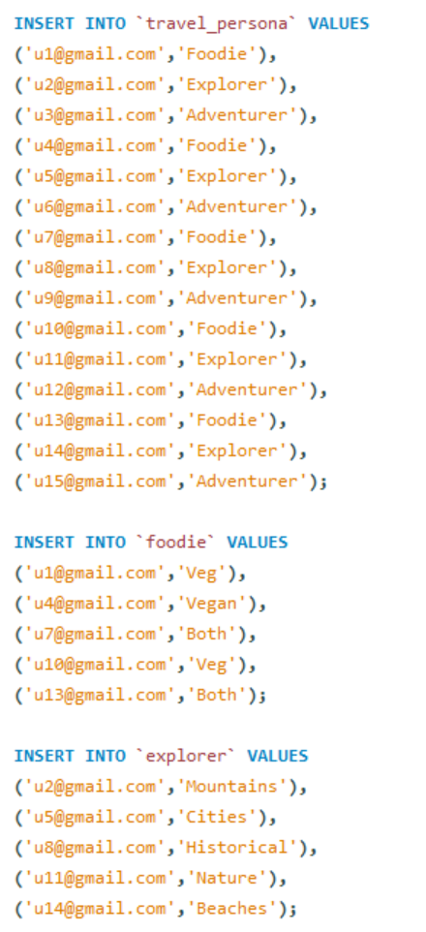

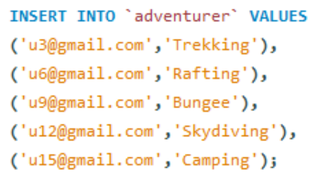

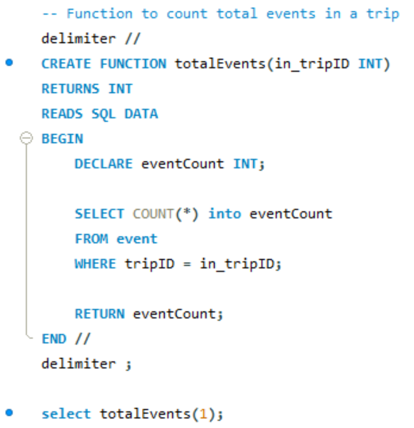
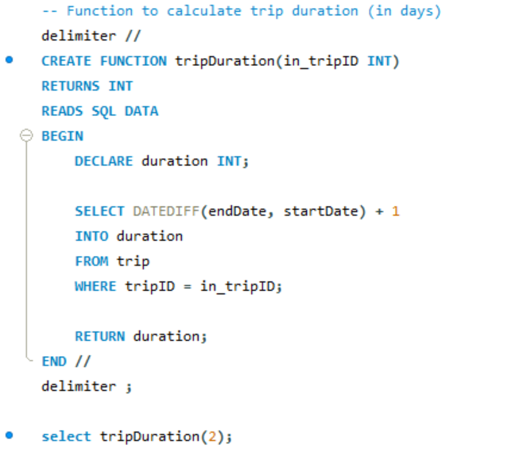

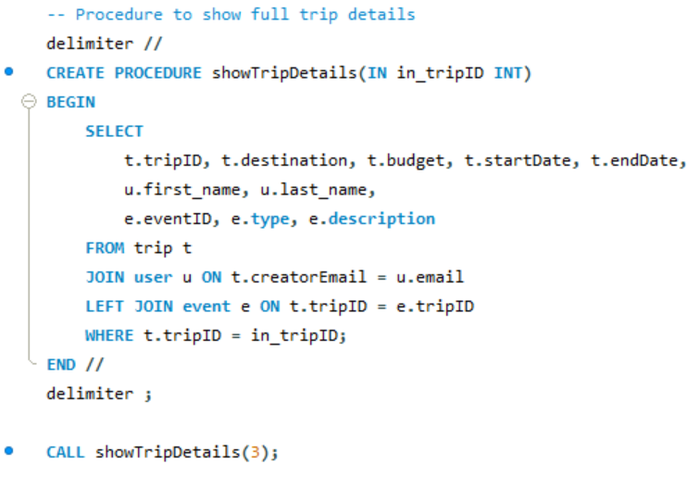
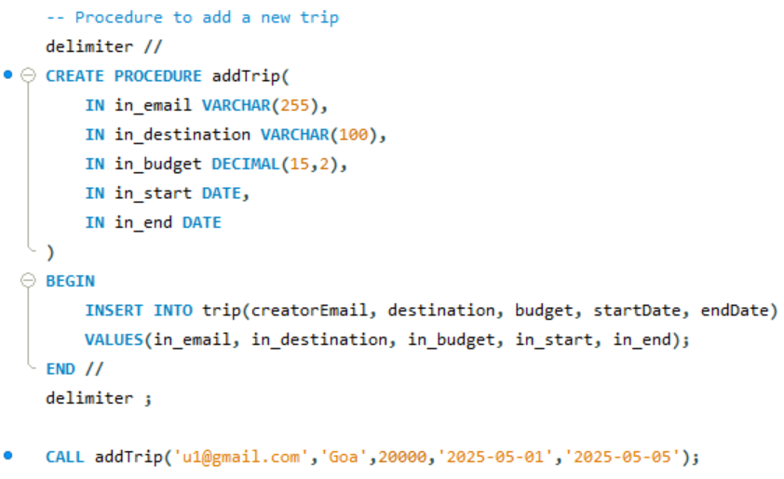

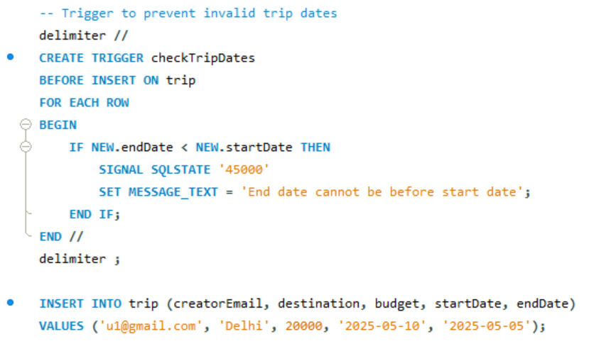
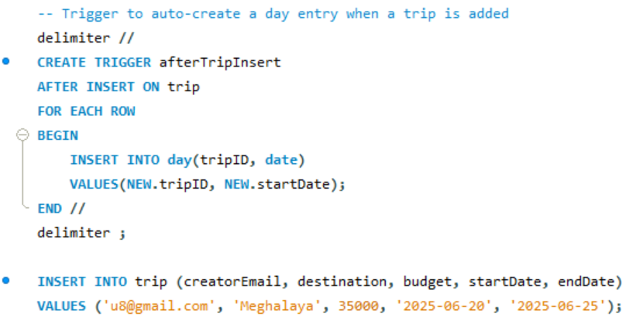

Table Outputs:
1. User
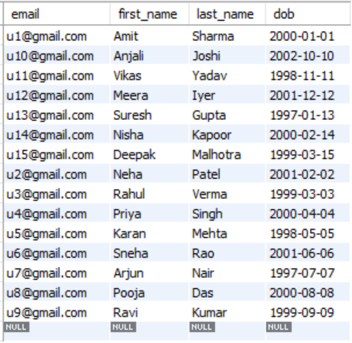

2. Phonenumber
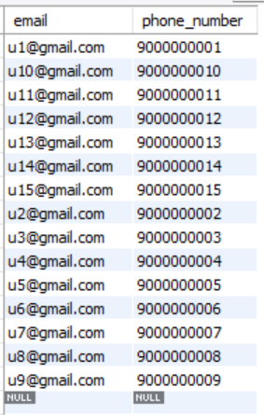

3. Trip
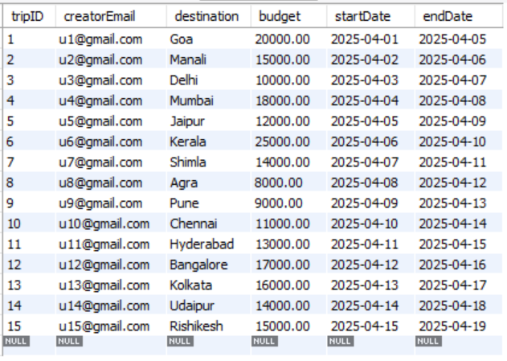
4. Day
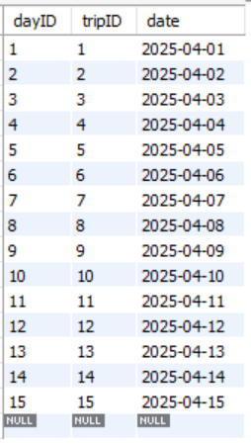

5. Event
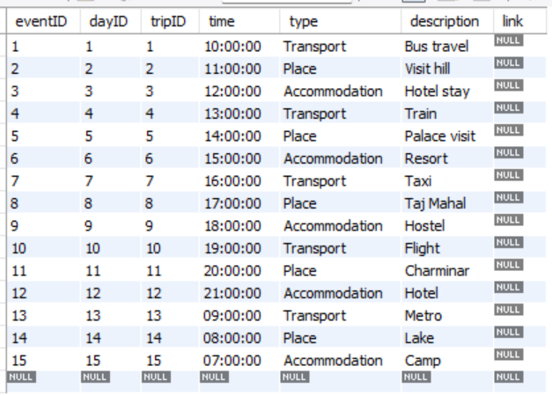
6. Transport
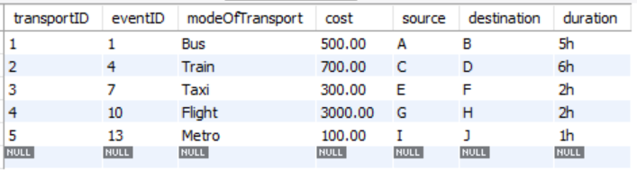

7. Place
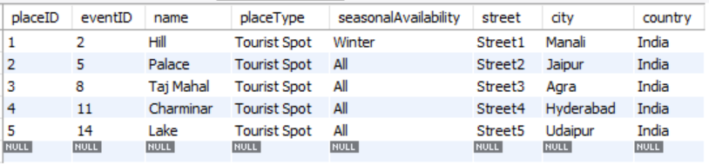
8. Accommodation
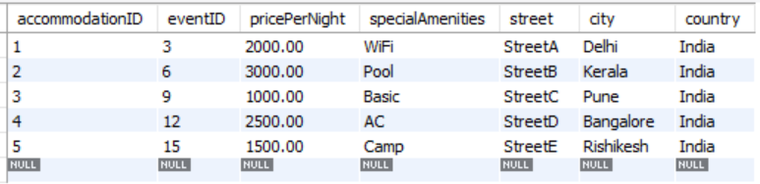

9. Reviews
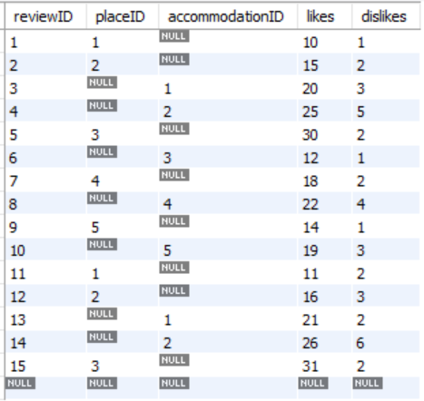
10. Travel Persona
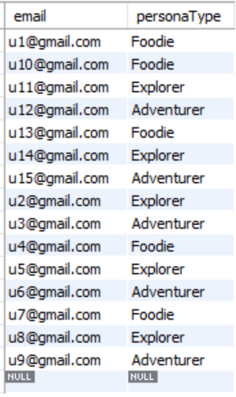

11. Foodie
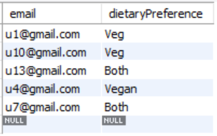
12. Explorer
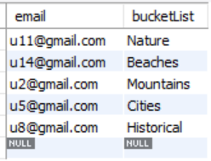
13. Adventurer
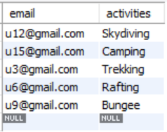
Query 1: Display Trip Details with User Name
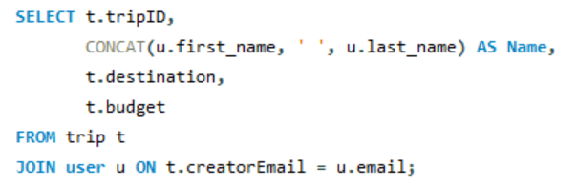
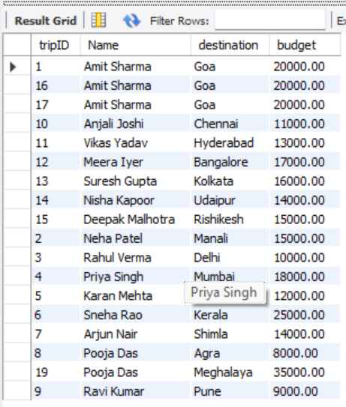

Query 2: Display All Events for Each Trip
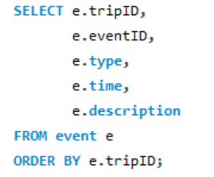
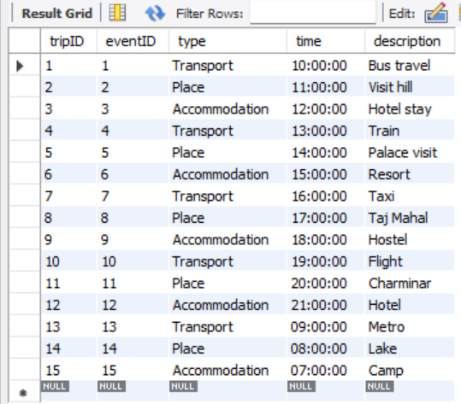

Query 3: Show Places Visited in Each Trip
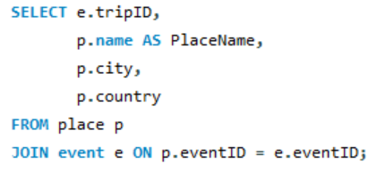
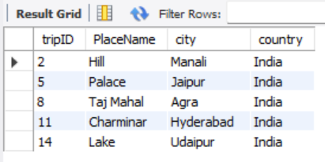
Query 4: Show Transport Details with Cost
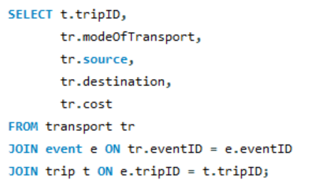
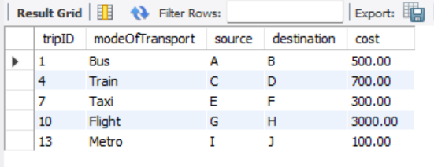

Query 5: Show Events by Type
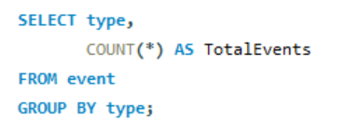
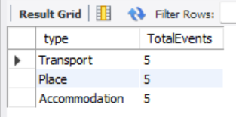

Function:
A function is a set of SQL statements, that you can pass parameters into, and they perform some operation and return a single value.
Functions:
1. Function to count total events in a trip
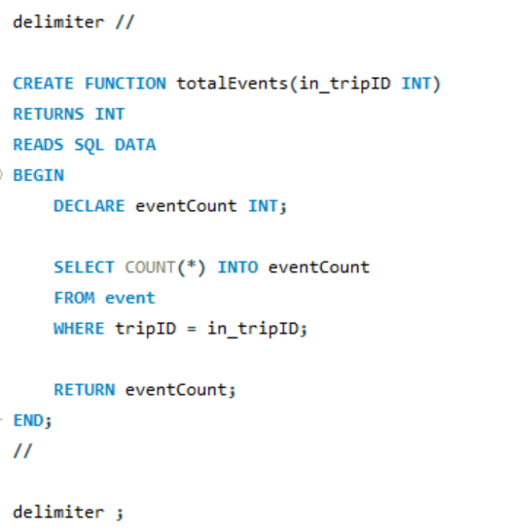
Query -> select totalEvents(1);
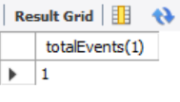
2. Function to calculate trip duration (in days)
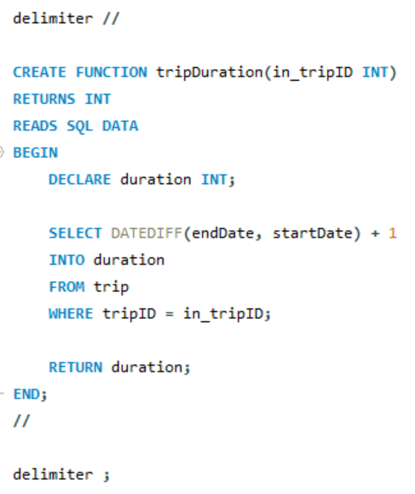
Query -> select tripDuration(2);
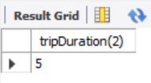

Stored Procedure:
A stored procedure is a set of pre-compiled Structured Query Languages (SQL), so it can be reused and shared by multiple programs. It can access or modify data in a database.
Procedure:
1. Procedure to show full trip details
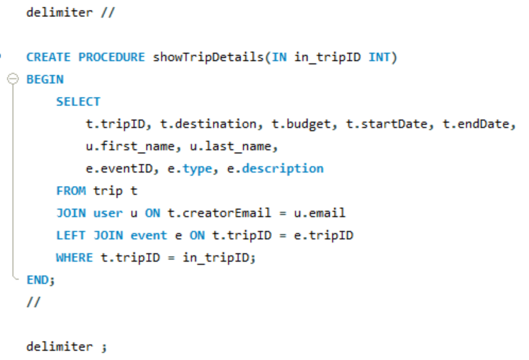

Query -> CALL showTripDetails(3);
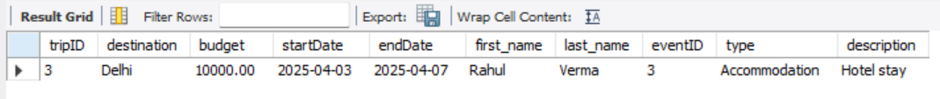

2. Procedure to add a new trip

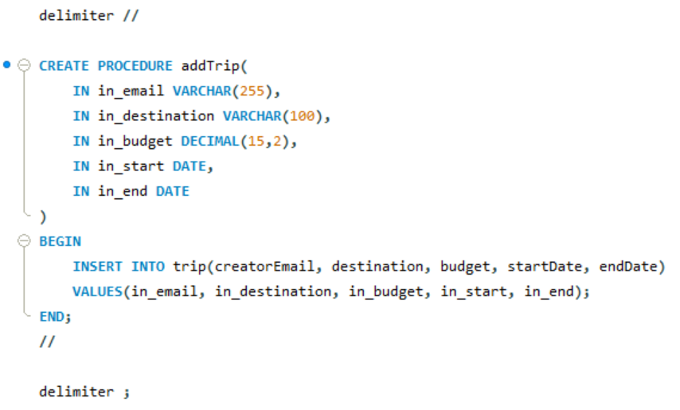

Query -> CALL addTrip('u1@gmail.com','Goa',20000,'2025-05-01','2025-05-05');
Select * from trip

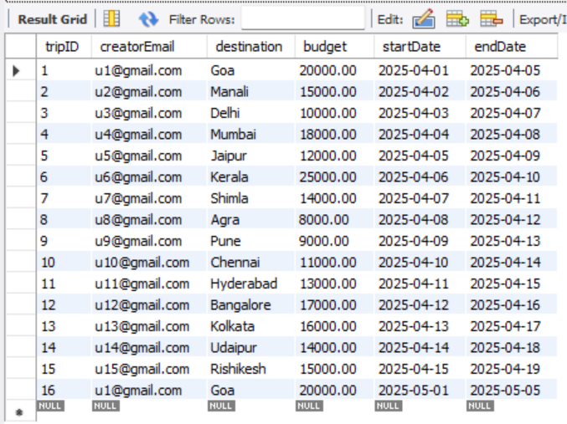

Trigger:
A trigger is also a set of SQL statements in the database which automatically execute whenever any special event occurs in the database, like insert, delete, update, etc.
Triggers:
1. Trigger to prevent invalid trip dates
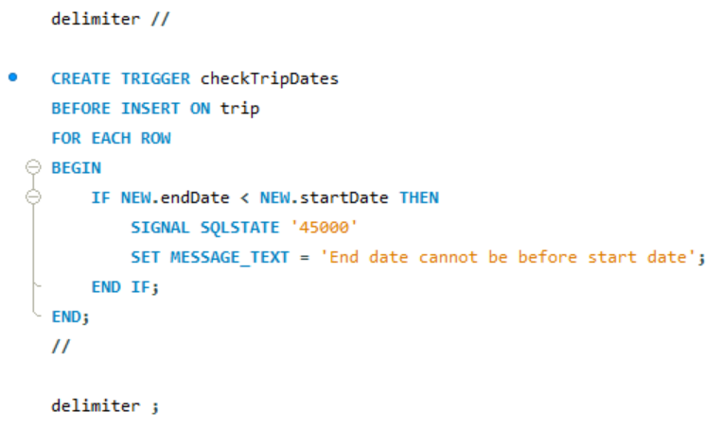
Query -> INSERT INTO trip (creatorEmail, destination, budget, startDate, endDate)
VALUES ('u1@gmail.com', 'Delhi', 20000, '2025-05-10', '2025-05-05');

2. Trigger to auto-create a day entry when a trip is added
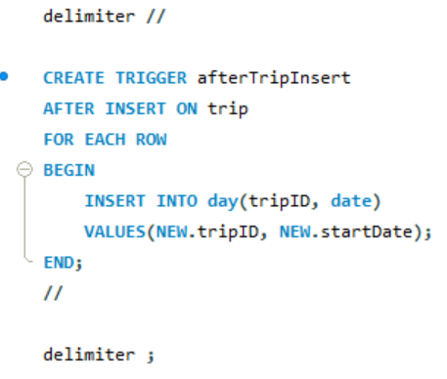
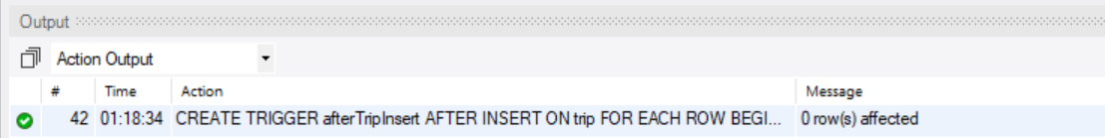
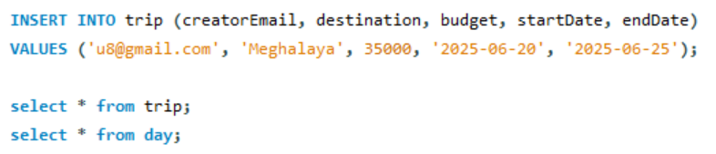
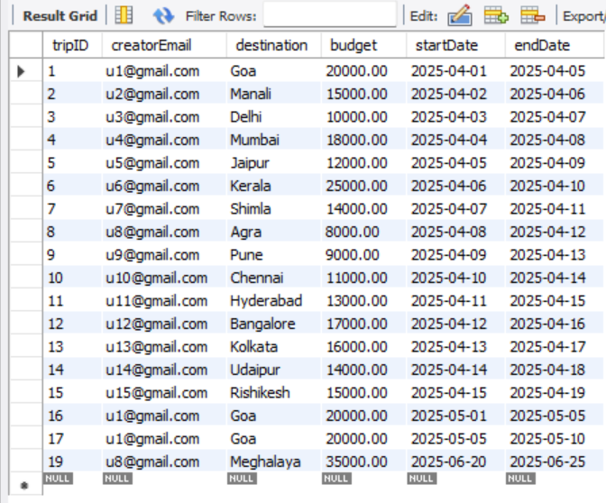
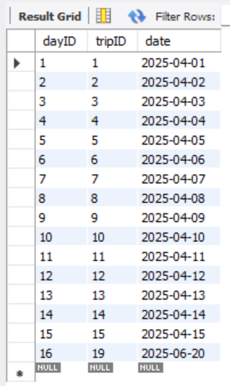
Day created for newly added trip

Tools Used:
- MySQL :: Download MySQL Workbench
Research:
- Software Architecture of Online Personal Finance Management System | Maharaj's Memoirs Academia.edu
- (PDF) DESIGN AND DEVELOPMENT OF PERSONAL FINANCE MANAGEMENT SYSTEM
(researchgate.net)
- Database Design in DBMS - GeeksforGeeks

