1. Docker version
2. docker info
3. docker – all commands
4. docker container run --publish 81:80 nginx [ **81: host; 80: container**]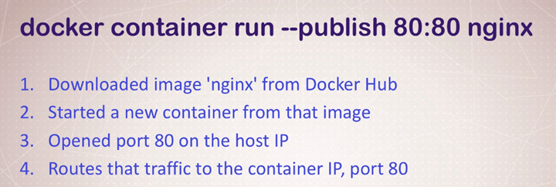
5. docker container run --publish 81:80 *--detach* nginx [**HELPS Container to Run in Background**]
6. docker container ls [**list outs all the available containers**]
7. docker container stop <Container ID> [**Stops the Container**]
8. docker container run --publish 81:80 --detach *--name webhost* nginx [**Docker Container with name**]
9. docker container logs *webhost* [**prints the log by the container name**]
10. docker container rm <25e4 2a901 6296 94c4 7bb81 5d48> [**Delete Multiple containers at a time; but doesn’t remove the running container**]
11. docker container rm -f <25e4> [**Removes running container forcefully**]
12. docker run --name mongo -d *mongo* [**creates a process in docker**]
13. docker top *mongo* [**returns process id of the process running inside docker**]
14. docker stop *mongo* [ **kills the process resides in docker]**
15. docker image ls [**All the images in a docker container**]
16. docker container inspect *<webhost1>* [**Details of one container config**]
17. docker container stats –help
18. docker container stats –all [**Live Status of all containers**]

GETTING INSIDE THE Container -> Opening a BASH Without SSH; Different Linux distros…….

1. docker container run -it --name proxy nginx bash [**-i: works as SSH; -t: Holds the session**]: [ **Opens a bash**]
2. root@ecc1431cbf87:/# ls -al [ **login as root into the container: ls -al to see the directory]**
3. root@ecc1431cbf87:/# exit [ **brings you out of the bash: CONTAINER IS STOPPED -> docker container ls: No entry]**
4. PS C:\Users\soham> docker container run -it --name ubuntu ubuntu [ **Install Ubuntu Full]**
5. [**UPDATE**] **apt-get update**
6. [**Install**] apt-get install -y curl
7. docker container start -ai *ubuntu* [ **Restart a closed container]**
8. *docker run --detach --name=****test-mysql*** *--env="MYSQL_RANDOM_ROOT_PASSWORD=true" mysql*  docker container exec -it **test-mysql** bash [**Exactly same as run -it, but it starts an existing container, never creates a new one]**
9. install Another Distro:
10. docker pull alpine [ **installs Alpine as an image**]
11. [**Run alpine bash**] docker container run -it --name *alpineproxy* alpine bash [ **ERROR: as alpine is a small version; doesn’t have bash on the path**]
12. docker image ls -a

REPOSITORY TAG IMAGE ID CREATED SIZE

ubuntu latest 1e4467b07108 5 hours ago 73.9MB

mysql latest e3fcc9e1cc04 2 days ago 544MB

httpd latest 9d2a0c6e5b57 2 days ago 166MB

nginx latest 8cf1bfb43ff5 2 days ago 132MB

mongo latest 6d11486a97a7 2 weeks ago 388MB

alpine latest a24bb4013296 7 weeks ago 5.57MB

1. [ **Alpine has SH instead of Bash**] docker container run -it --name alpineproxy1 alpine sh

**Docker Networking (-p: expose port)**

1. docker container run -p 82:80 --name webhost -d nginx

docker container port webhost [ **Available ports: 80/tcp -> 0.0.0.0:82**]

1. DEFAULT container doesn’t have same IP as Host (Home Network)

**[BATTRIES INCLUDED, BUT REMOVABLE]**

docker container inspect --format '{{ .NetworkSettings.IPAddress }}' webhost

[**container IP: 172.17.0.3; home IP: 192.168.0.104**]

1. Port inter communication 