

Enhancing Visitor Engagement through an Adaptive, Language-Specific Interaction System:
A multimodal Question-Answer system with translation capabilities

A project report for the fulfillment of completion requirements of the course: Deep Learning for Natural Language Processing

Submitted to:
Dr. Khyathi Raghavi Chandu

By:

Salmoli Chandra
Praveen Kumar Singh
Soham Sanyal
Meera Karamta
Kishnu Srivastava

Post Graduate Program, Co24
Artificial Intelligence and Data Science

ABSTRACT

Leveraging cutting-edge multimodal large language model, the project focuses on two crucial aspects: building a translation system for Bengali (an India language) to English and English to Bengali and finetuning the LLAVA model to perform the Q&A task for the artifacts of Cleveland Museum of Art.

Large Language and Vision Assistant (LLAVA) is a multimodal language model that integrates language and visual data. With this capability a highly interactive agent is feasible based on nuanced visual elements as well as textual descriptions.

The main component of this project includes data collection and preparation, implementation of translation models, fine-tuning LLAVA on custom dataset for Q&A and deployment.

This report consists of section-wise segregation of the background, the objectives, the methodology used, results and discussions and the future scope of the project.

ACKNOWLEDGEMENT

We would like to extend our sincere gratitude to all those who have contributed to the completion of this project.
Firstly, we are immensely thankful to Dr. Khyathi Raghavi Chandu, for her invaluable guidance throughout the duration of this project. Her constant encouragement has been a driving force behind our determination to push our limits and strive for excellence in this project.
We would also like to thank Mr. Rishabh Sharma for his immense support and motivation. Your guidance has helped us overcome challenges and has also instilled a sense of confidence in our capabilities.
We are also grateful to Jio Institute for providing the necessary resources and facilities that enabled me to carry out this research effectively. Special thanks to Mr. Bharath for facilitating the compute requirements for this project.
We extend our appreciation to colleagues and friends at Jio Institute. Their constructive feedback and discussions have greatly enriched the quality of this work.
Thank you all for your invaluable contributions.

Salmoli Chandra
Meera Karamta
Soham Sanyal
Kishnu Srivastava
Praveen Kumar Singh

Table of Contents

ABSTRACT 2
ACKNOWLEDGEMENT 3
INTRODUCTION 5
LARGE LANGUAGE AND VISION ASSISTANT (LLAVA) 5
Visual Instruction Tuning 5
Architecture 6
Enhancing Training Efficiency 7
Adapters 7
Re-parameterization based PEFT: QLoRA 7
DATASET PREPARATION AND PROCESSING 8
NEURAL MACHINE TRANSLATION 9
Evaluation metrics 9
EXPERIMENT 10
Fine-Tuning LLAVA 10
Deployment 11
Future Scope of Work 12

INTRODUCTION

The project at hand harnesses the power of cutting-edge multimodal large language models to address two pivotal objectives:
- Development of a translation system bridging Bengali (an Indian language) and English, and
- Fine-tuning of the LLAVA model to undertake the question-and-answer (Q&A) task concerning artifacts from the Cleveland Museum of Art.
- Deploy the model and design a UI.
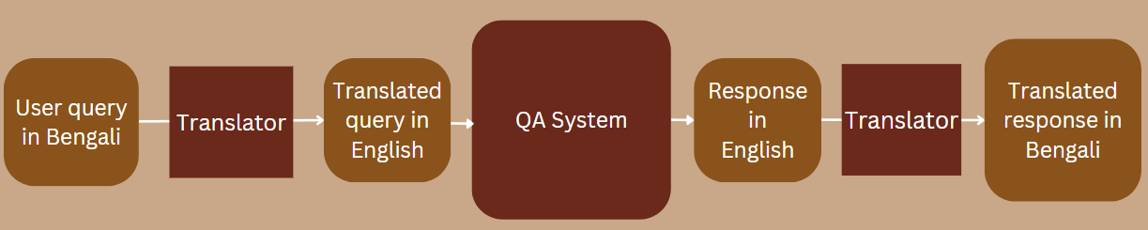
Fig 1 Project Components and Pipeline

LARGE LANGUAGE AND VISION ASSISTANT (LLAVA)
Large language models (LLMs) with machine-generated instruction-tuning has improved zero-shot capabilities on new tasks in the language domain, but the idea is less explored in the multimodal field. Large Language And Vision Assistant (LLAVA) is an end-to-end trained large multimodal model that connects a vision encoder and LLM for general-purpose visual and language understanding. It is essentially visual instruction-tuning of a large language model.
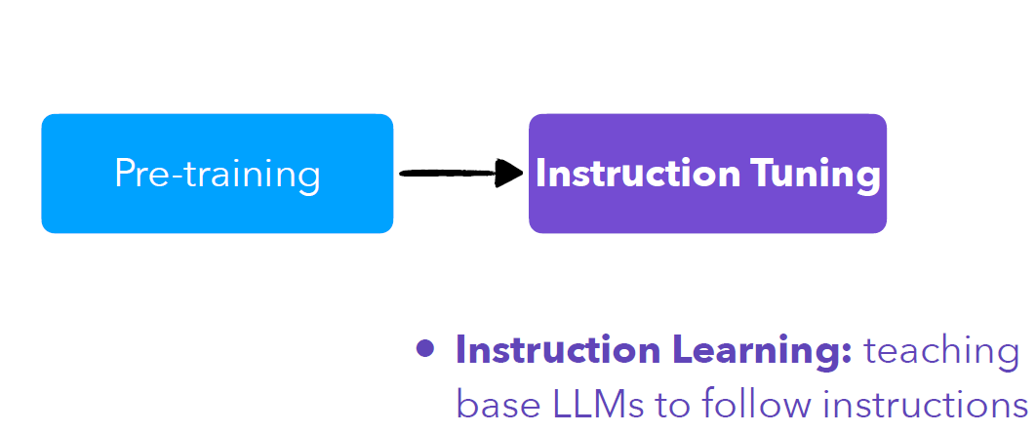
Fig.2 Instruction Tuning

Visual Instruction Tuning

The authors of LLaVA introduced a novel technique for refining visual instructions, marking a pioneering step in multimodal generative AI. They employ GPT-4, a model solely based on language, to generate instruction-following data by pairing textual descriptions with images. This innovative process involves transforming image-text pairs into formats suitable for instruction-following tasks, thereby establishing a link between visual data and language comprehension.

In essence, they utilize existing datasets comprising text-image pairs and prompt GPT-4 to produce more elaborate textual data based on the text-only labels associated with each image. By leveraging these datasets, they initiate a process where GPT-4, primarily a text-based model, expands upon the textual labels to enrich the dataset. Through this method, GPT-4 generates various questions and detailed descriptions rooted in the initial image captions, thus enhancing the contextual understanding and instructional content of the data.

This augmentation not only increases the textual volume but also enriches the quality and depth of information. The language model explores the intricacies of each image, posing relevant questions and offering detailed descriptions that surpass surface-level information. As a result, the dataset becomes more comprehensive and suitable for training AI models capable of nuanced multimodal comprehension and response.

Architecture
The primary goal is to effectively leverage the capabilities of both the pre-trained LLM and visual model. The network architecture of LLAVA is illustrated in Figure 3.

LLaVA architecture includes a vision encoder with a Large Language Model (LLM). The visual encoder, CLIP ViT-L/14, excels in extracting features from images, while the language model, Vicuna, is an enhanced version of the open-source LLaMA model, specifically tailored for precise instruction adherence.
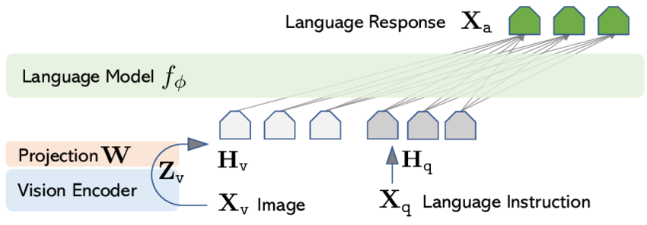
Fig: 3. LLAVA Architecture

For LLaVA model training a two-stage instruction-tuning procedure is used.

Stage 1: Pre-training for Feature Alignment: To strike a balance between concept coverage and training efficiency.
Stage 2: Fine-tuning End-to-End: Keep the visual encoder weights frozen, and continue to update both the pre-trained weights of the projection layer and LLM in LLaVA

Enhancing Training Efficiency
Training large language models typically involves trade-off between computational efficiency and model performance. They suffer common problems such as Out of Memory Issues. Reducing the number of trainable parameters can reduce the memory significantly. Traditionally, this balance forces a choice between extensive computational resources for large models or settling for reduced performance with smaller ones.

There are several approaches to overcome this. (See Figure 4) These techniques combined conceptualize the Parameter Efficient Fine-Tuning (PEFT).
Fig: 4. Parameter Efficient Fine-Tuning

Adapters
Adapters are a type of additive parameter-efficient fine-tuning method that involves introducing small fully connected networks after Transformer sub-layers. Unlike the transformer FFN block, Adapters usually have a smaller hidden dimension than the input.

Re-parameterization based PEFT: QLoRA
These methods use the idea of reparametrizing the weights of the network using a low-rank transformation. This decreases the trainable parameter count while still allowing the method to work with high-dimensional matrices, such as the pre-trained parameters of the networks.

An established re-parameterization technique is LoRA (Layer-wise Relevance Adaptation). It preserves the original pre-trained backbone of a model while adding additional, more trainable layers. This approach enables quick adaptation to new tasks without retraining the entire network. QLoRA goes further by introducing a novel data type, the 4-bit NormalFloat, tailored for normally distributed weights, outperforming other 4-bit data types. This advancement in 4-bit NormalFloat further reduces computational requirements, enhancing efficiency even more.

DATASET PREPARATION AND PROCESSING
The dataset for this project is derived from the Cleveland Museum’s API, for getting all its data, including metadata, images, etc. Image as well as other metadata is required to finetune the Vision and Language model (VLM).
The link for the access to the data is : https://openaccess-api.clevelandart.org/api/artworks/

Some of the important metadata used for the training is listed below.
id | type
accession_number | measurements
tombstone | provenance
title | did_you_know
creation_date_earliest | description
creation_date_latest | external_resources
culture | url
technique | creditline
department | creators
collection | accession_date
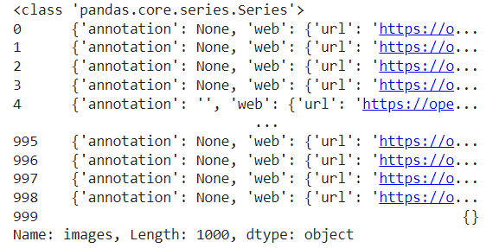
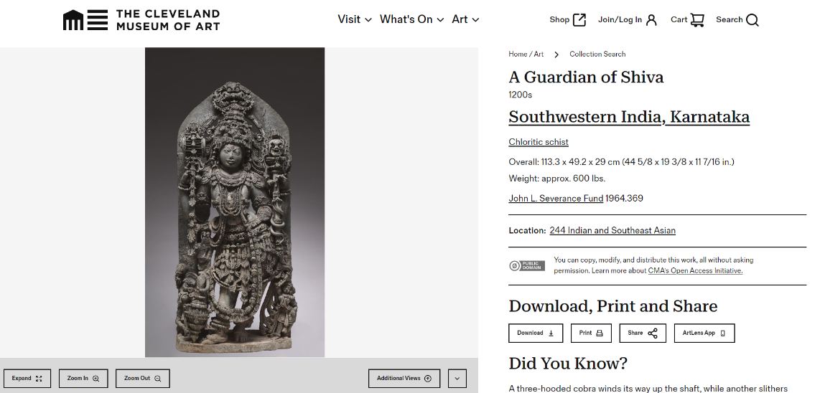

The raw dataset size is 1000 x 55 samples. Preprocessing steps such as cleaning, removing of null values, and feature selection were performed to obtain final 762 x 22 cleaned data sample.

Fig.5 Cleveland Museum of Art

We created Question answer samples for the artifacts images so that it could be used to fine-tune our VLM. Below is the Q&A sample.
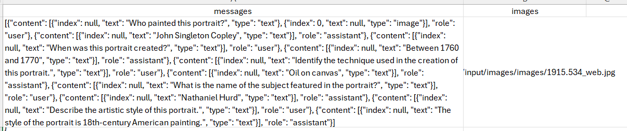

NEURAL MACHINE TRANSLATION

Machine translation has undergone remarkable transformations in recent years, largely propelled by the advent of transformer-based architectures. These innovative models have revolutionized the field, offering unprecedented levels of translation quality, fluency, and efficiency.

In this project, we use machine translation for Bengali-English-Bengali Language. For this we have used several models as listed below:

- Ai4bharat  - Translator from Google Trans  - GoogleTranslator from Deep_translator  - m2m100_418M from Facebook  - GPT3.5Turbo from Openai | - Banglat5 (Beng to Eng)  - Opus-mt-en-to-bn (Eng to Beng)  - madlad400-10b-mt from Google  - Facebook: mbart-large-50-many-to-many-mmt

Evaluation metrics
We carried out comparative analysis on the translation models through evaluation scores.

BLUE | BERT | METEOR | ROUGE
Purpose: BLEU is commonly used for evaluating machine translation systems. | Purpose: BERTScore evaluates the quality of token-level embeddings. | Purpose: METEOR aims to address limitations in BLEU and ROUGE. | Purpose: ROUGE was initially designed for automatic summarization tasks.
Focus:  It measures the precision of word n-grams (phrases) between the generated output (hypothesis) and the reference (human-written) text. | Focus:  It matches words/phrases using BERT contextual embeddings. | Focus:  It incorporates recall, precision, and additional semantic matching based on stems and paraphrasing. | Focus:  It measures the recall of word n-grams and longest common sequences between the hypothesis and reference.
Strengths:  Simple and fast, correlates well with human judgments. | Strengths: Incorporates meaning and accounts for paraphrasing. | Strengths:  Accounts for semantic similarity beyond simple word matching. | Strengths:  Captures some semantic similarity.
Limitations:  Focuses only on word matching. | Limitations:  Requires pre-trained BERT models. | Limitations:  Still relies on n-gram overlap | Limitations:  Still relies on word matching.

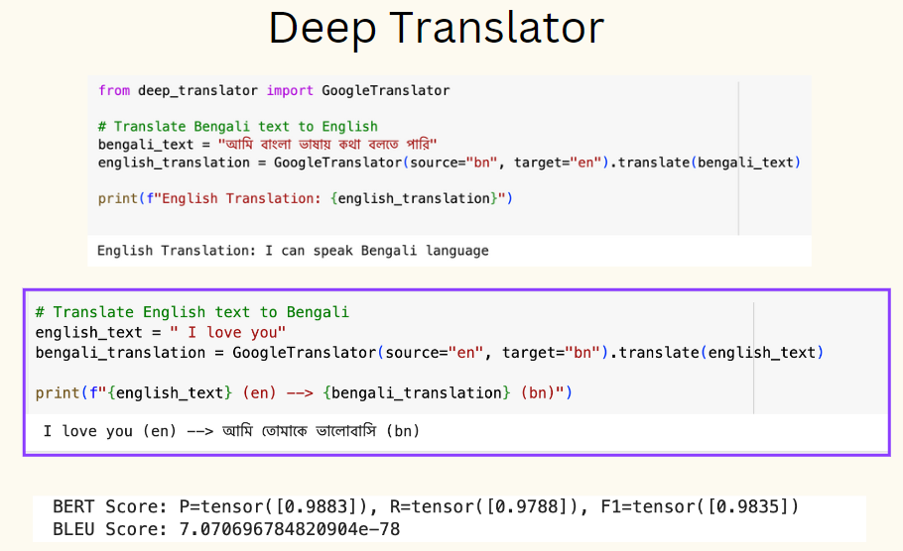
Here is the inference of the most suitable model for our translation block. Google Deep translator performs very well and thus we proceed with Deep translator as the NMT model.
Fig 6. Evaluation of translation model

EXPERIMENT
The scope of this project includes the following 6 main tasks to be performed. Data collection and processing,Question Answer preparation, Translation, Evaluation, Finetuning, Deployment.
In the previous sections of the report , we have given elaborate account on data collection, Q&A preparation task and the translation models. Thus in this section we show the results and discussion on the finetuning of the multi-modal model and deployment of the whole pipeline.

Fine-Tuning LLAVA
For this experiment, we'll focus on fine-tuning LLaVA on a custom dataset. We prepared a dataset, which contains image text pairs that involve reasoning to answer questions about images.


Finetuning is required so that the model learns specific questions about the image and derive knowledge from the other training data as well. Instead of simply asking the model to describe the image, we want a Q&A system that could be able to perform complex reasoning tasks, involving image-text pairs with questions that go beyond simple image descriptions in Cleveland Museums. In order to convert the dataset into a format suitable for use with the official LLaVA repo, we will need to write a python script to covert our data into the following format:

Deployment
The model is deployed on hugging face Spaces. The User interface of the model for inference is prepared in Gradio as well as Streamlit.
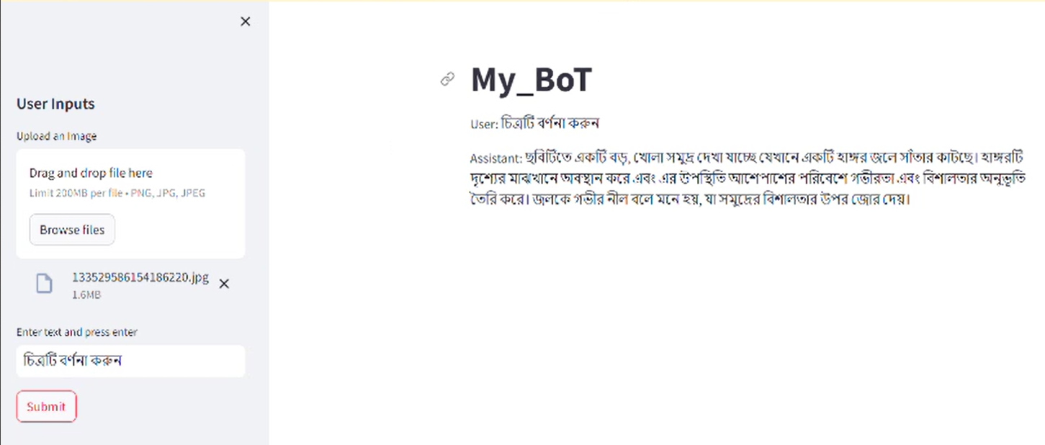
Fig 7. Streamlit based Front End developed for the model
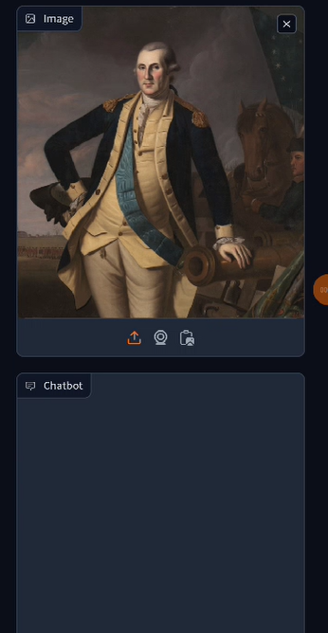 | 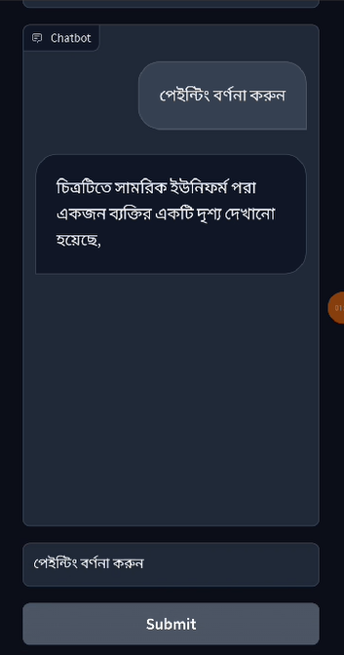
Fig 8. Gradio based Front End

Future Scope of Work

