**Tarun Tirupati-45532729**

**Description of Original Dataset:**

The dataset chosen in the research paper for training and evaluation is WiderFace dataset.

The WIDER FACE dataset is currently the largest face detection dataset, of which images selected are the publicly available .They have choosen 32, 203 images and label 393, 703 faces with a high degree of variability in scale, pose and occlusion.Images are collected in following ways:

1. Event categories were defined and chosen following the Large Scale Ontology for Multimedia
2. Images are retrieved using search engines like Google and Bing.

For each category, 1, 000-3, 000 images were collected

The data were cleaned by manually examining all the images and filtering out images without human face. Then, similar images in each event category were removed to ensure large diversity in face appearance. A total of 32, 203 images are eventually included in the WIDER FACE dataset.

The WIDER FACE dataset is organized based on 61 event classes. For each event class, data is randomly selected into 40%/10%/50% data as training, validation and testing sets. Then based on the detection rate of EdgeBox [76], three levels of difficulty (i.e. Easy, Medium and Hard) are defined by incrementally incorporating hard samples

Research paper defines five levels of face image quality and annotate by five facial landmarks (i.e. eye centres, nose tip and mouth corners) on faces that can be annotated from the WIDER FACE training and validation subset. In total, they have annotated 84.6k faces on the training set and 18.5k faces on the validation set. The download size of the original data is 3.42GB and the split in the data is given below:

| **Split** | **Examples** |
| --- | --- |
| ‘test’ | 16,097 |
| ‘train’ | 12,880 |
| ‘validation’ | 3,226 |
|  |  |

**Construction of Newdataset:**

Our aim is to collect new data that is similar to original dataset in order to obtain equivalent results as produced in the paper.

Hence we have chosen the process of scraping images using google search engine and the process of web scraping images from few websites.

High resolution images are selected as the initially the we have faced complications while running the dataset through the code as the code was unable to identify and locate human facial landmarks due the low image quality. This issue has been rectified by selecting the images that have high resolution and pixel density for the code to run efficiently.

The new dataset in arranged in such a way that the image data has a high degree of variability in scale, pose, expression, occlusion and illumination which similar to the original dataset .After putting together the dataset of 100 images our next step was to annotate five facial landmarks i.e. eye centres, nose tip and mouth corners on faces that can be annotated in accordance to the outlines specified for the WiderFace dataset

We have manually annotated 100 images by drawing a bounding box coordinates using Microsoft paint application and with the help of five facial landmarks .The annotations have been written into text file in the form of (x,y) bounding box coordinates, breadth and length of bounding box The new dataset is then run through the code and evaluation results are observed and documented to check for similarity with original data results**.**

**Example of manual annotation:**

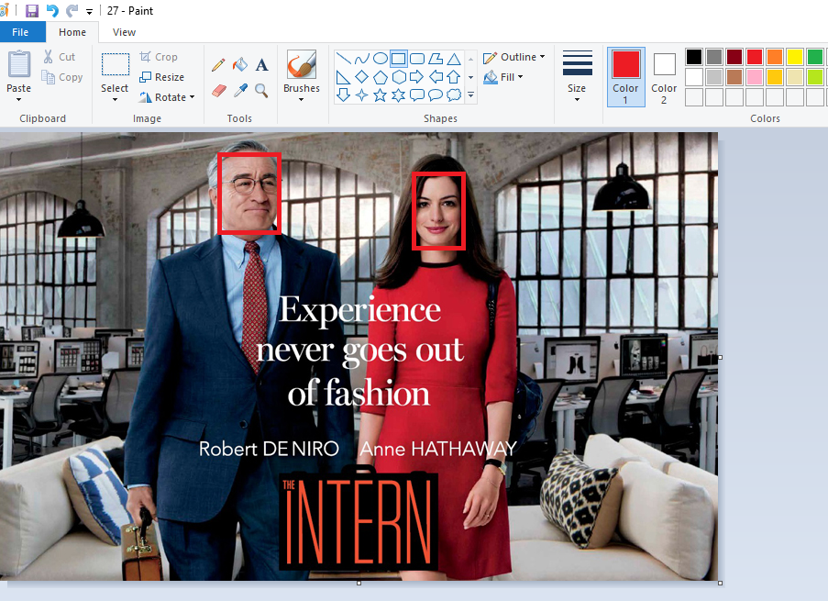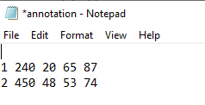

**🡪**We have manually .The first two columns define the (x,y) coordinates of the bounding box followed by breadth in the third column and length in the final column.First row indicates the first face in the image starting from left and second row indicated the second human face in the image.A default of 10 pixels is used for checking the accuracy of annotations in the code.

After running our annotated images we have obtained the following outputs:

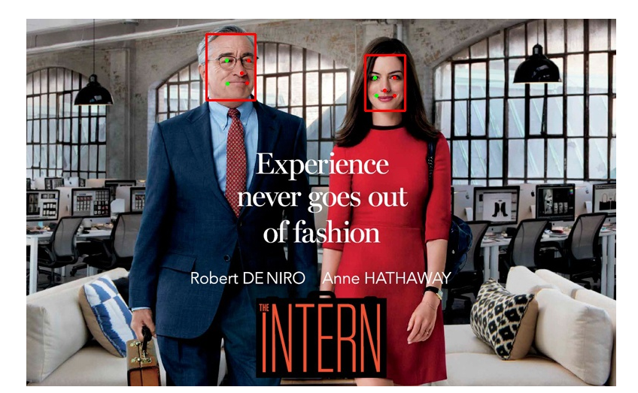

The dots indicates the five facial landmarks on the human face.