
SANJIVANI UNIVERSITY, KOPARGAON
Faculty of Engineering & Technology
Department of Artificial Intelligence & Data Science

DEVOPS — UNIT 2 MINI PROJECT
“ENTERPRISE STUDENT RECORD AND
ACADEMIC MANAGEMENT PLATFORM”

“EduTrack”
Agile Planning & Scrum Implementation

Submitted By
SOHAM SASKAR
B.Tech. Artificial Intelligence & Data Science
Direct Second Year
PRN No.: 2126UDSM2556

Academic Year
2026–2027

SANJIVANI UNIVERSITY, KOPARGAON

1. Project Objective
The objective of this mini-project is to apply Agile methodology and Scrum practices to the proposed EduTrack platform. The project demonstrates how a software team can organize requirements, divide work into smaller tasks, prioritize features, estimate effort, and plan development through Sprints.
EduTrack is an Enterprise Student Record and Academic Management Platform designed to organize student profiles, course registration, attendance, internal marks, examination information, results, and academic reports.
Instead of attempting to develop every feature at once, the team will plan the product incrementally. Each Sprint will focus on a manageable set of features that can be designed, developed, tested, and reviewed.
1.1 Expected Learning Outcomes
After completing this project, students should be able to:
- Explain how Agile methodology is applied to a software project.
- Identify Scrum roles and their responsibilities.
- Convert product requirements into Epics and User Stories.
- Define measurable Acceptance Criteria.
- Prepare and prioritize a Product Backlog.
- Estimate work using Story Points.
- Create a Sprint Goal and Sprint Backlog.
- Organize tasks using a Scrum Board.
- Explain Daily Scrum, Sprint Review, and Sprint Retrospective.
- Understand how Agile practices support future DevOps activities.

1.2 Project Scope
This project focuses on the planning and Scrum workflow for EduTrack. The planned activities and sample Sprint results are documentation examples unless the team actually implements and demonstrates them.

2. Introduction to Agile Methodology
Agile is a software development approach in which a product is developed through small, manageable increments. Instead of completing the entire project before collecting feedback, the team delivers parts of the product and improves them based on user requirements.
Agile is useful for EduTrack because the platform contains several modules and involves different users, including students, faculty members, and administrators.
2.1 Principles of Agile Applied to EduTrack
- Customer satisfaction: The system should solve actual academic management problems.
- Incremental development: Features should be delivered in smaller parts.
- Collaboration: Developers, stakeholders, and the Product Owner should communicate regularly.
- Adaptability: Requirements can be refined when new needs are identified.
- Continuous improvement: The team should review its process after every Sprint.

2.2 Agile vs Traditional Development

Traditional approach | Agile approach
Most work is planned upfront. | Work is planned and refined incrementally.
Feedback may come late. | Feedback is collected regularly.
Changes can be difficult to accommodate. | Requirements can be reprioritized.
Delivery often happens near the end. | Working increments can be delivered throughout development.
Testing may occur in a later phase. | Testing is included throughout the process.

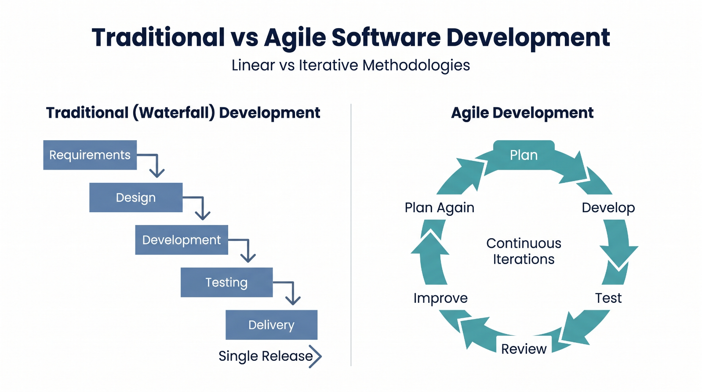
Figure 1: Comparison of Traditional and Agile Software Development.

3. Project Scenario: EduTrack
Educational institutions manage different types of academic information throughout the academic year. These records include student details, registered courses, attendance, internal assessment marks, examinations, results, and reports.
When this information is maintained in separate records or systems, users may experience difficulties finding updated information. Faculty members may also need additional effort to maintain attendance and marks, while administrators need accurate records for academic activities.
EduTrack proposes a centralized platform to organize these operations. The Agile team will plan the platform in stages and prioritize the features that provide the greatest initial value.

3.1 Major Product Modules

Module | Planned functionality
Student Management | Maintain student profiles and academic details
Course Management | Manage courses and student registrations
Attendance Management | Record and view attendance
Marks Management | Enter and view internal assessment marks
Examination Management | Maintain examination-related information
Result Management | Store and display student results
Academic Reports | Generate basic academic reports
User Access | Separate student, faculty, and administrator permissions

3.2 Agile Development Strategy
The team will first plan the essential functions, such as user access and student records. After establishing the foundation, it can plan course registration, attendance, marks, results, and reports in subsequent Sprints.

4. Introduction to Scrum
Scrum is an Agile framework that helps teams work toward a common Product Goal through short, time-boxed Sprints. It provides defined accountabilities, events, and artifacts to make work visible and encourage regular inspection and improvement.
For EduTrack, Scrum will help the team manage the product backlog, select work for a Sprint, track progress, and collect feedback from stakeholders.
4.1 Scrum Accountabilities
Role | Responsibility in EduTrack
Product Owner | Communicates product needs, orders the Product Backlog, and maximizes product value.
Scrum Master | Helps the team understand Scrum, facilitates events, and helps address impediments.
Developers | Design, implement, test, integrate, and document the selected work.
Stakeholders | Provide requirements and feedback about academic workflows.

4.2 Team Collaboration
The Product Owner clarifies which features are most valuable. The Developers decide how to complete the selected work. The Scrum Master supports effective collaboration and helps the team follow Scrum.

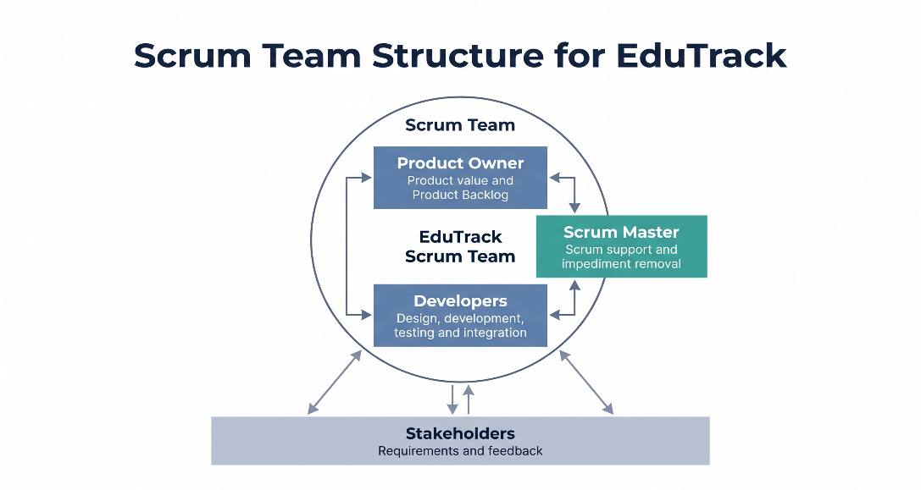
Figure 2: Scrum Team Structure and Stakeholder Collaboration in EduTrack.

5. Product Goal and Product Vision
The Product Vision describes the long-term purpose of EduTrack, while the Product Goal describes a meaningful future state that the product aims to achieve.
Product Vision
“To provide a centralized and user-friendly platform that simplifies the management and access of student academic information for students, faculty, and administrators.”
Proposed Product Goal
“To establish a usable academic management platform that allows authorized users to maintain student records and access essential academic information through an organized system.”

5.1 Product Value
EduTrack aims to create value by:
- Reducing dependence on scattered academic records.
- Making important student information easier to access.
- Organizing attendance and internal marks.
- Supporting accurate examination and result management.
- Helping administrators retrieve academic information efficiently.
- Providing a foundation for future testing, deployment, and improvement.

5.2 Initial Product Focus
The team will prioritize essential functionality before advanced analytics or optional integrations. This approach helps keep the initial scope manageable and allows feedback to guide later development.

6. Epics in EduTrack
An Epic is a broad area of functionality that can be divided into smaller User Stories. Epics help organize the Product Backlog into understandable groups.

6.1 Proposed EduTrack Epics
Epic ID | Epic | Main scope
E01 | User Access | Login and role-based access
E02 | Student Management | Student profiles and academic details
E03 | Course Management | Course information and registration
E04 | Attendance Management | Recording and viewing attendance
E05 | Marks Management | Internal assessment marks
E06 | Examination and Results | Examination details and results
E07 | Academic Reporting | Basic academic reports

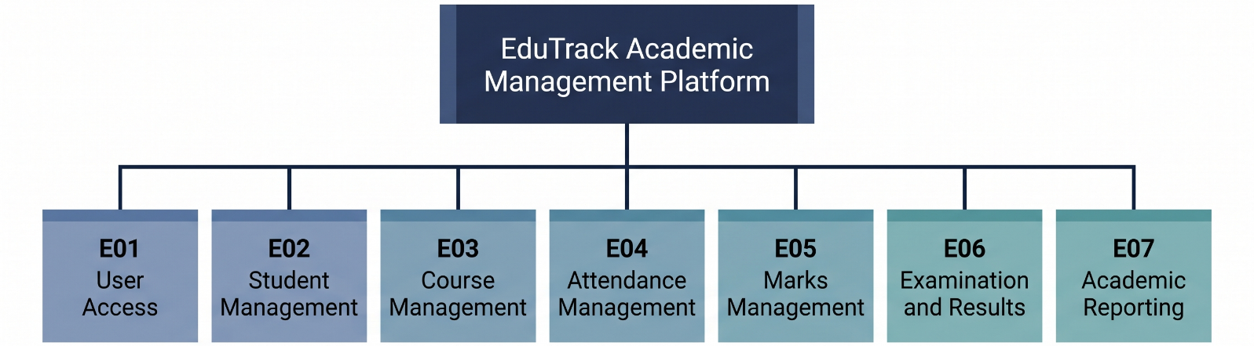
Figure 3: Major Product Epics of the EduTrack Platform.

7. Writing User Stories
A User Story describes a feature from the perspective of the person who needs it. It explains the functionality and the value the feature provides.
The standard format is:
As a [user], I want [functionality], so that [benefit].
7.1 EduTrack User Stories
ID | User Story
US01 | As a student, I want to log in securely so that I can access my academic information.
US02 | As an administrator, I want to maintain student profiles so that student records remain organized.
US03 | As a student, I want to register for available courses so that my selected courses are recorded.
US04 | As a faculty member, I want to record attendance so that student attendance is maintained accurately.
US05 | As a faculty member, I want to enter internal marks so that student performance can be recorded.
US06 | As a student, I want to view my results so that I can understand my academic performance.
US07 | As an administrator, I want to generate academic reports so that I can review relevant academic records.

7.2 Benefits of User Stories
User Stories help the team understand who needs a feature and why it is useful. They also support backlog prioritization, estimation, and acceptance testing.

8. Acceptance Criteria for EduTrack
Acceptance Criteria define the conditions that must be satisfied for a User Story to meet its requirements.

8.1 Example: Student Login
User Story: As a student, I want to log in securely so that I can access my academic information.
Acceptance Criteria:
- The system should accept valid login credentials.
- Invalid credentials should not grant access.
- The system should display a clear message when login fails.
- The student should be directed to the appropriate dashboard after successful login.
- A student should not be able to access administrator-only functions.
- Login information should be handled securely.

8.2 Example: Attendance Management
User Story: As a faculty member, I want to record attendance so that student attendance is maintained accurately.
Acceptance Criteria:
- Only authorized faculty should be able to update attendance for assigned classes.
- The system should identify the relevant course and students.
- Attendance should be saved against the correct student and session.
- Authorized users should be able to view saved attendance.
- The system should provide confirmation when attendance is saved successfully.

9. Product Backlog
The Product Backlog is an ordered list of work that may be required to improve the product. It can include features, bug fixes, technical tasks, and other improvements.
The Product Owner orders backlog items according to product value, dependencies, risks, and stakeholder needs.
9.1 Proposed Prioritized Product Backlog
Order | Backlog item | Priority
1 | Student login and role-based access | High
2 | Student profile management | High
3 | Course information management | High
4 | Course registration | High
5 | Attendance recording | High
6 | Internal marks management | High
7 | Examination information | Medium
8 | Result management | Medium
9 | Academic reports | Medium
10 | Advanced academic analytics | Future

9.2 Prioritization Explanation
Login and role-based access are prioritized because the platform must identify users and restrict access appropriately. Student profiles and course information establish the foundation for other modules. Attendance and marks are important academic operations. Reports and advanced analytics can be developed after the core records are available.
The backlog is not fixed permanently. The Product Owner may reorder it when stakeholder feedback or new information changes the product priorities.

10. Story Point Estimation
Story Points are a relative estimate of the effort, complexity, and uncertainty involved in completing a User Story.
The team may use a Fibonacci-like scale such as 1, 2, 3, 5, 8, and 13.

10.1 Proposed EduTrack Estimates
User Story | Suggested Story Points
Student login | 3
Student profile | 3
Course information | 3
Course registration | 5
Attendance recording | 5
Internal marks management | 5
Result management | 8
Academic reports | 8

10.2 Planning Poker
Planning Poker is a collaborative estimation technique. Team members select estimates independently, reveal them together, discuss significant differences
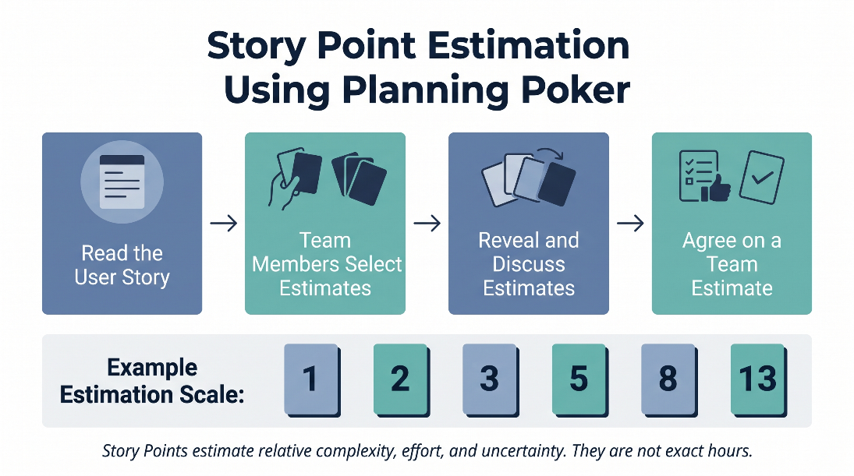
Figure 4: Planning Poker Process for Story Point Estimation.
11. Sprint Planning for EduTrack
A Sprint is a fixed-length period during which the Scrum Team works toward a Sprint Goal and creates a valuable, usable increment. For this project, a two-week Sprint is proposed as a planning example.
During Sprint Planning, the team discusses why the Sprint is valuable, what work can be completed, and how that work will be performed.
11.1 Proposed Sprint 1 Goal
“To establish the initial EduTrack foundation with secure user access and basic student profile management.”
11.2 Proposed Sprint 1 Backlog
Item | Planned task | Estimate
1 | Create project repository | 2
2 | Set up project structure | 2
3 | Prepare initial database design | 3
4 | Implement login workflow | 5
5 | Implement student profile workflow | 5
6 | Prepare tests for selected functions | 3
7 | Update project documentation | 2

11.3 Definition of Done
For the selected work to be considered Done, the team should agree that:
- The functionality meets its acceptance criteria.
- Relevant tests have passed.
- The changes have been reviewed as agreed by the team.
- The feature integrates with the current project.
- Relevant documentation is updated.
- No known critical issue prevents the feature from being used.
12. Creating a Scrum Board
A Scrum Board is a visual way to track the work selected for a Sprint. It helps the team see what is waiting, what is being worked on, and what has been completed.
For EduTrack, the proposed board columns are:
- To Do
- In Progress
- Code Review
- Testing
- Done
The team should move a task only when its actual status changes. Work that is blocked should be discussed so the team can resolve the issue.

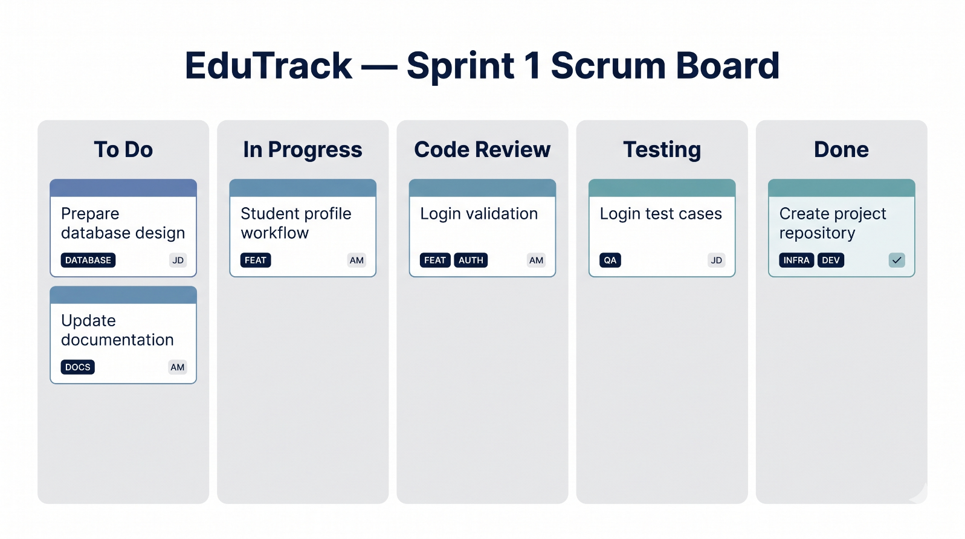
Figure 5: Proposed Scrum Board for EduTrack Sprint 1.

13. Daily Scrum Meeting
The Daily Scrum is a short event for Developers to inspect progress toward the Sprint Goal and adapt their plan for the next working day. It helps the team identify obstacles and coordinate its work.
For EduTrack, the Developers may discuss:
- What progress has been made toward the Sprint Goal?
- What work should be done next?
- Are there any impediments or dependencies?

13.1 Example Daily Scrum Discussion
The following is an illustrative example, not a record of an actual meeting.
- Developer 1: Prepared the initial student profile design and will work on the profile fields next.
- Developer 2: Is working on login validation and needs clarification about the role-based access rules.
- Developer 3: Prepared initial test cases and will review them against the acceptance criteria.
13.2 Benefits
The Daily Scrum improves coordination, makes impediments visible, and helps Developers adjust their plan. It is not intended to become a long status-reporting meeting.
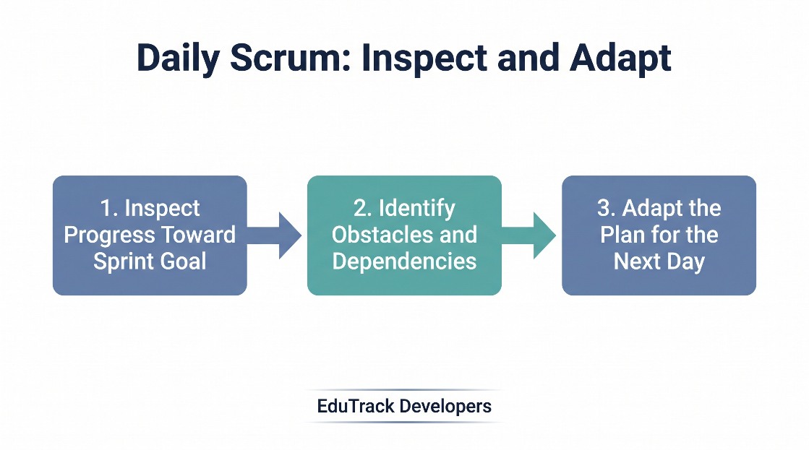
Figure 6: Daily Scrum Inspection and Adaptation Process.

14. Sprint Review
The Sprint Review takes place near the end of the Sprint. The Scrum Team and stakeholders inspect the outcome of the Sprint and discuss what should happen next.
For EduTrack, a Sprint Review may demonstrate the completed login workflow or student profile functionality, provided those features have actually been developed.
14.1 Proposed Review Activities
- Demonstrate completed functionality.
- Compare the result against the acceptance criteria.
- Collect feedback from students, faculty, or administrators.
- Discuss incomplete work and newly discovered requirements.
- Consider whether the Product Backlog needs to be reordered.
14.2 Example Stakeholder Feedback
Suppose stakeholders reviewing a student profile prototype request clearer course information and easier access to attendance. The Product Owner can record these suggestions as new or refined backlog items and prioritize them for future work.
This example describes a possible review scenario, not feedback that has already been collected.
14.3 Expected Outcome
The Sprint Review improves transparency and helps ensure that the product continues to meet user needs.

15. Sprint Retrospective
The Sprint Retrospective is an opportunity for the Scrum Team to inspect how it worked during the Sprint and identify ways to improve quality and effectiveness.
Unlike the Sprint Review, which focuses on the product and stakeholder feedback, the Retrospective focuses on the team's process and collaboration.

15.1 Example Retrospective for EduTrack
The following is a proposed example for documentation.
Area | Example observation | Improvement action
Communication | Some requirements were clarified late. | Discuss unclear requirements before development.
Testing | Testing started later than planned. | Prepare test cases while refining stories.
Coordination | Database dependencies affected a task. | Identify dependencies during Sprint Planning.
Documentation | Some changes were not documented immediately. | Update documentation as work progresses.

15.2 Expected Outcome
The team should select a small number of practical improvements and follow them in the next Sprint. This creates a continuous improvement cycle.
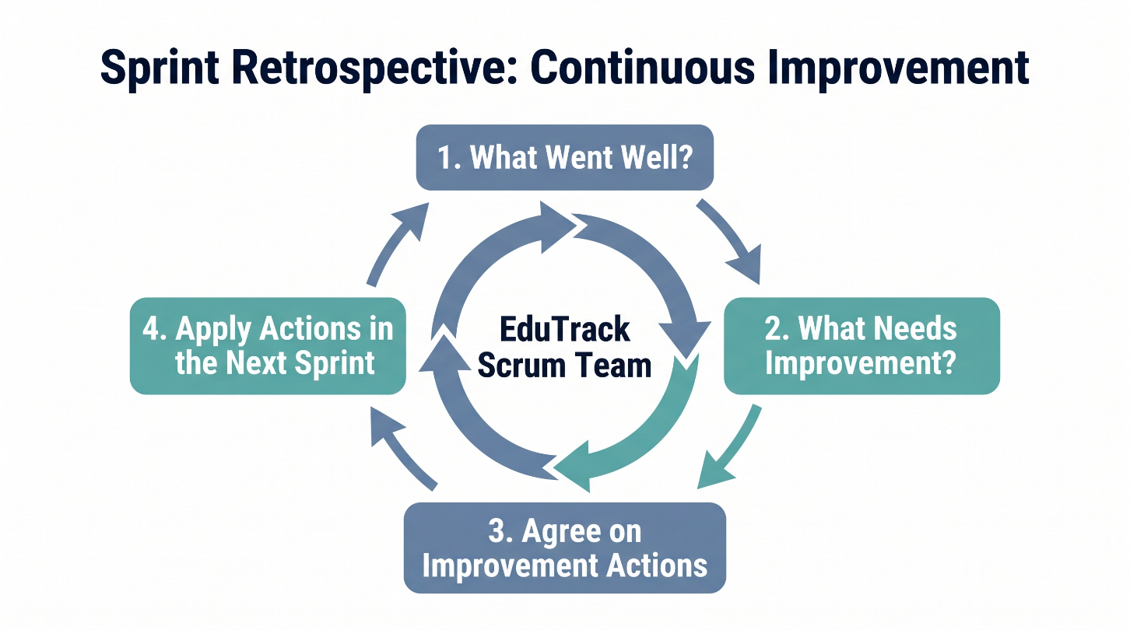
Figure 7: Sprint Retrospective and Continuous Improvement Cycle.
16. Connecting Agile with DevOps
Agile and DevOps complement each other. Agile helps the team organize work, deliver increments, and adapt to feedback. DevOps practices help the team build, test, integrate, deploy, and monitor software more consistently.
For EduTrack, Agile planning can be used to select and organize work, while DevOps practices can support the quality and delivery of the planned features.
16.1 Proposed DevOps Workflow
Stage | Application to EduTrack
Plan | Select prioritized User Stories for a Sprint.
Code | Develop the selected features.
Build | Prepare the application build.
Test | Run automated and manual tests.
Integrate | Combine reviewed changes with the project.
Deploy | Deploy the tested version when deployment is configured.
Monitor | Check application behavior and identify issues.
Feedback | Use issues and user feedback to plan improvements.

16.2 Benefits of Combining Agile and DevOps
- Smaller changes are easier to review and test.
- Automated testing can identify errors earlier.
- Version control supports collaboration and traceability.
- Continuous integration helps detect integration problems.
- Deployment and monitoring can improve reliability.
- Feedback can inform the next Sprint's priorities.

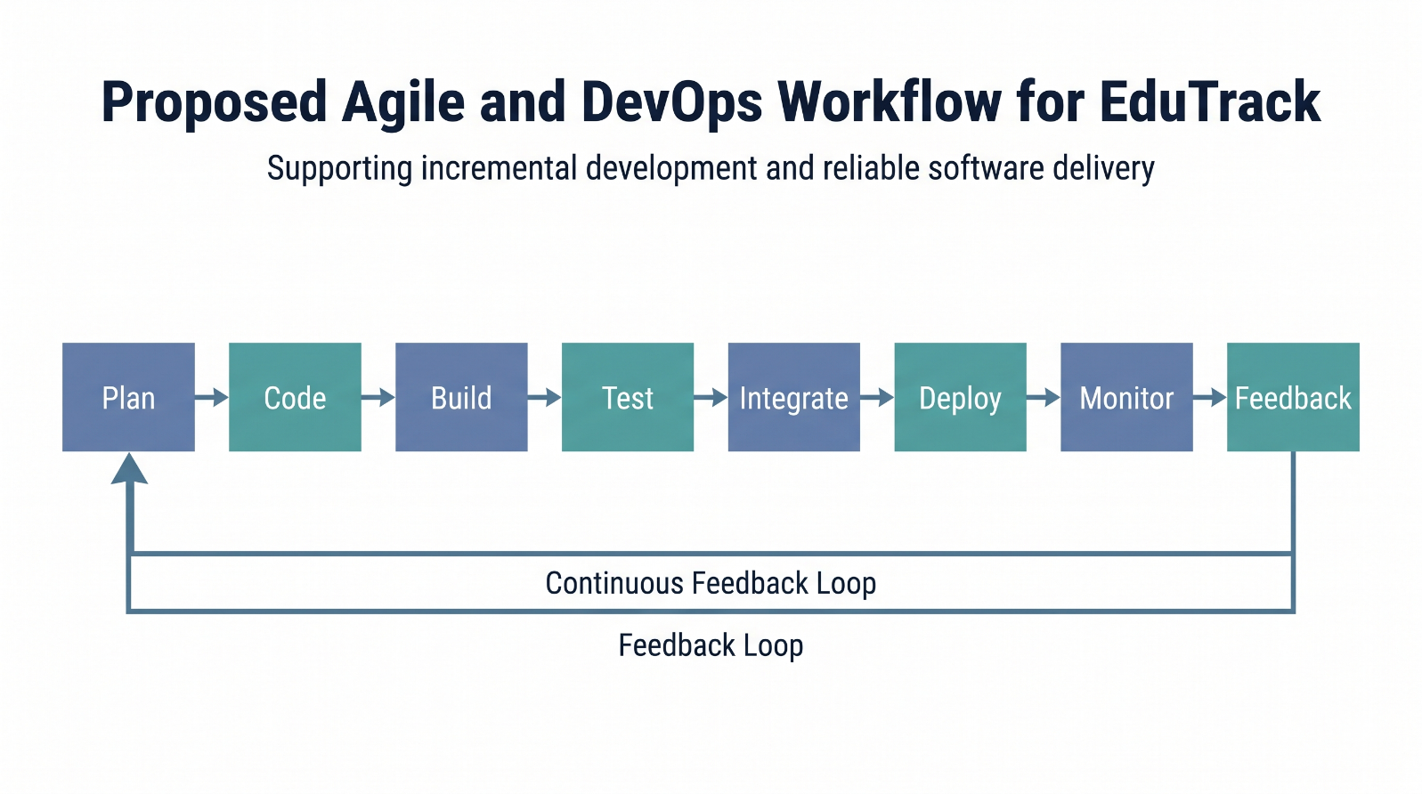
Figure 8: Proposed Agile and DevOps Workflow for EduTrack.

17. Project Deliverables
The planned outputs of the EduTrack Unit 2 mini-project are:
- Scrum team roles and responsibilities.
- Product Goal and Sprint Goal.
- Epic list and User Stories.
- Acceptance Criteria.
- Prioritized Product Backlog.
- Story Point estimation sheet.
- Sprint Planning documentation.
- Scrum Board.
- Daily Scrum example or actual meeting notes.
- Sprint Review plan and feedback record.
- Sprint Retrospective and improvement actions.
- Proposed Agile and DevOps workflow.
17.1 Conclusion
The EduTrack Unit 2 mini-project demonstrates how Agile methodology and Scrum can be applied to a student academic management platform. The project organizes the planned features into Epics and User Stories, defines Acceptance Criteria, prioritizes the Product Backlog, and proposes a Sprint plan.
Scrum events such as Daily Scrum, Sprint Review, and Sprint Retrospective help the team coordinate work, inspect progress, collect feedback, and improve its process.
By connecting Agile planning with DevOps practices, EduTrack establishes a foundation for future development, testing, integration, deployment, and monitoring. The approach supports incremental delivery while keeping the platform focused on the needs of students, faculty members, and administrators.
17.2 Future Scope
Future work may include implementing the planned modules, configuring a version-control workflow, introducing automated tests, establishing a CI/CD pipeline, deploying the application, and monitoring its behavior. Further improvements can be prioritized using feedback from actual users.

