**Declaring Variables**



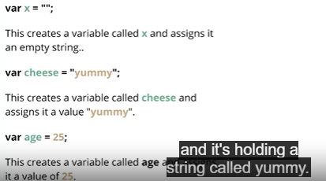



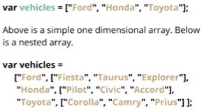 **Arrays**



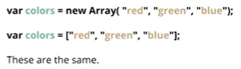



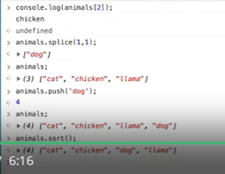



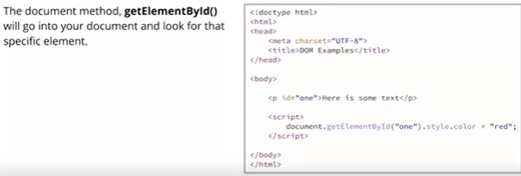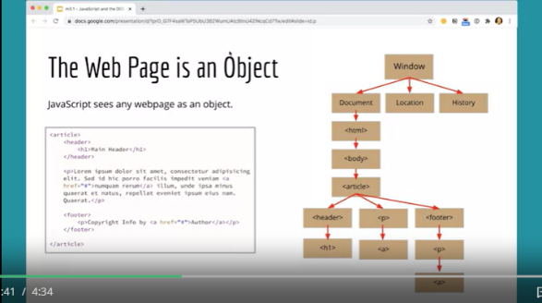 DOM



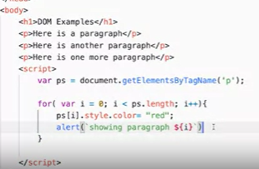



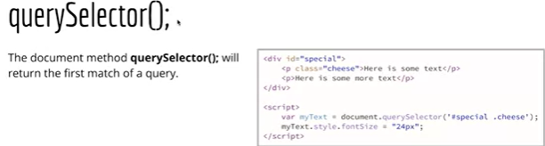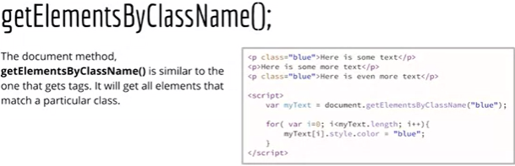



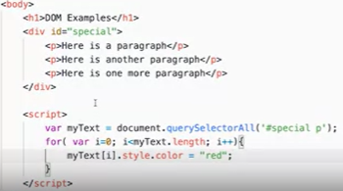



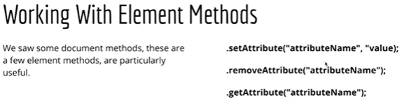



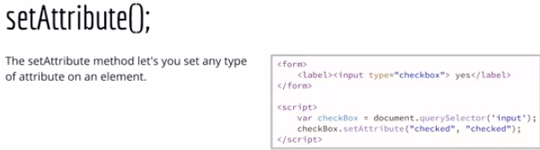



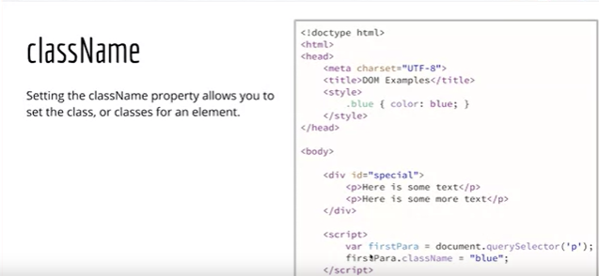



Creating elements and text nodes



