# Experiment – 1

Lab Assignments to complete

1. Create a static page as image posted below:

<!DOCTYPE html>

<html lang="en">

<head>

    <meta charset="UTF-8">

    <meta name="viewport" content="width=device-width, initial-scale=1.0">

    <title>Document</title>

</head>

<body>

    <h1>Welcome to SiteRaw</h1>

    <ul>

        <li><a href="Home">Home</a><br></li>

        <li><a href="Forum">Forum</a><br></li>

        <li><a href="Contact">Contact</a></li>

    </ul>

    <h2>

        SiteRaw is awesome

    </h2>

    <p>SiteRaw is the best site in the web.SiteRaw is the best site in the web.<br><br>

        SiteRaw is awesome. True Story.</p>

    <h2>About the author</h2>

    <p>SiteRaw was created by....find out never!</p>

    <p>&copy SiteRaw, best site on the web</p>

</body>

</html>

OUTPUT:  
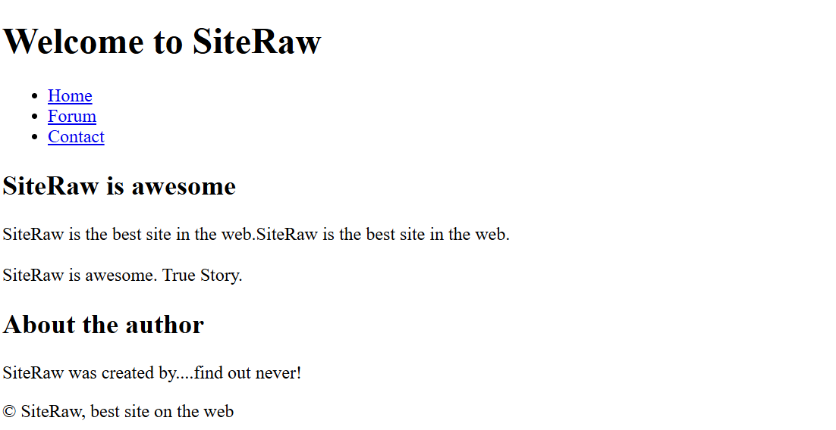

1. Create the exact time table of your Semester IV of your class.

CODE:

<!DOCTYPE html>

<html lang="en">

<head>

    <meta charset="UTF-8">

    <meta name="viewport" content="width=device-width, initial-scale=1.0">

    <title>Timetable</title>

</head>

<body>

    <table border = "1" cellpadding = "5" cellspacing = "4">

        <tr>

            <th>Period</th>

            <th>Monday</th>

            <th>Tueday</th>

            <th>Wednesday</th>

            <th>Thursday</th>

            <th>Friday</th>

            <th>Saturday</th>

        </tr>

        <tr>

            <td align="center" >08:00 - 09:00</td>

            <td rowspan="2" align="center">WEB LAB</td>

            <td rowspan="2" align="center">PBC</ align="center"td>

            <td rowspan="2" align="center">IPD</td>

            <td rowspan="2" align="center">CPCM</td>

            <td rowspan="2" align="center">DS</td>

            <td align="center">ML-1</td>

        </tr>

        <tr>

            <td align="center">09:00 - 10:00</td>

            <td align="center">DS</td>

        </tr>

        <tr>

            <td  align="center">10:00 - 10:30</td>

            <td colspan="6" align="center">Break</td>

        </tr>

        <tr>

            <td  align="center">10:30 - 11:30</td>

            <td align="center">ML -1</td>

            <td align="center">EFM</td>

            <td rowspan="2" align="center">CPCM</td>

            <td rowspan="2" align="center">WEB LAB</td>

            <td rowspan="1" align="center">SDS</td>

            <td rowspan="2" align="center">ML -1 </td>

        </tr>

        <tr>

            <td  align="center">11:30 - 12:30</td>

            <td align="center">SDS</td>

            <td align="center">ML - 1</td>

            <TD align="center">EFM</TD>

        </tr>

        <tr>

            <td  align="center">12:30 - 13:30</td>

            <td align="center" rowspan="2">SDS</td>

            <td align="center" rowspan="2">OE</td>

            <td  align="center"rowspan="5">IPD</td>

            <TD align="center">SDS</TD>

            <td align="center">OE</td>

            <td align="center">DS</td>

        </tr>

        <tr>

            <td  align="center">13:30 - 14:30</td>

            <TD align="center"></TD>

            <td align="center">DS</td>

            <td></td>

        </tr>

        <TR>

            <td align="center" >14:30 - 15:00</td>

            <td></td>

            <td></td>

            <td></td>

            <td></td>

            <td></td>

        </TR>

        <TR>

            <td align="center" >15:00 - 16:00</td>

            <td></td>

            <td></td>

            <td></td>

            <td></td>

            <td></td>

        </TR>

        <TR>

            <td align="center" >16:00 - 17:00</td>

            <td></td>

            <td></td>

            <td></td>

            <td>CPCM</td>

            <td></td>

        </TR>

    </table>

</body>

</html>

OUTPUT:

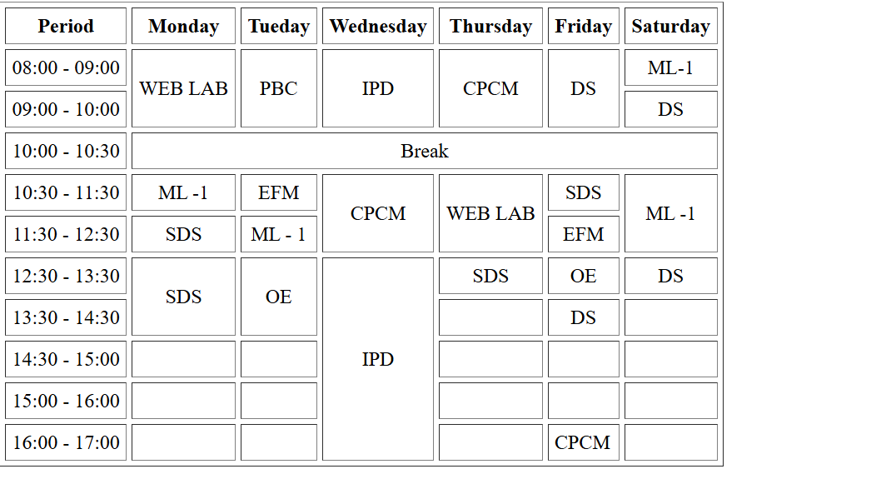

1. Create a registration form using HTML as per the image shown below.

CODE:

<!DOCTYPE html>

<html lang="en">

<head>

    <meta charset="UTF-8">

    <meta name="viewport" content="width=device-width, initial-scale=1.0">

    <title>Q3</title>

    <h1>Email Account Form</h1>

    <style>

        h1{

            text-align: center;

            font-family: 'Gill Sans', 'Gill Sans MT', Calibri, 'Trebuchet MS', sans-serifx;

        }

    </style>

</head>

<body>

    <form>

        Enter Username: <input type="text" placeholder="Enter your name"><br><br>

        Enter Password: <input type="password"><br><br>

        Address: <textarea cols="50" rows="5" value="address"></textarea><br><br>

        Fields of Interest: <input type="checkbox" value="Entertainment">Entertainment

        <input type="checkbox" value="Sports">Sports

        <input type="checkbox" value="News">News<br><br>

        Gender: <input type="radio" value="Male">Male

        <input type="radio" value="Female">Female

        <br><br>

        Select Languages: <select>

            <option value="Marathi">Marathi</option>

            <option value="Hindi">Hindi</option>

            <option value="English">English</option>

        </select><br><br>

        Select Country: <select>

            <option value="India">India</option>

            <option value="USA">USA</option>

            <option value="UK">UK</option>

        </select><br><br>

        Upload Photo:

        <button value="Upload">Choose File</button> no file chosen<br><br>

        <button value="Validate">Validate</button>

        <button value="Reset">Reset</button>

        <button value="Submit">Submit</button>

    </form>

</body>

</html>

OUTPUT:

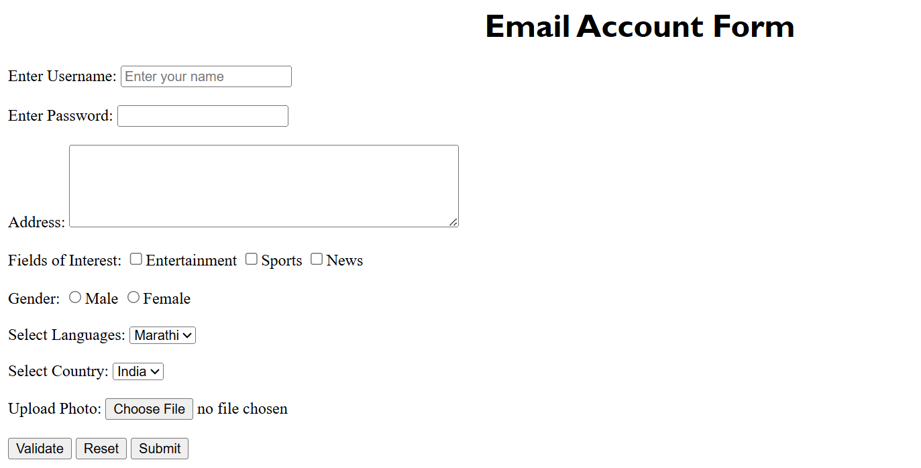

1. Create a Web page using HTML5 tags.

OUTPUT:  
<!DOCTYPE html>

<html lang="en">

<head>

    <meta charset="UTF-8">

    <meta name="viewport" content="width=device-width, initial-scale=1.0">

    <title>Spotify - your love is here</title>

    <link rel="stylesheet" href="style1.css">

</head>

<body>

    <div class="sidebar">

      <div class="logo">

        <a href="#">

          <img src="topify.png" alt="Logo" />

        </a>

      </div>

      <div class="navigation">

        <ul>

          <li>

            <a href="#">

              <span class="fa fa-home"></span>

              <span>Home</span>

            </a>

          </li>

          <li>

            <a href="#">

              <span class="fa fa-search"></span>

              <span>Search</span>

            </a>

          </li>

          <li>

            <a href="#">

              <span class="fa fas fa-book"></span>

              <span>Your Library</span>

            </a>

          </li>

        </ul>

      </div>

      <div class="navigation">

        <ul>

          <li>

            <a href="#">

              <span class="fa fas fa-plus-square"></span>

              <span>Create Playlist</span>

            </a>

          </li>

          <li>

            <a href="#">

              <span class="fa fas fa-heart"></span>

              <span>Liked Songs</span>

            </a>

          </li>

        </ul>

      </div>

      <div class="policies">

        <ul>

          <li>

            <a href="#">Cookies</a>

          </li>

          <li>

            <a href="#">Privacy</a>

          </li>

        </ul>

      </div>

    </div>

    <div class="main-container">

      <div class="topbar">

        <div class="prev-next-buttons">

          <button type="button" class="fa fas fa-chevron-left"></button>

          <button type="button" class="fa fas fa-chevron-right"></button>

        </div>

        <div class="navbar">

          <ul>

            <li>

              <a href="#">Premium</a>

            </li>

            <li>

              <a href="#">Support</a>

            </li>

            <li>

              <a href="#">Download</a>

            </li>

            <li class="divider">|</li>

            <li>

              <a href="#">Sign Up</a>

            </li>

          </ul>

          <button type="button">Log In</button>

        </div>

      </div>

      <div class="spotify-playlists">

        <h2>Topify Playlists</h2>

        <div class="list">

          <div class="item">

          <img src='sonunigam.jpeg'>

             <div class="play">

               <span class="fa fa-play">

                <a href="https://open.spotify.com/embed/playlist/37i9dQZF1DZ06evO0FcUGj?utm_source=generator" width="100%" height="352" frameBorder="0" allowfullscreen="" allow="autoplay; clipboard-write; encrypted-media; fullscreen; picture-in-picture" loading="lazy">Play</a>

               </span>

             </div>

            <h4>Today's Top Hits</h4>

            <a href = "https://www.youtube.com/watch?v=WcIcVapfqXw" alt="Description"><button type="button1">For Video</button></a>

            <a href="https://open.spotify.com/embed/playlist/37i9dQZF1DZ06evO0FcUGj?utm_source=generator" width="100%" height="352" frameBorder="0" allowfullscreen="" allow="autoplay; clipboard-write; encrypted-media; fullscreen; picture-in-picture" loading="lazy"></a>

            <p>Sonu Nigam with his brilliant voice...</p>

          </div>

          <div class="item">

            <img src="juicewrld.jpg" />

            <div class="play">

              <span class="fa fa-play"></span>

            </div>

            <h4>Hip-Hop</h4>

            <a href="https://www.youtube.com/watch?v=mzB1VGEGcSU" alt="Description"><button>For Video</button></a>

            <p>New Music from Lil Baby, Juice WRLD an...</p>

          </div>

          <div class="item">

            <img src="brunomars.png" />

            <div class="play">

              <span class="fa fa-play"></span>

            </div>

            <h4>All out 2010s</h4>

            <p>The biggest songs of 2010s Cover:...</p>

          </div>

          <div class="item">

            <img src="rocklegends.jpg" />

            <div class="play">

              <span class="fa fa-play"></span>

            </div>

            <h4>Rock Classics</h4>

            <p>Rock Legends & epic songs that continue t...</p>

          </div>

          <div class="item">

            <img src="https://i.scdn.co/image/ab67616d0000b2733b5e11ca1b063583df9492db" />

            <div class="play">

              <span class="fa fa-play"></span>

            </div>

            <h4>Chill Hits</h4>

            <p>Kick back to the best new and recent chill...</p>

          </div>

          <div class="item">

            <img src="https://i.scdn.co/image/ab67616d0000b2733b5e11ca1b063583df9492db" />

            <div class="play">

              <span class="fa fa-play"></span>

            </div>

            <h4>Viva Latino</h4>

            <p>Today's top Latin hits elevando nuestra...</p>

          </div>

          <div class="item">

            <img src="https://i.scdn.co/image/ab67616d0000b2733b5e11ca1b063583df9492db" />

            <div class="play">

              <span class="fa fa-play"></span>

            </div>

            <h4>Mega Hit Mix</h4>

            <p>A mega mix of 75 favorites from the last...</p>

          </div>

          <div class="item">

            <img src="https://i.scdn.co/image/ab67616d0000b2733b5e11ca1b063583df9492db" />

            <div class="play">

              <span class="fa fa-play"></span>

            </div>

            <h4>All out 80s</h4>

            <p>The biggest songs of the 1980s.</p>

          </div>

        </div>

      </div>

      <div class="spotify-playlists">

        <h2>Focus</h2>

        <div class="list">

          <div class="item">

            <img src="pp.jpg" />

            <div class="play">

              <span class="fa fa-play"></span>

            </div>

            <h4>Peaceful Piano</h4>

            <p>Relax and indulge with beautiful piano pieces</p>

          </div>

          <div class="item">

            <img src="deepfocus.jpg" />

            <div class="play">

              <span class="fa fa-play"></span>

            </div>

            <h4>Deep Focus</h4>

            <p>Keep calm and focus with ambient and pos...</p>

          </div>

          <div class="item">

            <img src="instru.jpeg" />

            <div class="play">

              <span class="fa fa-play"></span>

            </div>

            <h4>Instrumental Study</h4>

            <p>Focus with soft study music in the...</p>

          </div>

          <div class="item">

            <img src="chillofi.jpeg" />

            <div class="play">

              <span class="fa fa-play"></span>

            </div>

            <h4>chill lofi study beats</h4>

            <p>The perfect study beats, twenty four...</p>

          </div>

          <div class="item">

            <img src="coding.jpeg" />

            <div class="play">

              <span class="fa fa-play"></span>

            </div>

            <h4>Coding Mode</h4>

            <p>Dedicated to all the programmers out there.</p>

          </div>

          <div class="item">

            <img src="https://i.scdn.co/image/ab67616d0000b2733b5e11ca1b063583df9492db" />

            <div class="play">

              <span class="fa fa-play"></span>

            </div>

            <h4>Focus Flow</h4>

            <p>Uptempo instrumental hip hop beats.</p>

          </div>

          <div class="item">

            <img src="https://i.scdn.co/image/ab67616d0000b2733b5e11ca1b063583df9492db" />

            <div class="play">

              <span class="fa fa-play"></span>

            </div>

            <h4>Calm Before The Storm</h4>

            <p>Calm before the storm music.</p>

          </div>

          <div class="item">

            <img src="https://i.scdn.co/image/ab67616d0000b2733b5e11ca1b063583df9492db" />

            <div class="play">

              <span class="fa fa-play"></span>

            </div>

            <h4>Beats to think to</h4>

            <p>Focus with deep techno and tech house.</p>

          </div>

        </div>

      </div>

      <div class="spotify-playlists">

        <h2>Mood</h2>

        <div class="list">

          <div class="item">

            <img src="mood.jpeg " />

            <div class="play">

              <span class="fa fa-play"></span>

            </div>

            <h4>Mood Booster</h4>

            <p>Get happy with today's dose of feel-good...</p>

          </div>

          <div class="item">

            <img src="feelingood.jpg" />

            <div class="play">

              <span class="fa fa-play"></span>

            </div>

            <h4>Feelin' Good</h4>

            <p>Feel good with this positively timeless...</p>

          </div>

          <div class="item">

            <img src="dark.jpg" />

            <div class="play">

              <span class="fa fa-play"></span>

            </div>

            <h4>Dark & Stormy</h4>

            <p>Beautifully dark, dramatic tracks.</p>

          </div>

          <div class="item">

            <img src="feelgoodpinao.jpeg" />

            <div class="play">

              <span class="fa fa-play"></span>

            </div>

            <h4>Feel Good Piano</h4>

            <p>Happy vibes for an upbeat morning.</p>

          </div>

          <div class="item">

            <img src="https://i.scdn.co/image/ab67616d0000b2733b5e11ca1b063583df9492db" />

            <div class="play">

              <span class="fa fa-play"></span>

            </div>

            <h4>Feelin' Myself</h4>

            <p>The hip-hop playlist that's a whole mood...</p>

          </div>

          <div class="item">

            <img src="https://i.scdn.co/image/ab67616d0000b2733b5e11ca1b063583df9492db" />

            <div class="play">

              <span class="fa fa-play"></span>

            </div>

            <h4>Chill Tracks</h4>

            <p>Softer kinda dance</p>

          </div>

          <div class="item">

            <img src="https://i.scdn.co/image/ab67616d0000b2733b5e11ca1b063583df9492db" />

            <div class="play">

              <span class="fa fa-play"></span>

            </div>

            <h4>Feel-Good Indie Rock</h4>

            <p>The best indie rock vibes - classic and...</p>

          </div>

          <div class="item">

            <img src="https://i.scdn.co/image/ab67616d0000b2733b5e11ca1b063583df9492db" />

            <div class="play">

              <span class="fa fa-play"></span>

            </div>

            <h4>idk.</h4>

            <p>idk.</p>

          </div>

        </div>

        <hr>

      </div>

      <div class="preview">

        <div class="text">

          <h6>Preview of Spotify</h6>

          <p>Sign up to get unlimited songs and podcasts with occasional ads. No credit card needed.</p>

        </div>

        <div class="button">

          <button type="button">Sign up free</button>

        </div>

      </div>

    </div>

    <div class="bottom">

        <input type="range" name="range" id="MyProgressBar" min="0" max="100">

        <div class="icons">

            <i class="fa-solid fa-backward-step"></i>

            <i class="fa-solid fa-play"></i>

            <i class="fa-solid fa-forward-step"></i>

        </div>

    </div>

    <script src="script.js"></script>

    <script src="https://kit.fontawesome.com/604d3ac1e0.js" crossorigin="anonymous"></script>

    <script type="text/javascript"> </script>

  </body>

</html>

OUTPUT:  
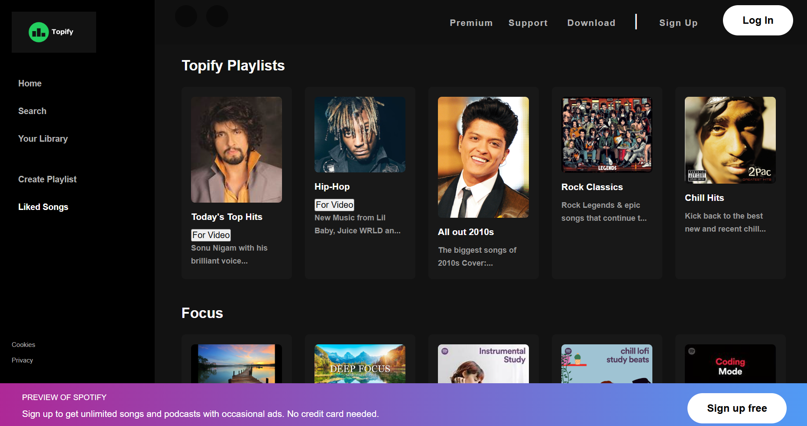

WRITEUPS:

