# Experiment – 2

## CSS

Aim : Implement the following using CSS.

Lab Assignment to complete:

1. Design a resume using Bootstrap and media queries.

**Index.html**

<!DOCTYPE html>

<html lang="en">

<head>

<meta charset="UTF-8">

<meta name="viewport" content="width=device-width, initial-scale=1.0">

<title>Soham Walam - Resume</title>

<link rel="stylesheet" href="https://stackpath.bootstrapcdn.com/bootstrap/4.5.2/css/bootstrap.min.css">

<link rel="stylesheet" href="style_ex.css">

</head>

<body>

<div class="container">

<div class="row">

<div class="col-12 col-md-4">

<div class="card shadow-sm">

<div class="card-body">

<h2 class="card-title">Soham Walam</h2>

<p class="card-text">Data Scientist</p>

<ul class="list-group list-group-flush">

<li class="list-group-item">Phone: +91 9987236183</li>

<li class="list-group-item">Email: soham.walam2005@gmail.com </li>

<li class="list-group-item"><img src="linkedin.jpg" height="30" width="30"><a href='https://www.linkedin.com/in/soham-walam-b82446296/'>LinkedIn</a></li>

</ul>

</div>

</div>

</div>

<div class="col-12 col-md-8">

<div class="card shadow-sm">

<div class="card-body">

<h3 class="card-title">Summary</h3>

<p class="card-text">I Mst.Soham Walam with a B.Tech Degree in Computer Science and Engineering with specialization in Data Science</p>

</div>

</div>

<div class="card shadow-sm mt-3">

<div class="card-body">

<h3 class="card-title">Experience</h3>

<ul class="list-group list-group-flush">

<li class="list-group-item">

<h4>Data Scientist</h4>

<p>Cognizant | Apr'22 - Oct'24</p>

<ul><li style="list-style-type:disc">

<p>Successfully implemented the work of Application services and contributed majorly to the Data Analysis section.</p></li>

</ul>

</li>

<li class="list-group-item">

<h4>Data and Artificial Intelligence</h4>

<p>Accenture | Nov'24 - Current</p>

<ul><li style="list-style-type:disc">

<p>As a project lead, I have driven AI-powered solutions to enhance enterprise efficiency and decision-making. As a speaker, I share insights on AI’s impact, strategy, and innovation, helping businesses leverage its full potential.</p></li>

</ul>

</li>

</ul>

</div>

</div>

<div class="card shadow-sm mt-3">

<div class="card-body">

<h3 class="card-title">Education</h3>

<ul class="list-group list-group-flush">

<li class="list-group-item">

<h4></h4>

<p>SVKM's D.J. Sanghvi College of Engineering | 2027</p>

</li>

<li class="list-group-item">

<h4>Degree</h4>

<p>SVKM's D.J. Sanghvi College of Engineering | 2027</p>

</li>

</ul>

</div>

</div>

</div>

</div>

</div>

<script src="https://code.jquery.com/jquery-3.5.1.slim.min.js"></script>

<script src="https://cdn.jsdelivr.net/npm/@popperjs/core@2.9.2/dist/umd/popper.min.js"></script>

<script src="https://stackpath.bootstrapcdn.com/bootstrap/4.5.2/js/bootstrap.min.js"></script>

</body>

</html>

Styles.css

body {

    font-family: Arial, sans-serif;

    background-image: url('https://ncube-digest.com/wp-content/uploads/2020/02/shutterstock_1134885563-1.jpg');

  }

  .card {

    margin-bottom: 20px;

    background-color: aquamarine;

  }

  @media (max-width: 768px) {

    .card-title {

      font-size: 1.5rem;

    }

    .card-text {

      font-size: 1rem;

    }

  }

  @media (max-width: 576px) {

    .card-title {

      font-size: 1.25rem;

    }

    .card-text {

      font-size: 0.9rem;

    }

  }

OUTPUT:

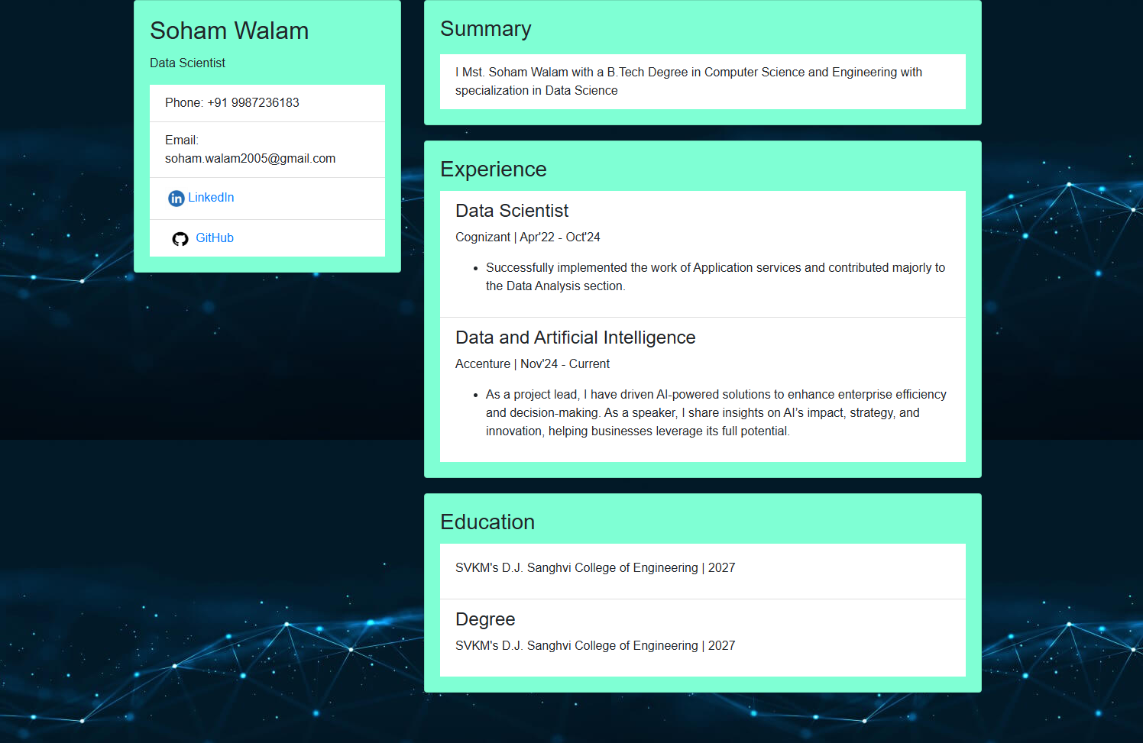

WriteUp:

