CAPSTONE PROJECT REPORT
Selenium Python Automation Framework
Capstone Assignment 2: Selenium Python Framework Development
Unittest + PyTest + Page Object Model
Application under test: TutorialsNinja Demo (https://tutorialsninja.com/demo/)

Submitted by: Soham Mondal
Department: Computer Science and Engineering
Institute: Institute of Engineering & Management (IEM), Kolkata
Enrollment No.: 12023002001361
Project Guide: Sramana Mukherjee
Date: 27 September 2026

1. Objective
The objective of this project is to automate the Login and Product Search functionality of an e-commerce web application using a scalable, reusable Selenium Python framework. The framework combines PyTest and Unittest, follows the Page Object Model (POM), reads configuration from a file and test data from CSV files, captures screenshots automatically when a test fails, and produces an HTML report.

2. Tools and Technologies
Tool / Concept | Use in this project
Python 3.11 | Programming language
Selenium WebDriver 4 | Browser automation; Selenium Manager downloads ChromeDriver automatically
PyTest 8 | Main test runner, fixtures, parametrization, markers, hooks
Unittest | unittest.TestCase tests for the utility classes
Page Object Model | One class per page holding locators and actions
CSV (csv module) | Data-driven test input for search and login
configparser (config.ini) | Base URL, browser, timeout, headless mode, screenshot folder
pytest-html 4 | Self-contained HTML test report with embedded failure screenshots
Google Chrome | Browser used for execution (Microsoft Edge also supported)

3. Framework Architecture
Tests never use Selenium locators directly. They call page-object methods, which use shared helpers from BasePage (explicit waits, click, type, read text). Utilities provide configuration, CSV data and screenshots, and conftest.py wires everything together with fixtures and a reporting hook.
File / Folder | Purpose
config/config.ini | Central configuration (no values hard-coded in code)
data/test_data.csv | Search terms, expected product, whether results are expected
data/login_data.csv | Invalid-login scenarios and the expected error message
pages/base_page.py | Common actions built on WebDriverWait
pages/home_page.py | Header search box and My Account menu
pages/search_results_page.py | Result heading, product names, no-results message
pages/login_page.py | E-mail, password, Login button, error alert
pages/register_page.py | Creates a fresh throwaway account for the valid-login test
pages/account_page.py | My Account page verification and logout
tests/test_login.py | Login test cases
tests/test_product_search.py | CSV-driven product search test cases
tests/test_failure_demo.py | Intentional failure to demonstrate screenshots (opt-in)
utils/config_reader.py | Reads config.ini with typed getters
utils/csv_reader.py | Reads CSV rows into dictionaries
utils/screenshot.py | Saves uniquely named, Windows-safe screenshots
utils/data_helper.py | Generates unique e-mails / ids for test data
conftest.py | driver fixture, registered_user fixture, screenshot-on-failure hook
pytest.ini | Test discovery, markers and default options
unittest_demo.py | Unittest test cases for the utilities

3.1 Page object example
class LoginPage(BasePage):
EMAIL_INPUT = (By.ID, "input-email")
PASSWORD_INPUT = (By.ID, "input-password")
LOGIN_BUTTON = (By.CSS_SELECTOR, "input[type='submit'][value='Login']")
ERROR_ALERT = (By.CSS_SELECTOR, ".alert-danger")

def login(self, email, password):
self.type_text(self.EMAIL_INPUT, email)
self.type_text(self.PASSWORD_INPUT, password)
self.click(self.LOGIN_BUTTON)

4. Requirement Coverage
Requirement | How it is satisfied
Unittest | unittest_demo.py (9 TestCase tests); runs with python unittest_demo.py and is also collected by PyTest
PyTest | Primary runner; fixtures in conftest.py; parametrized tests; markers login, search, registration
Page Object Model | Six page classes in pages/; no raw locators in test files
Utility classes | ConfigReader, CSV reader, screenshot helper, data helper in utils/
Configuration management | config/config.ini read by utils/config_reader.py; CLI overrides --browser, --headless
CSV test data | test_data.csv drives 5 search tests; login_data.csv drives 3 invalid-login tests
Screenshots on failure | pytest_runtest_makereport hook saves screenshots/<test>_<timestamp>.png and embeds it in the report
HTML reporting | pytest-html: pytest -v --html=report.html --self-contained-html
Explicit waits | WebDriverWait in BasePage; no time.sleep() anywhere

5. Test Scenarios and Evidence
The screenshots in this section were captured on 27 September 2026 by capture_evidence.py, which drives the live TutorialsNinja site using the same page objects as the tests.

5.1 Product Search
Each row of data/test_data.csv becomes one test case:
search_term | expected_product | expect_results
MacBook | MacBook Air | true
iPhone | iPhone | true
Samsung | Samsung Galaxy Tab 10.1 | true
canon | Canon EOS 5D | true
xyznonexistentproduct | (none) | false

Steps performed by test_product_search:
- Open the home page.
- Type the search term from the CSV into the header search box and click the search button.
- Wait (explicitly) for the search results page to load.
- Assert the heading is "Search - <term>" and the search box keeps the term.
- If results are expected: assert the expected product is listed and every result name contains the term.
- If no results are expected: assert no products are shown and the "no product matches" message is displayed.
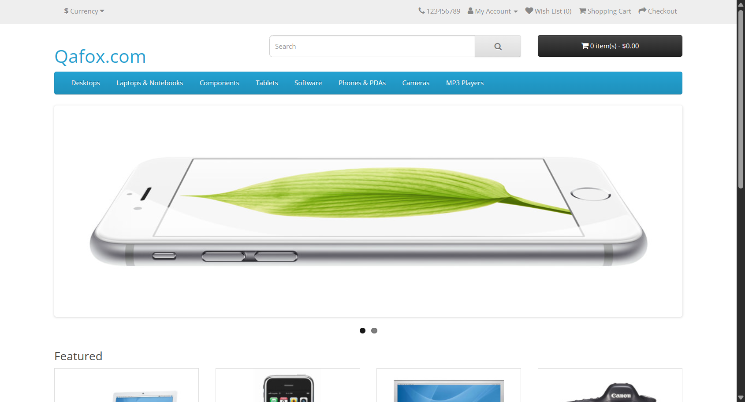
Figure 1: Home page of TutorialsNinja Demo opened by the framework
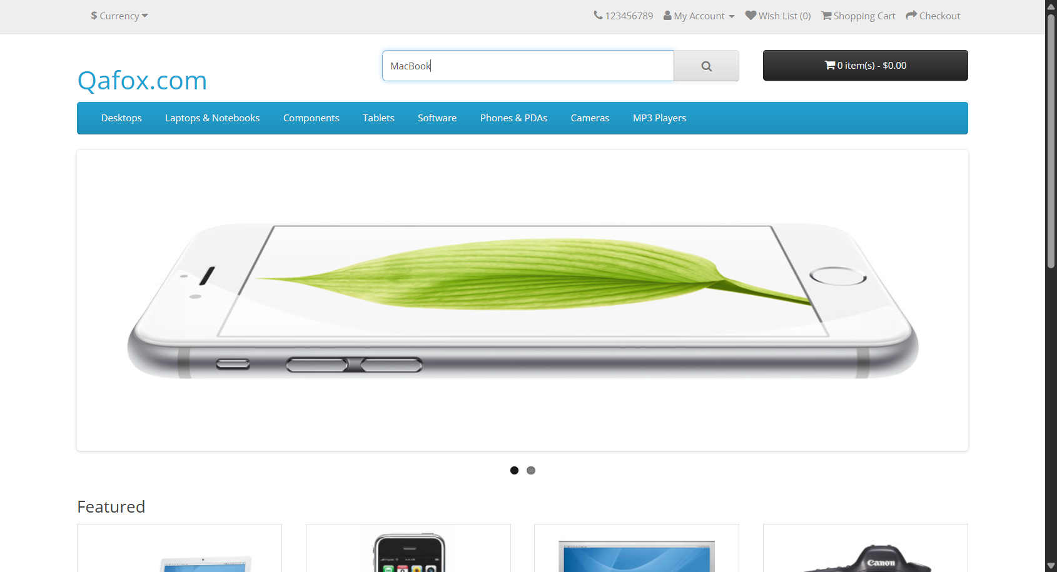
Figure 2: Search term "MacBook" typed into the header search box
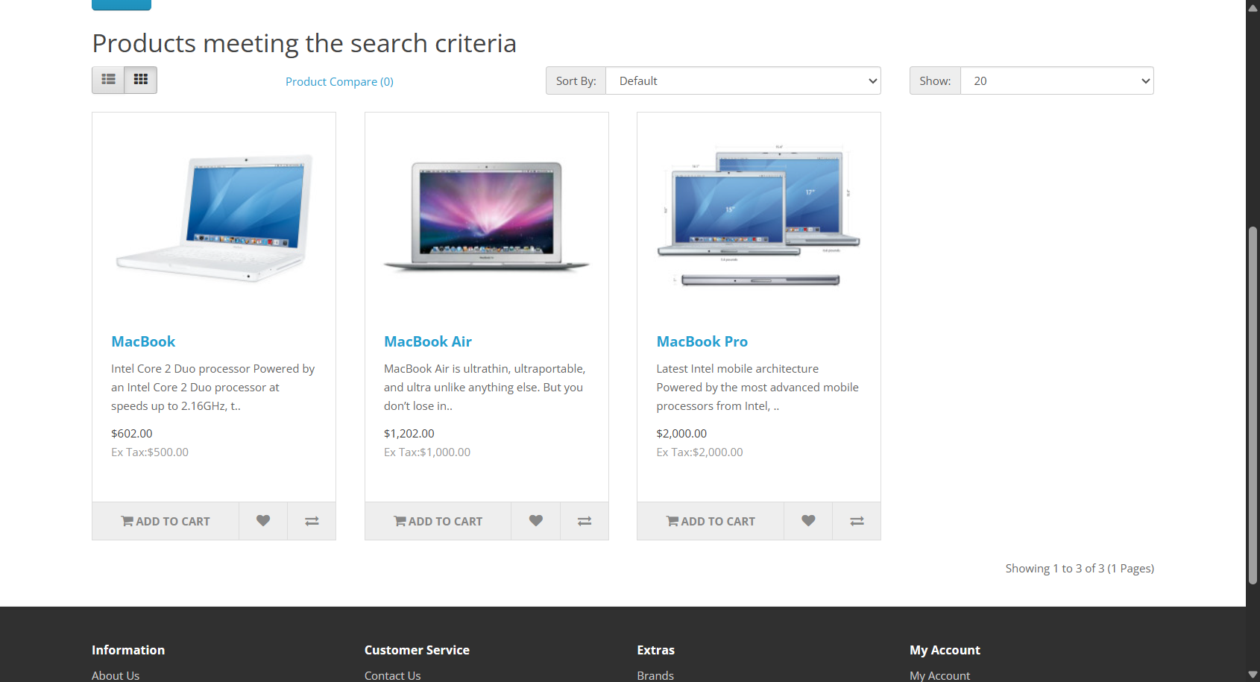
Figure 3: Search results for "MacBook": MacBook, MacBook Air, MacBook Pro
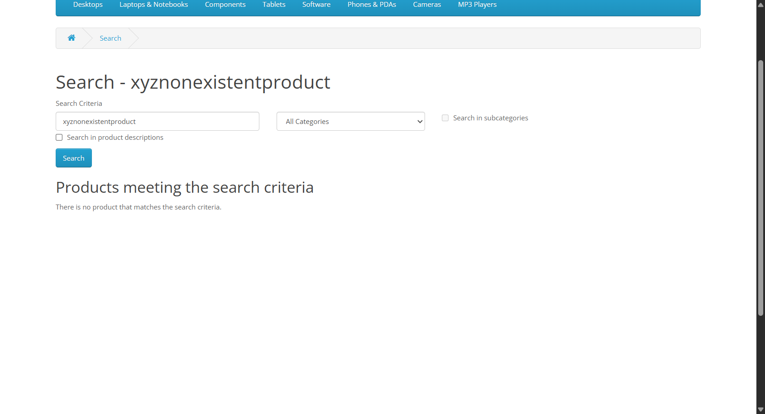
Figure 4: Negative search: "There is no product that matches the search criteria."

5.2 Login
TutorialsNinja does not publish demo credentials, so no working credentials are stored in the project. Login is tested in two honest ways:
- Invalid login (CSV-driven): each row of login_data.csv is submitted and the exact error message is asserted. The {uid} placeholder is replaced with a random id every run, because the site temporarily locks an e-mail after repeated failed attempts.
- Valid login (fresh account): the registered_user fixture registers a new account with a unique @example.com e-mail and random password, logs out, and the test then logs in and verifies the My Account page and Logout link.

scenario | email | password
unregistered_email | unregistered_{uid}@example.com | WrongPass@123
wrong_password_format | not_a_user_{uid}@example.com | 123
empty_credentials | (blank) | (blank)
Expected message for all three rows: "Warning: No match for E-Mail Address and/or Password."
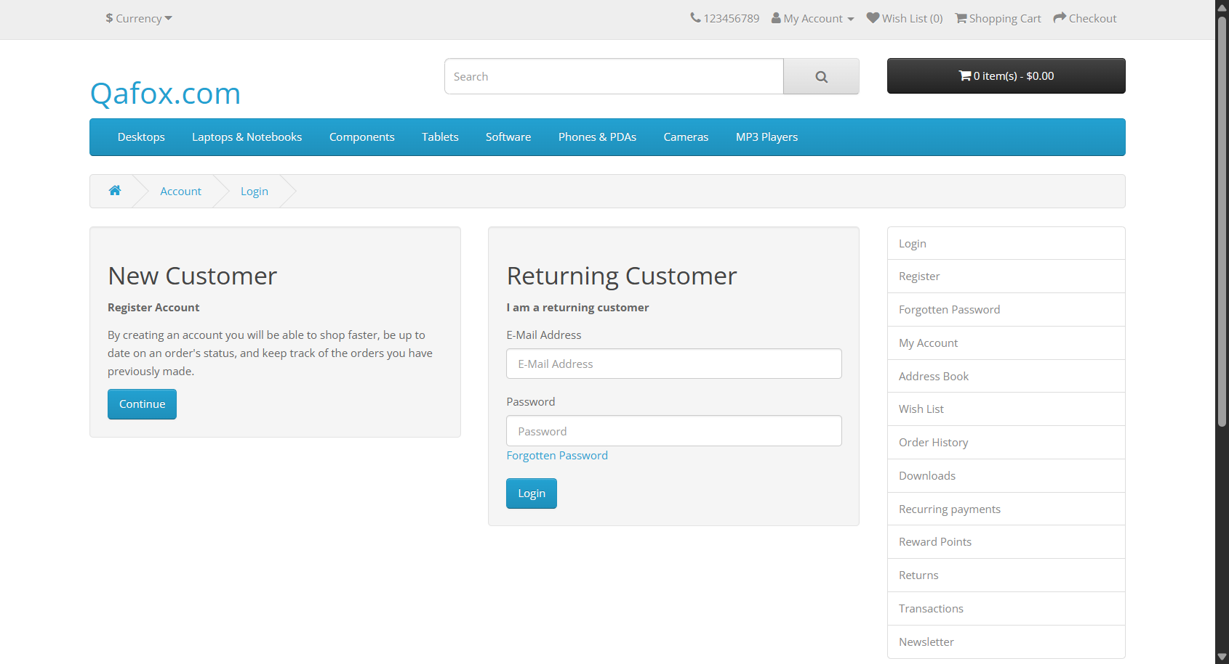
Figure 5: Login page reached via My Account > Login
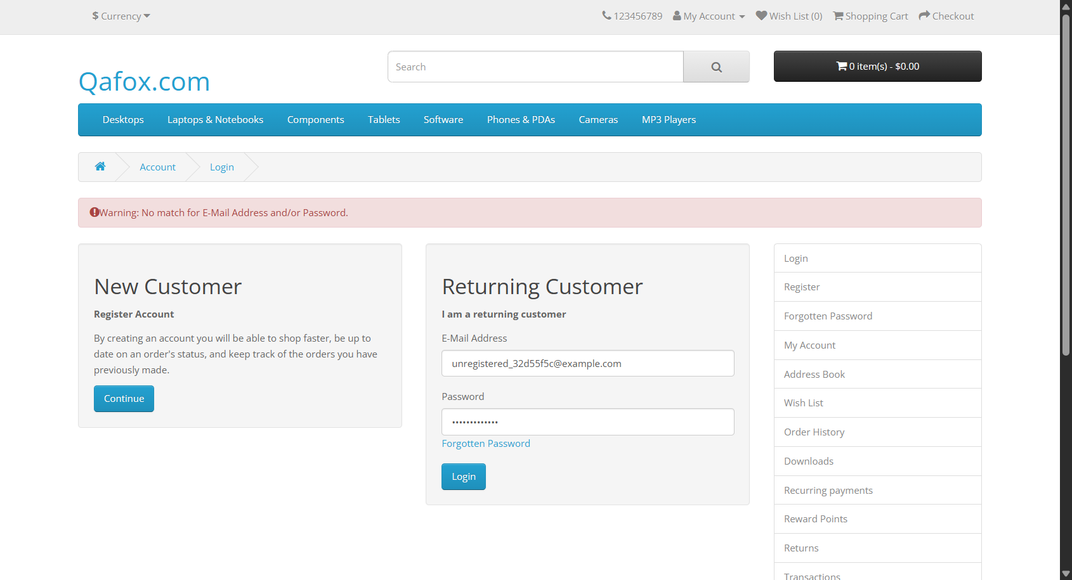
Figure 6: Invalid login: warning message displayed and user stays on the login page
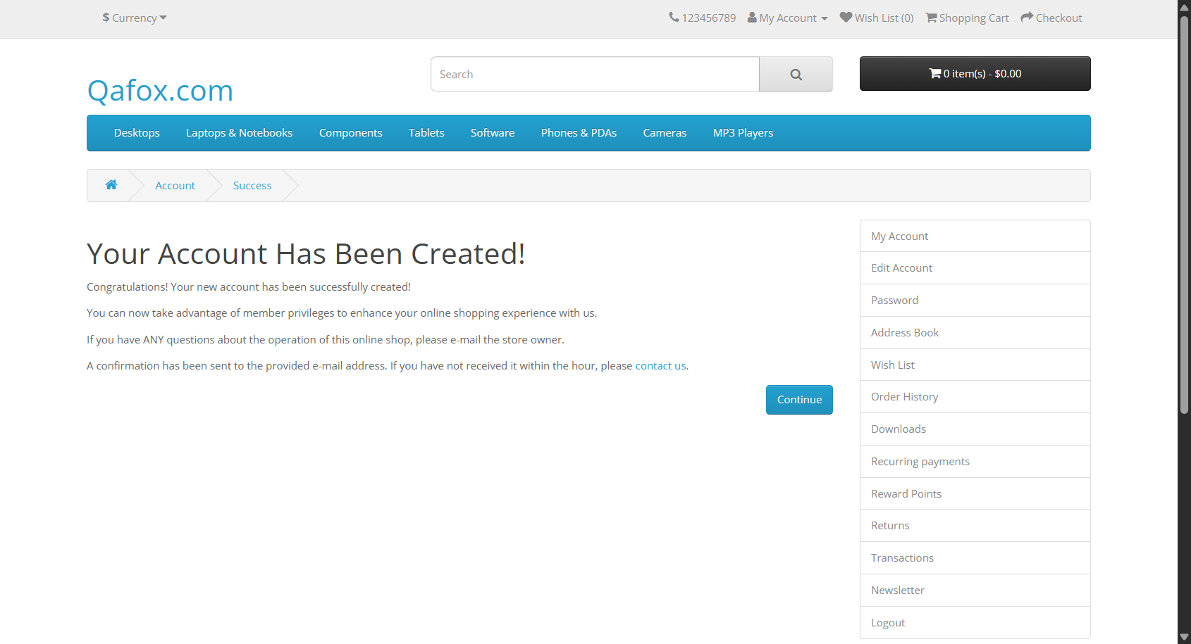
Figure 7: Fresh test account created through the public registration form
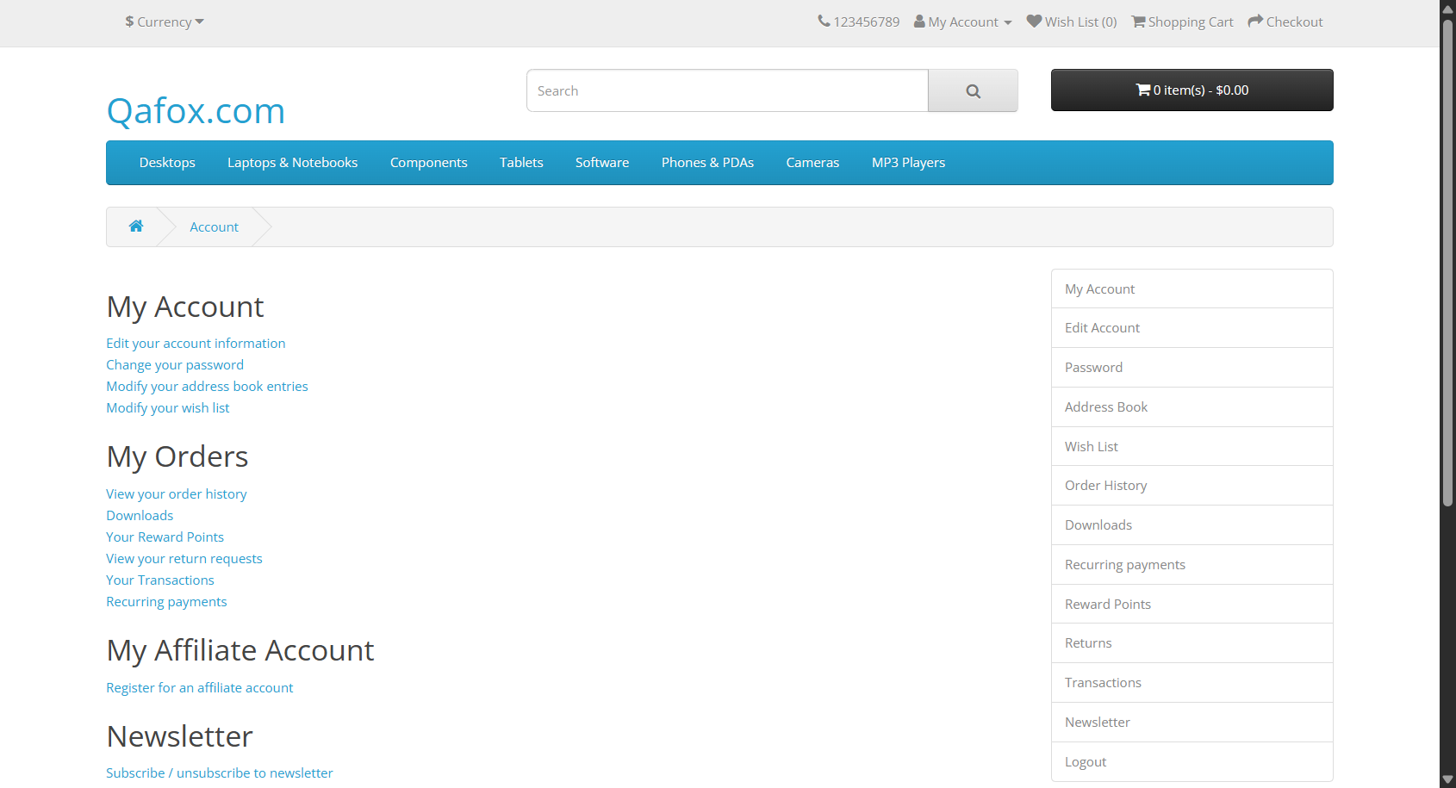
Figure 8: Valid login with the new account: My Account page with Logout link

6. Test Execution Results
The full suite was executed on Windows 11 (Python 3.11.4, pytest 8.4.2, pytest-html 4.2.0) inside a virtual environment.
Run | Result
pytest -v (Selenium + Unittest) | 19 passed, 1 skipped (failure demo) in 51.55 s
python unittest_demo.py | Ran 9 tests - OK
pytest -m "not registration" | 18 passed, 1 skipped, 1 deselected
Failure demo (--run-failure-demo) | 1 failed as intended; screenshot captured

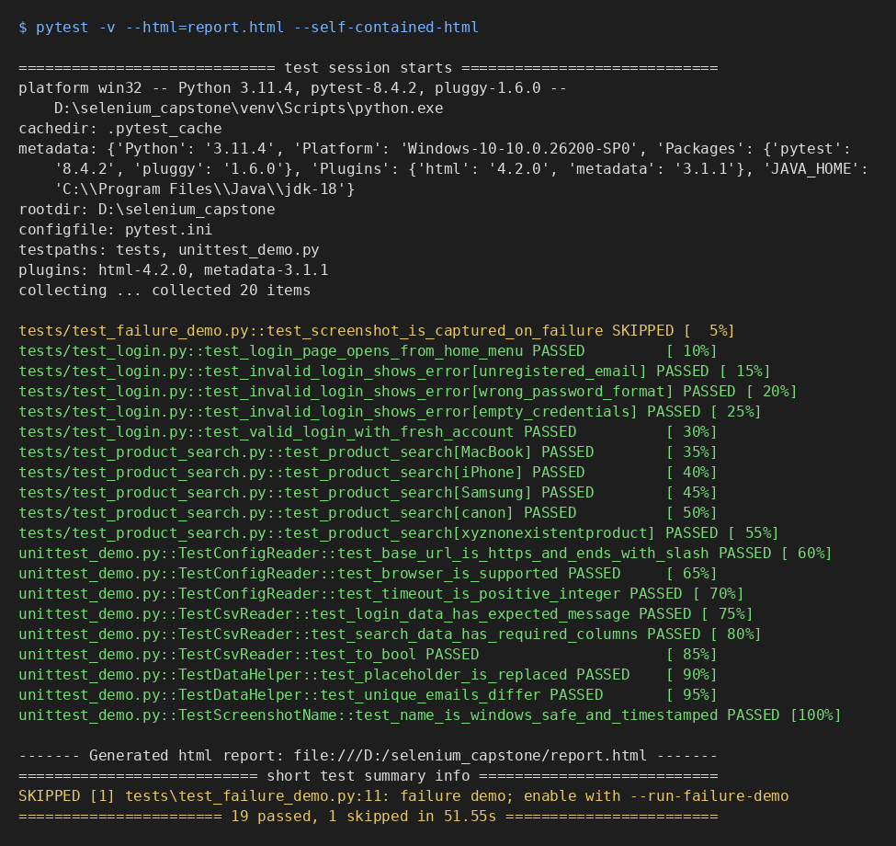
Figure 9: Console output of the complete PyTest run
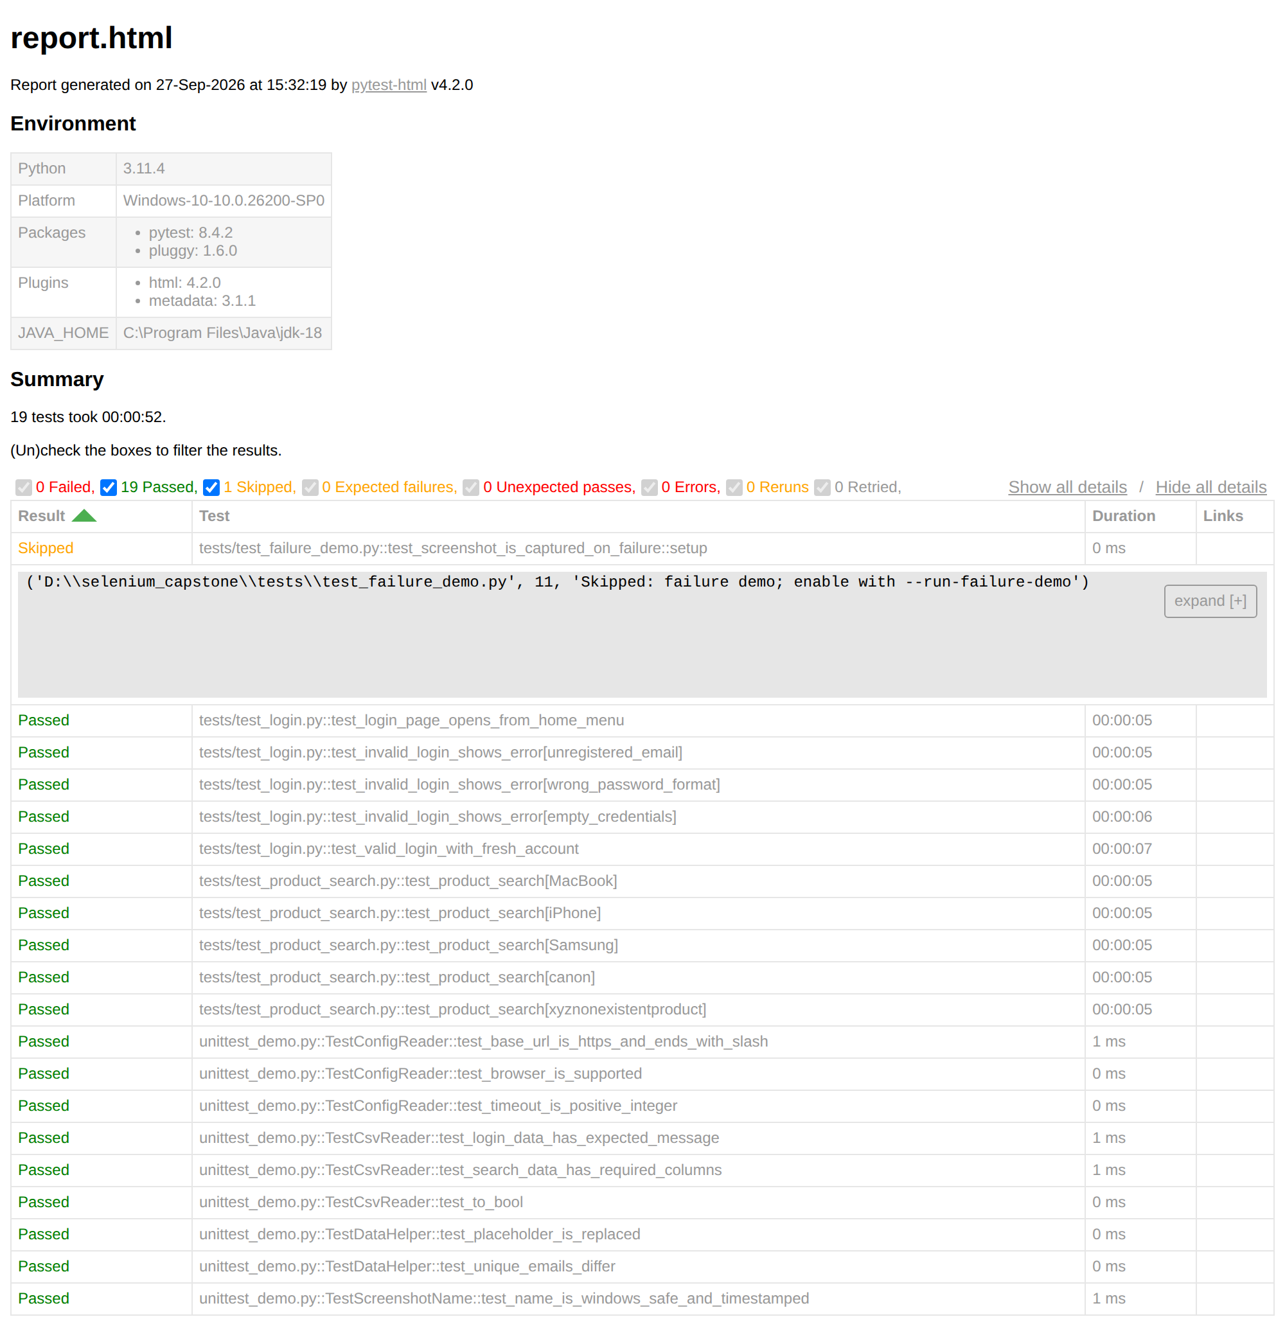
Figure 10: pytest-html report (report.html): 19 passed, 1 skipped, 0 failed
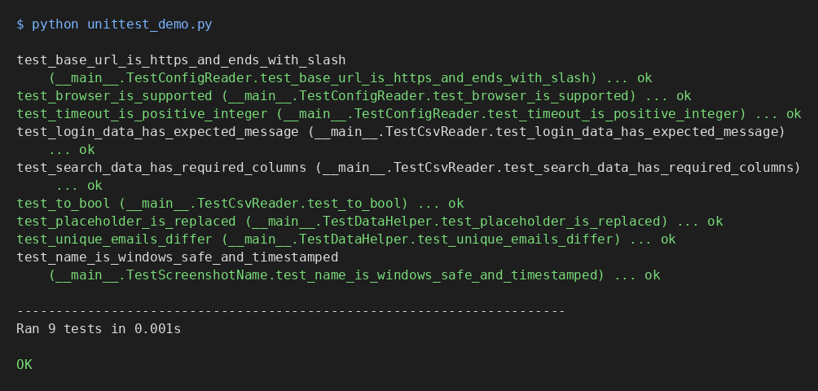
Figure 11: Unittest execution with python unittest_demo.py

7. Screenshot on Failure
conftest.py implements the pytest_runtest_makereport hook. When a test that uses the driver fixture fails, the hook saves a screenshot named <test_name>_<YYYYmmdd_HHMMSS_microseconds>.png in the screenshots/ folder and embeds the same image in the HTML report. The timestamp prevents overwriting, and characters that Windows does not allow in file names are replaced.
@pytest.hookimpl(hookwrapper=True)
def pytest_runtest_makereport(item, call):
outcome = yield
report = outcome.get_result()
if report.when in ("setup", "call") and report.failed:
driver = item.funcargs.get("driver")
file_path = take_screenshot(driver, item.name)
# ...also attached to the pytest-html report as an image

To demonstrate this, tests/test_failure_demo.py searches for "MacBook" and deliberately asserts a product that does not exist. It is skipped by default and enabled with --run-failure-demo.
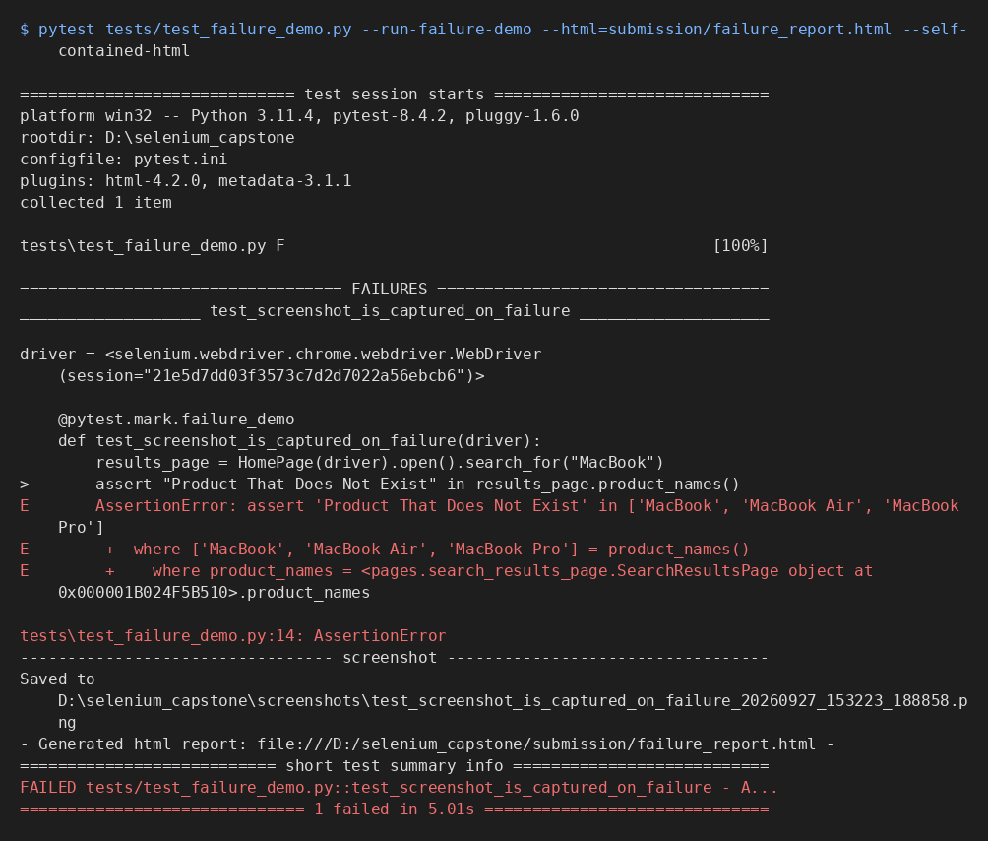
Figure 12: Console output of the failure demo showing where the screenshot was saved
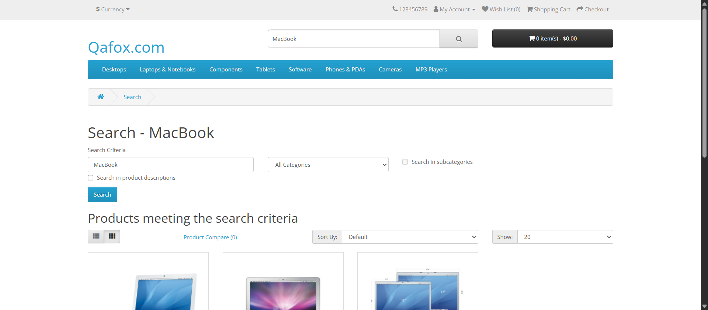
Figure 13: Screenshot captured automatically at the moment of failure
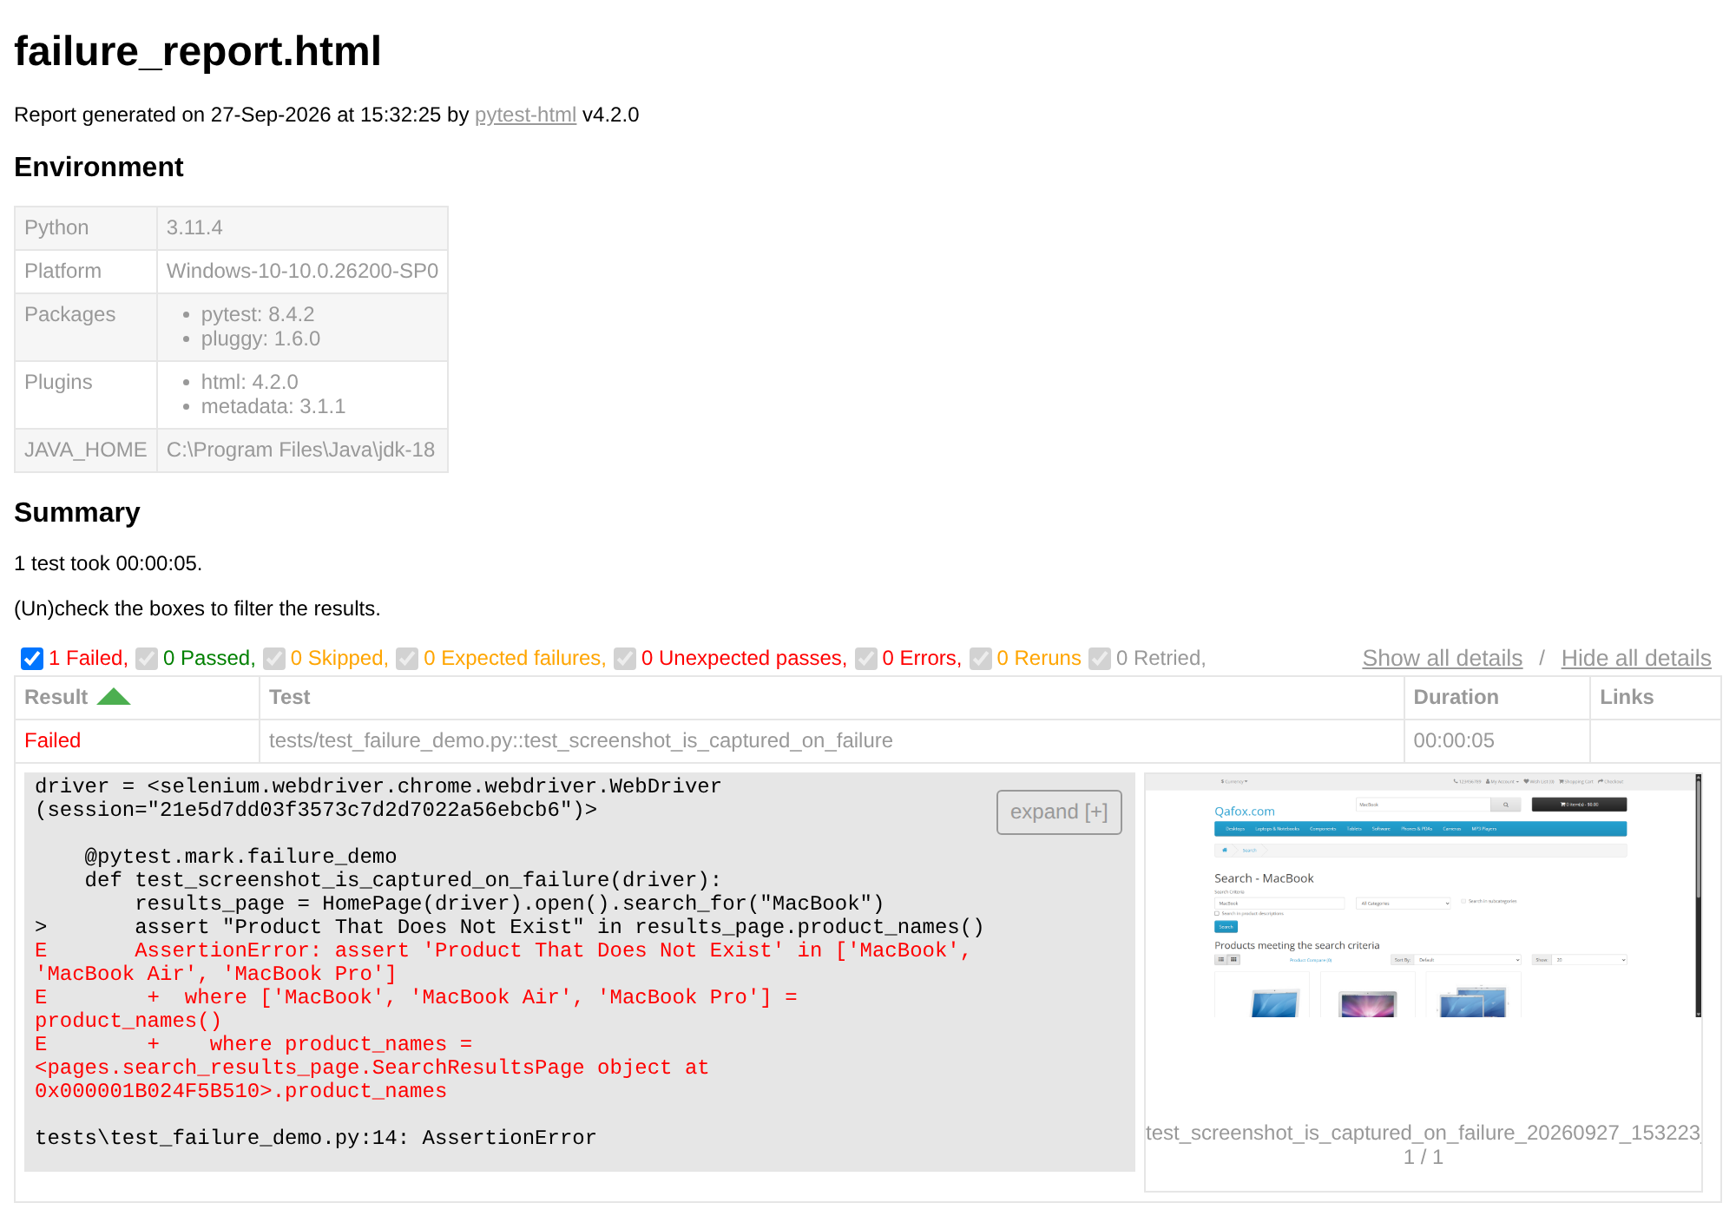
Figure 14: Failure report (failure_report.html) with the screenshot embedded

8. How to Run
python -m venv venv
venv\Scripts\activate (Git Bash: source venv/Scripts/activate)
pip install -r requirements.txt

pytest -v
pytest -v --html=report.html --self-contained-html
python unittest_demo.py
pytest -v -m search (only search tests)
pytest -v -m "not registration" (skip the account-creating test)
pytest tests/test_failure_demo.py --run-failure-demo --html=report.html --self-contained-html

9. Limitations
- The tests depend on the public TutorialsNinja demo being online and on its current product catalogue.
- The site has no official test credentials; the valid-login test therefore creates one throwaway account per run.
- Repeated failed logins for the same e-mail are locked by the site for an hour; unique e-mails avoid this.
- Chrome and Edge are configured; other browsers would need a small addition to the driver factory.

10. Conclusion
The project delivers a working, data-driven Selenium Python framework that satisfies every requirement of Capstone Assignment 2. Page objects keep locators in one place, configuration and test data are external to the code, explicit waits make the tests stable, and failures are documented automatically with screenshots in a shareable HTML report. All 19 active tests passed against the live application.

