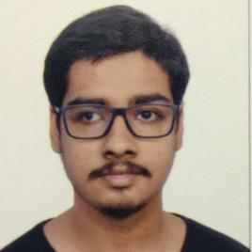
Soham Chakraborty
Final Year Undergraduate | Computer Engineering
Terna Engineering College, Mumbai
9930864402 | sohamchakraborty@ternaengg.ac.in

LANGUAGES
- Python
- Javascript
- C

WEB TECHNOLOGIES
- HTML
- CSS

VERSION CONTROL SYSTEMS
- Git
- GitHub

SOFT SKILLS
- Adaptable
- Quick Learner
- Dedicated
- Multi-tasking
- Soft Spoken

SPOKEN LANGUAGES
- English
- Hindi
- Bengali

HOBBIES
- Reading books
- Listening to music
- Aquascaping

Profile

A meticulous and organized individual skilled in design and integration with intuitive problem-solving skills. Proficient in PYTHON and Passionate about implementing and launching new projects. Ability to translate business requirements into technical solutions. Looking to start my career as an entry-level software engineer with a reputed firm driven by technology.

Education
EXAMINATION | INSTITUTION | YEAR | CGPA/%
B.E | Terna Engineering College | 2019 – 2023  (6th Sem) | 9.02/10
HSC | Atomic Energy Central  School-4, BARC | 2019 | 81%
SSC | Atomic Energy Central  School-1, BARC | 2017 | 10/10

Internships
Engineering trainee - Nuclear Power Corporation of India (NPCIL)(Govt of India) - June 2022
- Worked on a neural network based prototype for a network intrusion detection system, targeting to secure the communication network between embedded reactor consoles and operator work stations.
- analyzed the performance of implemented system and prepared technical documentation for it.

Projects Machine learning based system for breast cancer prediction | 2022 -
- Machine learning algorithms were implemented to learn trends from a medical dataset and then use them to predict ocurrence of cancer based on patient biopsy data.
Image processing based system for Intruder detection | 2021 -
- OpenCV libraries were used in python to create a motion detection algorithm which detected motion by comparing frames and finding out relative differences between frames.
Voice based email system for visually impaired users | 2020 -
- Implemented an email system which performed the task of sending and reading emails by using voice commands.

Courses
- Introduction To Programming With Python, University Of Michigan
- Machine Learning For All, University Of London
- CS50W web programming, Harvard university

