

Mini Project 3

Product Service Management – Factor Hair



February 18, 2019

Saurabh MUDGal

**Table of Contents**

1 Business Objective .............................................................................. 3

2 Proposed Solution ............................................................................... 5

2.1 Question 1 ..................................................................................... 5

2.2 Question 2 ..................................................................................... 7

2.3 Question 3 ................................................................................... 12

2.4 Question 4 ....................................................................................12

# **Business Objective**

Data file Facto-Hair.CSV contains 12 variables used for market Segmentation in the Context of Product Service Management. First 11 are independent variables and 12th (Satisfaction) is dependent variable .

## 1.1 **Data to be analysed**

|  |  |  |  |  |  |  |  |  |  |  |  |  |
| --- | --- | --- | --- | --- | --- | --- | --- | --- | --- | --- | --- | --- |
| ID | ProdQual | Ecom | TechSup | CompRes | Advertising | ProdLine | SalesFImage | ComPricing | WartyClaim | OrdBilling | DelSpeed | Satisfaction |
| 1 | 8.5 | 3.9 | 2.5 | 5.9 | 4.8 | 4.9 | 6 | 6.8 | 4.7 | 5 | 3.7 | 8.2 |
| 2 | 8.2 | 2.7 | 5.1 | 7.2 | 3.4 | 7.9 | 3.1 | 5.3 | 5.5 | 3.9 | 4.9 | 5.7 |
| 3 | 9.2 | 3.4 | 5.6 | 5.6 | 5.4 | 7.4 | 5.8 | 4.5 | 6.2 | 5.4 | 4.5 | 8.9 |
| 4 | 6.4 | 3.3 | 7 | 3.7 | 4.7 | 4.7 | 4.5 | 8.8 | 7 | 4.3 | 3 | 4.8 |
| 5 | 9 | 3.4 | 5.2 | 4.6 | 2.2 | 6 | 4.5 | 6.8 | 6.1 | 4.5 | 3.5 | 7.1 |
| 6 | 6.5 | 2.8 | 3.1 | 4.1 | 4 | 4.3 | 3.7 | 8.5 | 5.1 | 3.6 | 3.3 | 4.7 |
| 7 | 6.9 | 3.7 | 5 | 2.6 | 2.1 | 2.3 | 5.4 | 8.9 | 4.8 | 2.1 | 2 | 5.7 |
| 8 | 6.2 | 3.3 | 3.9 | 4.8 | 4.6 | 3.6 | 5.1 | 6.9 | 5.4 | 4.3 | 3.7 | 6.3 |
| 9 | 5.8 | 3.6 | 5.1 | 6.7 | 3.7 | 5.9 | 5.8 | 9.3 | 5.9 | 4.4 | 4.6 | 7 |
| 10 | 6.4 | 4.5 | 5.1 | 6.1 | 4.7 | 5.7 | 5.7 | 8.4 | 5.4 | 4.1 | 4.4 | 5.5 |
| 11 | 8.7 | 3.2 | 4.6 | 4.8 | 2.7 | 6.8 | 4.6 | 6.8 | 5.8 | 3.8 | 4 | 7.4 |
| 12 | 6.1 | 4.9 | 6.3 | 3.9 | 4.4 | 3.9 | 6.4 | 8.2 | 5.8 | 3 | 3.2 | 6 |
| 13 | 9.5 | 5.6 | 4.6 | 6.9 | 5 | 6.9 | 6.6 | 7.6 | 6.5 | 5.1 | 4.4 | 8.4 |
| 14 | 9.2 | 3.9 | 5.7 | 5.5 | 2.4 | 8.4 | 4.8 | 7.1 | 6.7 | 4.5 | 4.2 | 7.6 |
| 15 | 6.3 | 4.5 | 4.7 | 6.9 | 4.5 | 6.8 | 5.9 | 8.8 | 6 | 4.8 | 5.2 | 8 |
| 16 | 8.7 | 3.2 | 4 | 6.8 | 3.2 | 7.8 | 3.8 | 4.9 | 6.1 | 4.3 | 4.5 | 6.6 |
| 17 | 5.7 | 4 | 6.7 | 6 | 3.3 | 5.5 | 5.1 | 6.2 | 6.7 | 4.2 | 4.5 | 6.4 |
| 18 | 5.9 | 4.1 | 5.5 | 7.2 | 3.5 | 6.4 | 5.5 | 8.4 | 6.2 | 5.7 | 4.8 | 7.4 |
| 19 | 5.6 | 3.4 | 5.1 | 6.4 | 3.7 | 5.7 | 5.6 | 9.1 | 5.4 | 5 | 4.5 | 6.8 |
| 20 | 9.1 | 4.5 | 3.6 | 6.4 | 5.3 | 5.3 | 7.1 | 8.4 | 5.8 | 4.5 | 4.4 | 7.6 |
| 21 | 5.2 | 3.8 | 7.1 | 5.2 | 3.9 | 4.3 | 5 | 8.4 | 7.1 | 3.3 | 3.3 | 5.4 |
| 22 | 9.6 | 5.7 | 6.8 | 5.9 | 5.4 | 8.3 | 7.8 | 4.5 | 6.4 | 4.3 | 4.3 | 9.9 |
| 23 | 8.6 | 3.6 | 7.4 | 5.1 | 3.5 | 7.3 | 4.7 | 3.7 | 6.7 | 4.8 | 4 | 7 |
| 24 | 9.3 | 2.4 | 2.6 | 7.2 | 2.2 | 7.2 | 4.5 | 6.2 | 6.4 | 6.7 | 4.5 | 8.6 |
| 25 | 6 | 4.1 | 5.3 | 4.7 | 3.5 | 5.3 | 5.3 | 8 | 6.5 | 4.7 | 4 | 4.8 |
| 26 | 6.4 | 3.6 | 6.6 | 6.1 | 4 | 3.9 | 5.3 | 7.1 | 6.1 | 5.6 | 3.9 | 6.6 |
| 27 | 8.5 | 3 | 7.2 | 5.8 | 4.1 | 7.6 | 3.7 | 4.8 | 6.9 | 5.3 | 4.4 | 6.3 |
| 28 | 7 | 3.3 | 5.4 | 5.5 | 2.6 | 4.8 | 4.2 | 9 | 6.5 | 4.3 | 3.7 | 5.4 |
| 29 | 8.5 | 3 | 5.7 | 6 | 2.3 | 7.6 | 3.7 | 4.8 | 5.8 | 5.7 | 4.4 | 6.3 |
| 30 | 7.6 | 3.6 | 3 | 4 | 5.1 | 4.2 | 4.6 | 7.7 | 4.9 | 4.7 | 3.5 | 5.4 |
| 31 | 6.9 | 3.4 | 8.5 | 4.3 | 4.5 | 6.4 | 4.7 | 5.2 | 7.7 | 3.7 | 3.3 | 6.1 |
| 32 | 8.1 | 2.5 | 7.2 | 4.5 | 2.3 | 5.1 | 3.8 | 6.6 | 6.8 | 3 | 3 | 6.4 |
| 33 | 6.7 | 3.7 | 6.5 | 5.3 | 5.3 | 5.1 | 4.9 | 9.2 | 5.7 | 3.5 | 3.4 | 5.4 |
| 34 | 8 | 3.3 | 6.1 | 5.7 | 5.5 | 4.6 | 4.7 | 8.7 | 5.9 | 4.7 | 4.2 | 7.3 |
| 35 | 6.7 | 4 | 5.2 | 3.9 | 3 | 5.4 | 6.8 | 8.4 | 6.2 | 2.5 | 3.5 | 6.3 |
| 36 | 8.7 | 3.2 | 6.1 | 4.3 | 3.5 | 6.1 | 2.9 | 5.6 | 6.1 | 3.1 | 2.5 | 5.4 |
| 37 | 9 | 3.4 | 5.9 | 4.6 | 3.9 | 6 | 4.5 | 6.8 | 6.4 | 3.9 | 3.5 | 7.1 |
| 38 | 9.6 | 4.1 | 6.2 | 7.3 | 2.9 | 7.7 | 5.5 | 7.7 | 6.1 | 5.2 | 4.9 | 8.7 |
| 39 | 8.2 | 3.6 | 3.9 | 6.2 | 5.8 | 4.9 | 5 | 9 | 5.2 | 4.7 | 4.5 | 7.6 |
| 40 | 6.1 | 4.9 | 3 | 4.8 | 5.1 | 3.9 | 6.4 | 8.2 | 5.1 | 4.5 | 3.2 | 6 |
| 41 | 8.3 | 3.4 | 3.3 | 5.5 | 3.1 | 4.6 | 5.2 | 9.1 | 4.1 | 4.6 | 3.9 | 7 |
| 42 | 9.4 | 3.8 | 4.7 | 5.4 | 3.8 | 6.5 | 4.9 | 8.5 | 4.9 | 4.1 | 4.1 | 7.6 |
| 43 | 9.3 | 5.1 | 4.6 | 6.8 | 5.8 | 6.6 | 6.3 | 7.4 | 5.1 | 4.6 | 4.3 | 8.9 |
| 44 | 5.1 | 5.1 | 6.6 | 6.9 | 4.4 | 5.4 | 7.8 | 5.9 | 7.2 | 4.9 | 4.5 | 7.6 |
| 45 | 8 | 2.5 | 4.7 | 7.1 | 3.6 | 7.7 | 3 | 5.2 | 5.1 | 4.3 | 4.7 | 5.5 |
| 46 | 5.9 | 4.1 | 5.7 | 5.9 | 5.8 | 6.4 | 5.5 | 8.4 | 6.4 | 5.2 | 4.8 | 7.4 |
| 47 | 10 | 4.3 | 7.1 | 6.3 | 2.9 | 5.4 | 4.5 | 3.8 | 6.7 | 5 | 3.5 | 7.1 |
| 48 | 5.7 | 3.8 | 6.8 | 7.5 | 5.7 | 5.7 | 6 | 8.2 | 6.6 | 6.5 | 5.2 | 7.6 |
| 49 | 9.9 | 3.7 | 3.7 | 6.1 | 4.2 | 7 | 6.7 | 6.8 | 5.9 | 4.5 | 3.9 | 8.7 |
| 50 | 7.9 | 3.9 | 4.3 | 5.8 | 4.4 | 6.9 | 5.8 | 4.7 | 5.2 | 4.1 | 4.3 | 8.6 |
| 51 | 6.7 | 3.6 | 5.9 | 4.2 | 3.4 | 4.7 | 4.8 | 7.2 | 5.7 | 4 | 2.8 | 5.4 |
| 52 | 8.2 | 2.7 | 3.7 | 7.4 | 2.7 | 7.9 | 3.1 | 5.3 | 5.3 | 4.5 | 4.9 | 5.7 |
| 53 | 9.4 | 2.5 | 4.8 | 6.1 | 3.2 | 7.3 | 4.6 | 6.3 | 6.3 | 4.7 | 4.6 | 8.7 |
| 54 | 6.9 | 3.4 | 5.7 | 4.4 | 3.3 | 6.4 | 4.7 | 5.2 | 6.4 | 3.2 | 3.3 | 6.1 |
| 55 | 8 | 3.3 | 3.8 | 5.8 | 3.2 | 4.6 | 4.7 | 8.7 | 5.3 | 4.9 | 4.2 | 7.3 |
| 56 | 9.3 | 3.8 | 7.3 | 5.7 | 3.7 | 6.4 | 5.5 | 7.4 | 6.6 | 4.1 | 3.4 | 7.7 |
| 57 | 7.4 | 5.1 | 4.8 | 7.7 | 4.5 | 7.2 | 6.9 | 9.6 | 6.4 | 5.7 | 5.5 | 9 |
| 58 | 7.6 | 3.6 | 5.2 | 5.8 | 5.6 | 6.6 | 5.4 | 4.4 | 6.7 | 4.6 | 4 | 8.2 |
| 59 | 10 | 4.3 | 5.3 | 3.7 | 4.2 | 5.4 | 4.5 | 3.8 | 6.7 | 3.7 | 3.5 | 7.1 |
| 60 | 9.9 | 2.8 | 7.2 | 6.9 | 2.6 | 5.8 | 3.5 | 5.4 | 6.2 | 5.6 | 4 | 7.9 |
| 61 | 8.7 | 3.2 | 8.4 | 6.1 | 2.8 | 7.8 | 3.8 | 4.9 | 7.2 | 5.4 | 4.5 | 6.6 |
| 62 | 8.4 | 3.8 | 6.7 | 5 | 4.5 | 4.7 | 5.9 | 6.7 | 5.1 | 2.7 | 3.6 | 8 |
| 63 | 8.8 | 3.9 | 3.8 | 5.1 | 4.3 | 4.7 | 4.8 | 5.8 | 5 | 4.4 | 2.9 | 6.3 |
| 64 | 7.7 | 2.2 | 6.3 | 4.5 | 2.4 | 4.7 | 3.4 | 6.2 | 6 | 3.3 | 2.6 | 6 |
| 65 | 6.6 | 3.6 | 5.8 | 4.1 | 4.9 | 4.7 | 4.8 | 7.2 | 6.5 | 3.5 | 2.8 | 5.4 |
| 66 | 5.7 | 3.8 | 3.5 | 6.7 | 5.4 | 5.7 | 6 | 8.2 | 5.4 | 4.7 | 5.2 | 7.6 |
| 67 | 5.7 | 4 | 7.9 | 6.4 | 2.7 | 5.5 | 5.1 | 6.2 | 7.5 | 5 | 4.5 | 6.4 |
| 68 | 5.5 | 3.7 | 4.7 | 5.4 | 4.3 | 5.3 | 4.9 | 6 | 5.6 | 4.5 | 4.3 | 6.1 |
| 69 | 7.5 | 3.5 | 3.8 | 3.5 | 2.9 | 4.1 | 4.5 | 7.6 | 5.1 | 4 | 3.4 | 5.2 |
| 70 | 6.4 | 3.6 | 2.7 | 5.3 | 3.9 | 3.9 | 5.3 | 7.1 | 5.2 | 4.7 | 3.9 | 6.6 |
| 71 | 9.1 | 4.5 | 6.1 | 5.9 | 6.3 | 5.3 | 7.1 | 8.4 | 7.1 | 5.4 | 4.4 | 7.6 |
| 72 | 6.7 | 3.2 | 3 | 3.7 | 4.8 | 6.3 | 4.5 | 5 | 5.2 | 2.9 | 3.1 | 5.8 |
| 73 | 6.5 | 4.3 | 2.7 | 6.6 | 6.5 | 6.3 | 6 | 8.7 | 4.7 | 4.6 | 4.6 | 7.9 |
| 74 | 9.9 | 3.7 | 7.5 | 4.7 | 5.6 | 7 | 6.7 | 6.8 | 7.2 | 4.1 | 3.9 | 8.6 |
| 75 | 8.5 | 3.9 | 5.3 | 5.5 | 5 | 4.9 | 6 | 6.8 | 5.7 | 4.4 | 3.7 | 8.2 |
| 76 | 9.9 | 3 | 6.8 | 5 | 5.4 | 5.9 | 4.8 | 4.9 | 7.3 | 3.1 | 3.8 | 7.1 |
| 77 | 7.6 | 3.6 | 7.6 | 4.6 | 4.7 | 4.6 | 5 | 7.4 | 8.1 | 4.5 | 3.9 | 6.4 |
| 78 | 9.4 | 3.8 | 7 | 6.2 | 4.7 | 6.5 | 4.9 | 8.5 | 7.3 | 4.3 | 4.1 | 7.6 |
| 79 | 9.3 | 3.5 | 6.3 | 7.6 | 5.5 | 7.5 | 5.9 | 4.6 | 6.6 | 5.2 | 4.6 | 8.9 |
| 80 | 7.1 | 3.4 | 4.9 | 4.1 | 4 | 5 | 5.9 | 7.8 | 6.1 | 2.6 | 2.7 | 5.7 |
| 81 | 9.9 | 3 | 7.4 | 4.8 | 4 | 5.9 | 4.8 | 4.9 | 5.9 | 3.2 | 3.8 | 7.1 |
| 82 | 8.7 | 3.2 | 6.4 | 4.9 | 2.4 | 6.8 | 4.6 | 6.8 | 6.3 | 4.3 | 4 | 7.4 |
| 83 | 8.6 | 2.9 | 5.8 | 3.9 | 2.9 | 5.6 | 4 | 6.3 | 6.1 | 2.7 | 3 | 6.6 |
| 84 | 6.4 | 3.2 | 6.7 | 3.6 | 2.2 | 2.9 | 5 | 8.4 | 7.3 | 2 | 1.6 | 5 |
| 85 | 7.7 | 2.6 | 6.7 | 6.6 | 1.9 | 7.2 | 4.3 | 5.9 | 6.5 | 4.7 | 4.3 | 8.2 |
| 86 | 7.5 | 3.5 | 4.1 | 4.5 | 3.5 | 4.1 | 4.5 | 7.6 | 4.9 | 3.4 | 3.4 | 5.2 |
| 87 | 5 | 3.6 | 1.3 | 3 | 3.5 | 4.2 | 4.9 | 8.2 | 4.3 | 2.4 | 3.1 | 5.2 |
| 88 | 7.7 | 2.6 | 8 | 6.7 | 3.5 | 7.2 | 4.3 | 5.9 | 6.9 | 5.1 | 4.3 | 8.2 |
| 89 | 9.1 | 3.6 | 5.5 | 5.4 | 4.2 | 6.2 | 4.6 | 8.3 | 6.5 | 4.6 | 3.9 | 7.3 |
| 90 | 5.5 | 5.5 | 7.7 | 7 | 5.6 | 5.7 | 8.2 | 6.3 | 7.4 | 5.5 | 4.9 | 8.2 |
| 91 | 9.1 | 3.7 | 7 | 4.1 | 4.4 | 6.3 | 5.4 | 7.3 | 7.5 | 4.4 | 3.3 | 7.4 |
| 92 | 7.1 | 4.2 | 4.1 | 2.6 | 2.1 | 3.3 | 4.5 | 9.9 | 5.5 | 2 | 2.4 | 4.8 |
| 93 | 9.2 | 3.9 | 4.6 | 5.3 | 4.2 | 8.4 | 4.8 | 7.1 | 6.2 | 4.4 | 4.2 | 7.6 |
| 94 | 9.3 | 3.5 | 5.4 | 7.8 | 4.6 | 7.5 | 5.9 | 4.6 | 6.4 | 4.8 | 4.6 | 8.9 |
| 95 | 9.3 | 3.8 | 4 | 4.6 | 4.7 | 6.4 | 5.5 | 7.4 | 5.3 | 3.6 | 3.4 | 7.7 |
| 96 | 8.6 | 4.8 | 5.6 | 5.3 | 2.3 | 6 | 5.7 | 6.7 | 5.8 | 4.9 | 3.6 | 7.3 |
| 97 | 7.4 | 3.4 | 2.6 | 5 | 4.1 | 4.4 | 4.8 | 7.2 | 4.5 | 4.2 | 3.7 | 6.3 |
| 98 | 8.7 | 3.2 | 3.3 | 3.2 | 3.1 | 6.1 | 2.9 | 5.6 | 5 | 3.1 | 2.5 | 5.4 |
| 99 | 7.8 | 4.9 | 5.8 | 5.3 | 5.2 | 5.3 | 7.1 | 7.9 | 6 | 4.3 | 3.9 | 6.4 |
| 100 | 7.9 | 3 | 4.4 | 5.1 | 5.9 | 4.2 | 4.8 | 9.7 | 5.7 | 3.4 | 3.5 | 6.4 |

## **Outstanding Questions**

* Is there evidence of multicollinearity?
* Perform FA by extracting four factors
* Name the factors
* Perform Multiple Linear Regression with customer satisfaction as Dependent variable and four factors as independent variables .Comment On Model validity.

# **Proposed Solution**

## 2.1 **Is there evidence of multicollinearity**

Multicollinearity is phenomena which occur when independent variables in regression models are correlated.

A correlation coefficient is a statistical measure of the degree to which changes to the value of one variable predict change to the value of another. It’s value lies between -1 to +1.

Given data file has 12 variables.

Here satisfaction is dependent variable and all other are independent

Variables. All 100 rows in variables depict the customer rating on the scale of 1 to 10 .

To check multicollinearity in all independent variables, we are using R as tool .

It shows correlation among all independent variable :

> mycorr

|  |
| --- |
| > mydata=mydata[,c(2:12)] ###extracting 2 to 12 columns only  > ##correlation  > mycorr = round (cor(mydata),2)  > mycorr  ProdQual Ecom TechSup CompRes Advertising ProdLine  ProdQual 1.00 -0.14 0.10 0.11 -0.05 0.48  Ecom -0.14 1.00 0.00 0.14 0.43 -0.05  TechSup 0.10 0.00 1.00 0.10 -0.06 0.19  CompRes 0.11 0.14 0.10 1.00 0.20 0.56  Advertising -0.05 0.43 -0.06 0.20 1.00 -0.01  ProdLine 0.48 -0.05 0.19 0.56 -0.01 1.00  SalesFImage -0.15 0.79 0.02 0.23 0.54 -0.06  ComPricing -0.40 0.23 -0.27 -0.13 0.13 -0.49  WartyClaim 0.09 0.05 0.80 0.14 0.01 0.27  OrdBilling 0.10 0.16 0.08 0.76 0.18 0.42  DelSpeed 0.03 0.19 0.03 0.87 0.28 0.60  SalesFImage ComPricing WartyClaim OrdBilling DelSpeed  ProdQual -0.15 -0.40 0.09 0.10 0.03  Ecom 0.79 0.23 0.05 0.16 0.19  TechSup 0.02 -0.27 0.80 0.08 0.03  CompRes 0.23 -0.13 0.14 0.76 0.87  Advertising 0.54 0.13 0.01 0.18 0.28  ProdLine -0.06 -0.49 0.27 0.42 0.60  SalesFImage 1.00 0.26 0.11 0.20 0.27  ComPricing 0.26 1.00 -0.24 -0.11 -0.07  WartyClaim 0.11 -0.24 1.00 0.20 0.11  OrdBilling 0.20 -0.11 0.20 1.00 0.75  DelSpeed 0.27 -0.07 0.11 0.75 1.00 |
|  |
| |  | | --- | | > | |

plot(mydata) : This command will plot the same correlation in graphical manner .

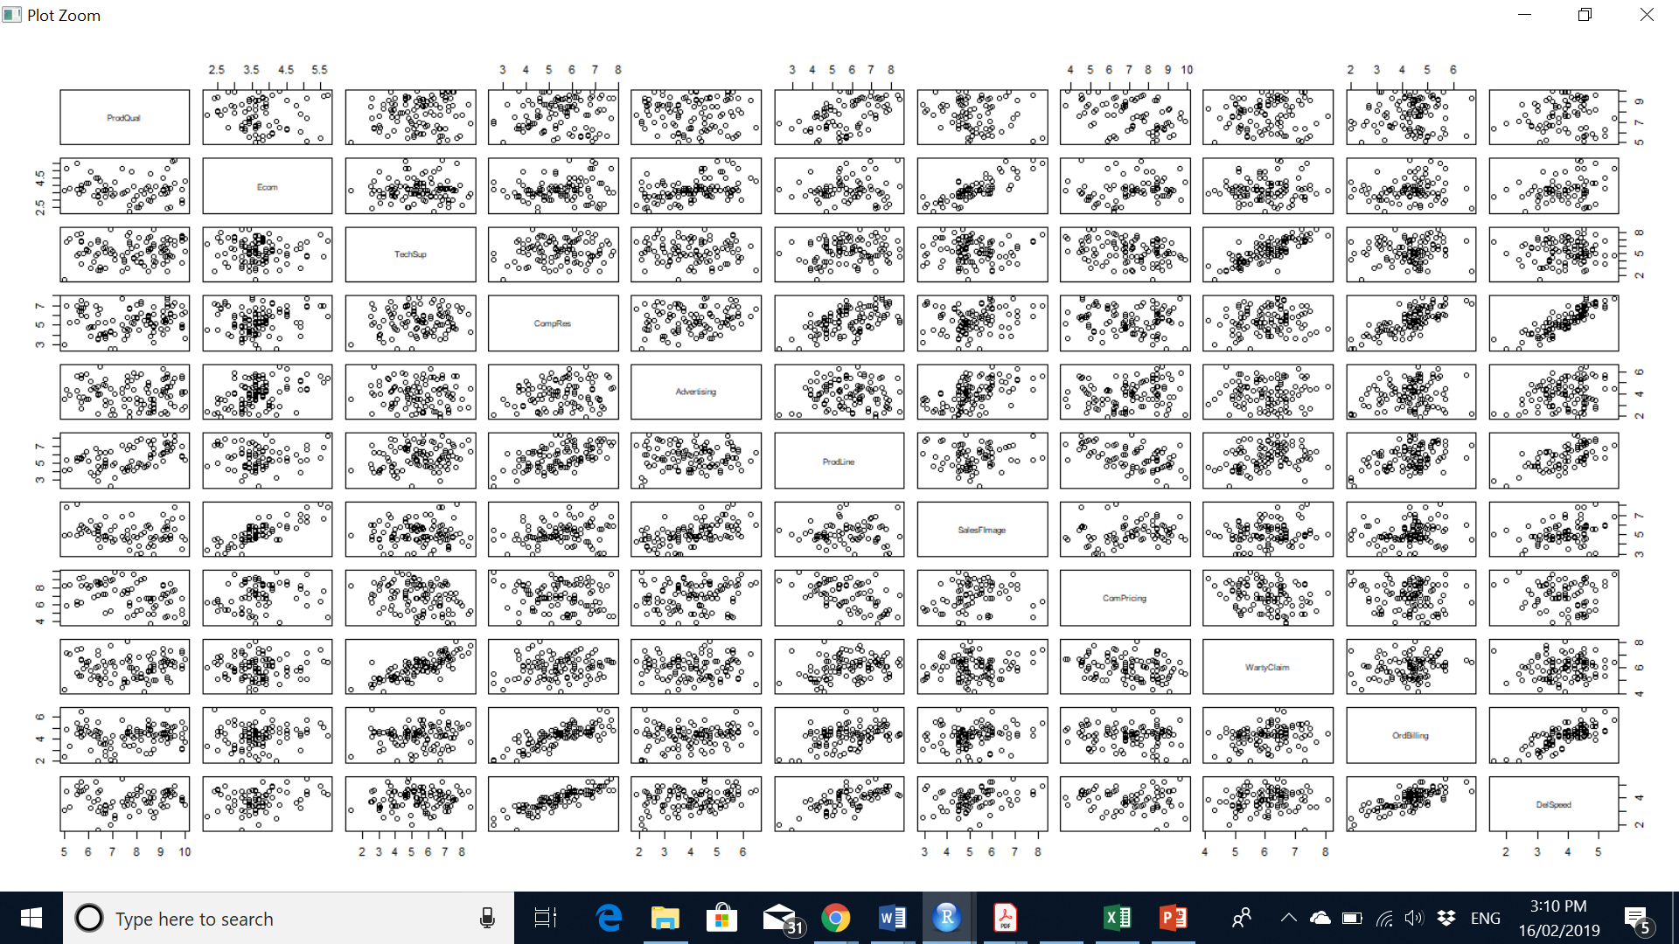

This clearly shows that –

**Product Quality**

* Product quality has moderate positive correlation with product line
* Product quality has moderate negative correlation with competitive pricing .

**E-commerce**

* + - Ecommerce has moderate positive correlation Advertising
    - Ecommerce has strong positive correlation Sales force image

**Tech Support**

* + - Tech Support has strong positive correlation with warranty claim

**Complain resolution**

* + - Complain resolution has strong positive correlation with ordering billing and delivery speed
    - Complain resolution has moderate positive correlation with prod line

**Advertising**

* Advertising has moderate positive correlation with e-commerce and sales force image

**Product line**

* + Product line has moderate positive correlation with product quality and complain resolution
  + Product line has moderate Negative correlation with Competitor Pricing .

**Salesforce Image**

* Salesforce image has string positive correlation with E-commerce

**Competitor Pricing**

* Competitor pricing has moderate negative correlation with product line

**Warranty claim**

* Warranty claim has strong positive correlation with Tech Support

**Order Billing**

* + Order billing has strong positive correlation with Delivery sped and complain resolution

**Delivery Speed**

* + Delivery speed has strong positive correlation with order billing and complain resolution

## **Perform Factor Analysis**

### Factor analysis Is the process of dimension reduction.

As there is multicollinearity in data set, hence Factor analysis can be used to explain Correlation between the variables. We have used eigen value and Scree plot to find the number of factors to be retained out of 11 dependent variables.

> library(nFactors)

> plot(mycorr)

> plot(mycorr)

> ev=eigen(cor(mydata)) ## eigen value is the basis for selecting # of factors

> ev

eigen() decomposition

$`values`

[1] 3.42697133 2.55089671 1.69097648 1.08655606 0.60942409

[6] 0.55188378 0.40151815 0.24695154 0.20355327 0.13284158

[11] 0.09842702

$vectors

[,1] [,2] [,3] [,4] [,5]

[1,] -0.1337896 0.31349802 0.06227164 0.6431362 0.23166620

[2,] -0.1659528 -0.44650918 -0.23524791 0.2723803 0.42228844

[3,] -0.1576926 0.23096734 -0.61095105 -0.1933931 -0.02395667

[4,] -0.4706836 -0.01944394 0.21035078 -0.2063204 0.02865743

[5,] -0.1837350 -0.36366471 -0.08809705 0.3178945 -0.80387024

[6,] -0.3867652 0.28478056 0.11627864 0.2029023 0.11667416

[7,] -0.2036696 -0.47069599 -0.24134210 0.2221772 0.20437283

[8,] 0.1516886 -0.41345650 0.05304529 -0.3335435 0.24892601

[9,] -0.2129336 0.19167191 -0.59856398 -0.1853020 -0.03292706

[10,] -0.4372177 -0.02639905 0.16892981 -0.2368536 0.02675377

[11,] -0.4730891 -0.07305172 0.23262477 -0.1973299 -0.03543294

[,6] [,7] [,8] [,9] [,10]

[1,] 0.56456996 -0.191641317 0.13547311 0.03132810 -0.06659717

[2,] -0.26325703 -0.059626208 -0.12202642 -0.54251104 -0.28155772

[3,] 0.10876896 0.017199915 0.46470964 -0.35929961 0.38817090

[4,] 0.02815231 0.008499596 0.51339754 0.09324751 -0.53467243

[5,] 0.20056937 0.063069619 -0.05347713 -0.15468169 -0.03715799

[6,] -0.09819533 0.608147555 -0.33320710 -0.08415534 0.23479794

[7,] -0.10497225 -0.001437351 0.16910665 0.64489911 0.35341191

[8,] 0.70973595 0.308248871 -0.09883227 -0.09414389 0.04518224

[9,] 0.13983966 0.030640243 -0.44354040 0.31756604 -0.43534752

[10,] 0.11947974 -0.659319893 -0.36601754 -0.09907265 0.30386545

[11,] -0.02979992 0.234239274 0.06539059 -0.02188514 0.12010386

[,11]

[1,] -0.18279209

[2,] -0.06233863

[3,] 0.05192956

[4,] 0.36253352

[5,] 0.08118684

[6,] 0.38507778

[7,] 0.08469869

[8,] 0.10295751

[9,] -0.12893245

[10,] 0.19415064

> EigenValue=ev$values

> ev

eigen() decomposition

$`values`

[1] 3.42697133 2.55089671 1.69097648 1.08655606 0.60942409

[6] 0.55188378 0.40151815 0.24695154 0.20355327 0.13284158

[11] 0.09842702

$vectors

[,1] [,2] [,3] [,4] [,5]

[1,] -0.1337896 0.31349802 0.06227164 0.6431362 0.23166620

[2,] -0.1659528 -0.44650918 -0.23524791 0.2723803 0.42228844

[3,] -0.1576926 0.23096734 -0.61095105 -0.1933931 -0.02395667

[4,] -0.4706836 -0.01944394 0.21035078 -0.2063204 0.02865743

[5,] -0.1837350 -0.36366471 -0.08809705 0.3178945 -0.80387024

[6,] -0.3867652 0.28478056 0.11627864 0.2029023 0.11667416

[7,] -0.2036696 -0.47069599 -0.24134210 0.2221772 0.20437283

[8,] 0.1516886 -0.41345650 0.05304529 -0.3335435 0.24892601

[9,] -0.2129336 0.19167191 -0.59856398 -0.1853020 -0.03292706

[10,] -0.4372177 -0.02639905 0.16892981 -0.2368536 0.02675377

[11,] -0.4730891 -0.07305172 0.23262477 -0.1973299 -0.03543294

[,6] [,7] [,8] [,9] [,10]

[1,] 0.56456996 -0.191641317 0.13547311 0.03132810 -0.06659717

[2,] -0.26325703 -0.059626208 -0.12202642 -0.54251104 -0.28155772

[3,] 0.10876896 0.017199915 0.46470964 -0.35929961 0.38817090

[4,] 0.02815231 0.008499596 0.51339754 0.09324751 -0.53467243

[5,] 0.20056937 0.063069619 -0.05347713 -0.15468169 -0.03715799

[6,] -0.09819533 0.608147555 -0.33320710 -0.08415534 0.23479794

[7,] -0.10497225 -0.001437351 0.16910665 0.64489911 0.35341191

[8,] 0.70973595 0.308248871 -0.09883227 -0.09414389 0.04518224

[9,] 0.13983966 0.030640243 -0.44354040 0.31756604 -0.43534752

[10,] 0.11947974 -0.659319893 -0.36601754 -0.09907265 0.30386545

[11,] -0.02979992 0.234239274 0.06539059 -0.02188514 0.12010386

[,11]

[1,] -0.18279209

[2,] -0.06233863

[3,] 0.05192956

[4,] 0.36253352

[5,] 0.08118684

[6,] 0.38507778

[7,] 0.08469869

[8,] 0.10295751

[9,] -0.12893245

[10,] 0.19415064

[11,] -0.77563222

> EigenValue=ev$values

> EigenValue ### eigen values are varying in magnitude and are

## in decreasing order so we have multicollinearity.

[1] 3.42697133 2.55089671 1.69097648 1.08655606 0.60942409

[6] 0.55188378 0.40151815 0.24695154 0.20355327 0.13284158

[11] 0.09842702

> Factor=c(1,2,3,4,5,6,7,8,9,10,11)

> Scree=data.frame(Factor,EigenValue)

> plot(Scree,main="Scree Plot", col="Blue")

> lines(Scree,col="Red")

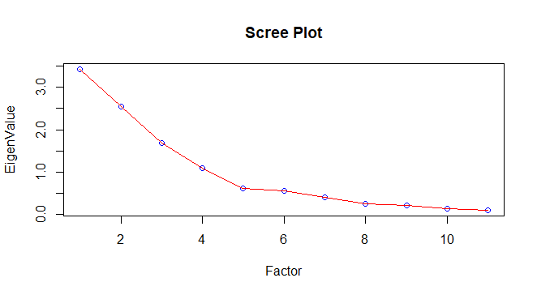

Scree plot is used to identify number of factors .As the eigen value is >1 for only 4 factors hence as per kaiser rule 4 factors are selected .

Here is Principal component Factor analysis which gives correlation between 4 factors and 11 variables .

> ## get principal component factors

> Unrotate=principal(mydata, nfactors=4, rotate="none")

> print(Unrotate,digits=4)

Principal Components Analysis

Call: principal(r = mydata, nfactors = 4, rotate = "none")

Standardized loadings (pattern matrix) based upon correlation matrix

PC1 PC2 PC3 PC4 h2 u2 com

ProdQual 0.2477 -0.5007 -0.0810 0.6704 0.7680 0.23197 2.196

Ecom 0.3072 0.7131 0.3059 0.2839 0.7771 0.22285 2.136

TechSup 0.2919 -0.3689 0.7945 -0.2016 0.8931 0.10689 1.873

CompRes 0.8713 0.0311 -0.2735 -0.2151 0.8813 0.11874 1.329

Advertising 0.3401 0.5808 0.1146 0.3314 0.5760 0.42402 2.379

ProdLine 0.7160 -0.4548 -0.1512 0.2115 0.7871 0.21289 2.011

SalesFImage 0.3770 0.7518 0.3138 0.2316 0.8594 0.14055 2.097

ComPricing -0.2808 0.6604 -0.0690 -0.3477 0.6406 0.35944 1.945

WartyClaim 0.3942 -0.3061 0.7784 -0.1932 0.8922 0.10775 1.984

OrdBilling 0.8094 0.0422 -0.2197 -0.2469 0.7661 0.23391 1.349

DelSpeed 0.8758 0.1167 -0.3025 -0.2057 0.9144 0.08557 1.397

PC1 PC2 PC3 PC4

SS loadings 3.4270 2.5509 1.6910 1.0866

Proportion Var 0.3115 0.2319 0.1537 0.0988

Cumulative Var 0.3115 0.5434 0.6972 0.7959

Proportion Explained 0.3914 0.2914 0.1931 0.1241

Cumulative Proportion 0.3914 0.6828 0.8759 1.0000

Mean item complexity = 1.9

Test of the hypothesis that 4 components are sufficient.

The root mean square of the residuals (RMSR) is 0.0596

with the empirical chi square 39.0225 with prob < 0.001774

* PC1 has high correlation with Comp res , prod line , ord billing and Del speed .
* PC2 shows correlation for Prod quality ,Ecom, advertising,salesFimage , and comp pricing
* PC3 shows high correlation for tech support , warranty claim
* PC4 shows correlation with prod quality only .
* SS loading gives eigen value and variance shows how much of variance is being explained

by these factors . In total 80% variance is being explained by 4 factors .

* H2 is communality which shows percentage variance explained by all factors together for particular variable . Example Del speed variance is more then 90% explained by 4 factors .

We are not getting concrete result hence not able to conclude . We can try orthogonal rotation to push lower values toward zero and higher value toward 1.

> ## orthogonal rotation

> UnrotatedProfile=plot(Unrotate,row.names(Unrotate$loadings))

> Rotate=principal(mydata,nfactors=4,rotate="varimax")

> print(Rotate,digits=4)

Principal Components Analysis

Call: principal(r = mydata, nfactors = 4, rotate = "varimax")

Standardized loadings (pattern matrix) based upon correlation matrix

RC1 RC2 RC3 RC4 h2 u2 com

ProdQual 0.0015 -0.0127 -0.0328 0.8757 0.7680 0.23197 1.003

Ecom 0.0568 0.8706 0.0473 -0.1175 0.7771 0.22285 1.051

TechSup 0.0183 -0.0245 0.9392 0.1005 0.8931 0.10689 1.025

CompRes 0.9258 0.1159 0.0486 0.0912 0.8813 0.11874 1.057

Advertising 0.1388 0.7415 -0.0816 0.0147 0.5760 0.42402 1.096

ProdLine 0.5912 -0.0640 0.1460 0.6420 0.7871 0.21289 2.118

SalesFImage 0.1325 0.9005 0.0756 -0.1592 0.8594 0.14055 1.122

ComPricing -0.0851 0.2256 -0.2455 -0.7226 0.6406 0.35944 1.471

WartyClaim 0.1098 0.0548 0.9310 0.1022 0.8922 0.10775 1.059

OrdBilling 0.8638 0.1068 0.0839 0.0393 0.7661 0.23391 1.054

DelSpeed 0.9382 0.1773 -0.0046 0.0523 0.9144 0.08557 1.078

RC1 RC2 RC3 RC4

SS loadings 2.8927 2.2336 1.8555 1.7736

Proportion Var 0.2630 0.2031 0.1687 0.1612

Cumulative Var 0.2630 0.4660 0.6347 0.7959

Proportion Explained 0.3304 0.2551 0.2119 0.2026

Cumulative Proportion 0.3304 0.5855 0.7974 1.0000

Mean item complexity = 1.2

Test of the hypothesis that 4 components are sufficient.

The root mean square of the residuals (RMSR) is 0.0596

with the empirical chi square 39.0225 with prob < 0.001774

Fit based upon off diagonal values = 0.9682

* RC1 has high correlation with Comp res , ord billing and Del speed .
* RC2 shows correlation for Ecom, advertising,salesFimage
* RC3 shows high correlation for tech support, warranty claim
* RC4 shows correlation with prod quality and prod line.

RotatedProfile=plot(Rotate,row.names(Rotate$loadings),cex=1.0)

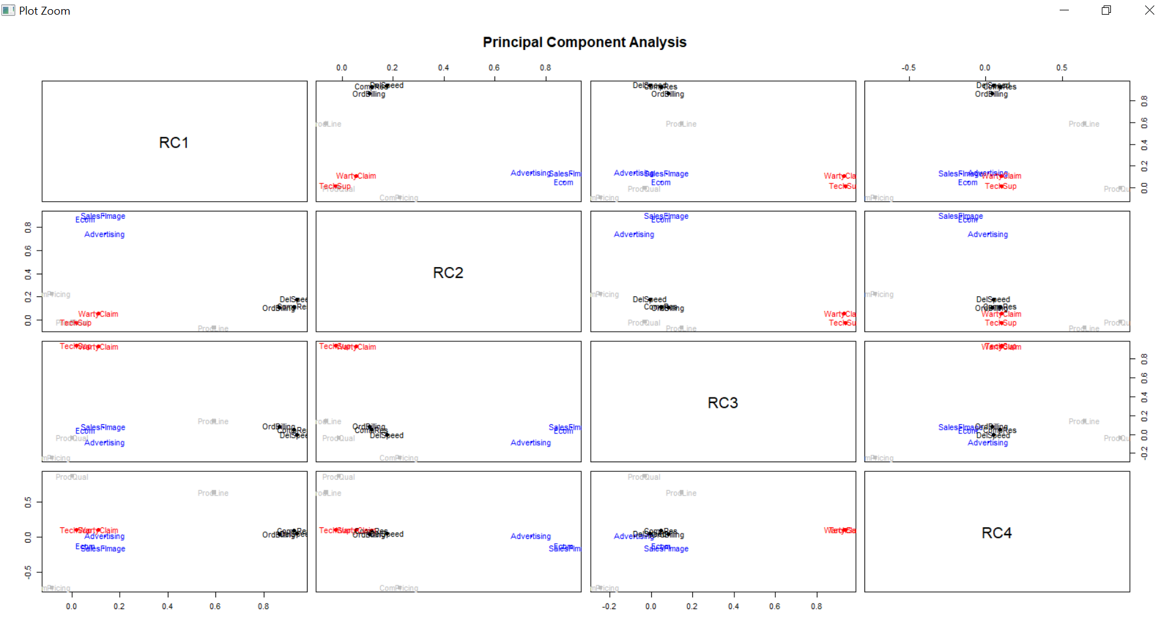Since now the loading has changed and moved toward higher and lower side . Rotation has achieved clear pattern recognition, hence we can recommend factors grouping.

## **2.3 Name the factors**

### 2.3.1 Factors can be names as :

* RC1 can be named as Order Management
* RC2 can be named as Sales Management
* RC3 can be named as Customer Management
* RC4 can be named as Product Management

## **Perform Multiple Linear Regression with customer satisfaction as Dependent variable and four factors as independent variables .Comment On Model validity.**

#### 2.4.1 Multiple Linear Regression is extension of Simple Linear regression.

It is used when we want to predict the value of dependent variable based on the

The value of two or more independent variables .

Here in problem statement we have Customer satisfaction as dependent

Variables and four derived factors obtained in section 2.3 as independent

Variables.

To start with let’s create the data frame for all 5 variables.

|  |
| --- |
| > Rotate$scores #will give scores for 4 factors, here we can check for these 4 factors  RC1 RC2 RC3 RC4  [1,] 0.12749104 0.76986860 -1.878446273 0.36648477  [2,] 1.22166663 -1.64586166 -0.614030010 0.81306481  [3,] 0.61582140 0.58000368 0.003689252 1.56997685  [4,] -0.84462665 -0.27192183 1.267493254 -1.25416452  [5,] -0.31979430 -0.83406501 -0.008096627 0.44753766  [6,] -0.64702925 -1.06726829 -1.303198892 -1.05277921  [7,] -2.62679851 -0.24588272 -0.555423494 -1.22601470  [8,] -0.27936394 -0.15732039 -0.749311481 -1.01464175  [9,] 1.05151341 -0.17228834 -0.092252815 -1.65809634  [10,] 0.42875382 0.76353272 -0.450377116 -0.89116595  [11,] -0.13580761 -0.76759698 -0.463706767 0.60634140  [12,] -1.45030579 1.35959912 0.437785016 -1.06981053  [13,] 0.62461823 2.11311565 -0.168284409 0.87466736  [14,] 0.42724294 -0.40405102 0.432245882 0.90236591  [15,] 1.43869881 0.66394839 -0.268050576 -1.04431806  [16,] 0.91969055 -1.05791159 -0.556847385 1.16667179  [17,] 0.52182175 -0.31959634 1.106009732 -1.03228845  [18,] 1.71349224 -0.16356534 0.254874808 -1.47834954  [19,] 1.16101062 -0.41943765 -0.375574495 -1.76167798  [20,] 0.29327394 1.77627892 -0.950139113 0.24112808  [21,] -0.61501848 -0.17897273 1.525943540 -1.83178487  [22,] -0.11282553 2.83382456 0.634265462 2.24434088  [23,] 0.08062000 -0.35141218 1.141318858 1.33498913  [24,] 1.94944755 -1.67141336 -0.859208476 0.50283683  [25,] 0.11534004 -0.01629685 0.471841920 -1.25041487  [26,] 0.57499258 -0.24490397 0.624292860 -1.35435360  [27,] 0.82896381 -0.98564797 1.042612499 0.92163700  [28,] 0.11695051 -1.10728007 0.379702318 -1.35959873  [29,] 1.15812632 -1.60628019 -0.055788125 0.79531052  [30,] -0.50739097 0.16192496 -1.551322987 -0.30617006  [31,] -0.81074131 -0.17909238 2.256638942 0.21624964  [32,] -1.07438259 -1.60132074 1.186706049 -0.07026025  [33,] -0.49992323 0.30576561 0.157100923 -0.97020760  [34,] 0.27885747 0.07142401 -0.032941868 -0.65628441  [35,] -1.21092268 0.61247373 0.275773660 -0.68907425  [36,] -1.37569442 -1.05901060 0.277541003 1.02901615  [37,] -0.62476762 -0.24359504 0.310901127 0.66051905  [38,] 1.36407521 0.03533514 0.111220579 0.58229289  [39,] 0.60127495 0.47053204 -1.291508459 -0.44567425  [40,] -0.58595295 1.48246242 -1.184474889 -1.03900017  [41,] 0.19167763 -0.38987441 -1.981705114 -0.59621998  [42,] 0.04337736 0.09038218 -1.165712378 0.53711635  [43,] 0.40978439 1.95821980 -1.094672035 0.98888677  [44,] 0.77547735 1.61343935 1.512055016 -1.14923990  [45,] 1.26977129 -1.77421869 -0.982794252 0.73741113  [46,] 1.06006213 0.67869812 0.324241314 -1.10289754  [47,] -0.12283972 -0.09120895 0.996132311 1.41658476  [48,] 2.09832312 0.46224836 0.840138645 -1.68134357  [49,] 0.15604110 0.88202250 -0.835276700 1.29848126  [50,] 0.22982346 0.50302016 -0.877037378 1.03687279  [51,] -0.94183170 -0.37565064 0.194174450 -0.65267018  [52,] 1.56112818 -1.90837771 -1.176496580 0.72135781  [53,] 0.86011758 -1.08934973 -0.241431240 0.87182584  [54,] -0.81818435 -0.52905894 0.539901007 0.33090833  [55,] 0.54057306 -0.67964718 -1.060702696 -0.81493134  [56,] -0.36862437 0.28299033 0.917529711 0.60437604  [57,] 1.97865621 1.43218345 -0.085319811 -0.83928511  [58,] 0.20552648 0.51721871 0.347543516 0.85780222  [59,] -1.34118399 0.55279292 0.326579529 1.94033636  [60,] 0.85269365 -1.57772836 0.565957142 0.74035745  [61,] 0.99335190 -1.26473291 1.700148685 0.79107349  [62,] -1.10480994 0.70911509 -0.152796271 0.39572776  [63,] -0.75921278 0.26001089 -1.188441475 0.78014681  [64,] -1.09474826 -1.95079477 0.427161087 -0.14850194  [65,] -1.20922892 0.15287985 0.577570622 -0.51556079  [66,] 1.34313803 0.53659415 -1.039141561 -1.24941075  [67,] 0.90215965 -0.58791187 2.062390350 -1.31875384  [68,] 0.42318247 -0.24798003 -0.301264201 -0.84662237  [69,] -0.87487795 -0.60376193 -0.997620068 -0.52944051  [70,] 0.14372369 -0.15149397 -1.275988102 -1.00015303  [71,] 0.34387385 2.05641521 0.686346140 0.09426189  [72,] -1.16028876 -0.18463387 -1.205197353 0.71392258  [73,] 0.92620350 1.31556747 -1.869872622 -0.55887325  [74,] -0.56659595 1.40049678 1.226627789 1.34965616  [75,] -0.29927186 0.87194345 -0.294625640 0.30300903  [76,] -0.89076271 0.23334622 1.037887857 1.61337977  [77,] -0.35535699 0.14354788 2.057316893 -0.63270298  [78,] 0.21054781 0.34218260 1.073262401 0.30917078  [79,] 1.12960563 0.64023318 0.441396478 1.46536309  [80,] -1.53178615 0.28775431 0.032504303 -0.31110748  [81,] -0.84995072 -0.24812793 0.452562850 1.53107516  [82,] 0.02821132 -0.91638751 0.493585747 0.40440014  [83,] -1.39215814 -0.98489128 0.207609940 0.62550901  [84,] -2.48589153 -0.73564594 1.633547463 -1.44488070  [85,] 1.00347560 -1.78211709 0.797684019 -0.01141758  [86,] -0.82905678 -0.41939997 -1.080457442 -0.45156381  [87,] -1.42542804 -0.29820535 -2.155317026 -1.27019948  [88,] 1.07076650 -1.29822928 1.400760179 0.04006707  [89,] 0.08823132 -0.05909838 0.134228700 0.23513720  [90,] 1.07621515 2.37671168 1.892951438 -1.01341980  [91,] -0.78483349 0.46274897 1.391773475 0.61318828  [92,] -2.34793070 -0.26426141 -0.534487111 -1.18940207  [93,] 0.29898878 0.20636519 -0.371416070 1.20810631  [94,] 1.10722906 0.37021414 0.053771549 1.44542651  [95,] -0.79676401 0.71175008 -1.087719898 1.06131961  [96,] -0.11270919 0.39627233 0.048312077 0.34767120  [97,] -0.20833274 -0.25264090 -1.880921516 -0.32081680  [98,] -1.58596201 -1.12347151 -1.337515839 1.23670188  [99,] -0.32827278 1.90243479 0.140227444 -0.12061112  [100,] -0.62744070 0.21100398 -0.748923176 -0.69590553  > #rather then going through all 11 fields.  >  >  > OrderMangement=Rotate$scores[,1] #RC1  > SalesMangement=Rotate$scores[,2] #RC2  > CustomerMangement=Rotate$scores[,3] #RC3  > ProductMangement=Rotate$scores[,4] #RC4  >  > ##getting customer satisfaciton variable  > mydata_Satisfation =read.csv("Factor-Hair-Revised.csv", header=TRUE)  > mydata_Satisfation=mydata_Satisfation[,13]  >  > ##make data frame  > RegressionModel = data.frame(OrderMangement,SalesMangement,CustomerMangement,  + ProductMangement,mydata_Satisfation) |
|  |
| |  | | --- | | > | |

Regression model has the data frame which we have to analyse .

> str(RegressionModel)

'data.frame': 100 obs. of 5 variables:

$ OrderMangement : num 0.127 1.222 0.616 -0.845 -0.32 ...

$ SalesMangement : num 0.77 -1.646 0.58 -0.272 -0.834 ...

$ CustomerMangement : num -1.87845 -0.61403 0.00369 1.26749 -0.0081 ...

$ ProductMangement : num 0.366 0.813 1.57 -1.254 0.448 ...

$ mydata_Satisfation: num 8.2 5.7 8.9 4.8 7.1 4.7 5.7 6.3 7 5.5

> pairs(RegressionModel)

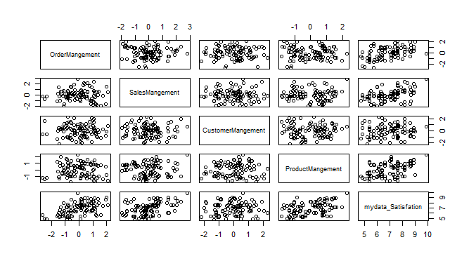

It helps to check the correlation between all the 5 variables .

> cor(RegressionModel)

OrderMangement SalesMangement CustomerMangement

OrderMangement 1.000000e+00 -4.511442e-16 -1.369372e-16

SalesMangement -4.511442e-16 1.000000e+00 2.966450e-16

CustomerMangement -1.369372e-16 2.966450e-16 1.000000e+00

ProductMangement 6.517479e-16 9.043410e-17 -6.490954e-16

mydata_Satisfation 5.185657e-01 4.276870e-01 5.632963e-02

ProductMangement mydata_Satisfation

OrderMangement 6.517479e-16 0.51856567

SalesMangement 9.043410e-17 0.42768695

CustomerMangement -6.490954e-16 0.05632963

ProductMangement 1.000000e+00 0.45334892

mydata_Satisfation 4.533489e-01 1.00000000

Let’s check graphically collinearity between each dependent variable and Customer satisfaction .

plot(mydata_Satisfation~OrderMangement)

> Model_OM = lm(mydata_Satisfation~OrderMangement,RegressionModel)

> summary(Model_OM)

Call:

lm(formula = mydata_Satisfation ~ OrderMangement, data = RegressionModel)

Residuals:

Min 1Q Median 3Q Max

-2.20278 -0.66916 0.04004 0.61769 3.05173

Coefficients:

Estimate Std. Error t value Pr(>|t|)

(Intercept) 6.9180 0.1024 67.542 < 2e-16 ***

OrderMangement 0.6180 0.1029 6.004 3.26e-08 ***

---

Signif. codes: 0 ‘***’ 0.001 ‘**’ 0.01 ‘*’ 0.05 ‘.’ 0.1 ‘ ’ 1

Residual standard error: 1.024 on 98 degrees of freedom

Multiple R-squared: 0.2689, Adjusted R-squared: 0.2615

F-statistic: 36.05 on 1 and 98 DF, p-value: 3.265e-08

> abline(Model_OM,col="red",lwd=2)

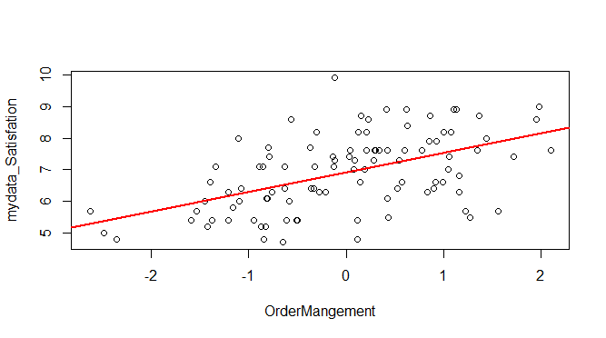

> plot(mydata_Satisfation~SalesMangement)

> Model_SM = lm(mydata_Satisfation~SalesMangement,RegressionModel)

> summary(Model_SM)

Call:

lm(formula = mydata_Satisfation ~ SalesMangement, data = RegressionModel)

Residuals:

Min 1Q Median 3Q Max

-2.1097 -0.7327 0.1749 0.6364 2.5340

Coefficients:

Estimate Std. Error t value Pr(>|t|)

(Intercept) 6.9180 0.1083 63.889 < 2e-16 ***

SalesMangement 0.5097 0.1088 4.684 9.07e-06 ***

---

Signif. codes: 0 ‘***’ 0.001 ‘**’ 0.01 ‘*’ 0.05 ‘.’ 0.1 ‘ ’ 1

Residual standard error: 1.083 on 98 degrees of freedom

Multiple R-squared: 0.1829, Adjusted R-squared: 0.1746

F-statistic: 21.94 on 1 and 98 DF, p-value: 9.068e-06

> abline(Model_SM,col="blue",lwd=2)

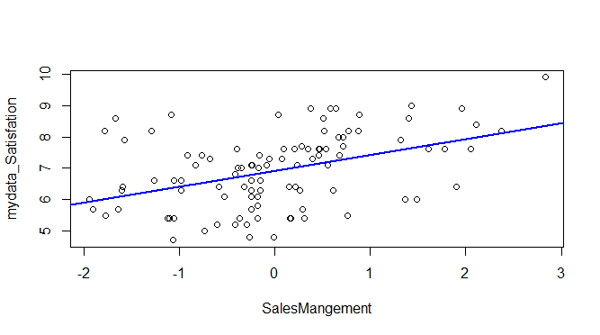

> plot(mydata_Satisfation~CustomerMangement)

> Model_CM = lm(mydata_Satisfation~CustomerMangement,RegressionModel)

> summary(Model_CM)

Call:

lm(formula = mydata_Satisfation ~ CustomerMangement, data = RegressionModel)

Residuals:

Min 1Q Median 3Q Max

-2.2031 -0.9469 0.1137 0.7624 2.9394

Coefficients:

Estimate Std. Error t value Pr(>|t|)

(Intercept) 6.91800 0.11960 57.843 <2e-16 ***

CustomerMangement 0.06714 0.12020 0.559 0.578

---

Signif. codes: 0 ‘***’ 0.001 ‘**’ 0.01 ‘*’ 0.05 ‘.’ 0.1 ‘ ’ 1

Residual standard error: 1.196 on 98 degrees of freedom

Multiple R-squared: 0.003173, Adjusted R-squared: -0.006999

F-statistic: 0.3119 on 1 and 98 DF, p-value: 0.5778

> abline(Model_CM,col="green",lwd=2)

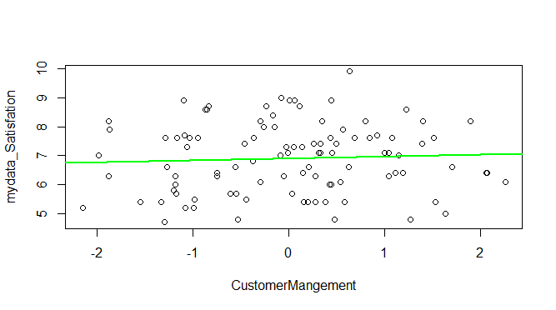

> plot(mydata_Satisfation~ProductMangement)

> Model_PM = lm(mydata_Satisfation~ProductMangement,RegressionModel)

> summary(Model_PM)

Call:

lm(formula = mydata_Satisfation ~ ProductMangement, data = RegressionModel)

Residuals:

Min 1Q Median 3Q Max

-2.1862 -0.9353 0.0345 0.9590 2.5355

Coefficients:

Estimate Std. Error t value Pr(>|t|)

(Intercept) 6.9180 0.1068 64.792 < 2e-16 ***

ProductMangement 0.5403 0.1073 5.035 2.17e-06 ***

---

Signif. codes: 0 ‘***’ 0.001 ‘**’ 0.01 ‘*’ 0.05 ‘.’ 0.1 ‘ ’ 1

Residual standard error: 1.068 on 98 degrees of freedom

Multiple R-squared: 0.2055, Adjusted R-squared: 0.1974

F-statistic: 25.35 on 1 and 98 DF, p-value: 2.174e-06

> abline(Model_PM,col="orange",lwd=2)

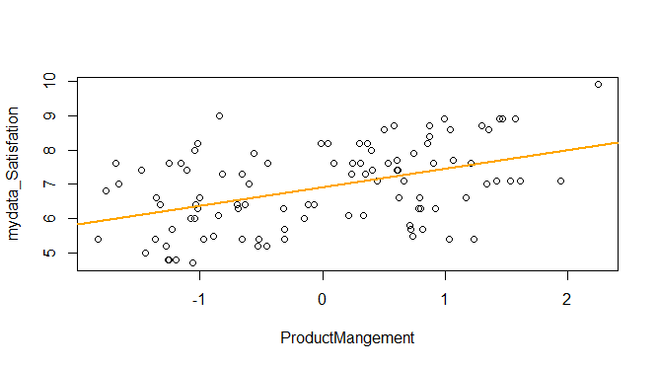

* clearly shows that only our dependent variable mydata_Satisfaction has moderate level of correlation with each of 4 independent variables except customer management which has very less degree of collinearity or no collinearity .
* All 4 independent variables are not correlated with each other , which is the first requirement for running regression analysis .Hence we can say that multicollinearity doesn’t exist .

Data frame is ready , we can apply multiple regression model

#### **2.4.2 Model 1**

> Model_MR = lm(mydata_Satisfation~OrderMangement+SalesMangement+CustomerMangement

+ +ProductMangement,RegressionModel)

> summary(Model_MR)

Call:

lm(formula = mydata_Satisfation ~ OrderMangement + SalesMangement +

CustomerMangement + ProductMangement, data = RegressionModel)

Residuals:

Min 1Q Median 3Q Max

-1.6308 -0.4996 0.1372 0.4623 1.5228

Coefficients:

Estimate Std. Error t value Pr(>|t|)

(Intercept) 6.91800 0.07089 97.589 < 2e-16 ***

OrderMangement 0.61805 0.07125 8.675 1.12e-13 ***

SalesMangement 0.50973 0.07125 7.155 1.74e-10 ***

CustomerMangement 0.06714 0.07125 0.942 0.348

ProductMangement 0.54032 0.07125 7.584 2.24e-11 ***

---

Signif. codes: 0 ‘***’ 0.001 ‘**’ 0.01 ‘*’ 0.05 ‘.’ 0.1 ‘ ’ 1

Residual standard error: 0.7089 on 95 degrees of freedom

Multiple R-squared: 0.6605, Adjusted R-squared: 0.6462

F-statistic: 46.21 on 4 and 95 DF, p-value: < 2.2e-16

Multiple regression model is

Mydata_satisfaction = 6.9+.61(OrderManagement)+.50(SalesManagement) + .06(CustomerManagement) + .54(ProductManagement)

* p-value of model is significant (2.2*e-16)far less then .05.
* R squared is .66, i.e 66% of customer satisfaction can be explained by our dependent variables . Or we can say that our model is 66% capable of explain customer satisfaction .
* Slope for OrderManagement is .61 , this is the effect of RC1 on Customer satisfaction .For 1 unit increase in RC1 there will be increase of .61 in customer satisfaction, hence it has high linear relation . p value is far less than .05 hence Order Management is significantly explaining the Customer Satisfaction .
* Slope for SalesManagement is .50 , this is the effect of RC2 on Customer satisfaction .For 1 unit increase in RC2 there will be increase of .50 in customer satisfaction , hence it has high linear relation . Sales Management is significantly explaining the Customer Satisfaction
* Slope for CustomerManagement is .06 , this is the effect of RC3 on Customer satisfaction .For 1 unit increase in RC3 there will be increase of .06 in customer satisfaction .

Since p value for Customer management > .05 , hence this factor will become insignificant in the model or we can say that its insignificant .

* Slope for {ProductManagement is .54 , this is the effect of RC4 on Customer satisfaction .For 1 unit increase in RC2 there will be increase of .50 in customer satisfaction , hence it has high linear relation . Product Management is significantly explaining the Customer Satisfaction
* Standard error shows, how wrong is our model . Since its value is close to zero , indicate that observation are closer to fitted line .

#### 2.4.3 **Testing the Regression assumptions**

* Mean of the residuals is zero

mean(Model_MR$residuals)

[1] 1.107363e-17

* Homoscedasticity of residuals 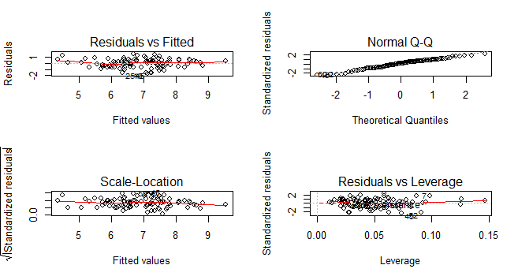
* In Normal Quartile Quartile graph, As the residuals are lying between -2 and +2 except outliers, So we can say residuals are normally distributed and are Homoscedastic.
* Errors and in-dependent variables are un-correlated
* > cor.test(OrderMangement+SalesMangement+CustomerMangement
* + +ProductMangement, Model_MR$residuals)
* Pearson's product-moment correlation
* data: OrderMangement + SalesMangement + CustomerMangement + ProductMangement and Model_MR$residuals
* t = -8.4036e-16, df = 98, p-value = 1
* alternative hypothesis: true correlation is not equal to 0
* 95 percent confidence interval:
* -0.1964181 0.1964181
* sample estimates:
* cor
* -8.488961e-17
* Explanatory variables are un-correlated
* cor(RegressionModel)
* OrderMangement SalesMangement CustomerMangement
* OrderMangement 1.000000e+00 -4.511442e-16 -1.369372e-16
* SalesMangement -4.511442e-16 1.000000e+00 2.966450e-16
* CustomerMangement -1.369372e-16 2.966450e-16 1.000000e+00
* ProductMangement 6.517479e-16 9.043410e-17 -6.490954e-16
* mydata_Satisfation 5.185657e-01 4.276870e-01 5.632963e-02
* ProductMangement mydata_Satisfation
* OrderMangement 6.517479e-16 0.51856567
* SalesMangement 9.043410e-17 0.42768695
* CustomerMangement -6.490954e-16 0.05632963
* ProductMangement 1.000000e+00 0.45334892
* mydata_Satisfation 4.533489e-01 1.00000000

#### 2.4.4 **Model 2**

Dropping the insignificant predictor and checking the model

> ##dropping customerManagement and checking model

>

>

> Model_MR1 = lm(mydata_Satisfation~OrderMangement+SalesMangement

+ +ProductMangement,RegressionModel)

> summary(Model_MR1)

Call:

lm(formula = mydata_Satisfation ~ OrderMangement + SalesMangement +

ProductMangement, data = RegressionModel)

Residuals:

Min 1Q Median 3Q Max

-1.69684 -0.49928 0.09364 0.46420 1.57638

Coefficients:

Estimate Std. Error t value Pr(>|t|)

(Intercept) 6.91800 0.07085 97.646 < 2e-16 ***

OrderMangement 0.61805 0.07120 8.680 1.01e-13 ***

SalesMangement 0.50973 0.07120 7.159 1.64e-10 ***

ProductMangement 0.54032 0.07120 7.588 2.09e-11 ***

---

Signif. codes: 0 ‘***’ 0.001 ‘**’ 0.01 ‘*’ 0.05 ‘.’ 0.1 ‘ ’ 1

Residual standard error: 0.7085 on 96 degrees of freedom

Multiple R-squared: 0.6574, Adjusted R-squared: 0.6466

F-statistic: 61.39 on 3 and 96 DF, p-value: < 2.2e-16

Model_MR1 has only 3 independent variables as we have dropped CustomerMangement

But there is almost no change in R squared value of model_MR1

Mydata_satisfaction = 6.9+.61(OrderManagement)+.50(SalesManagement) + +.54(ProductManagement)

#### 2.4.5 **Quality of model**

#### Let’s apply AIC – Akaike information criterion to check the relative quality of models

> AIC(Model_MR) ## with all 4 independent variables

[1] 221.8468

> AIC(Model_MR1) ## with 3 independent variables , dropping customer management

[1] 220.7771

As per rule lower the AIC value better the model is . AS there is slight decrease in AIC value

Hence model_MR1(Model 2) is better and can better explain the Customer Satisfaction.