

BansilalRamnathAgarwalCharitableTrust’s

VishwakarmaInstituteofTechnology, Pune

*(AnautonomousInstituteofSavitribaiPhulePuneUniversity)*

**Department of Multidisciplinary Engineering**

|  |  |
| --- | --- |
| **Division** | **CS(AI)- A** |
| **Batch** | **B3** |
| **GR-no** | **12** |
| **Rollno** | **55** |
| **Name** | **Soham Kolhatkar (12310981)** |

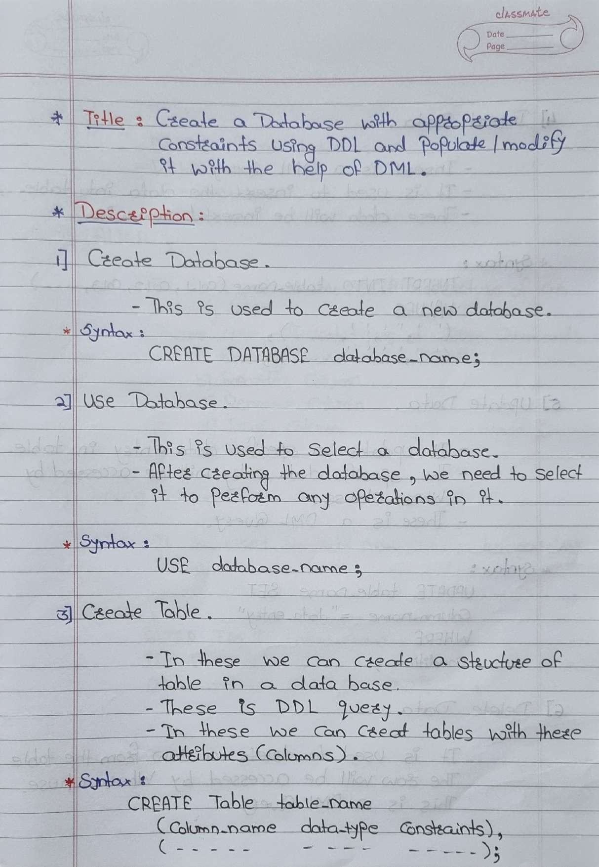

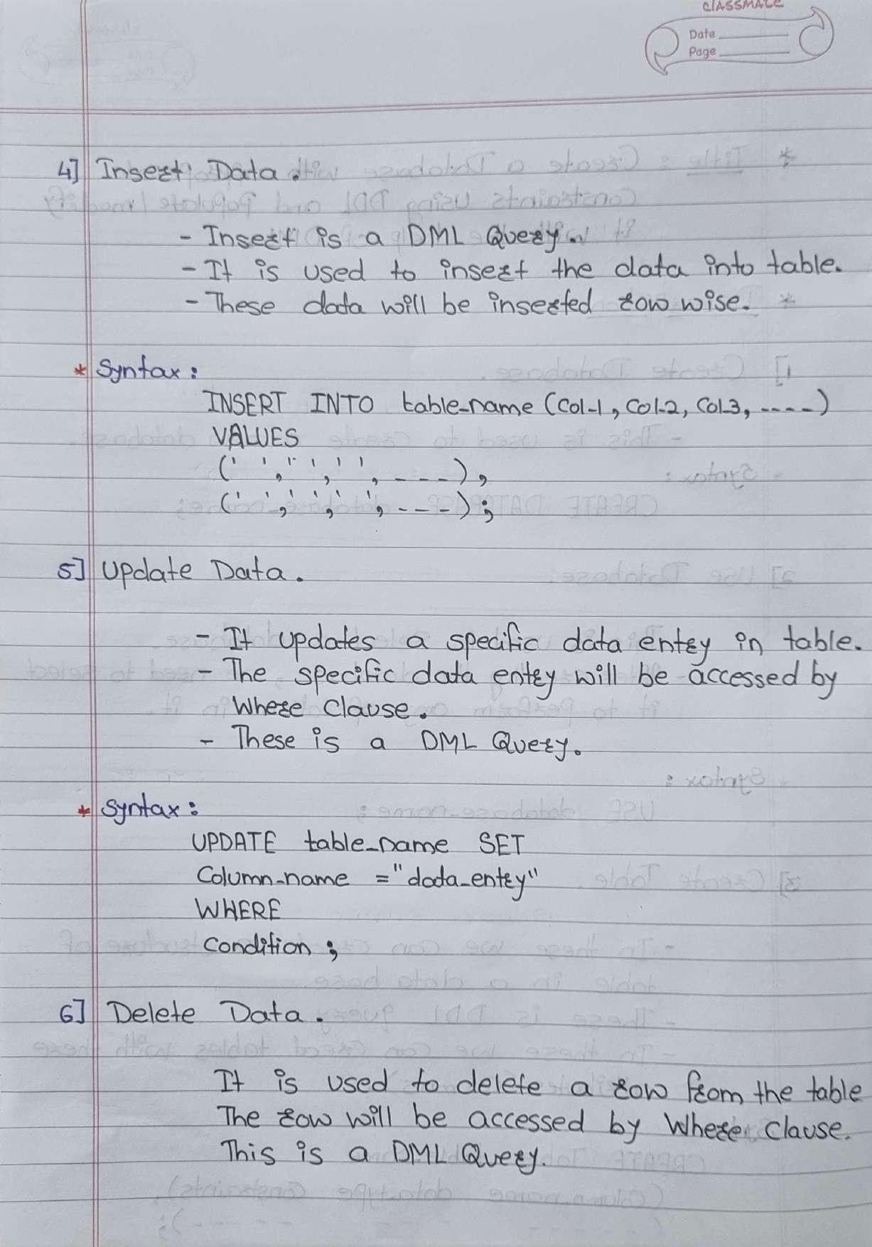

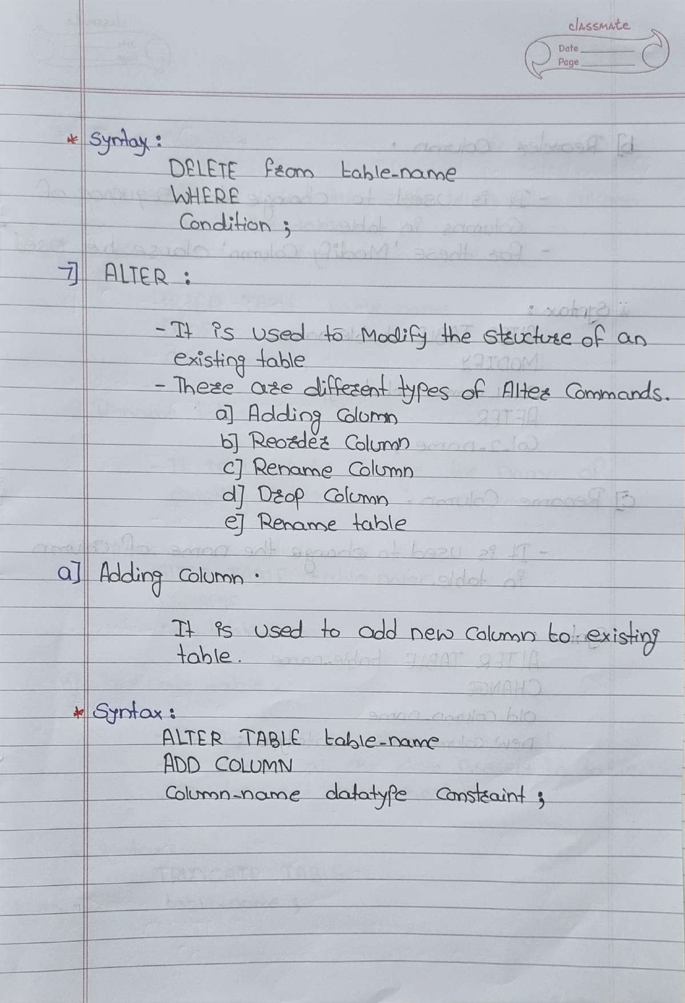

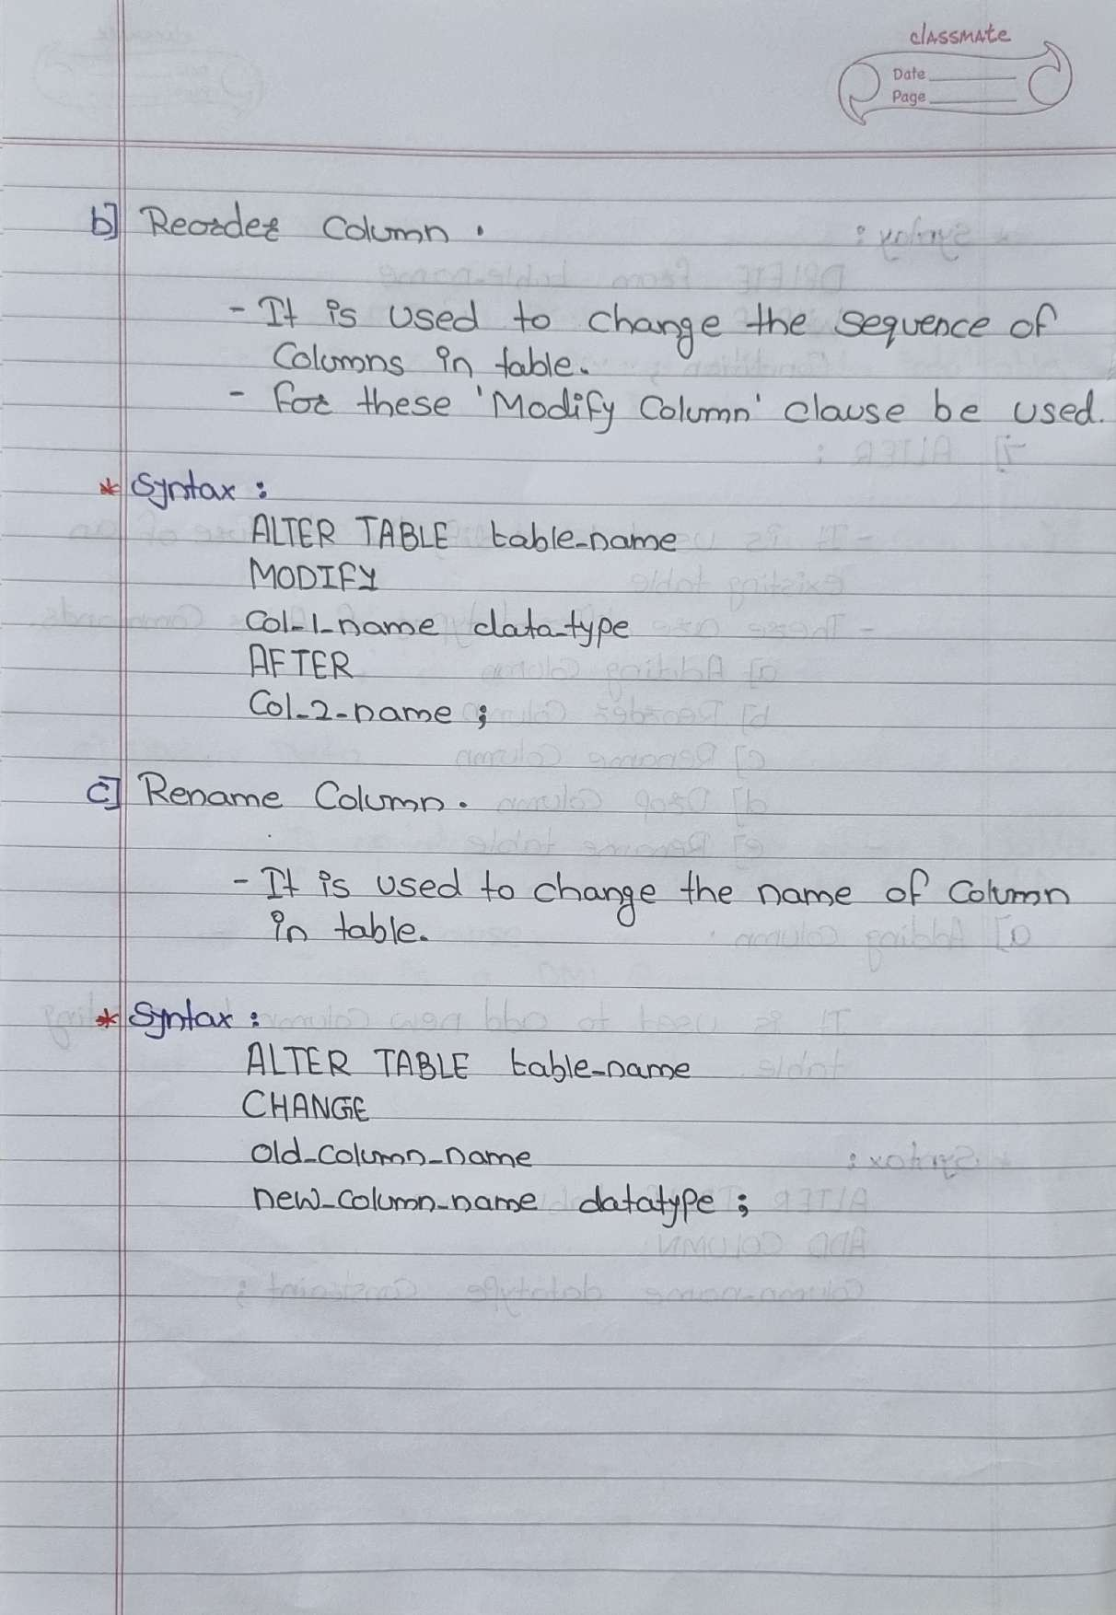

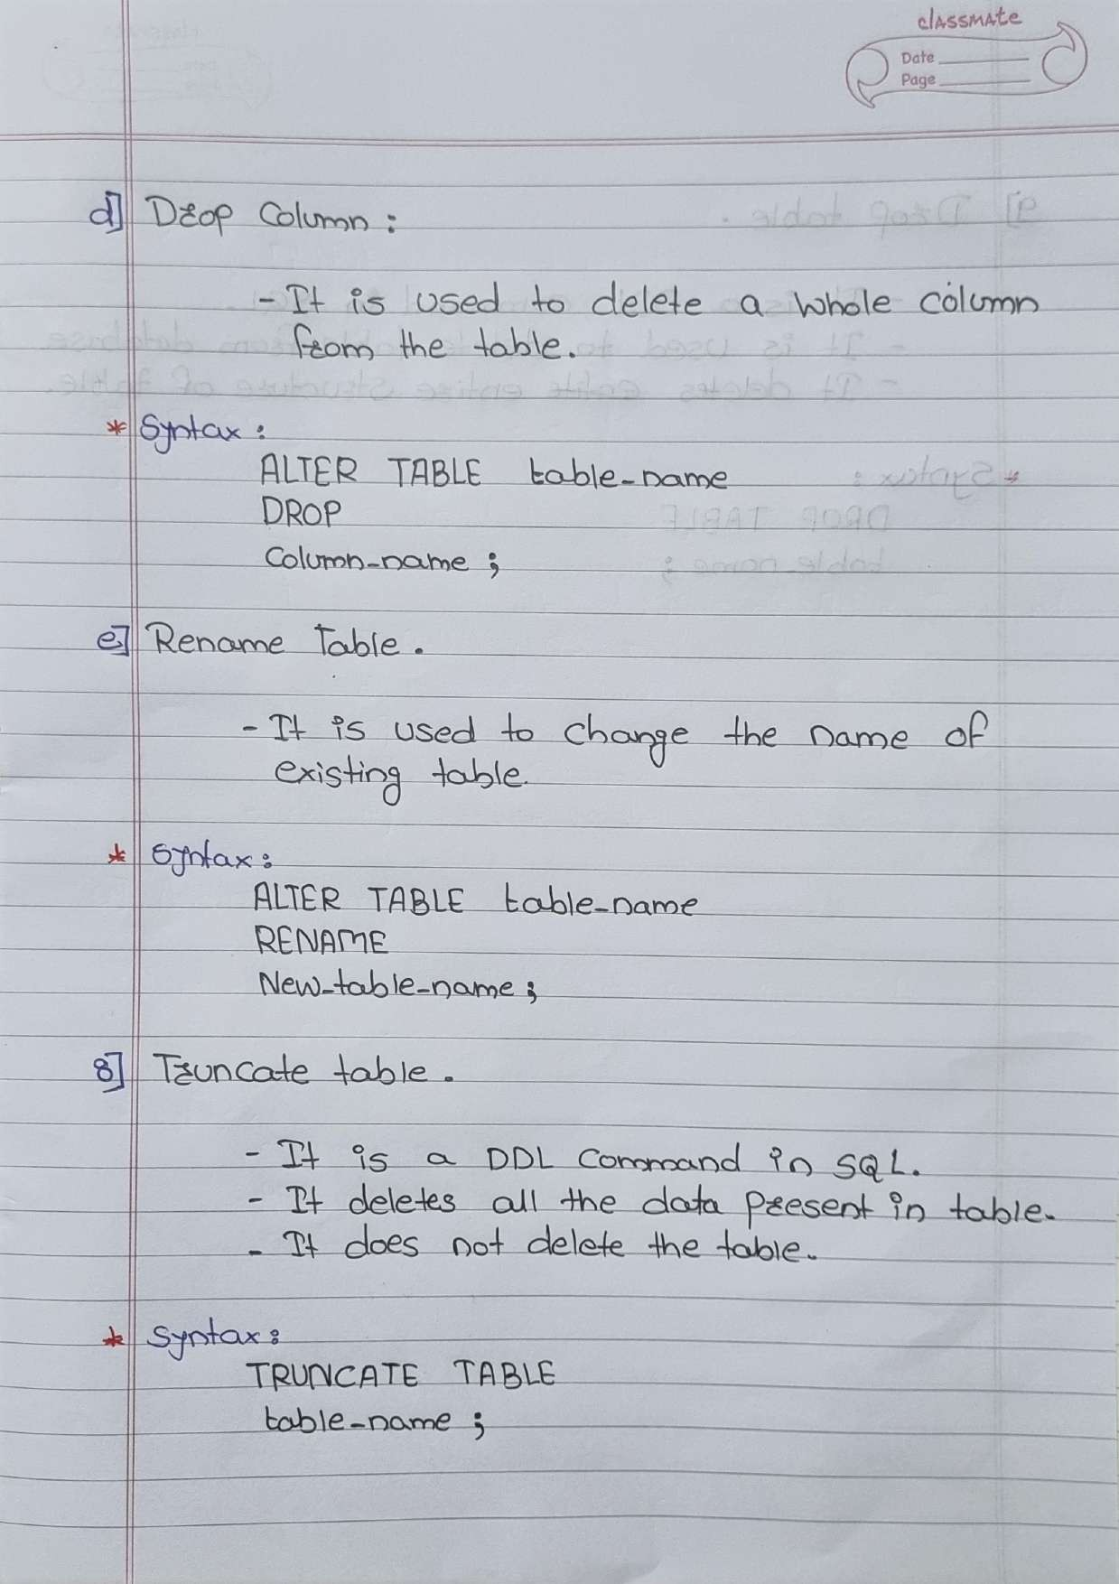

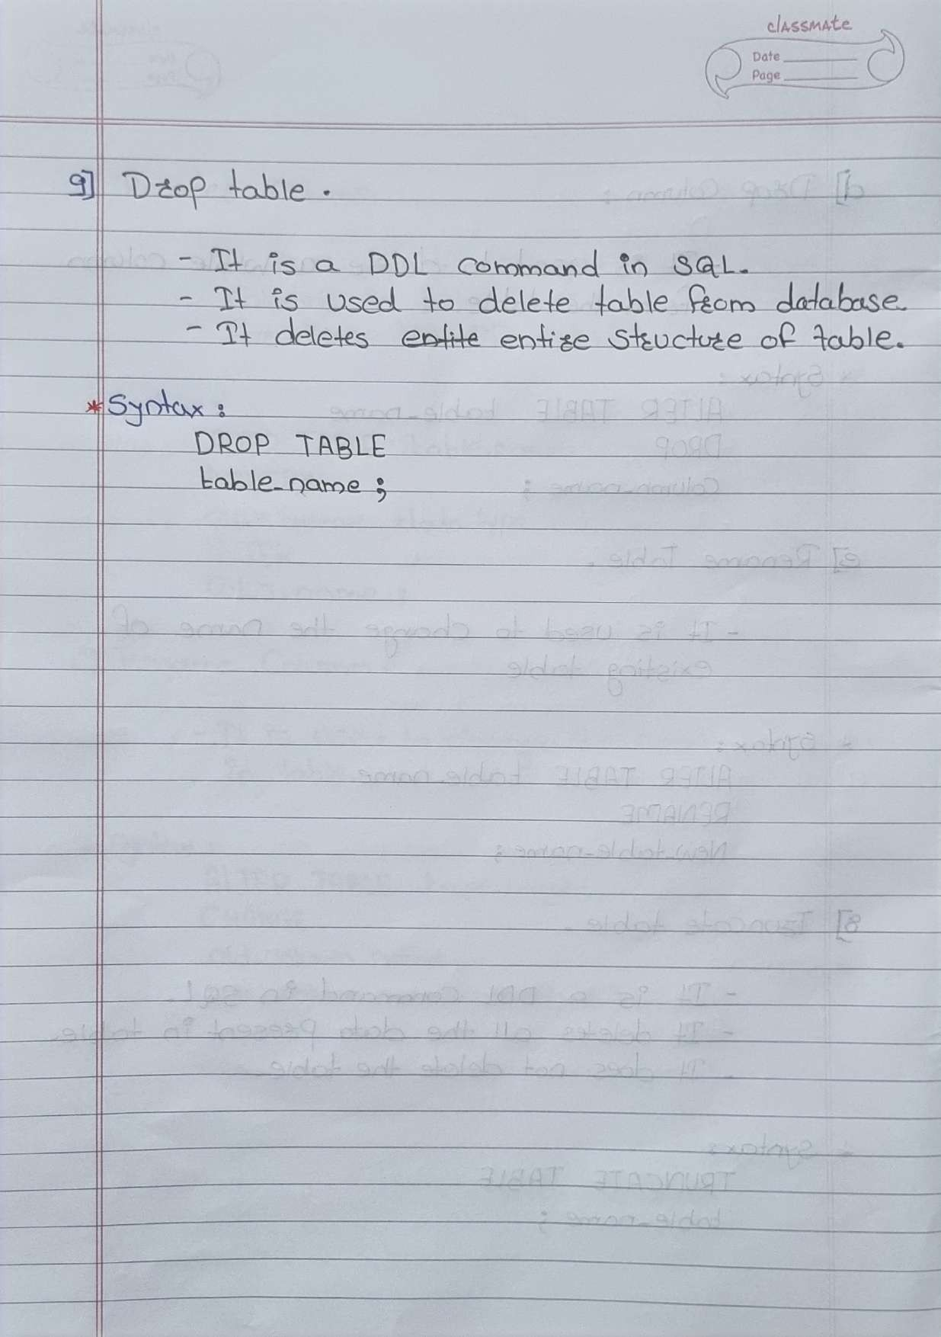

1. **CREATE DATABASE :**

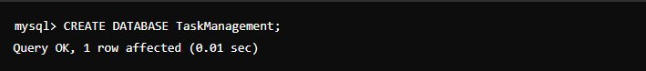

1. **USE DATABASE :**



1. **CREATE TABLE :**

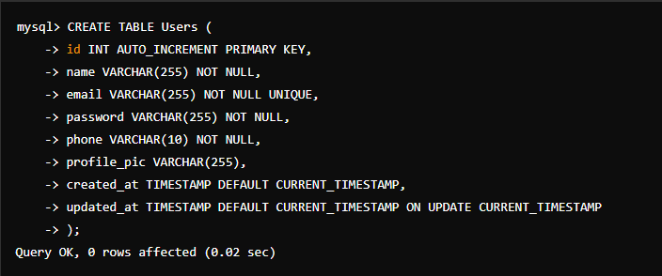

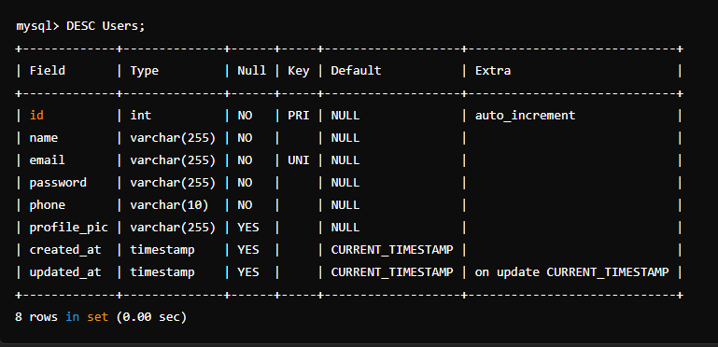

1. **INSERT DATA :**



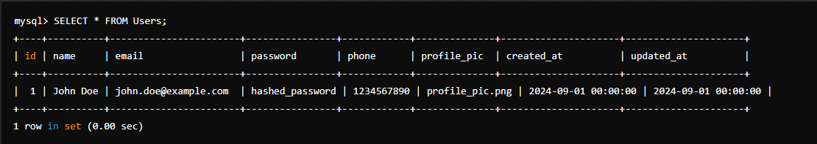

1. **UPDATE DATA :**

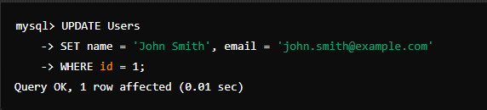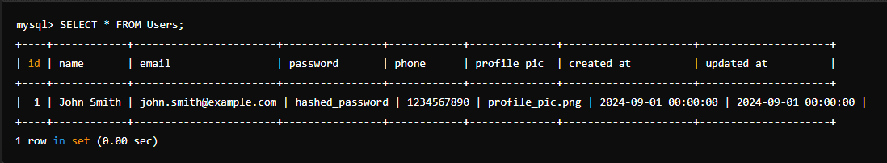

1. **DELETE DATA :**

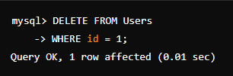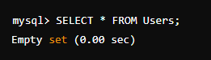

1. **ALTER :**
   1. **ADD COLUMN :**

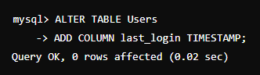

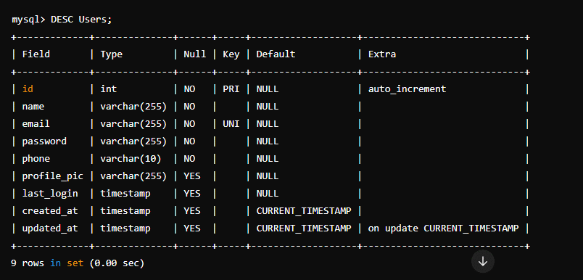

* 1. **RENAME COLUMN :**

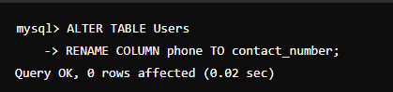

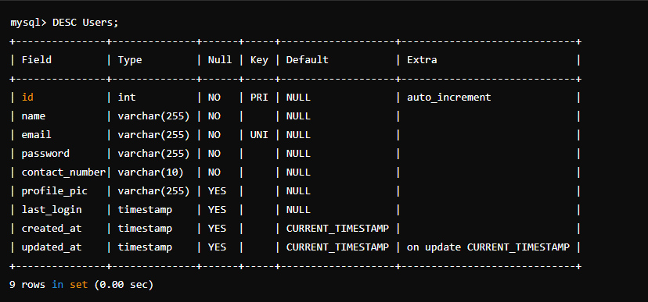

* 1. **DROP COLUMN :**

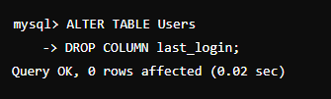

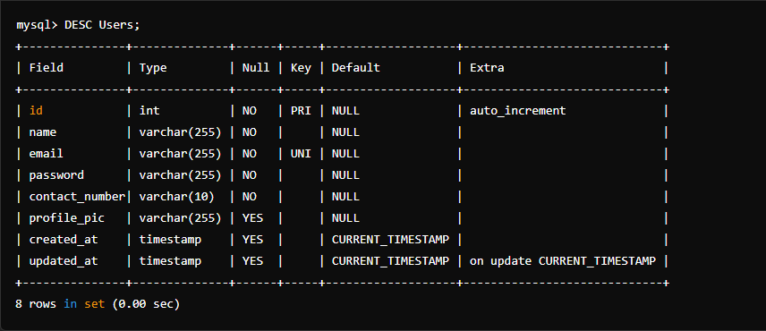

* 1. **RENAME TABLE :**

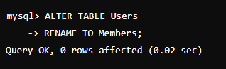

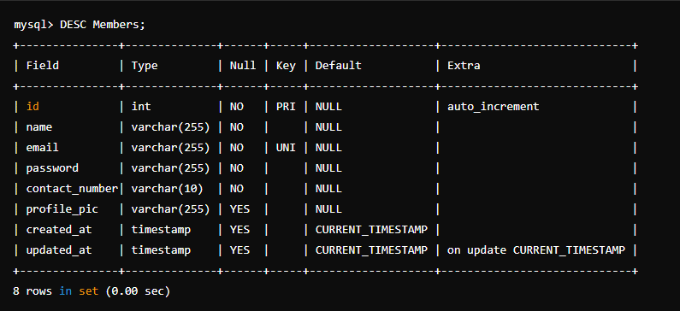

* 1. **TRUNCATE TABLE :**

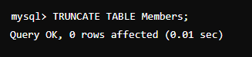 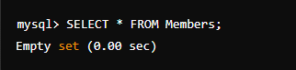

* 1. **DROP TABLE :**

