1. Creating and Renaming Files/Directories
$ mkdir test_dir

$ ls
Test_dir
$ cd test_dir

$ ls

$ touch example.txt

$ ls
example.txt
$ mv example.txt renamed_example.txt

$ ls
Renamed_example.txt

2. Viewing File Contents
labex@ubuntu:~$ cat /etc/passwd
root:x:0:0:root:/root:/bin/bash
daemon:x:1:1:daemon:/usr/sbin:/usr/sbin/nologin
bin:x:2:2:bin:/bin:/usr/sbin/nologin
sys:x:3:3:sys:/dev:/usr/sbin/nologin
sync:x:4:65534:sync:/bin:/bin/sync
games:x:5:60:games:/usr/games:/usr/sbin/nologin
man:x:6:12:man:/var/cache/man:/usr/sbin/nologin
lp:x:7:7:lp:/var/spool/lpd:/usr/sbin/nologin
mail:x:8:8:mail:/var/mail:/usr/sbin/nologin
news:x:9:9:news:/var/spool/news:/usr/sbin/nologin
uucp:x:10:10:uucp:/var/spool/uucp:/usr/sbin/nologin
proxy:x:13:13:proxy:/bin:/usr/sbin/nologin
www-data:x:33:33:www-data:/var/www:/usr/sbin/nologin
backup:x:34:34:backup:/var/backups:/usr/sbin/nologin
list:x:38:38:Mailing List Manager:/var/list:/usr/sbin/nologin
irc:x:39:39:ircd:/run/ircd:/usr/sbin/nologin
gnats:x:41:41:Gnats Bug-Reporting System (admin):/var/lib/gnats:/usr/sbin/nologin
nobody:x:65534:65534:nobody:/nonexistent:/usr/sbin/nologin
_apt:x:100:65534::/nonexistent:/usr/sbin/nologin
systemd-network:x:101:102:systemd Network Management,,,:/run/systemd:/usr/sbin/nologin
systemd-resolve:x:102:103:systemd Resolver,,,:/run/systemd:/usr/sbin/nologin
_chrony:x:103:105:Chrony daemon,,,:/var/lib/chrony:/usr/sbin/nologin
sshd:x:104:65534::/run/sshd:/usr/sbin/nologin
user:x:1000:1000:,,,:/home/user:/bin/bash
labex:x:1001:1001::/home/labex/project:/usr/bin/zsh
labex@ubuntu:~$ head -n 5 /etc/passwd
root:x:0:0:root:/root:/bin/bash
daemon:x:1:1:daemon:/usr/sbin:/usr/sbin/nologin
bin:x:2:2:bin:/bin:/usr/sbin/nologin
sys:x:3:3:sys:/dev:/usr/sbin/nologin
sync:x:4:65534:sync:/bin:/bin/sync
labex@ubuntu:~$ tail -n 5 /etc/passwd
systemd-resolve:x:102:103:systemd Resolver,,,:/run/systemd:/usr/sbin/nologin
_chrony:x:103:105:Chrony daemon,,,:/var/lib/chrony:/usr/sbin/nologin
sshd:x:104:65534::/run/sshd:/usr/sbin/nologin
user:x:1000:1000:,,,:/home/user:/bin/bash
labex:x:1001:1001::/home/labex/project:/usr/bin/zsh
labex@ubuntu:~$

3.Searching for Patterns
labex@ubuntu:~$ grep -iR "root" /etc/passwd
root:x:0:0:root:/root:/bin/bash
4. Zipping and Unzipping
pwd
mkdir test_dir
zip test_dir.zip test_dir
ls
unzip test_dir.zip -d unzipped_dir/
ls

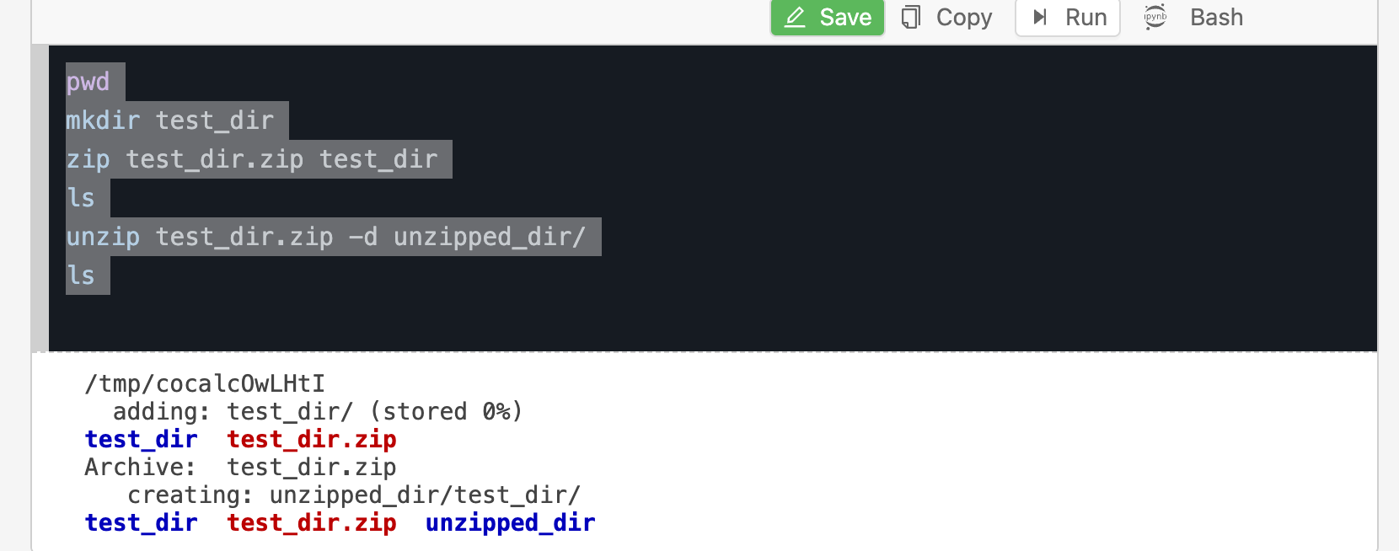

5. Downloading Files
labex:project/ $ wget https://example.com/sample.txt
--2026-03-17 19:27:55-- https://example.com/sample.txt
Resolving example.com (example.com)... 104.18.26.120, 104.18.27.120, 2606:4700::6812:1b78, ...
Connecting to example.com (example.com)|104.18.26.120|:443...
_

failed: Connection timed out.
Connecting to example.com (example.com)|104.18.27.120|:443... failed: Connection timed out.
Connecting to example.com (example.com)|2606:4700::6812:1b78|:443... failed: Cannot assign requested address.
Connecting to example.com (example.com)|2606:4700::6812:1a78|:443... failed: Cannot assign requested address.
Retrying.
6. Changing Permissions:

labex:project/ $
labex:project/ $ touch secure.txt
labex:project/ $ ls -lrth
total 0
-rw-rw-r-- 1 labex labex 0 Mar 17 19:36 secure.txt
labex:project/ $ chmod 444 secure.txt
labex:project/ $ ls -lrth
total 0
-r--r--r-- 1 labex labex 0 Mar 17 19:36 secure.txt
labex:project/ $

7. Working with Environment Variables

labex:project/ $
labex:project/ $ export MY_VAR=Hello,Linux!
labex:project/ $
labex:project/ $
labex:project/ $ echo $MY_VAR
Hello,Linux!
labex:project/ $

