Docker task:
1. Frontend (Node.js with Express):
- Create a frontend using Express and Node.js.
- Include a form similar to the one from the Flask Assignment 2.
- Configure the form to send a request to the Flask backend.
- Backend (Flask):
- Use the Flask backend to handle the form submission and process the data.
- Folder Structure:
- Organize the project with separate folders for the frontend and backend.
- Docker Configuration:
- Create a Dockerfile for both the frontend and backend.
- Write a .yaml file (Docker Compose) to connect both services in the same network.
- Upload both images to docker hub and push your whole code to github and add the node_modules and other non required files(.vscode) in .gitignore

Folder structure for project:

Github link: https://github.com/Sohamtewary/tutedude_docker.git

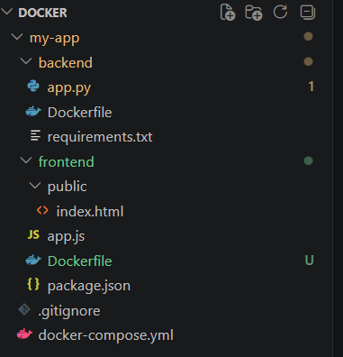

- My app is a project folder where I have created separate backend and frontend folders. Each folder has a dockerfile to create container images for both.my-app folder also has .gitignore and docker-compose.yml file as requested in the task.

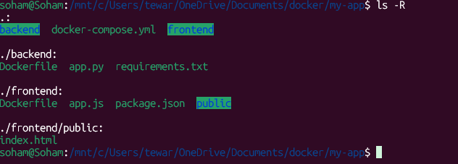

Git init and git add run to add the files in local repo
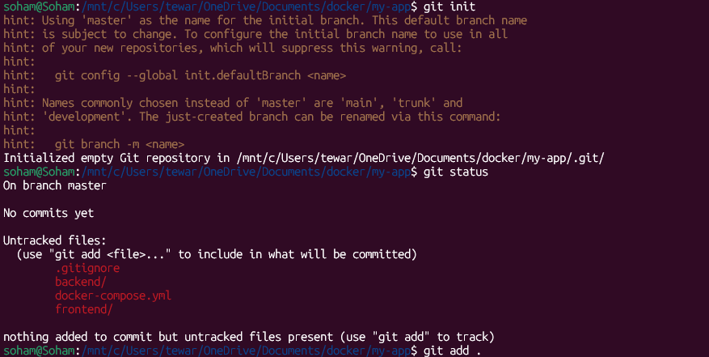

Git commit to commit the files and add remote repo(github)
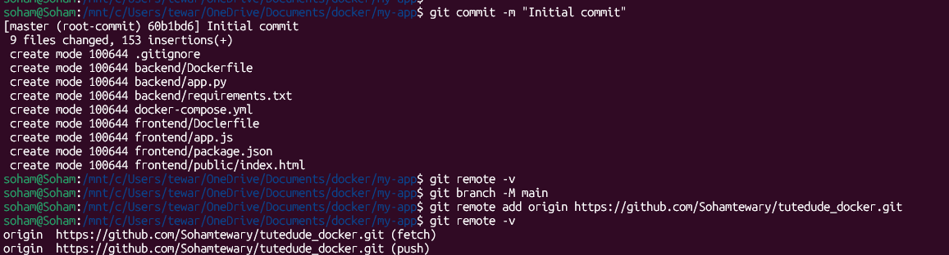

Git push to ush the codes in github
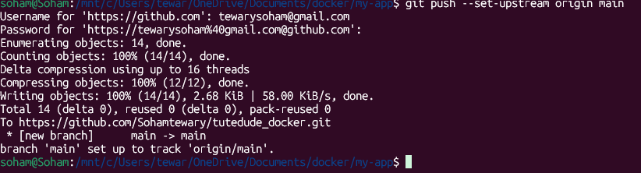

2nd commit for frontend file to modify some typo error
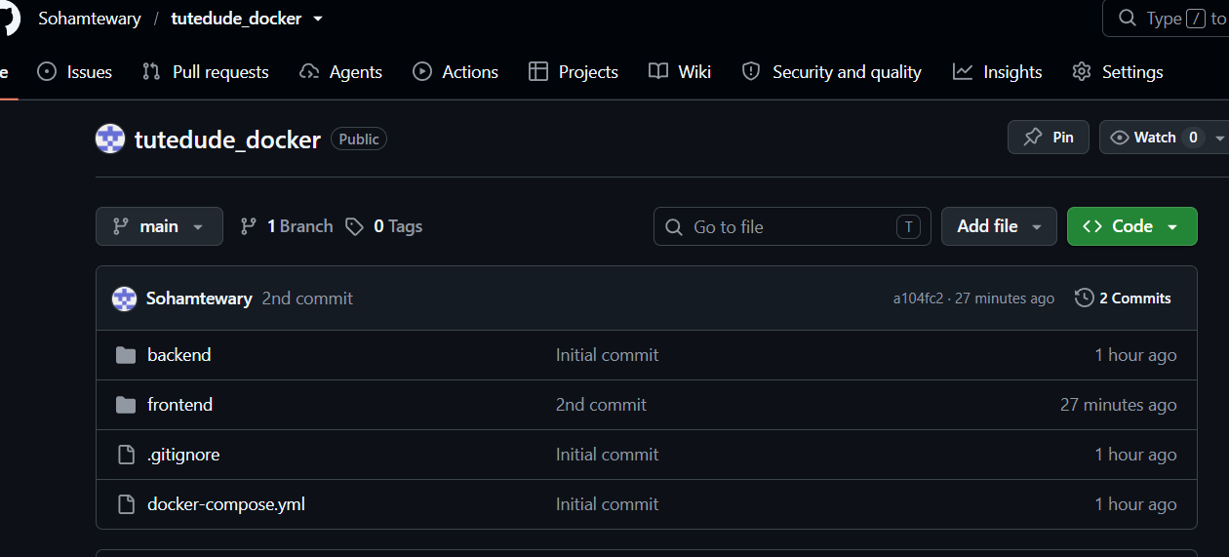

Build and push the backend in docker hub
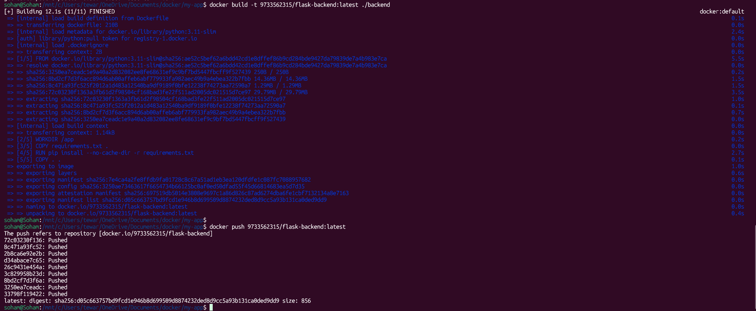

Build and push the frontend in docker hub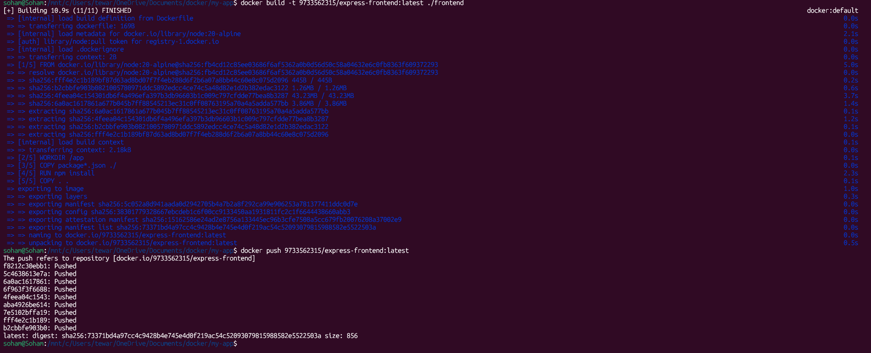
Docker hub:
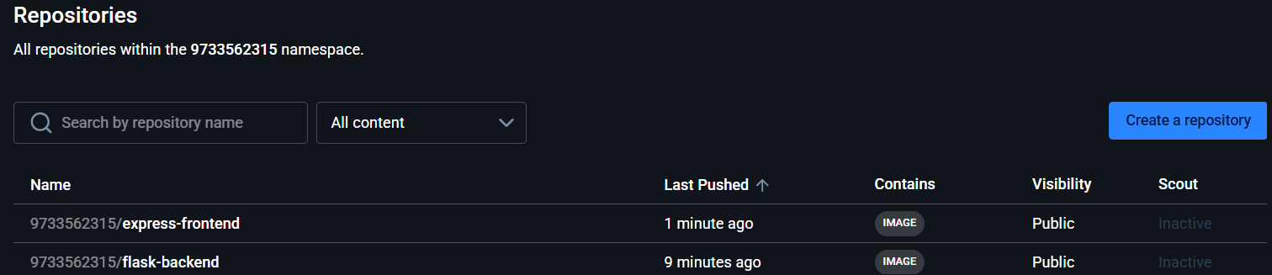

Docker pull successfully done
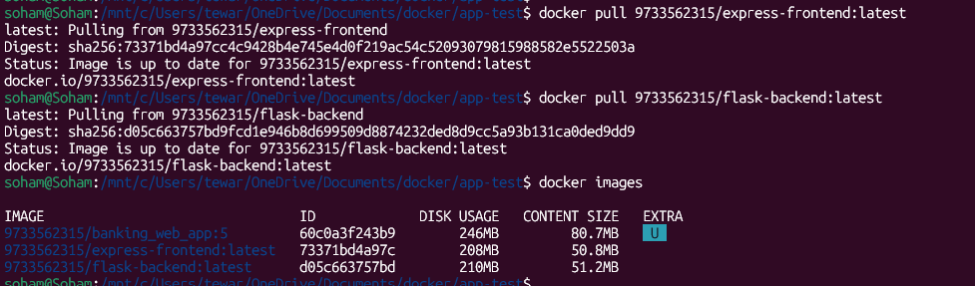

Ran both container individually to test with port forwarding
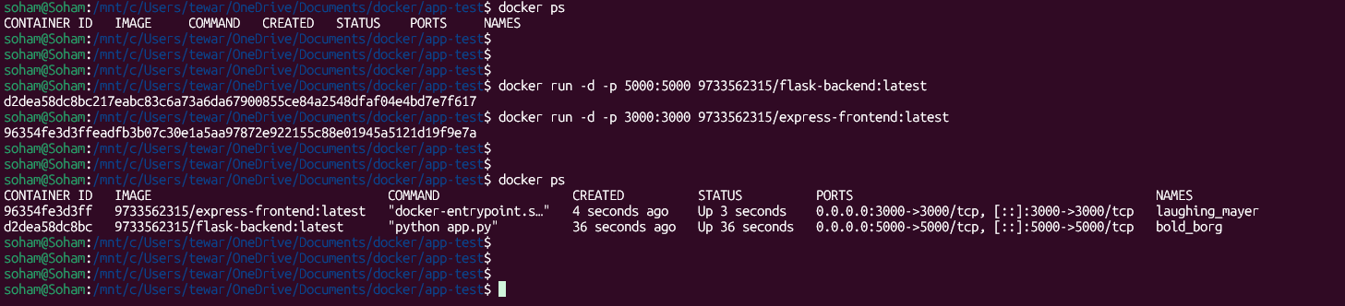
Also ran docker compose up command to check docker-compose yaml file and app working fine.
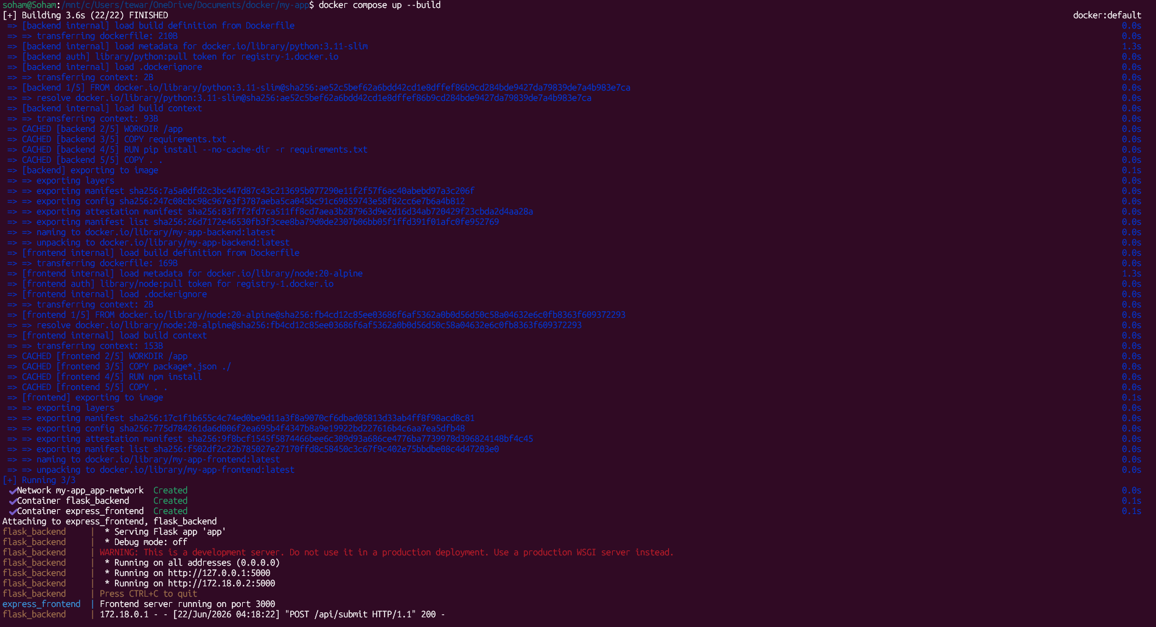

Testing of the project:

