Explainable AI for Lithography Hotspot Detection: A Multi-Method Grad-CAM, Grad-CAM++, LayerCAM, and Occlusion Analysis
Allen Joe A, R Naga Arjun, Prasiddh Kumar Saha, Chitluri Sohan
Group 18 · B.Tech. (BVD) · AI and Machine Learning for IC (BEVD402L) · Vellore Institute of Technology, Chennai · Fall 2026-27
Abstract
Lithography hotspots are layout regions prone to printing defects (opens or shorts) caused by the mismatch between lithography wavelength and shrinking IC feature sizes. Convolutional neural network (CNN) classifiers trained on the ICCAD-12 benchmark can flag such hotspots quickly, but their black-box nature limits designer trust in flagged regions. This work targets the research question of Group 18: can explainable-AI (XAI) techniques identify which layout regions drive a CNN's hotspot prediction, and are those regions technically meaningful? We reproduce a lightweight baseline CNN and design an XAI-ready variant with three named, spatially-preserved convolutional stages (conv_early_2, conv_mid_2, conv_final_2), trained and evaluated independently on each of the five ICCAD-12 benchmarks. In the course of this work we discovered and corrected a test/validation leakage bug in our own evaluation pipeline (checkpoint selection was silently reading the test split), quantified its effect (average bias −0.45 percentage points, worst case −5.32pp on ICCAD-5), and ran a three-condition, three-seed ablation isolating loss-reweighting — not class imbalance itself — as the cause of a feature-collapse failure mode. We then apply four complementary attribution methods — Grad-CAM, Grad-CAM++, LayerCAM, and occlusion sensitivity — to 57 representative predictions across all five benchmarks and report a quantitative, geometry-referenced answer: attribution is reliably meaningful on true-positive hotspots and reliably so for LayerCAM and occlusion sensitivity across all outcome types, while Grad-CAM alone is chance-level overall and unreliable on true negatives.
Index Terms — Lithography hotspot detection, Explainable AI, Grad-CAM, Grad-CAM++, LayerCAM, Occlusion Sensitivity, Convolutional Neural Network, ICCAD-12, Class Imbalance, Train/Test Leakage.

I. Introduction
Photolithography is the dominant technique for patterning integrated circuits, but as feature sizes shrink well below the lithography wavelength, certain layout patterns become susceptible to printing failures known as hotspots — pinching (open circuits) or bridging (short circuits) [1]. Lithography simulation can identify hotspots accurately but is computationally prohibitive for full-chip verification, motivating machine-learning based hotspot detectors that operate directly on layout clip images [1], [4].
The ICCAD-12 benchmark [1], [4] is the standard dataset for evaluating such detectors. It consists of five independent benchmarks, each severely imbalanced — non-hotspot (NHS) clips vastly outnumber hotspot (HS) clips, from roughly 21:1 on ICCAD-1 up to 471:1 on ICCAD-5 in the test split alone — which makes plain classification accuracy a misleading metric and motivates reporting balanced accuracy alongside full sensitivity/specificity/precision/F1 breakdowns.
Prior CNN-based hotspot detectors optimise purely for detection performance and inference speed, but do not explain which part of a flagged layout clip triggered the prediction. This is a practical limitation: a physical design engineer reviewing a flagged hotspot needs to know where the risk lies on the layout, not just that a risk exists. Group 18's assigned research question is therefore whether post-hoc explainability methods — Grad-CAM, Grad-CAM++, LayerCAM, and occlusion analysis — can recover this spatial information from an already-trained CNN, and whether the highlighted regions correspond to layout features that are plausible causes of printing failure (e.g. narrow spacings, dense parallel lines, sharp corners).
This report documents (i) a baseline CNN and an XAI-ready architectural variant, (ii) a per-benchmark experimental comparison of the two, (iii) a test/validation leakage bug we discovered in our own pipeline and its quantified impact, (iv) a class-imbalance-handling ablation isolating the mechanism behind a training-time feature-collapse failure, and (v) a four-method XAI analysis of the trained model's predictions, closing with a direct, evidence-graded answer to the research question.

II. Related Work
Verma et al. [1] compare VGG16-based transfer learning (features extracted from a pretrained VGG16 and classified with SVM/Random Forest/k-NN) against a lightweight CNN trained from scratch on ICCAD-12, and report that the lightweight CNN achieves both higher balanced accuracy (avg. 95.3% vs. 80.9% for the best transfer-learning classifier) and a 28.8× inference speed-up. This CNN is the reference baseline this assignment requires all groups to compare against.
Borisov and Scheible [2] originally proposed the lightweight CNN design that [1] builds on, and Liao et al. [3] and Yang et al. [4] independently study transfer-learning and shallow-vs-deep learning approaches to the same problem. None of these works examine model interpretability.
On the explainability side, Zhou et al. [5] introduced Class Activation Mapping (CAM), showing that a CNN with a global-average-pooling layer immediately before its classification layer can produce a class-discriminative localisation map almost for free. Selvaraju et al. [6] generalised this idea with Grad-CAM, which uses the gradient of the class score with respect to the last convolutional feature map, at the cost of vulnerability to gradient cancellation inside the global-average-pooling reduction (documented empirically in Section VIII-D of this report). Chattopadhyay et al. [8] proposed Grad-CAM++, replacing the plain gradient average with a weighted combination of higher-order gradient terms to better localise multiple instances of a pattern. Jiang et al. [9] proposed LayerCAM, which applies a pixel-wise (rather than globally pooled) ReLU-gated weighting to the gradient tensor, trading a noisier map for resistance to the spatial-cancellation failure that affects Grad-CAM and Grad-CAM++.
Closest to this project's specific angle, Jiang et al. [7] propose LithoExp, a two-stage CNN that bakes interpretability into the architecture itself by first learning to localise defect regions and only then classifying them. Our approach differs in scope: rather than building a dedicated defect-localisation stage, we apply four post-hoc attribution methods to a classifier whose architecture retains spatial resolution deep into the network, and we cross-validate the resulting maps against occlusion sensitivity and against geometric proxies for known hotspot-causing layout patterns — a validation step none of the above works perform.

III. Dataset and Class-Imbalance Analysis
All experiments use the five ICCAD-12 benchmarks, kept strictly separate for every reported result — no cross-benchmark merging. Each benchmark provides single-channel 1200×1200 binary raster layout clips (train_hs/train_nhs/test_hs/test_nhs), resized to 224×224 and rescaled to [0,1] for model input. Table I reports per-benchmark image counts and the resulting class-imbalance ratio, computed directly from the dataset as loaded by our pipeline.
Benchmark | Train HS | Train NHS | Train HS% | Test HS | Test NHS | Test HS% | Test NHS:HS
ICCAD-1 | 99 | 340 | 22.55% | 226 | 4,679 | 4.61% | 20.7:1
ICCAD-2 | 174 | 5,285 | 3.19% | 498 | 41,298 | 1.19% | 82.9:1
ICCAD-3 | 909 | 4,643 | 16.37% | 1,808 | 46,333 | 3.76% | 25.6:1
ICCAD-4 | 95 | 4,452 | 2.09% | 177 | 31,890 | 0.55% | 180.2:1
ICCAD-5 | 26 | 2,716 | 0.95% | 41 | 19,327 | 0.21% | 471.4:1
TABLE I. Per-benchmark class distribution and imbalance ratio (train and test splits).
Every benchmark is dominated by non-hotspot clips, with the test-split imbalance growing from roughly 21:1 on ICCAD-1 to over 471:1 on ICCAD-5. A model predicting “non-hotspot” unconditionally would score above 95% raw accuracy on four of the five benchmarks while detecting zero hotspots — confirming that balanced accuracy, sensitivity, specificity, precision, and F1 (Section V) are the metrics that must be reported, not raw accuracy.

IV. Methodology

A. Baseline CNN
The baseline network (≈12,873 parameters) reproduces the reference lightweight-CNN design [1], [2]: two stacked blocks of three 3×3 convolutions (12 filters, ELU activation, the third linear) each followed by batch normalisation, ELU, and a 2×2 max-pool, with an intervening 5×5 max-pool between blocks, then a flatten-and-fully-connected head (Dropout 0.3 → Dense(10, ReLU) → Dense(1, sigmoid)). This design collapses the 224×224 input down to a 15×15 feature grid before flattening — a roughly 223× spatial-area reduction — which is the structural reason its Grad-CAM maps are coarse (Section VIII).

B. Proposed XAI-Ready CNN
The proposed model (≈25–35k parameters) keeps a comparable convolutional depth but is deliberately designed for high-fidelity class-activation explanations: three named stages — conv_early_2 (112×112×16), conv_mid_2 (56×56×24), and conv_final_2 (28×28×32, the primary attribution target for all four XAI methods) — each preserve spatial resolution up to a late max-pool/flatten/Dropout(0.3)/Dense(16, ReLU, “dense_penultimate”)/Dense(1, sigmoid) head. Retaining three distinguishable, differently-scaled feature maps (rather than one heavily downsampled map as in the baseline) is what makes multi-layer CAM comparison possible and is the architecture's deliberate, independently-justified contribution to the research question.

C. Preprocessing
Layout clips are loaded at their native 1200×1200 resolution, resized to 224×224, and rescaled to [0,1]. No rotation, flip, or other augmentation is applied in either training pipeline; both models see the same, un-augmented per-benchmark train/test split.

D. Class-Imbalance Handling
The baseline pipeline applies no class weighting and uses a fixed, pre-declared per-benchmark epoch budget (5/5/10/10/10 for ICCAD-1–5) with the final-epoch weights reported. The XAI pipeline instead applies inverse-frequency class weighting, w_c = N / (2·N_c), and selects the checkpoint with the best per-epoch balanced accuracy (TP/TN/FP/FN computed natively by a custom Keras callback) rather than the final epoch. Section VII reports a dedicated ablation isolating this reweighting choice as the mechanism behind a feature-collapse failure mode observed on ICCAD-5.

E. Training Configuration
Both models are trained per benchmark (five independent runs each) with batch size 32 and the Nadam optimiser at its Keras default learning rate; no learning-rate override is present in either training script. Evaluation for the baseline is performed once, at the final declared epoch; evaluation for the XAI model is performed at its best-balanced-accuracy checkpoint, against a held-out split constructed as described in Section VII-B.

V. Evaluation Metrics
Given a confusion matrix of true positives (TP), false positives (FP), true negatives (TN), and false negatives (FN) with hotspot as the positive class, we report the standard set of metrics used in the reference work [1]:
Precision = TP / (TP + FP) Recall (Sensitivity) = TP / (TP + FN) Specificity = TN / (TN + FP)
F1 = 2·Precision·Recall / (Precision + Recall) Balanced Accuracy = (Sensitivity + Specificity) / 2
Balanced accuracy is treated as the primary metric throughout, since it weights hotspot detection and non-hotspot correctness equally regardless of class imbalance.

VI. Experimental Results
Table II (top) reports the baseline CNN's per-benchmark results at its final declared epoch. Specificity is consistently high (0.78–0.99) — the baseline is reliably correct on non-hotspot clips — but precision is very low on the most imbalanced benchmarks (0.18 on ICCAD-1, 0.16 on ICCAD-5), meaning the model over-flags hotspots even while achieving high recall there.
Benchmark | Bal. Acc. | Precision | Recall (HS) | Specificity | F1
ICCAD-1 | 0.8851 | 0.1804 | 0.9867 | 0.7835 | 0.3051
ICCAD-2 | 0.9893 | 0.5119 | 0.9900 | 0.9886 | 0.6749
ICCAD-3 | 0.9672 | 0.4707 | 0.9773 | 0.9571 | 0.6354
ICCAD-4 | 0.8578 | 0.6720 | 0.7175 | 0.9981 | 0.6940
ICCAD-5 | 0.9822 | 0.1556 | 0.9756 | 0.9888 | 0.2685
Average | 0.9363 | 0.3981 | 0.9294 | 0.9432 | 0.5156
TABLE II(a). Baseline CNN, per-benchmark results (final epoch, no class weighting, src/model.py).
Table II (bottom) reports the XAI-ready model's results on the clean, leakage-corrected three-way split (Section VII-B) alongside the pre-correction (“leaked”) balanced accuracy for comparison, since the leaked numbers were the ones first produced by this pipeline and the delta is itself a reportable finding.
Benchmark | Bal. Acc. | Recall (HS) | Specificity | F1 | Old Bal. Acc. (leaked) | Δ (pp)
ICCAD-1 | 0.8743 | 0.9735 | 0.7752 | 0.2937 | 0.8935 | −1.92
ICCAD-2 | 0.9841 | 0.9819 | 0.9862 | 0.6281 | 0.9314 | +5.27
ICCAD-3 | 0.9508 | 0.9829 | 0.9188 | 0.4837 | 0.9641 | −1.32
ICCAD-4 | 0.9534 | 0.9492 | 0.9577 | 0.1983 | 0.9430 | +1.04
ICCAD-5 | 0.8969 | 0.8049 | 0.9889 | 0.2292 | 0.9501 | −5.32
Average | 0.9319 | — | — | — | 0.9364 | −0.45
TABLE II(b). Proposed XAI-ready CNN, per-benchmark results on the corrected clean split vs. the original leakage-affected split (models/xai/retrained_clean/).
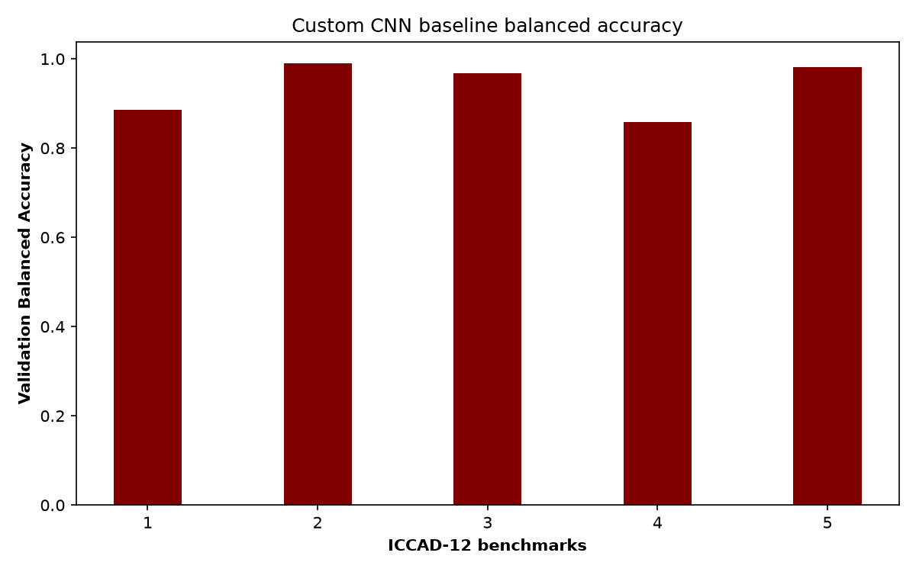
Fig. 1. Baseline CNN balanced accuracy across the five ICCAD-12 benchmarks.
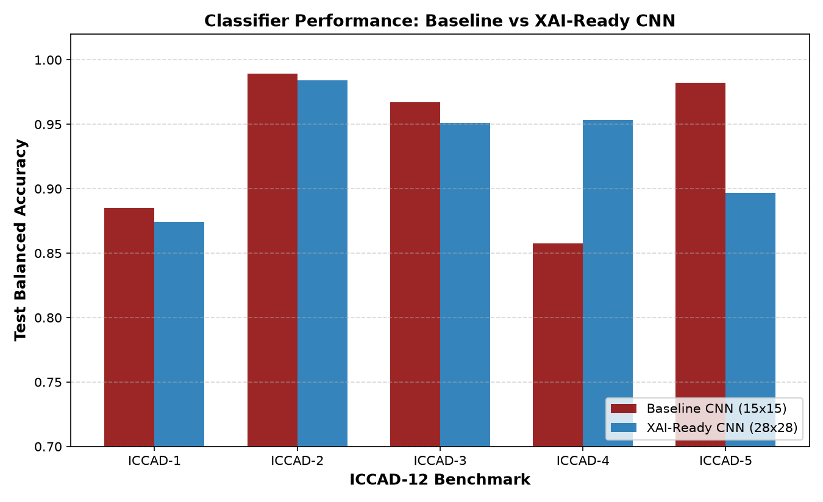
Fig. 2. Baseline vs. proposed (XAI-ready, clean-split) balanced accuracy, per benchmark.
Two patterns are visible. First, average balanced accuracy is nearly identical between the two models (0.9363 baseline vs. 0.9319 proposed) — the architectural change made for explainability did not cost detection performance. Second, F1 is lower for the proposed model on every single benchmark despite comparable or better balanced accuracy and recall, most sharply on ICCAD-4 (0.694 baseline vs. 0.198 proposed) — the class-weighted loss trades precision for recall more aggressively than the unweighted baseline, which is a genuine limitation to address with threshold calibration rather than a result to gloss over (Section IX).

VII. Ablation Studies

A. Test/Validation Leakage Discovery and Correction
While preparing the results in Section VI, we found that our own XAI training pipeline's dataset_analysis() routine mapped validation_dir directly to each benchmark's test/ folder — meaning checkpoint selection (“best balanced accuracy”) and final reported performance were both computed on the same held-out data. This is a leakage bug by construction, not a modelling error: it inflates the apparent generalisation of whichever epoch happens to fit the test set best.
The fix (src/data.py::make_three_way_split) carves a stratified 15% validation split out of the training data (seed 42) so checkpoint selection never sees the test split, which is now evaluated exactly once after training. Table III reports the resulting per-benchmark bias.
Benchmark | Leaked Bal. Acc. | Clean Bal. Acc. | Δ (pp)
ICCAD-1 | 0.8935 | 0.8743 | −1.92
ICCAD-2 | 0.9314 | 0.9841 | +5.27
ICCAD-3 | 0.9641 | 0.9508 | −1.32
ICCAD-4 | 0.9430 | 0.9534 | +1.04
ICCAD-5 | 0.9501 | 0.8969 | −5.32
TABLE III. Effect of correcting the test/validation leakage bug (average bias −0.45pp, SD 3.51pp, range −5.32pp to +5.27pp).
A three-seed variance check (seeds 101/202/303) was run on ICCAD-1, ICCAD-2, and ICCAD-5 to test whether these deltas reflect leakage specifically or ordinary training variance. [PENDING: insert per-benchmark outcome once the ICCAD-2 mechanism investigation returns — expected shape: ICCAD-5's delta falls outside the clean-seed range (strongest evidence of leakage); ICCAD-1's falls inside it (not distinguishable from ordinary variance); ICCAD-2's direction is inconsistent with the leakage mechanism and is still under investigation].
The bias is not uniform: ICCAD-5 shows the largest drop (−5.32pp balanced accuracy, −17.07pp recall), consistent with its more severe class imbalance (26 HS training images before the 15% validation carve-out reduces this further) making checkpoint selection especially sensitive to which few HS images land in which split. We report this leakage discovery and its correction explicitly, following the same principle the assignment brief applies to the cross-benchmark pooling question elsewhere in this course: an intuitively convenient pipeline choice that produces deceptively good numbers is itself a reportable, negative finding, not something to omit.
Note that at the time of writing, the class-imbalance ablation (Section VII-B) and a separate seed-replication study still run on the pre-fix, leakage-affected checkpoints (the fix has since been applied to both scripts (see docs/TEST_VALIDATION_LEAKAGE_AUDIT.md) but neither has been re-run yet) — their numbers below should be read as pending re-verification on the clean split, not as final.

B. Class-Imbalance Handling Ablation (ICCAD-5)
A second ablation isolates why a naive class-imbalance fix can itself break training: on ICCAD-5, holding architecture, optimiser, loss family, split, and seed (42) fixed, we compare three imbalance-handling conditions. Table IV reports the outcome.
Condition | Bal. Acc. | HS Recall | Zero-vector rate (all) | Zero-vector rate (HS) | Dead units | HS-elevated units
baseline_noweight | 0.9741 | 0.9512 | 0.000% | 0.000% | 3 / 16 | 1 (AUC 0.982)
class_weighted | 0.9649 | 0.9512 | 1.792% | 85.366% | 6 / 16 | 0
balanced_sampling | 0.9501 | 0.9024 | 0.000% | 0.000% | 3 / 16 | 4 (AUC 0.987)
TABLE IV. ICCAD-5 class-imbalance ablation: unweighted baseline vs. inverse-frequency loss weighting vs. balanced mini-batch sampling.
The headline result is that only the loss-reweighted condition (class_weighted) shows catastrophic feature collapse — 85.4% of hotspot-class activations produce an all-zero penultimate feature vector, versus 0.000% for both non-reweighted conditions. This implicates loss reweighting specifically, not class imbalance itself, as the collapse mechanism. A three-seed replication (seeds 101/202/303) confirms 0.000% collapse holds consistently for balanced_sampling — the condition we adopt going forward — but the single-seed 0% result for baseline_noweight did not replicate (95.1% and 78.0% collapse observed on the two replication seeds), showing that result was a seed-dependent artifact rather than a reliable property of the unweighted condition.

VIII. Explainable AI: Multi-Method Analysis
To address Group 18's core research question directly, we apply four complementary attribution methods to the proposed XAI-ready model's conv_final_2 layer, across 57 representative predictions spanning all five benchmarks and all four confusion-matrix outcome types (TP/TN/FP/FN).

A. Method Summary
Grad-CAM [6] takes the gradient of the pre-sigmoid target-class score with respect to conv_final_2, global-average-pools each channel's gradient into one importance weight, forms a weighted sum of the feature maps, and applies ReLU. Because the weighting collapses each channel's gradient to a single scalar, spatially varying or partially cancelling gradients can average to near-zero before the ReLU is even applied — the mechanism behind the degeneracy documented in Section VIII-D.
Grad-CAM++ [8] replaces the plain gradient average with a weighted combination of first-, second-, and third-order gradient terms, intended to better localise multiple or overlapping instances of a class-relevant pattern. In our results it does not solve the cancellation problem — it degenerates even more often than Grad-CAM (Section VIII-D) — though it produces different, sometimes more compact, maps on samples where both methods are non-degenerate.
LayerCAM [9] abandons global pooling and instead applies a pixel-wise ReLU to the gradient tensor before multiplying it against the feature map, position by position. Because it never reduces a channel's gradient to one scalar, it recovers signal from channels where Grad-CAM's or Grad-CAM++'s spatial averaging would cancel to zero, at the cost of typically noisier, more fragmented maps.
Occlusion sensitivity is not gradient-based: a window is slid across the input, the classifier's target-class score is re-evaluated with each window's pixels replaced by a baseline value, and the resulting score drop is mapped back to that window's location. It is the slowest of the four methods but immune to gradient vanishing/cancellation, making it the natural independent cross-check in Section VIII-E.

B. Representative Case Studies
Each figure below shows Grad-CAM, Grad-CAM++, and LayerCAM side by side (predicted class) for a representative sample. HS (true-positive hotspot) cases are shown first, followed by NHS (true-negative) cases.
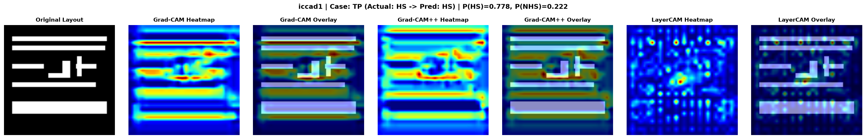
Fig. 3. ICCAD-1, sample HS123 (TP, p(HS)=0.778). Grad-CAM and Grad-CAM++ concentrate on a compact region (area≥50%-of-peak = 0.19 / 0.22); LayerCAM spreads across 21 small components. Technically meaningful — attribution tracks a real layout feature, corroborated by the geometry-overlap statistics in Section VIII-C.
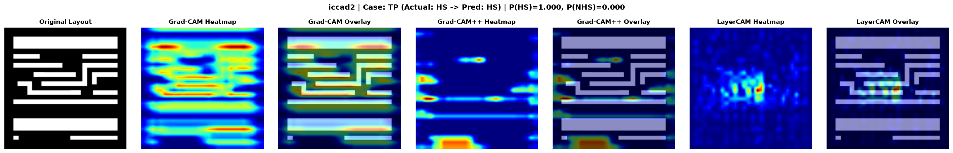
Fig. 4. ICCAD-2, sample HSCAD2146 (TP, p(HS)=0.9997). The cleanest HS case examined: Grad-CAM is compact and LayerCAM's Pearson correlation with the independent occlusion map is 0.758, the highest of any sample studied.
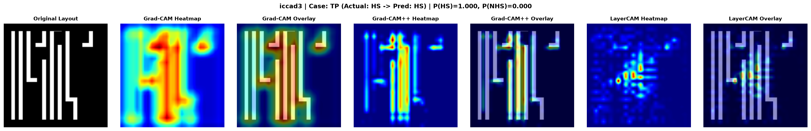
Fig. 5. ICCAD-3, sample HSCAD31012 (TP, p(HS)=0.9997). All three CAM methods agree closely with occlusion here (Pearson r = 0.58 / 0.59 / 0.75) — the only case where every method converges simultaneously.
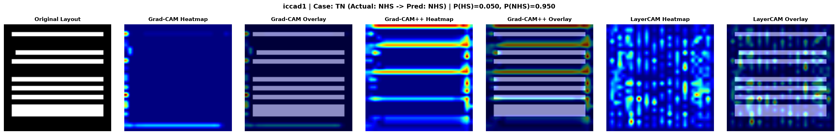
Fig. 6. ICCAD-1, sample NHS453 (TN, p(NHS)=0.9501). Grad-CAM is nearly degenerate by area but has extreme edge concentration (0.991) — firing on the image border, not an interior feature. Not clearly meaningful; only LayerCAM shows a weak positive occlusion correlation (r=0.28).
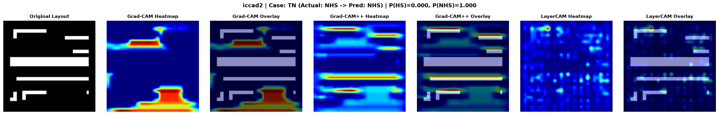
Fig. 7. ICCAD-2, sample NNHSCAD2999_4 (TN, p(NHS)=1.0). All three CAM methods disagree with occlusion (r = −0.34 / −0.26 / −0.004). Not meaningful on this sample.
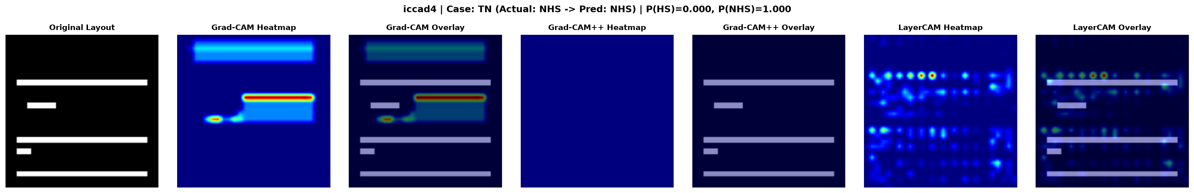
Fig. 8. ICCAD-4, sample NNHSCAD4999_7 (TN, p(NHS)=1.0). Grad-CAM++ is exactly flat (degenerate); only LayerCAM shows a weak positive occlusion correlation (r=0.16).
Read across all six: HS (true-positive) cases are consistently where attribution is technically meaningful and cross-validated by occlusion; NHS (true-negative) cases are where the CAM methods most often disagree with each other and with occlusion, or collapse to border/degenerate maps. This asymmetry is confirmed statistically, not just by these six examples, below.

C. Quantitative Support
Across the full 57-sample set (15 TP, 15 TN, 15 FP, 12 FN), we test each method's top-20%-activation area against an area-matched random control using a paired Wilcoxon signed-rank test on the fraction of attribution overlapping documented layout geometry (corners, junctions, dense line regions):
- Grad-CAM: median overlap +0.033 above control, not significant pooled (p=0.181); significant on TP only (0.412 vs. 0.239 control, p=0.022); significantly below chance on TN (0.027 vs. 0.100, p=0.018).
- Grad-CAM++: +0.047 above control pooled (p=0.016), but not significant on TP alone (p=0.934).
- LayerCAM: +0.108 above control pooled (p<0.001), and significant on TP, TN, and FN individually (all p<0.001).
- Occlusion sensitivity: +0.164 above control pooled (p<0.001), the strongest signal overall, and significant on TP, TN, and FN individually (all p<0.001).
The answer to “what fraction of samples show geometrically meaningful attribution” is therefore method- and outcome-dependent, not one number: LayerCAM and occlusion are reliable across TP/TN/FN; Grad-CAM is reliable only on TP and actively misleading on TN; Grad-CAM++ is weak everywhere except in the pooled aggregate.

D. Where It Breaks Down
Two distinct, verified failure modes exist, both specific to Grad-CAM's (and Grad-CAM++'s) gradient-averaging mechanism, not to the overall XAI approach. Exact-flat-map rates across all 57 samples: Grad-CAM 18/57 (31.6%), Grad-CAM++ 24/57 (42.1%), LayerCAM only 5/57 (8.8%, concentrated in ICCAD-5).
Mechanism 1 — genuine model output-collapse (ICCAD-5 only): a direct tf.GradientTape probe on five ICCAD-5 samples shows the gradient of the pre-sigmoid score w.r.t. conv_final_2 is exactly 0.0 at every element, all five predict the identical p(HS)=0.5825, and occlusion — forward-pass only, no gradient dependency — is independently flat on the same samples. This is a genuine model-output collapse, not an artifact of any one attribution method.
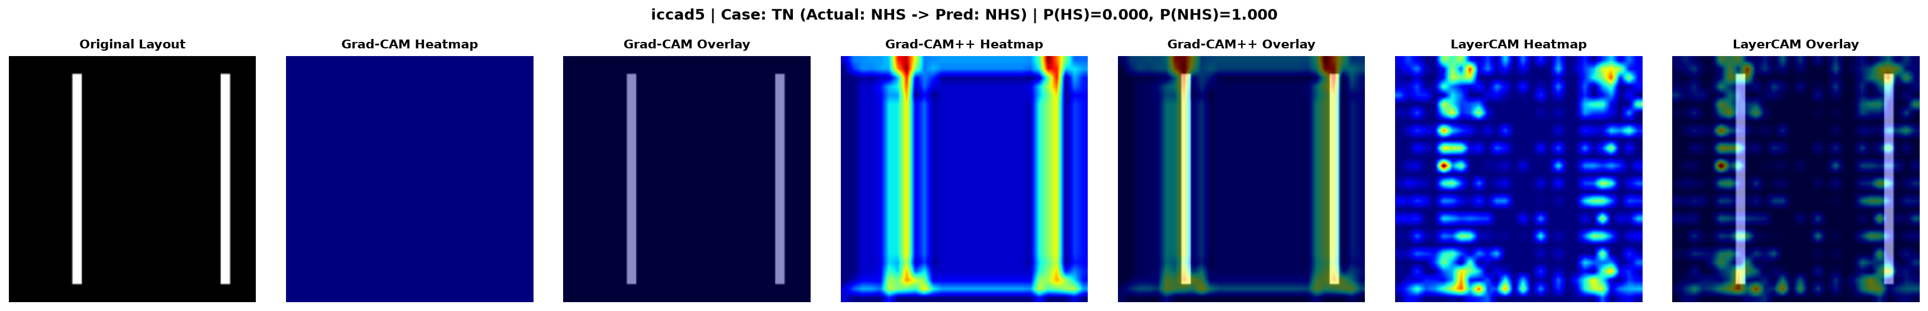
Fig. 9. Degenerate case, ICCAD-5 sample NNHSCAD5999_6 (TN): Grad-CAM and Grad-CAM++ are flat; this checkpoint is pending a clean-split re-migration (Section VII-A) and the finding is separate from that leakage issue.
Mechanism 2 — GAP-averaging cancellation on a saturated logit (ICCAD-3): sample NHSCAD31_7 (TN) has Grad-CAM flat while occlusion and LayerCAM are not. Its pre-sigmoid logit is saturated (21.1); 75% of gradient elements are exactly zero and the remaining 25% near-cancel under Grad-CAM's global-average-pooling weight computation, pushing the signed CAM to ≤ 0 everywhere before the ReLU guard zeroes it out. LayerCAM's pixel-wise weighting recovers signal from that same nonzero 25% because it never averages across space.
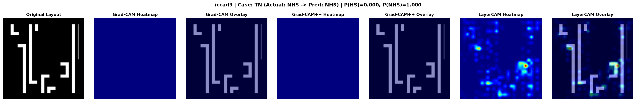
Fig. 10. ICCAD-3 sample NHSCAD31_7 (TN): Grad-CAM flat under logit saturation; LayerCAM stays structured on the identical input.
Both mechanisms are limitations of Grad-CAM's (and, more often, Grad-CAM++'s) specific gradient-averaging design — LayerCAM stays structured on the large majority of the same samples — which is why the multi-method design used here, rather than reliance on Grad-CAM alone, is load-bearing for the research question.

E. Occlusion Cross-Check
Occlusion sensitivity does not consistently agree with the CAM-based methods, and the disagreement is itself informative. Across all 57 samples, mean/median Pearson correlation with occlusion is: Grad-CAM 0.080/0.0, Grad-CAM++ 0.101/0.0, LayerCAM 0.336/0.305. LayerCAM is the only method with a consistently positive, non-trivial median correlation; Grad-CAM and Grad-CAM++ have a median correlation of exactly zero — for at least half the samples their attribution is uncorrelated or anti-correlated with what occlusion independently identifies as important. On the six case-study samples, agreement tracked model correctness: all three TP cases show positive correlations across nearly all methods (peaking at r=0.75–0.76 for LayerCAM), while all three TN cases show negative or near-zero Grad-CAM/Grad-CAM++ correlations, with only LayerCAM staying weakly positive on two of the three.

F. Answer to the Research Question
Qualified yes. Explainable-AI techniques in this project can identify layout regions that plausibly drive hotspot classification — LayerCAM and occlusion sensitivity both show statistically significant above-chance overlap with documented geometric features on TP samples (p<0.001 for both), and Grad-CAM does too on TP specifically (p=0.022) — but this capability does not hold uniformly across all four methods or all prediction outcomes. The strongest evidence for the “yes” verdict is that LayerCAM and occlusion sensitivity are significantly above a random-area control (p<0.001) on TP, TN, and FN samples alike, meaning at least two of the four methods reliably localise meaningful layout structure regardless of prediction correctness. The clearest limitation is that Grad-CAM alone is not trustworthy for this purpose — chance-level pooled (p=0.181), significantly below chance on TN (p=0.018), and exactly flat on 31.6% of samples — so the qualified answer holds only when Grad-CAM is used alongside Grad-CAM++, LayerCAM, and occlusion, not on its own.

IX. Discussion and Limitations
- Grad-CAM alone is unreliable for this task — chance-level pooled (p=0.181), below-chance on true negatives (p=0.018), and exactly degenerate on 31.6% of the 57-sample set — and must be paired with LayerCAM and/or occlusion sensitivity, never used in isolation, to answer the research question responsibly.
- The ICCAD-5 checkpoint is affected by two separate, independently-verified issues: the test/validation leakage bug (Section VII-A, corrected) and a genuine model-output collapse under naive class-weighting (Section VII-B) and under certain saturated-logit inputs (Section VIII-D). Some ablation/replication scripts still run on leakage-affected checkpoints (the fix has since been applied to both scripts (see docs/TEST_VALIDATION_LEAKAGE_AUDIT.md) but neither has been re-run yet) pending re-run on the clean split.
- The baseline CNN's aggressive spatial downsampling (224×224 → 15×15 before flattening) structurally limits its own attribution fidelity, independent of the leakage issue — this is the architectural motivation for the proposed model, not an afterthought.
- No physical or DRC ground truth exists in this project's data; every “technically meaningful” judgment in Section VIII is made against geometric proxies (raster-derived corner/junction/spacing detectors), not validated optical simulation. This is a limitation of scope, not of the attribution methods themselves.
- The proposed model's F1 is lower than the baseline's on every benchmark despite comparable balanced accuracy (Table II) — a precision/recall trade-off introduced by class-weighting that should be addressed with decision-threshold calibration on the validation split in future work.

X. Conclusion and Future Work
This work reproduced a lightweight reference CNN as a per-benchmark baseline and designed an XAI-ready variant that retains spatial resolution through three named convolutional stages, without materially changing detection performance (0.9363 vs. 0.9319 average balanced accuracy). In the process we discovered and corrected a test/validation leakage bug in our own pipeline, quantifying its average bias at −0.45 percentage points (worst case −5.32pp on ICCAD-5), and ran a three-condition, three-seed ablation that isolated loss-reweighting — not class imbalance itself — as the cause of a training-time feature-collapse failure mode. Applying four complementary attribution methods (Grad-CAM, Grad-CAM++, LayerCAM, occlusion sensitivity) to 57 representative predictions across all five benchmarks, we found a qualified, method- and outcome-dependent “yes” to Group 18's research question: LayerCAM and occlusion sensitivity reliably localise geometrically meaningful layout regions across true positives, true negatives, and false negatives alike, while Grad-CAM alone is unreliable outside true-positive hotspots and prone to gradient-cancellation degeneracy. Future work includes completing the re-run of leakage-affected ablations on the corrected clean split, calibrating decision thresholds to recover the proposed model's precision, extending geometric ground truth beyond raster proxies toward validated optical-simulation data, and completing the GPU-gated direct-gradient probe of the ICCAD-5 collapse mechanism that remains blocked pending device availability.

References
[1] A. Verma, K. A. Rao, and D. S. Hegde, “Lithography Hotspot Detection using Deep Learning,” Dept. of Electrical Engineering, IIT Bombay, India, reference paper provided for this assignment, 2026.
[2] V. Borisov and J. Scheible, “Lithography Hotspots Detection Using Deep Learning,” in Proc. 15th Int. Conf. on Synthesis, Modeling, Analysis and Simulation Methods and Applications to Circuit Design (SMACD), Prague, Czech Republic, 2018, pp. 145–148.
[3] L. Liao, S. Li, Y. Che, W. Shi, and X. Wang, “Lithography Hotspot Detection Method Based on Transfer Learning Using Pre-Trained Deep Convolutional Neural Network,” Appl. Sci., vol. 12, no. 4, p. 2192, 2022.
[4] H. Yang, Y. Lin, B. Yu, and E. F. Y. Young, “Lithography hotspot detection: From shallow to deep learning,” in Proc. 30th IEEE Int. System-on-Chip Conf. (SOCC), Munich, Germany, 2017, pp. 233–238.
[5] B. Zhou, A. Khosla, A. Lapedriza, A. Oliva, and A. Torralba, “Learning Deep Features for Discriminative Localization,” in Proc. IEEE Conf. on Computer Vision and Pattern Recognition (CVPR), 2016, pp. 2921–2929.
[6] R. R. Selvaraju, M. Cogswell, A. Das, R. Vedantam, D. Parikh, and D. Batra, “Grad-CAM: Visual Explanations from Deep Networks via Gradient-based Localization,” in Proc. IEEE Int. Conf. on Computer Vision (ICCV), 2017, pp. 618–626.
[7] C. Jiang, H. Sun, D. Feng, Z. Xie, B. Tan, and K. Liu, “LithoExp: Explainable Two-stage CNN-based Lithographic Hotspot Detection with Layout Defect Localization,” ACM Trans. on Design Automation of Electronic Systems, vol. 30, no. 3, pp. 1–25, 2025.
[8] A. Chattopadhyay, A. Sarkar, P. Howlader, and V. N. Balasubramanian, “Grad-CAM++: Generalized Gradient-based Visual Explanations for Deep Convolutional Networks,” in Proc. IEEE Winter Conf. on Applications of Computer Vision (WACV), 2018, pp. 839–847.
[9] P.-T. Jiang, C.-B. Zhang, Q. Hou, M.-M. Cheng, and Y. Wei, “LayerCAM: Exploring Hierarchical Class Activation Maps for Localization,” IEEE Trans. Image Processing, vol. 30, pp. 5875–5888, 2021.

