Automatic Class Time Table Management System

Submitted to

Dr. Md Manjur Ahmed

Chairman, Department of CSE

University of Barisal

Submitted by

Samira Tasnim

14CSEO18

1. Introduction:
   1. Background Studies:

Every department of a university have routines for the management of classes and time allocated to them. Currently these routines are manually created by a particular department in the institution. The parameters like teachers’ time, number of periods, class time, etc. for creating routines are also manually kept in mind while creating these routines. Also the routines keep changing with time. Hence making their management even more difficult due to change in parameters value/state. If the above harsh process of creating and maintaining the routine

could be done using an automated system then it would help the department of an institution to loosen the burden and increase the efficiency.

* 1. Objectives:

1. To develop a web based system that allows users to create and maintain the class routines.

2. To develop an android system to view the created class routines.

* 1. Scope:

Routine Management System benefits all the educational institutions that currently uses manual creation and maintenance of the class routines. Users can easily create and maintain class routines using the system’s simple user interface. It also resolves the issue of manual staffing process into a controlled and closely monitored system. It can be used by every educational institution interested to create class routines using a computerized system.

1. Methodology:

Using Genetic Algorithm approach for find the best schedule of class. First make some random class for initial children then make some random schedule from this classes then make some random population from this schedules then crossover population select tournament population then crossover schedule then mutates crossover schedule then Find Final Schedule where fitness value 1.

1. Functional Requirements:

|  |  |  |  |  |  |  |  |
| --- | --- | --- | --- | --- | --- | --- | --- |
| |  |  | | --- | --- | | FR-1 |  | |  |  | |  |  | | Member Information |
| Description | This module helps admin to register of class routine management system members. Admin is able to maintain all the information of register of class routine management system members. |
| Stakeholders | Admin |

|  |  |  |  |  |  |  |  |
| --- | --- | --- | --- | --- | --- | --- | --- |
| |  |  | | --- | --- | | FR-02 |  | |  |  | |  |  | | Update System Details |
| Description | This module helps admin to update teachers and student’s information. Teachers can also update some important information and store these details in database. |
| Stakeholders | Admin |

|  |  |  |  |  |  |  |  |
| --- | --- | --- | --- | --- | --- | --- | --- |
| |  |  | | --- | --- | | FR-03 |  | |  |  | |  |  | | Login system |
| Description | Teacher must have a login option. Admin never give permission any teacher if they go through into the login option. |
| Stakeholders | Admin, Teacher |

|  |  |  |  |  |  |
| --- | --- | --- | --- | --- | --- |
| |  |  | | --- | --- | | Fr-04 |  | |  |  | | Search Option |
| Description | Search option for teachers for find out their own class routine and other purpose. |
| Stakeholders | Admin, Teacher |

1. Diagrams:
   1. Module Diagram:

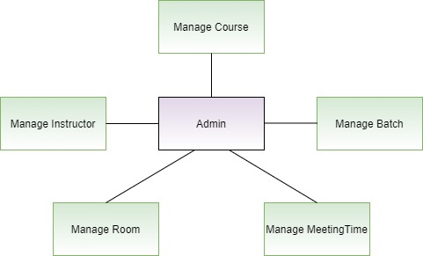

* 1. Dataflow Diagram:
     1. Admin:

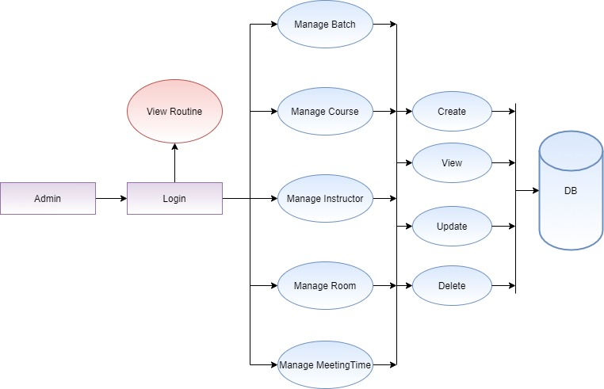

* + 1. Teacher:

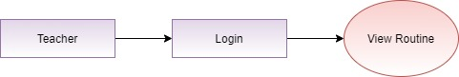

* + 1. Student:

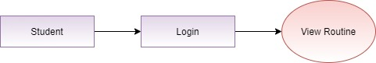

* 1. Class Diagram:

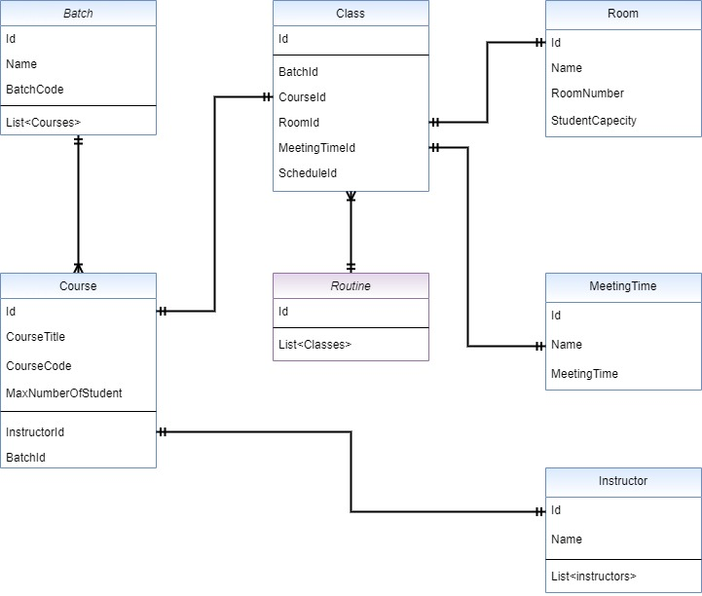

* 1. ER Diagram:

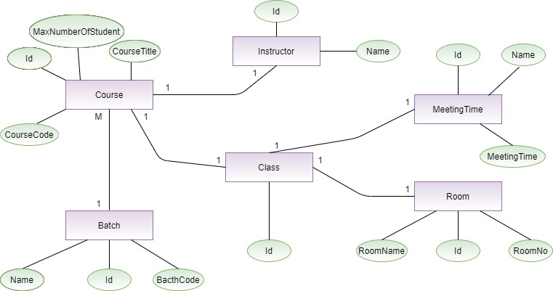

1. Screen Shots:

