1. Parallel Efficiency Analysis:

Tested on the 1000 nodes, 3000 edges sample test case given.
For 1 process :
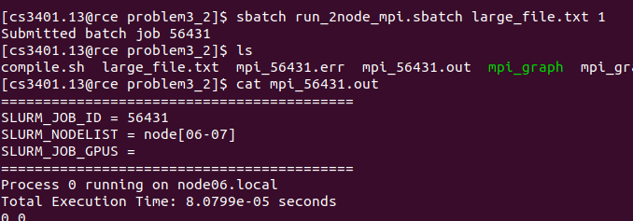
For 2 processes :
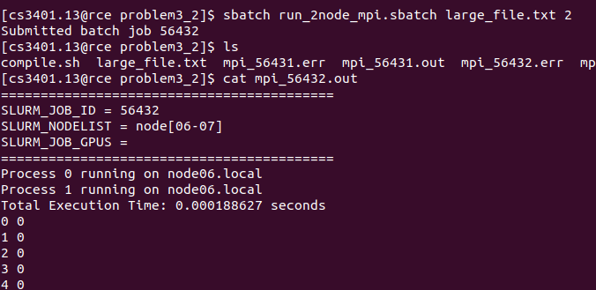

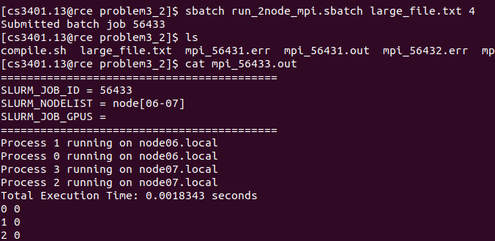
For 4 processes :
Here, we observe that the execution time is increasing instead of decreasing.
There are three major reasons:
1. The Problem Size Is Extremely Small :
For 1 process, it was just 80 microseconds.
MPI startup + synchronization overhead alone is often:
- 50–500 microseconds
So what we are measuring is mostly : MPI initialization, MPI_Allreduce latency, Synchronization overhead. But not the actual computation.
When the workload is too small:
T_{communication} >>> T_{computation}
So adding more processes increases overhead.

2. MPI_Allreduce on Full n Array Every Iteration :
This is expensive:
MPI_Allreduce(MPI_IN_PLACE, new_comp.data(), n, MPI_INT, MPI_MIN, MPI_COMM_WORLD);
Cost per iteration: O(nlogP)
When n is small => latency dominates
When P increases => communication cost increases

Speedup and Efficiency :
S(2)=0.00008/0.000188≈0.42
S(4)=0.00008/0.0018343≈0.043
Parallel efficiency:
E(2)=0.42/2=0.21=21%
E(4)=0.043/4≈1%

Estimating maximum graph size processable :
Theoritically, since each iteration scans all edges: T is I(m+nlogP)
If time roughly scales linearly with m: T is proportional to m
For 3000 edges, it took about 0.00008 seconds => in 600 seconds, we can do – (600/0.00008)*3000 = 22500000000 edges = 22.5 B edges
2. Communication Profiling:
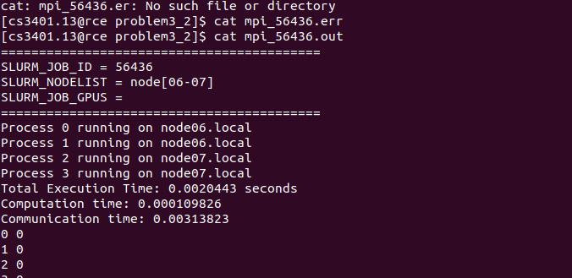
Communication-to-Computation Ratio = 0.00313823/0.000109826 = 2.85745634
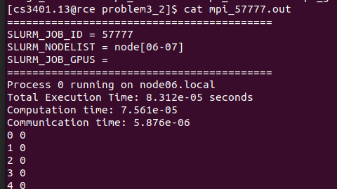
For 1 process :

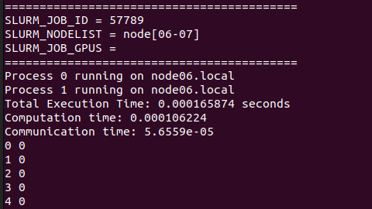
For 2 processes :

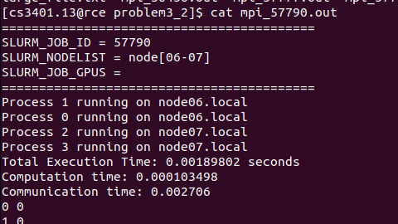
For 4 processes :

As expected in parallel effeciency analysis, the communication time communication cost increases significantly.
From 1 process to 2 processes -> increased by 0.000056559/0.00000587 = 9.635264055x = 10x times
From 2 processes to 4 processes -> increased by 0.002706/0.000056559 = 47.843844481x = 48x times
=> From 1 process to 4 processes -> increased by 480x times.
If we look at the actual computation time,
From 1 to 2 processes -> S(2) = 0.00007561/0.000106224 = 0.71179771
From 2 to 4 processes -> 0.000103498/0.000106224 = 0.97433725
The main message is MPI_Allreduce(... n integers ...)
Message size per iteration: n×sizeof(int)
From logs, message size per Allreduce: 0.0038147 MB

3. Computational Complexity:

FLOPs Analysis:
Per edge:
1 min() operation
2 comparison operations
2 assignment operations
~5 operations per edge.
Per iteration: operations = 5m operations
If I iterations: TotalFLOPs = 5mI
Plus: n comparisons for local_changed = nI
So total: O(I(m+n))

Communication Complexity:
Each iteration:O(nlogP)
So total:O(I(m+nlogP))

Theoretical Scaling :
If:
- m >> n
- I constant
Then: T = O(m)

