1. Iteration Time Analysis:

A.) Profile time taken for 10 iterations :
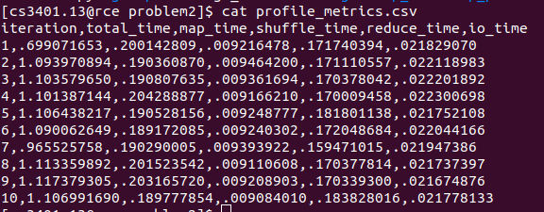

On the shared test case containing 1000 nodes, these are the profile times for the 10 iterations.

Average values (approximately):
- Total iteration time = 1.07 sec
- Map time = 0.195 sec (18%)
- Shuffle time = 0.009 sec (0.84%)
- Reduce time = 0.172 sec (16%)
- IO time = 0.022 sec (2%)
B.) Overhead per iteration :
Now, Map + Shuffle + Reduce = 0.376 sec
=> Overhead = 1.07 - 0.376 = 0.694 sec
=> 65% of time is framework overhead.
C.) Time for I/O : 0.022 sec approx

2. Scalability Analysis:

We analyze scaling with:
- |V| (nodes)
- |E| (edges)

A.) Theoretical Complexity
Each iteration:

Map Phase:
For each node:
- emit adjacency list => O(|V|)
- emit one contribution per outgoing edge => O(|E|)
So:
Map complexity = O(V + E)

Shuffle + Sort:
Sort on intermediate data:
Intermediate size=≈ O(V + E)
Sorting complexity: O((V+E) log(V+E))
This is the dominant cost.

Reduce:
One reduce per node: O(V + E)

Overall Per Iteration:
O((V+E) log(V+E))
Total:
O(I (V+E) log(V+E))

B.) Validation :
For 1000 nodes, with average degree of 5 :
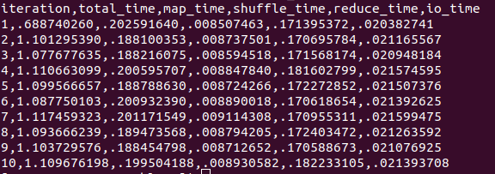

For 5000 nodes, with average degree of 5 :

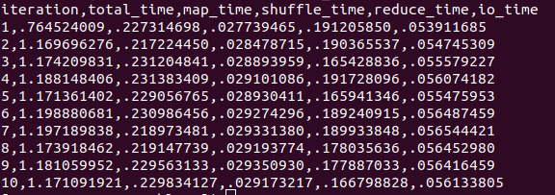
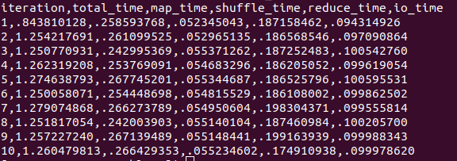
For 1000 nodes, with average degree of 5 :
=> Average iteration time
for 1000 nodes is 1.09 seconds
for 5000 nodes is 1.18 seconds
for 10000 nodes is 1.26 seconds
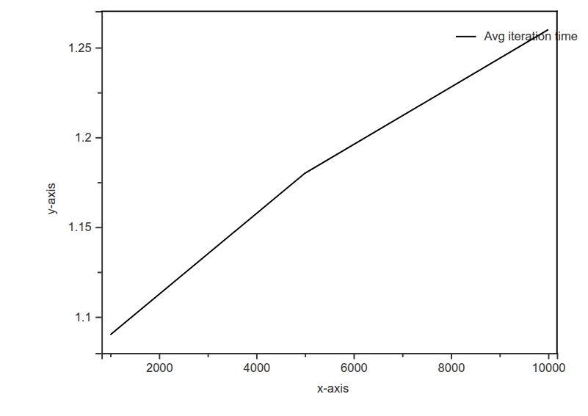

C.) Observations:
From 1k to 10k:
- Nodes increased 10×
- Edges increased 10×
- Time increased only ~15%
That means: runtime is not dominated by graph size yet. It is dominated by fixed overhead.
Shuffle time :
Nodes | Shuffle
1k | ~0.009s
5k | ~0.029s
10k | ~0.055s
This scales almost perfectly linearly with edges. That is expected because shuffle size = O(E)
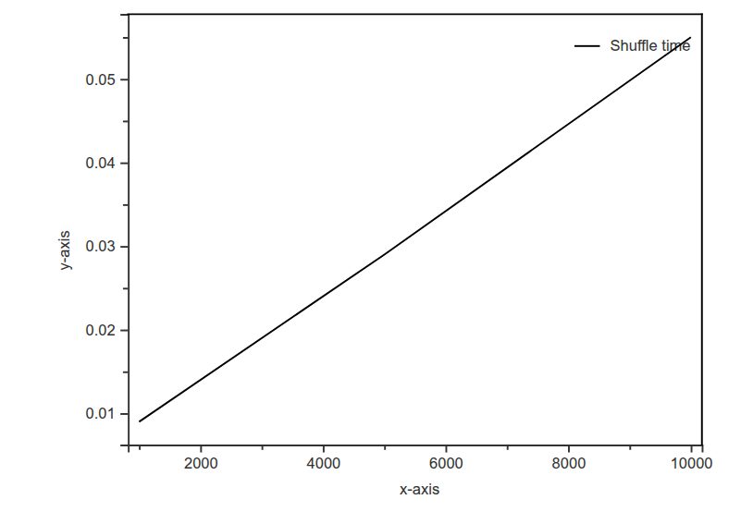

IO Time:
Nodes | IO
1k | 0.021s
5k | 0.055s
10k | 0.10s
Also nearly linear with E.
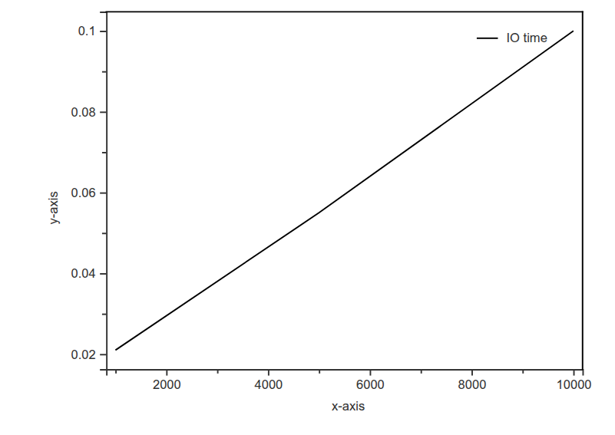

Map Time:
Nodes | Map
1k | 0.19–0.20
5k | 0.22–0.23
10k | 0.25–0.27

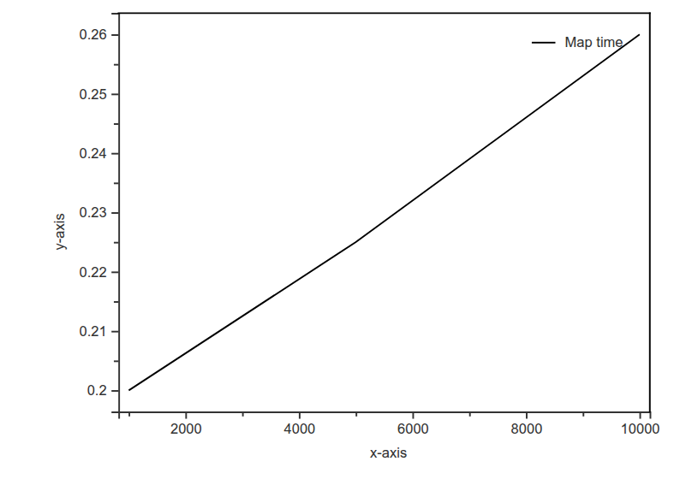
Reduce Time:
Almost constant (~0.18–0.19). That means reducer cost is small relative to overhead.

D.) Compare With Theoretical Complexity
Theoretical per iteration: O((V+E)log(V+E))
Since avg degree is constant (5): E=O(V)
So: T(V)≈O(VlogV)
Now check growth: If pure V log V -
For 1k: 1000log(1000)
For 10k: 10000log(10000)
Ratio ≈100000log100000/1000log1000
≈ 13.3×
But the observed ratio:
1.26/1.09≈1.15×
This huge difference might be due to the dominance of overhead at small scale, i.e – the true compute time is being hidden by SLURM startup, Barrier sync, Process creation, etc.
Validation to this claim : Extract Real Compute Scaling -
Subtract fixed overhead.
From 1k:
Total ≈ 1.09
Map + Shuffle + Reduce + IO ≈0.20 + 0.009 + 0.17 + 0.02 ≈ 0.40
So overhead ≈ 0.69 sec.
Subtract that overhead from others:
For 5k:
1.18 − 0.69 ≈ 0.49 sec compute
For 10k:
1.26 − 0.69 ≈ 0.57 sec compute
Now compare compute only:
0.40 to 0.57 ≈ 1.4×
Much closer to theoretical scaling.

E.) Estimating Maximum Graph Size for 10 Minutes
10 iterations of 10k:
10 × 1.26 ≈ 12.6 sec
Time limit = 600 sec
Scale factor:
600 / 12.6 ≈ 47×
So estimated maximum:
Nodes ≈ 10k × 47 ≈ 470k nodes
Edges ≈ 50k × 47 ≈ 2.35 million edges
Before hitting 10 min limit.
*But, sorting will eventually dominate, so actual max slightly lower.

F.) Conclusions

Observation 1
Execution time increases sub-linearly with graph size for small graphs because distributed framework overhead dominates computation.

Observation 2
Shuffle and I/O times scale linearly with number of edges, confirming O(E) behavior.

Observation 3
Sorting cost grows but remains small relative to SLURM startup overhead for graphs <= 10k nodes.

Observation 4
True asymptotic behavior will approach O(V log V) once graph size becomes large enough for compute to dominate overhead.

3. I/O Performance
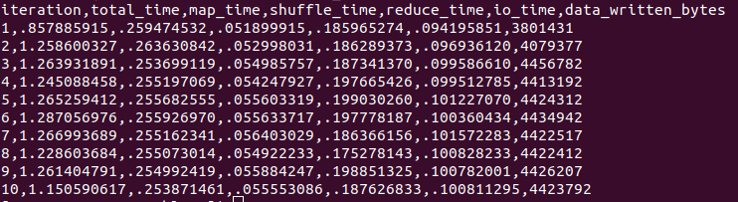
A.) Average data volume per iteration = 4.4MB
(this is for graph input with 10k nodes, 5 edges on average)

B.) Disk throughput = data_written/io_time = 4.4 MB/0.1 s = 44 MB/s

C.) Network overhead - In real distributed Hadoop, shuffle causes network transfer of intermediate key-value pairs. Our approximation can be - Network cost ≈ size of merged.txt. Because in real cluster, that would be transferred across nodes.

