**The Currency Converter**

**Ratul Hossain Shuvo**

**ID: CSE 06607822**

**Mizanur Rahman Shohan**

**ID: CSE 06607751**

**Project Details**

Currency converter (or currency exchange) is a mini project coded in Java programming language. This simple application provides a web-based interface for exchanging/converting money from one currency (say $) to another currency (say €).

**Motivation**

* 1. Block chain
* 2. Digital currency
* 3. E- coin

**Implementation**

Constructor: A constructor in Java is a special method that is used to initialize objects. The constructor is called when an object of a class is created. It can be used to set initial values for object attributes

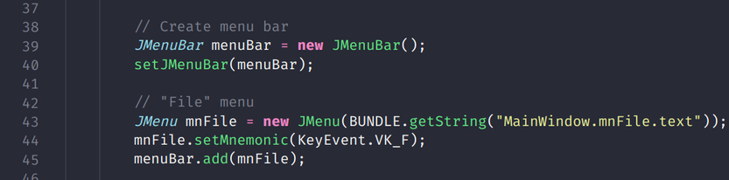

Encapsulation: The meaning of Encapsulation, is to make sure that "sensitive" data is hidden from users. To achieve this, you must declare class variables/attributes as private provide public get and set methods to access and update the value of a private variable

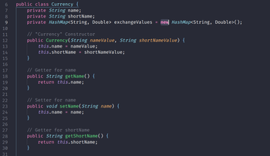

Inheritance: inherit attributes and methods from one class to another

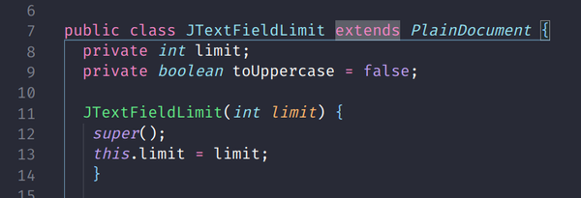

Inspirational gift Repo:

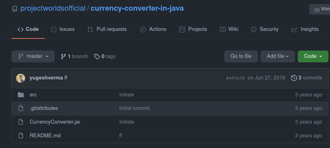



**Pros and Cons**

Pros: Anyone can easily convert currency, because of its simple GUI

Cons: Currency rate we gate is not up to date or current rate, its hard coded not dynamic

**Limitation and Future work**

Limit: User now only can calculate currency.

Future work: In future, there will be a visualization graph for every currency rate like stock market