AgriAssist Real-World Field Image Analysis
Input field images and website output evidence for real-world advisory use
Purpose
This document shows how real orchard and field images were used as input examples in the AgriAssist website. Each case includes the real-world input image, the query used for retrieval, and website output screenshots showing retrieved documents and AI-generated agricultural advisory. This demonstrates practical field-level analysis beyond clean dataset images.
Important Note
The CNN model is mainly trained on close-up crop disease leaf images, while these examples are wide field/orchard images. Therefore, these images are used primarily to demonstrate real-world advisory generation with user context and RAG retrieval, not guaranteed disease classification.

Case 1: Mango orchard with fruits
Useful for fruiting-stage orchard management, pest monitoring, irrigation planning, and general precautions.
Input query used on website
Mango orchard with fruits India farmer advisory
Real-world input image
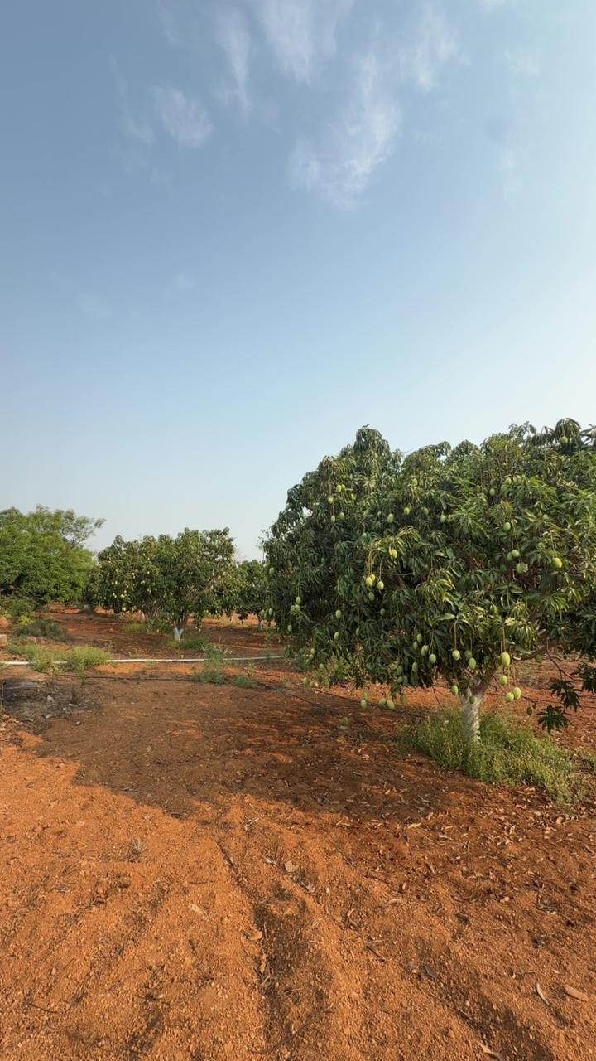
Website output screenshots
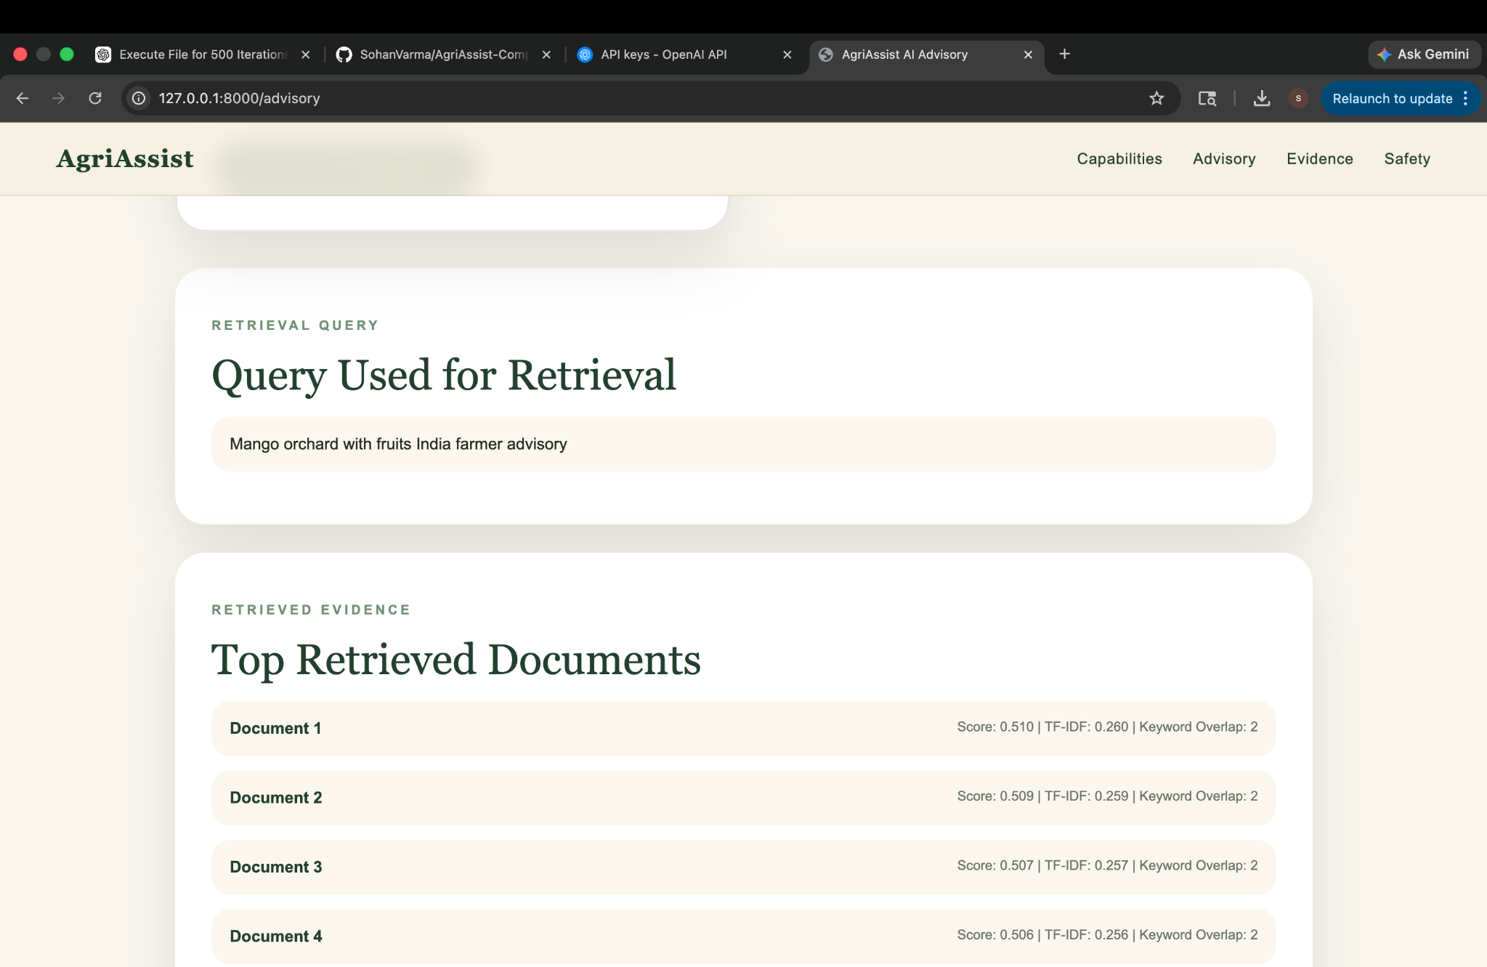 | 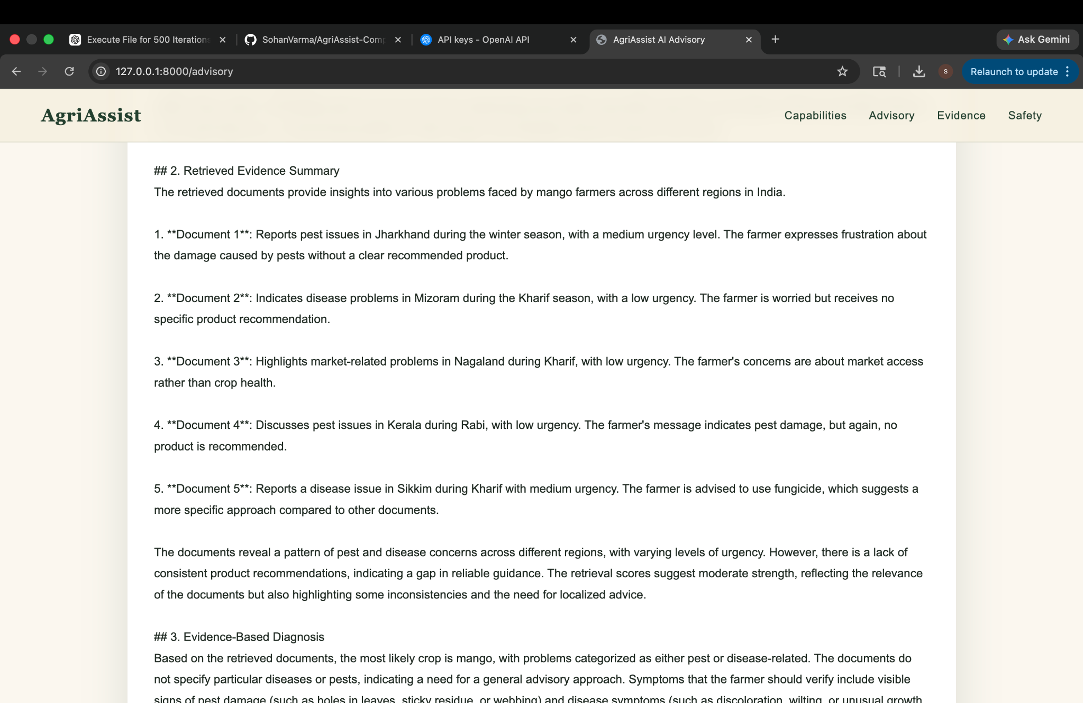
How this was useful in real life
Shows that AgriAssist can convert a real field photo plus farmer context into a retrieval query, retrieve agricultural evidence, and generate a practical advisory. It also highlights where the knowledge base needs more orchard-specific records when scores are moderate or weak.

Case 2: Dry/unused field with weeds
Useful for land preparation, weed management, soil preparation, and cultivation readiness analysis.
Input query used on website
Dry/unused field with weeds India farmer advisory
Real-world input image
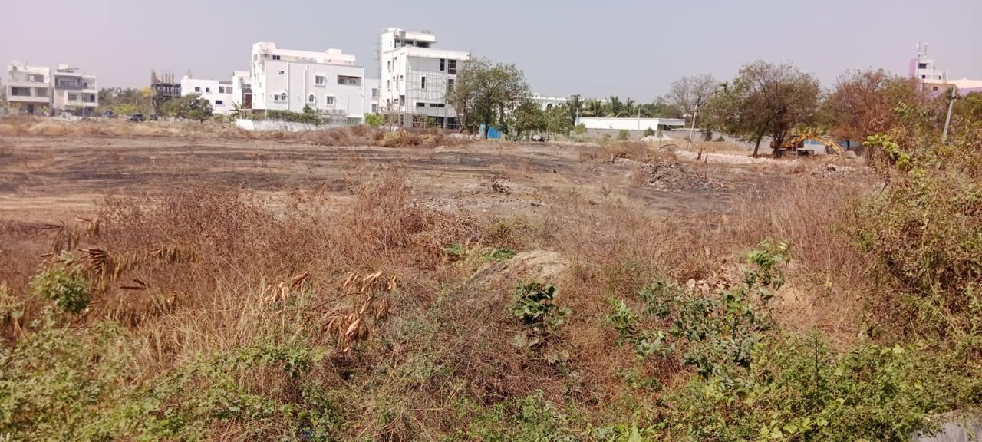
Website output screenshots
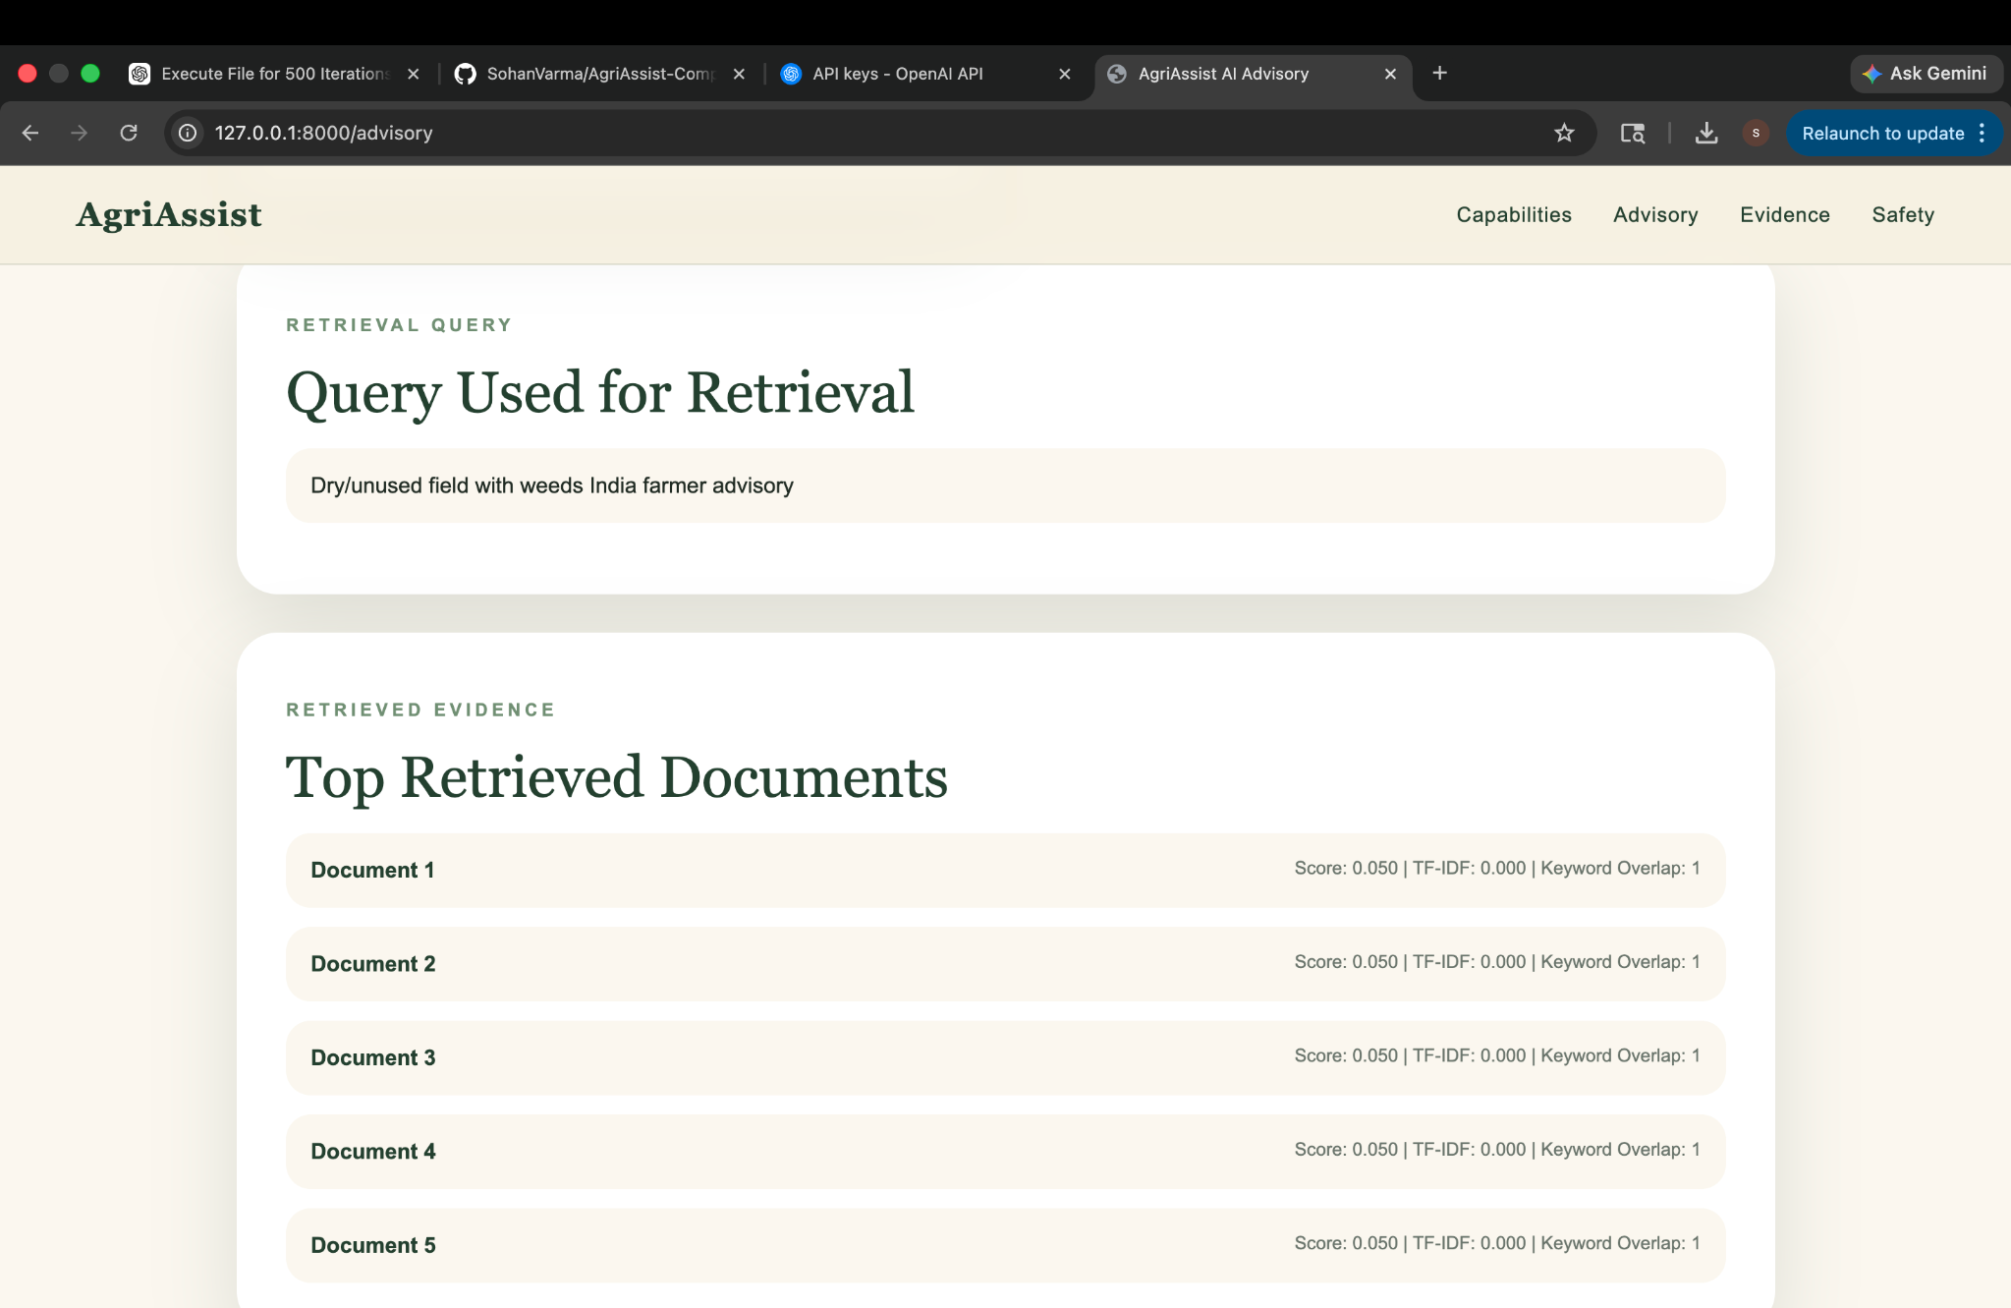 | 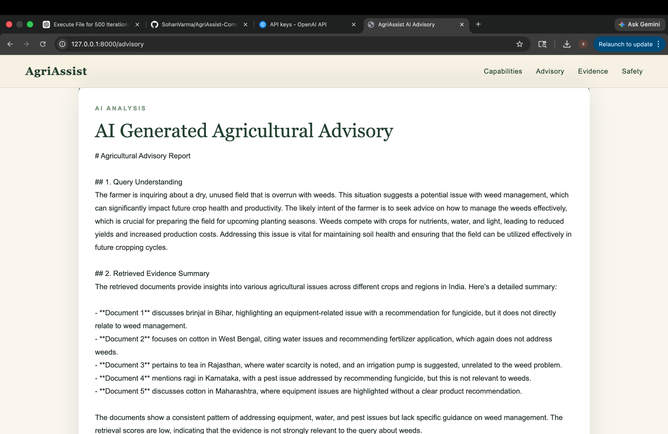
How this was useful in real life
Shows that AgriAssist can convert a real field photo plus farmer context into a retrieval query, retrieve agricultural evidence, and generate a practical advisory. It also highlights where the knowledge base needs more orchard-specific records when scores are moderate or weak.

Case 3: Mango flowering stage
Useful for flowering-stage management, fruit-set precautions, pest/disease monitoring, and irrigation guidance.
Input query used on website
mango flowering stage India farmer advisory
Real-world input image
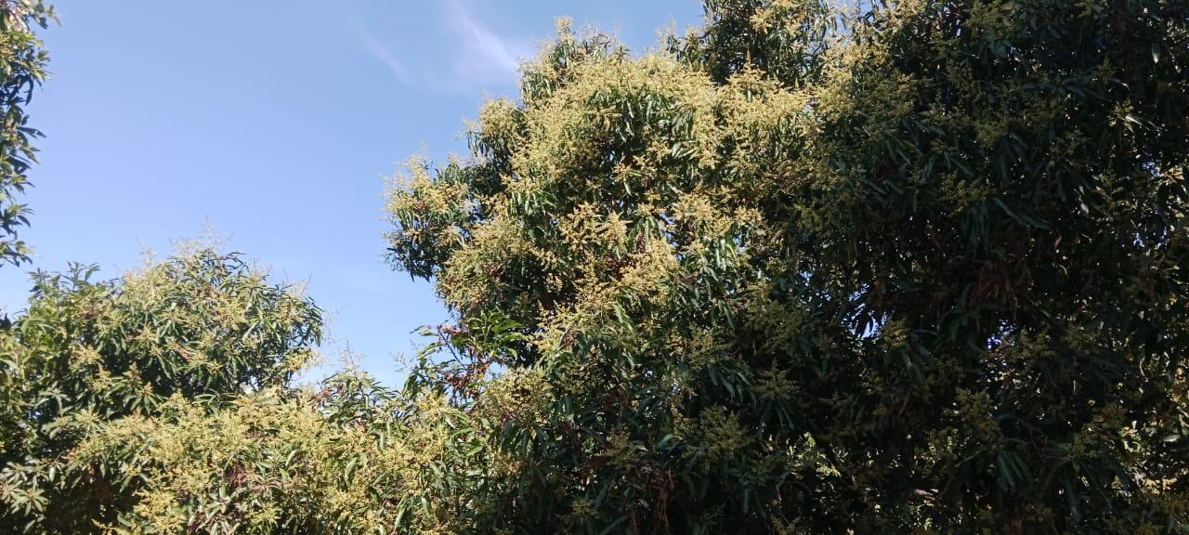
Website output screenshots
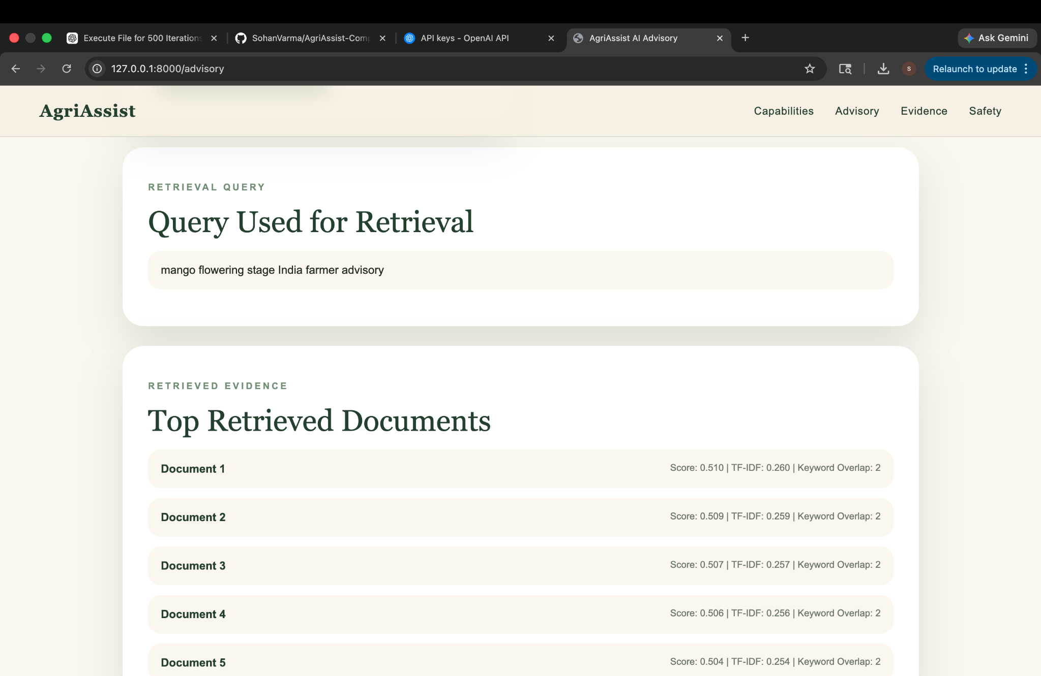 | 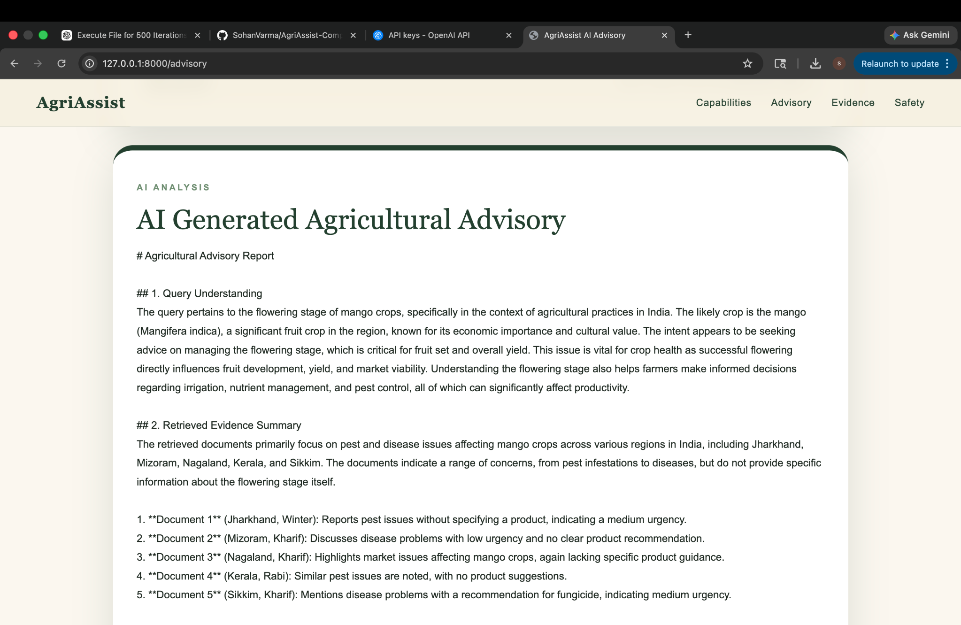
How this was useful in real life
Shows that AgriAssist can convert a real field photo plus farmer context into a retrieval query, retrieve agricultural evidence, and generate a practical advisory. It also highlights where the knowledge base needs more orchard-specific records when scores are moderate or weak.

Case 4: Orchard boundary with weeds/overgrowth
Useful for orchard hygiene, boundary weed control, pest habitat reduction, and fire-risk prevention.
Input query used on website
Orchard boundary with weeds/overgrowth India farmer advisory
Real-world input image
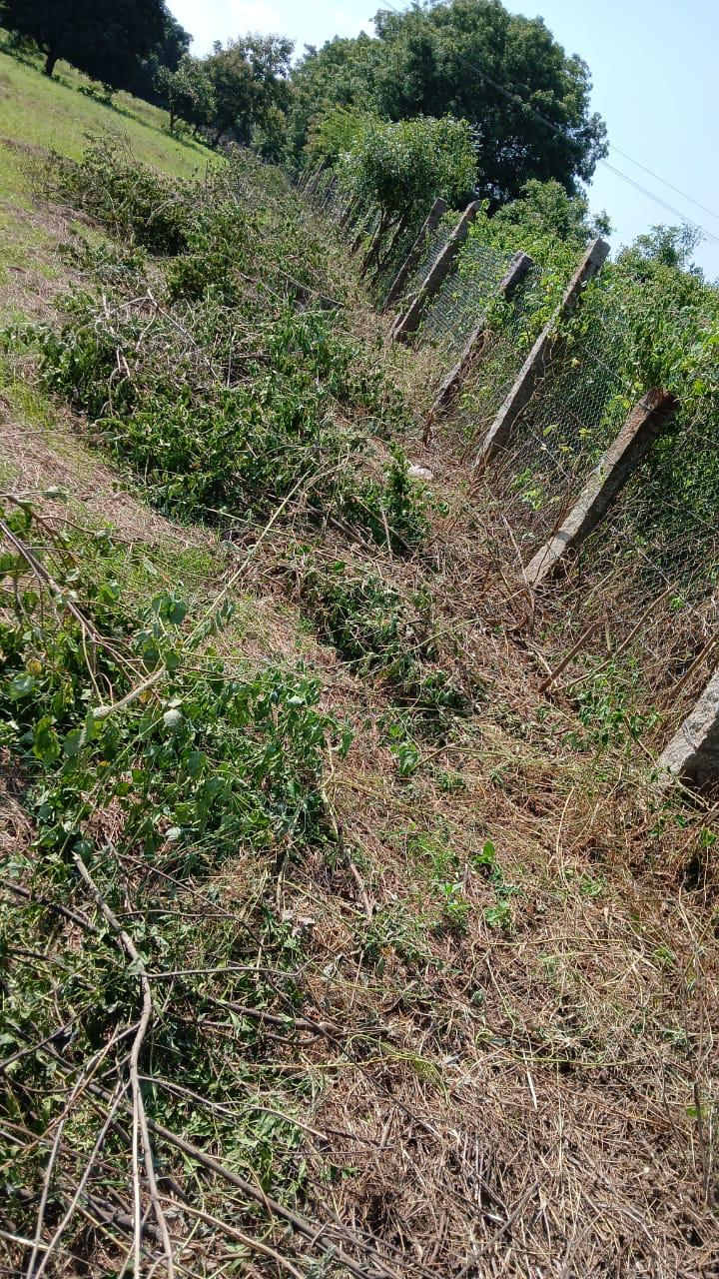
Website output screenshots
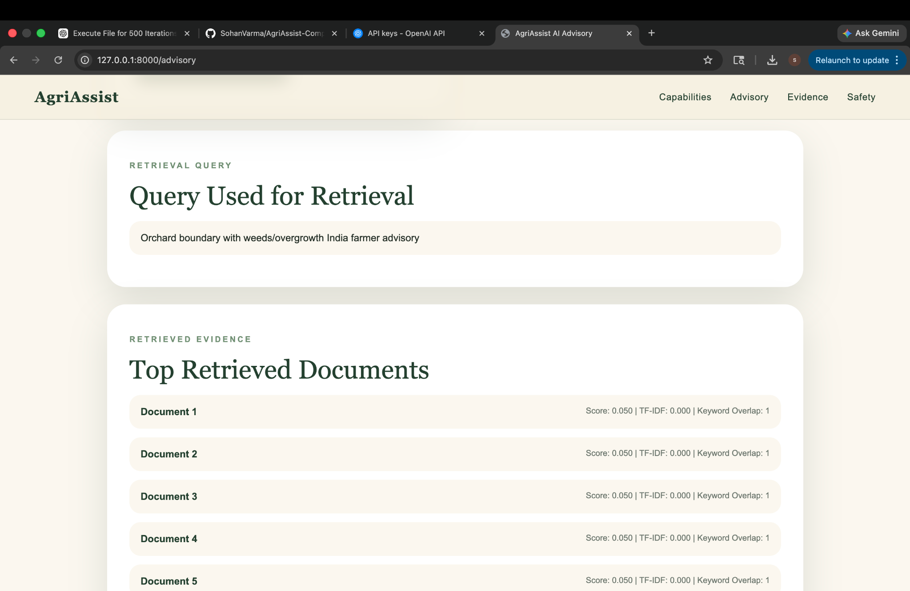 | 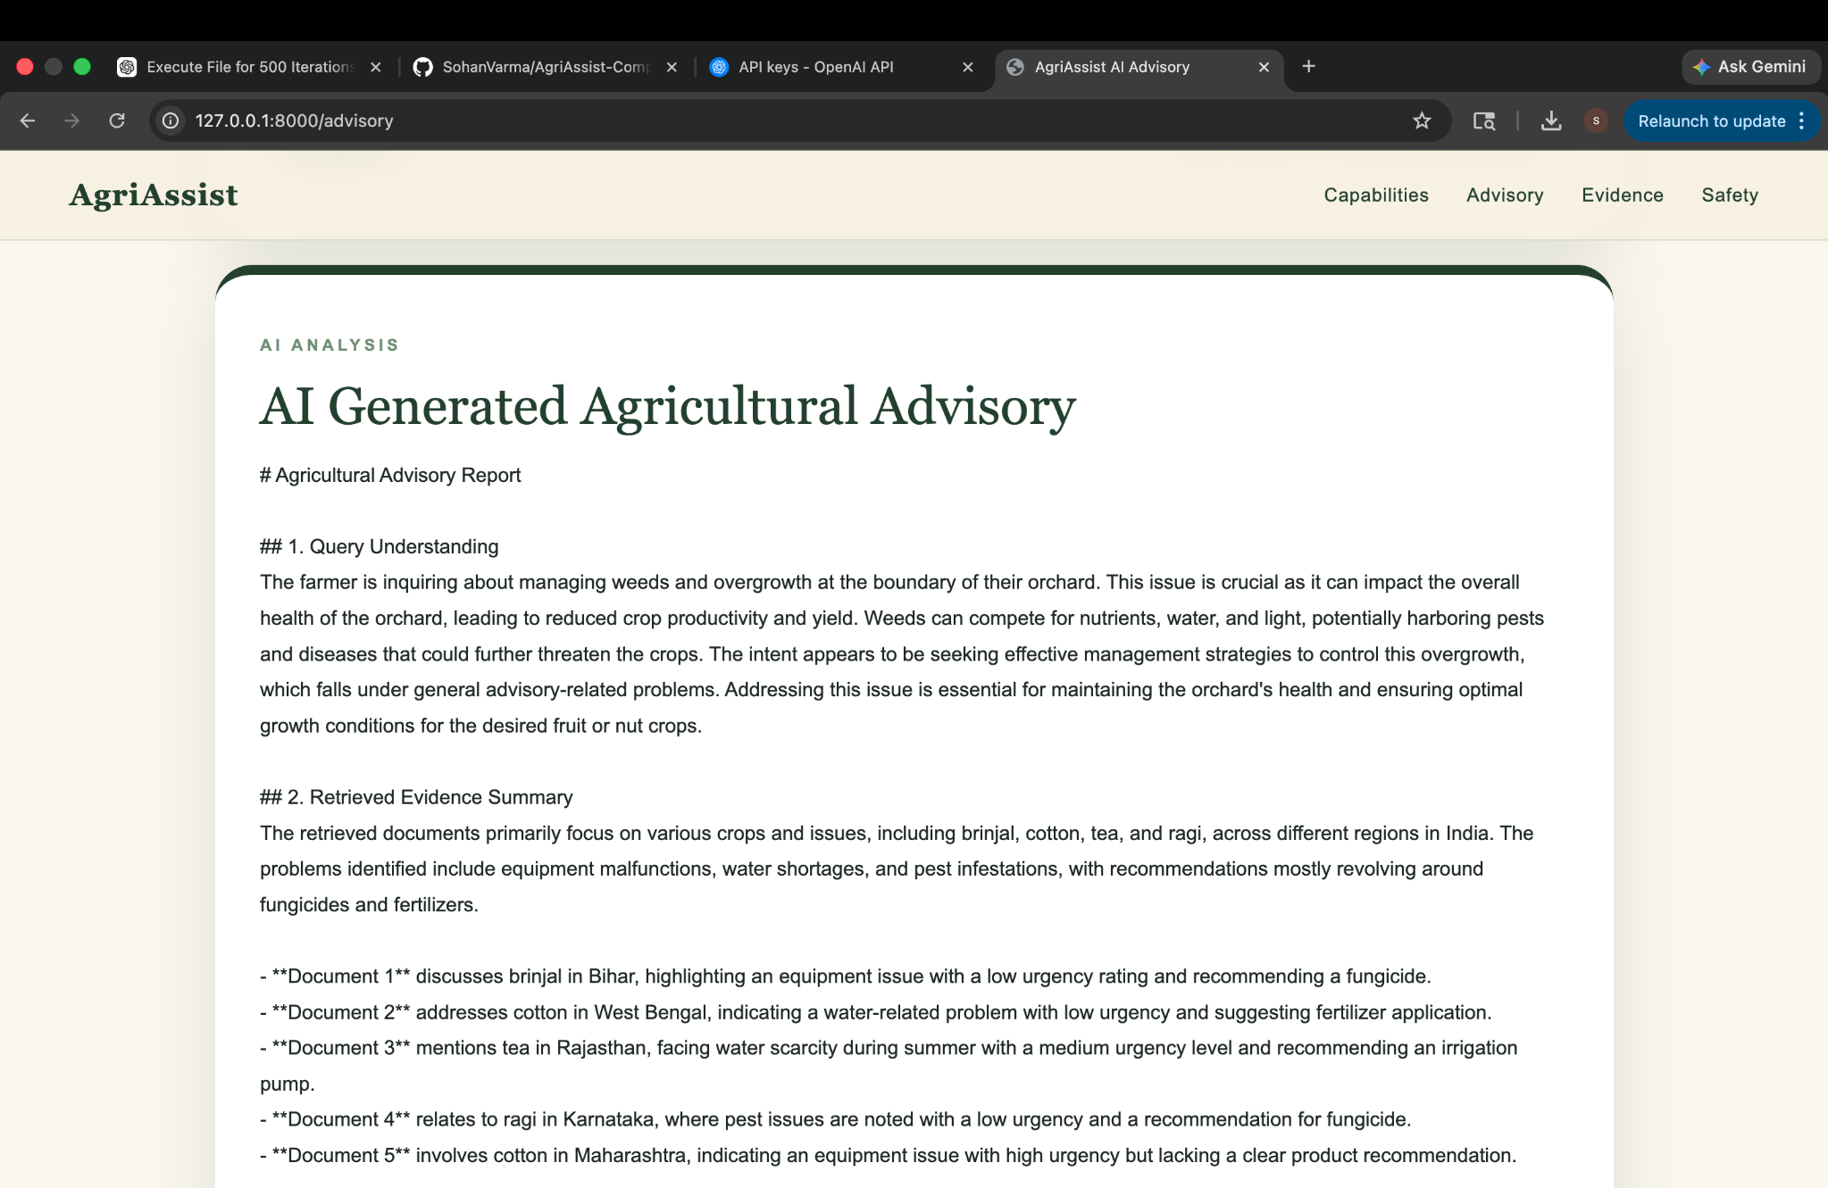
How this was useful in real life
Shows that AgriAssist can convert a real field photo plus farmer context into a retrieval query, retrieve agricultural evidence, and generate a practical advisory. It also highlights where the knowledge base needs more orchard-specific records when scores are moderate or weak.

Case 5: Cleaned mango orchard with irrigation pipes
Useful for post-weeding orchard floor management, drip irrigation inspection, soil moisture monitoring, and maintenance planning.
Input query used on website
Cleaned mango orchard with irrigation pipes India farmer advisory
Real-world input image
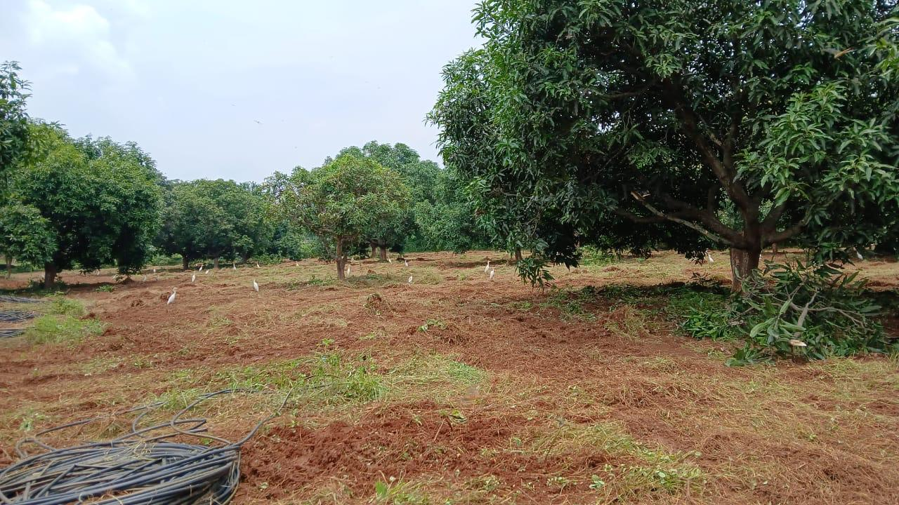
Website output screenshots
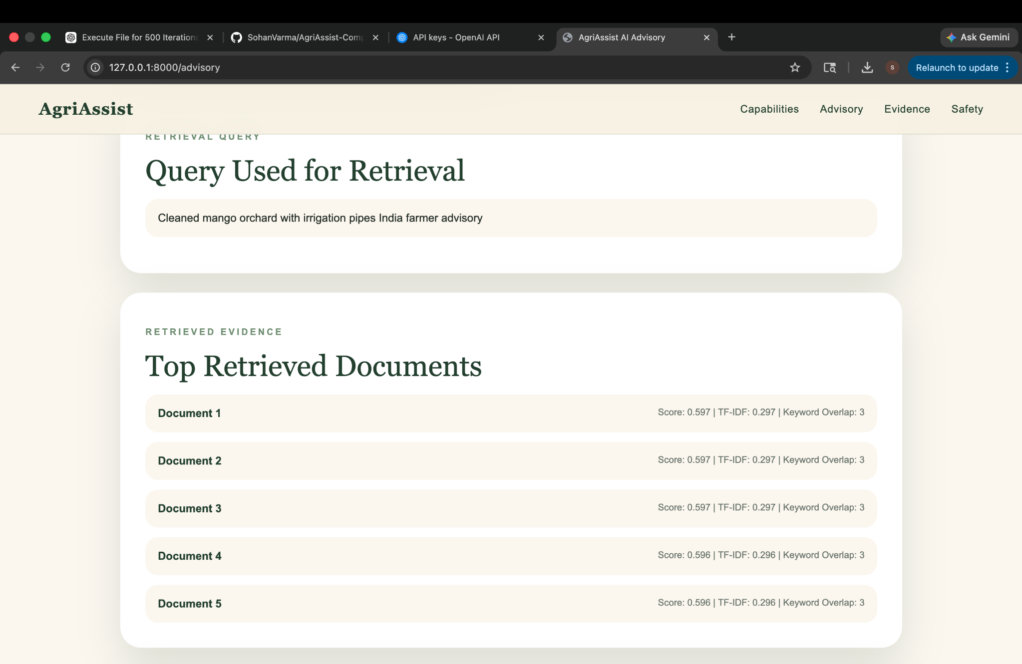 | 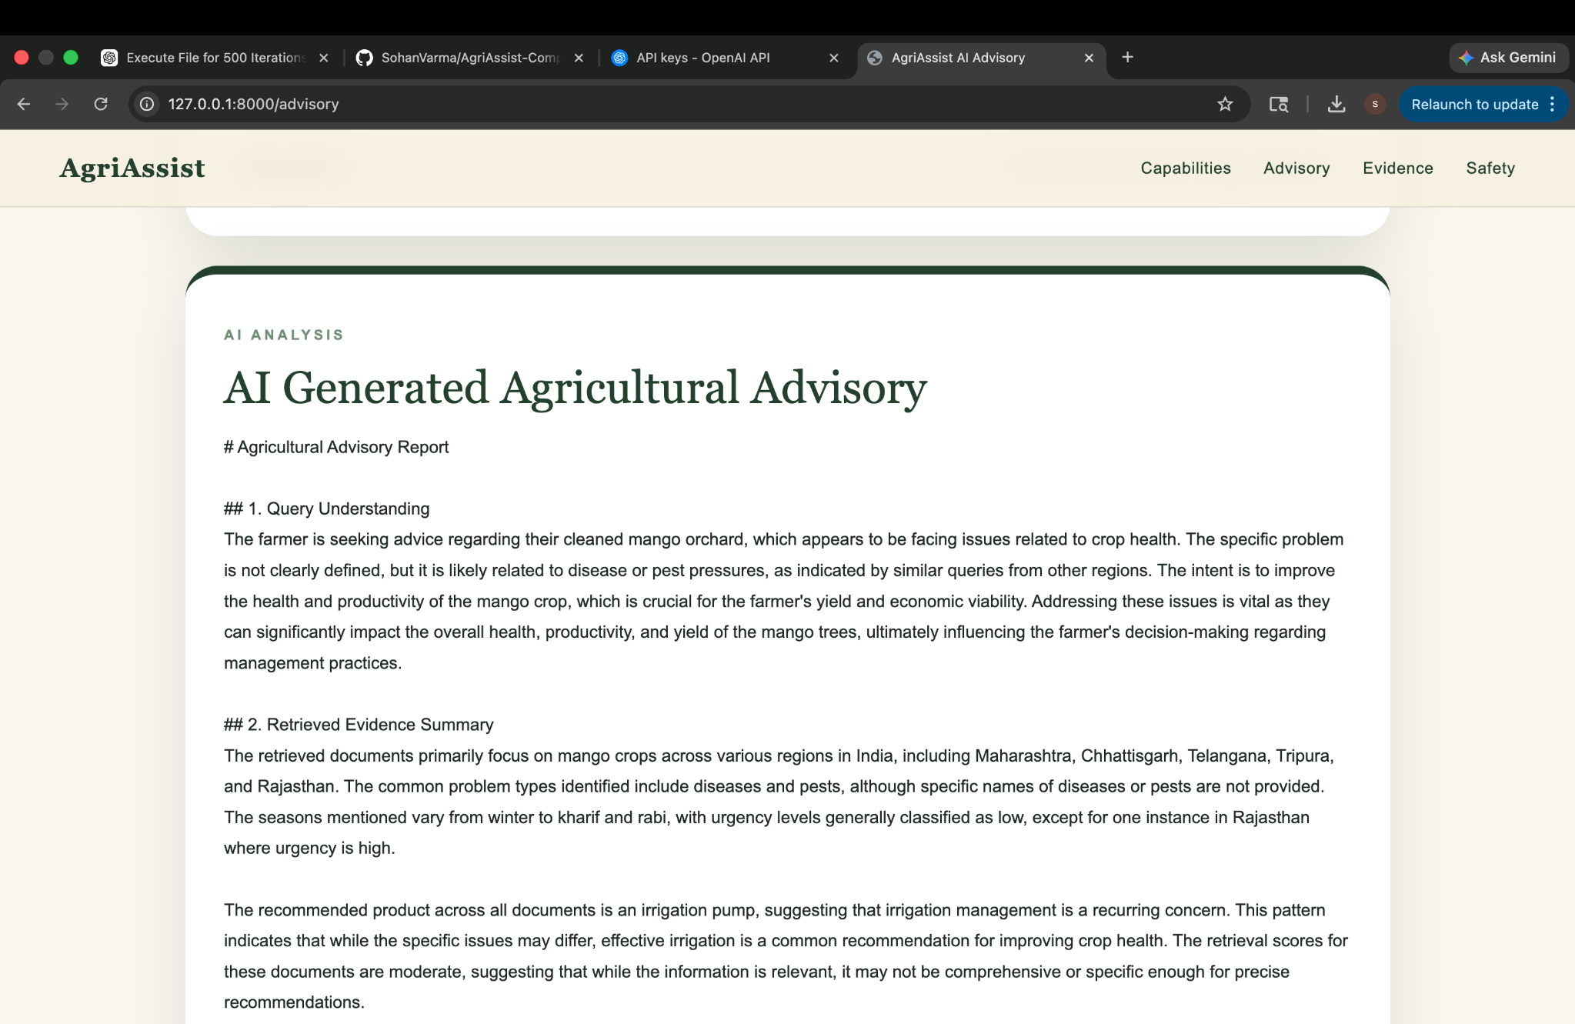
How this was useful in real life
Shows that AgriAssist can convert a real field photo plus farmer context into a retrieval query, retrieve agricultural evidence, and generate a practical advisory. It also highlights where the knowledge base needs more orchard-specific records when scores are moderate or weak.

Summary
These examples show AgriAssist as a real-world agricultural decision-support system for orchard management, weed control, irrigation maintenance, flowering-stage monitoring, and field advisory. The screenshots document both the inputs and the outputs used during testing.

