# Fire Alarm System Project by Interfacing Arduino with Temperature & Gas Sensor using TinkerCad

**Components:**

1. **Arduino Uno**
2. **Temperature Sensor (TMP36)**
3. **Gas Sensor (Assuming MQ-2)**
4. **Piezo Buzzer**
5. **Resistors**
6. **Breadboard & Jumper Wires**

**Circuit Explanation:**

* The temperature sensor and gas sensor send analog signals to the Arduino.
* When either sensor crosses a threshold (temperature or gas level), the buzzer is activated.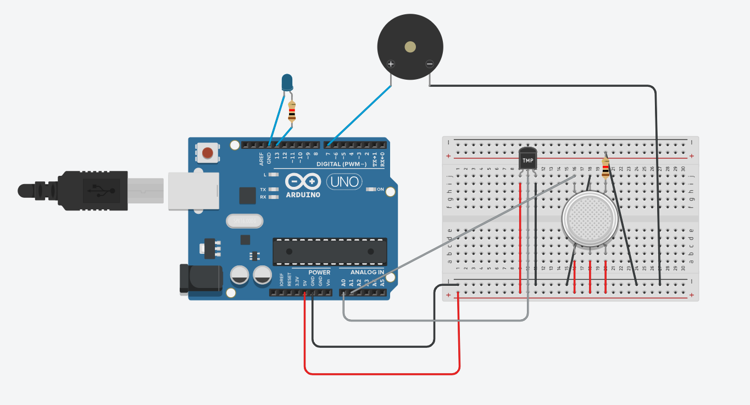

CODE:

// Define the pins for sensors and buzzer

const int tempSensorPin = A0; // Analog input pin for temperature sensor

const int gasSensorPin = A1; // Analog input pin for gas sensor

const int buzzerPin = 9; // Digital output pin for buzzer

// Define the threshold values

const float tempThreshold = 50.0; // Temperature threshold (in Celsius)

const int gasThreshold = 300; // Gas sensor threshold (Analog value)

void setup() {

// Initialize the Serial Monitor

Serial.begin(9600);

// Initialize the buzzer pin as output

pinMode(buzzerPin, OUTPUT);

// Initialize sensors pins as input

pinMode(tempSensorPin, INPUT);

pinMode(gasSensorPin, INPUT);

}

void loop() {

// Read the temperature sensor value

int tempReading = analogRead(tempSensorPin);

// Convert the analog reading to voltage (0-1023 mapped to 0-5V)

float voltage = tempReading * (5.0 / 1023.0);

// Convert the voltage to temperature in Celsius (for TMP36)

float temperatureC = (voltage - 0.5) * 100.0;

// Read the gas sensor value

int gasReading = analogRead(gasSensorPin);

// Display the readings on the Serial Monitor

Serial.print("Temperature: ");

Serial.print(temperatureC);

Serial.print(" C, Gas Level: ");

Serial.println(gasReading);

// Check if temperature exceeds the threshold or gas level is high

if (temperatureC > tempThreshold || gasReading > gasThreshold) {

// Turn on the buzzer if either threshold is exceeded

digitalWrite(buzzerPin, HIGH);

} else {

// Turn off the buzzer if everything is normal

digitalWrite(buzzerPin, LOW);

}

// Small delay before the next loop

delay(1000);

}

**How It Works:**

* **Temperature Sensor (TMP36)**: The sensor's output voltage is proportional to the temperature. The code converts this voltage into a temperature reading in Celsius.
* **Gas Sensor (MQ-2 or similar)**: The gas sensor outputs an analog signal that corresponds to the gas concentration.
* If either the temperature exceeds 50°C or the gas level exceeds a threshold (analog value of 300), the buzzer will sound, simulating a fire alarm.

**Adjustments:**

* You may need to adjust the temperature and gas threshold values depending on the sensitivity you desire.
* If you're using a different temperature or gas sensor model, update the code accordingly.
* 