**Project Name** : 3D animation video on Graphic Tablet

**Introduction:** A graphics tablet is an input device used by artists to allows them to draw a picture onto a computer screen without having to use a mouse or keyboard. It consists of a flat, touch-sensitive pad and some sort of drawing device, usually either a pen or stylus. With 3D animation this important thing will be represented. For better Knowledge of graphic tablet , a 3D model will be generated and animation will be done. Beginner student don’t have to panic as they will have this video manual file.

**Objective :** 3D animation gives realistic object representation , it helps to communicate more specific way. While 2D animation just about drawing 3D animation gives 3D images that can be viewed in any angle. In this project we will represent Graphics Tablet in 3D animation so that beginner students can visualize the manual better than reading. It will help them to work more interactively.

**Project Time frame** : Our whole project time frame is :

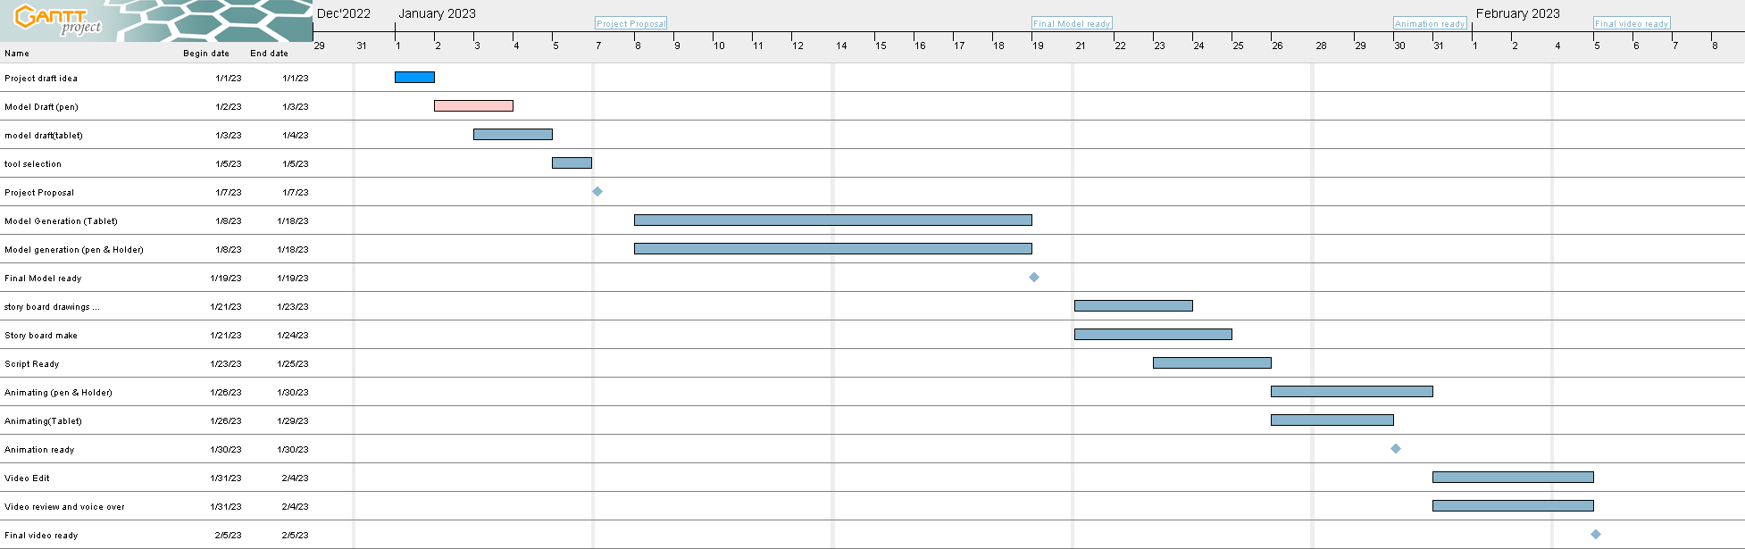

Our project starts from 1st January 2023 and final product will be ready in 5th February.

In whole project we will focus on following things :

* Model Generation
* Video story board
* Script Writtings
* Voice recordings
* Sound Design
* Animation
* Videography

**Tool :**

* Blender
* Kdenlive
* Ardour

**Project Brief:**

* 2-3 min video
* Female voice over ( Bangla )
* Suitable sound background
* 3D animation

**Hindrance :**

* Tool Selection
* Learning tools in short time