আমার দুইটা জিনিস নিয়া কাজ করতে হবে
~ ফ্রন্ট এন্ড
~ ব্যাক এন্ড ( সার্ভার সাইট )

১। ফ্রন্ট এন্ড
# এইচটিএমএল
# সিএসএস
# জাভাস্ক্রিপ্ট (React js, Angular js, Jquery )

২। ব্যাক এন্ড
( a server, an application, and a database. )

# জাভা ( স্প্রিং বুট ? Java EE, spring, struts and many more )
Java is mainly used for android development, software development and most importantly for back-end web development.

# নোড
can use javascript both at the front-end and back-end of the web application using a runtime environment.

# পিএইচপি
It is conjointly compatible with a variety of Content Management Systems and include interesting frameworks like Laravel, Symphony and CakePHP.

# রুবি অন রেইলস
Not only like other web frameworks it is simple to use and learn, but reduces your development time by 25%. RoR is suitable for every kind of industries by providing both front-end and back-end web solution just like Node.
It is a very good choice if your budget is limited and project is a long term.

# পাইথন ( জ্যাঙ্গো , ফ্লাস্ক )
nowadays prefer python because of its extensive support libraries, short learning curve, powerful integration feature and speedy productivity.

# ডট নেট
Even though it has few disadvantages like slow run-time, limited future development from Microsoft, higher cost many developers prefer this because of availability of resources, support from the larger community and multiple server platforms.

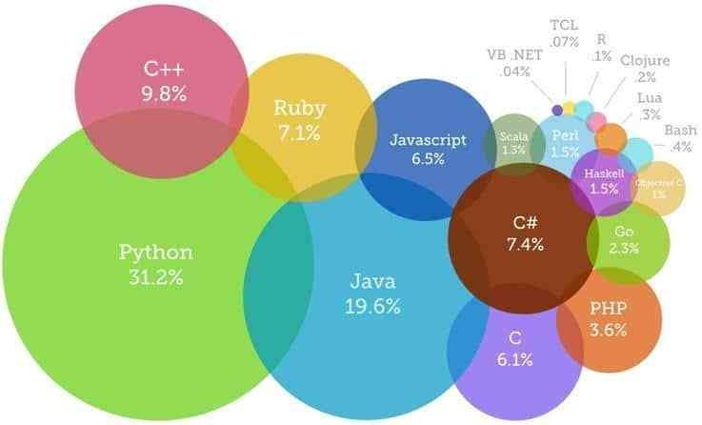
# Some companies that use python are:

- Google (Youtube)
- Facebook (Tornado)
- Dropbox.
- Yahoo.
- NASA.
- IBM.
- Mozilla.
- Quora :D. (Source: Quora)

# Amazing Features of Python:-
- Versatile Features
- Fewer Programming codes
- Easiest language for backend
- Extensive Support Libraries
- Integration Feature
- Improved Productivity
- Unique and Faster to work with Framework Django
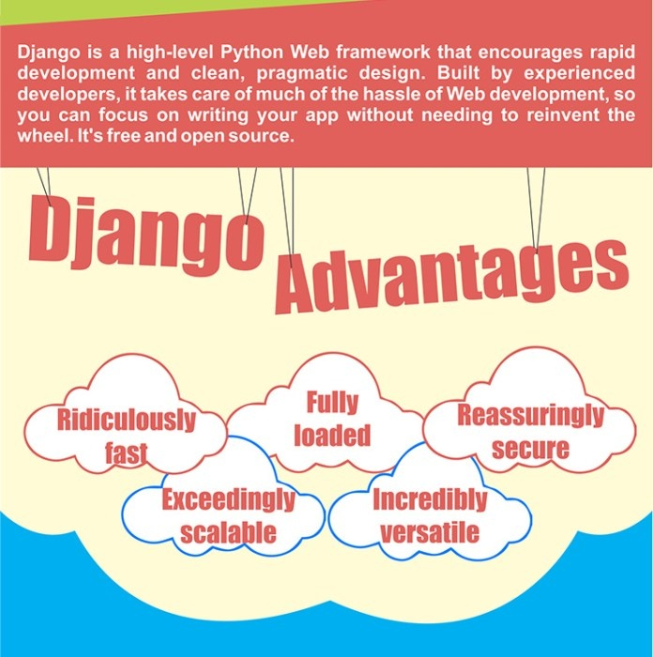

@ Personally I usually use PHP for anything simple, and Java for anything more complicated.
@ The problem with PHP is, it’s a bit rambling. The problem with Java is it doesn’t run under the world’s most common web server, Apache (technically, the Apache HTTP server — but widely known simply as “Apache”).

