CHAPTER 5
RESULT
To run project double click on ‘run.bat’ file to get below screen
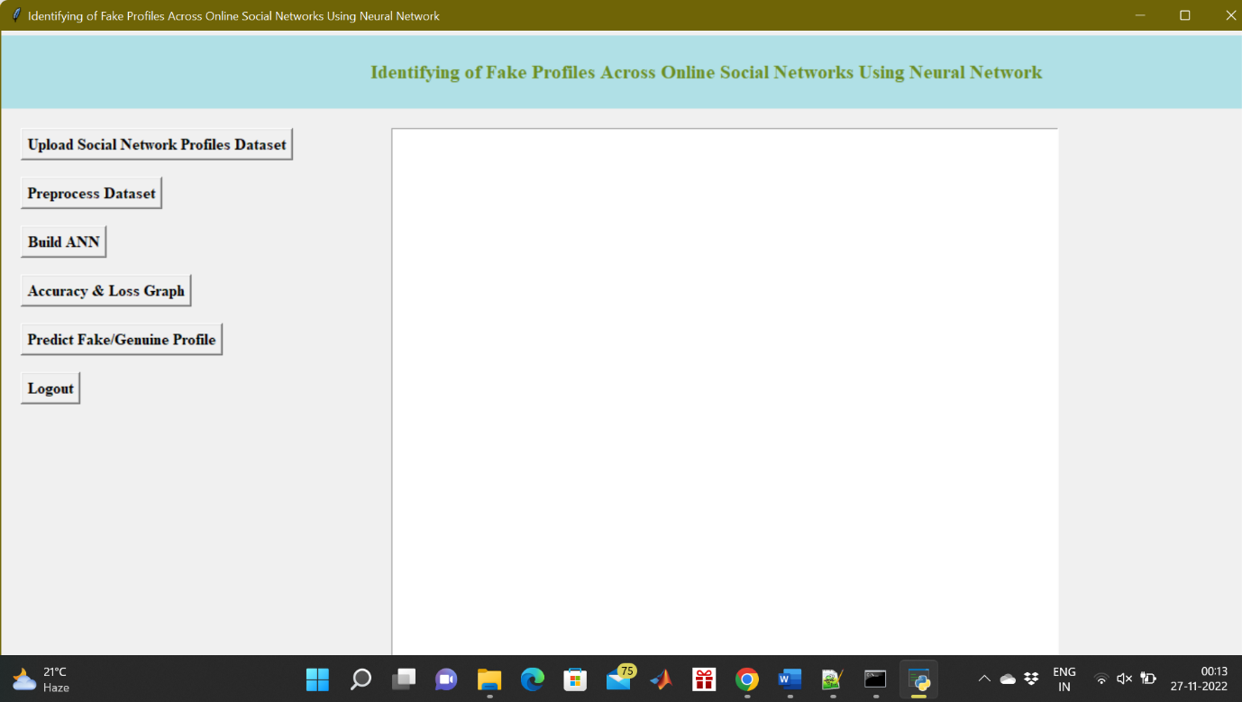
Fig.5.1 Upload Social Network Profiles Dataset
In above screen click on ‘Upload Social Network Profiles Dataset’ button and upload dataset
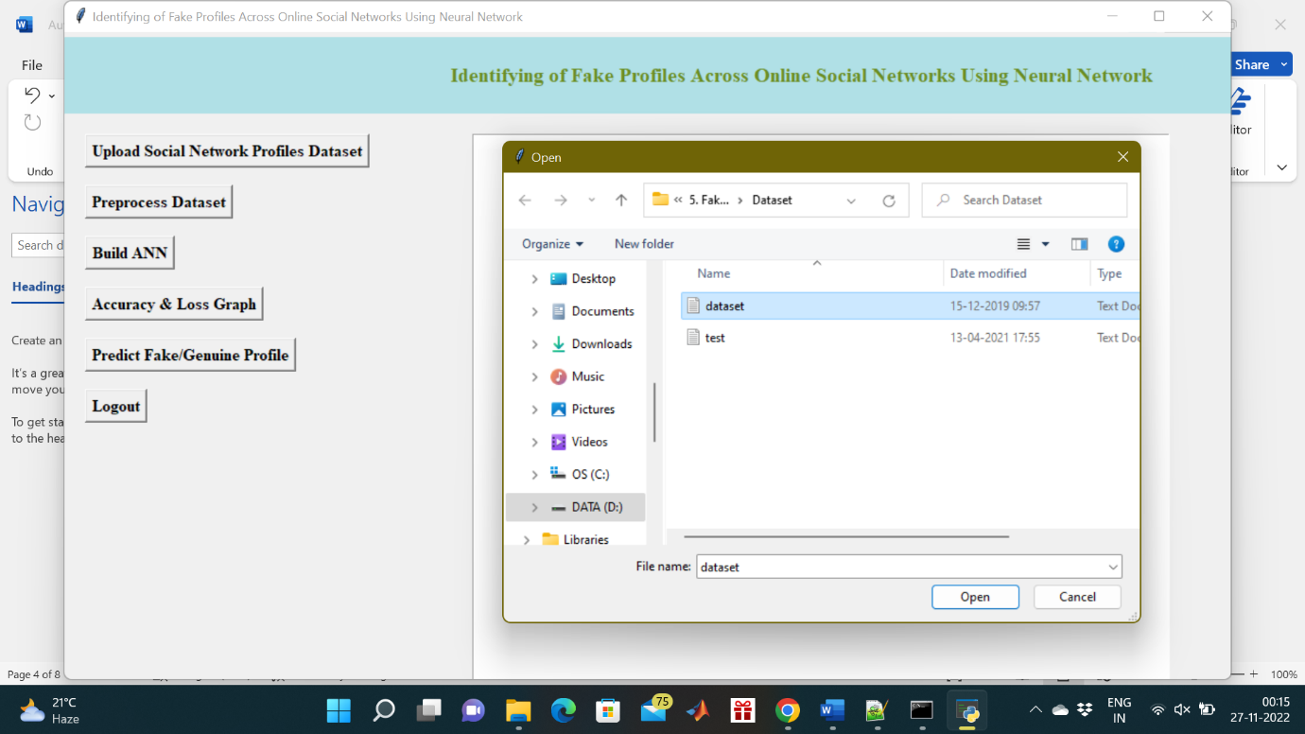
Fig.5.2 selecting and uploading ‘dataset.txt’ file
In above screen selecting and uploading ‘dataset.txt’ file and then click on ‘Open’ button to load dataset and to get below screen
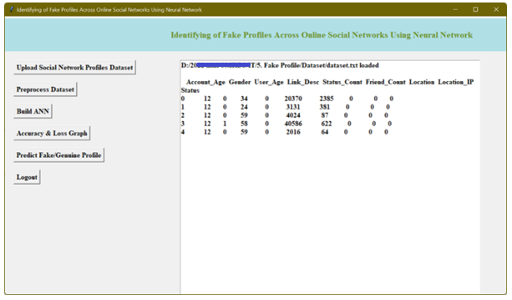
Fig.5.3 dataset loaded and displaying few records
In above screen dataset loaded and displaying few records from dataset and now click on ‘Preprocess Dataset’ button to remove missing values and to split dataset into train and test part
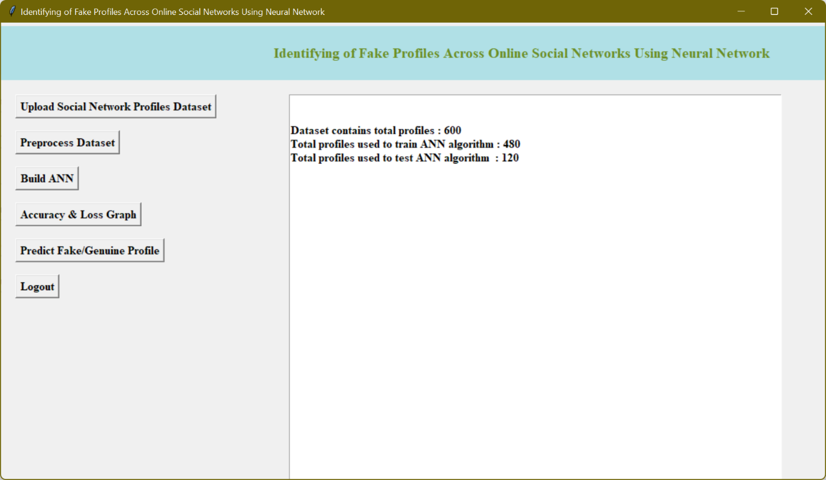
Fig.5.4 dataset contains total 600 records
In above screen we can see dataset contains total 600 records and application using 480 records for training and 120 records to test ANN and now dataset is ready and now click on ‘Run ANN Algorithm’ button to ANN algorithm
In below screen we can see ANN start iterating model generation and at each increasing epoch we can see accuracy is getting increase and loss getting decrease.
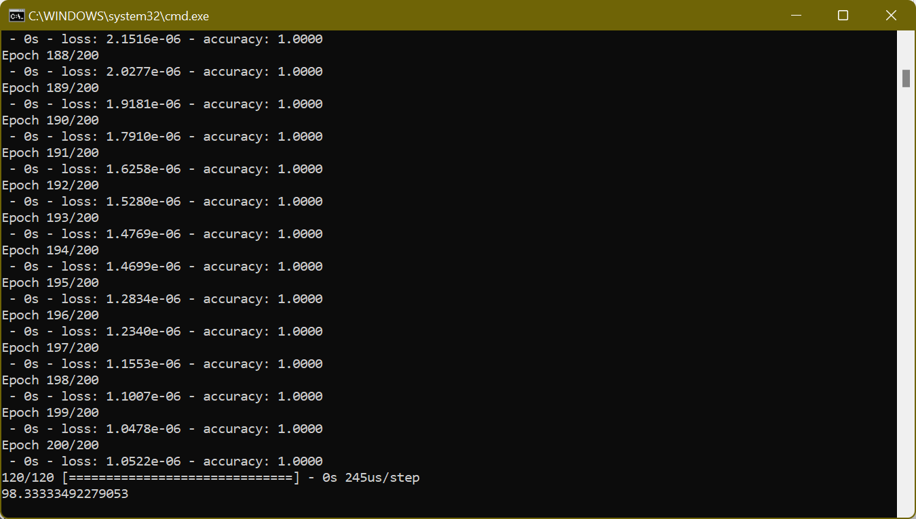
Fig.5.5 after 200 epoch ANN got 98.33% accuracy
In above screen we can see after 200 epoch ANN got 98.33% accuracy and in below screen we can see final ANN accuracy
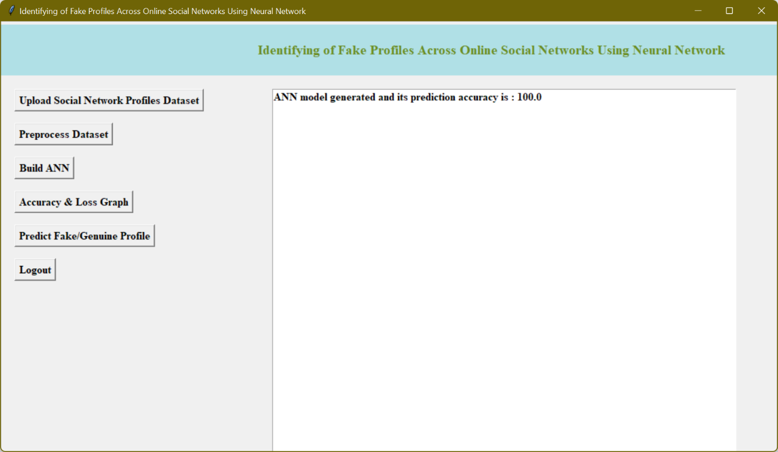
Fig.5.6 ANN model generated
In above screen ANN model generated and now click on ‘ANN Accuracy & Loss Graph’ button to get below graph
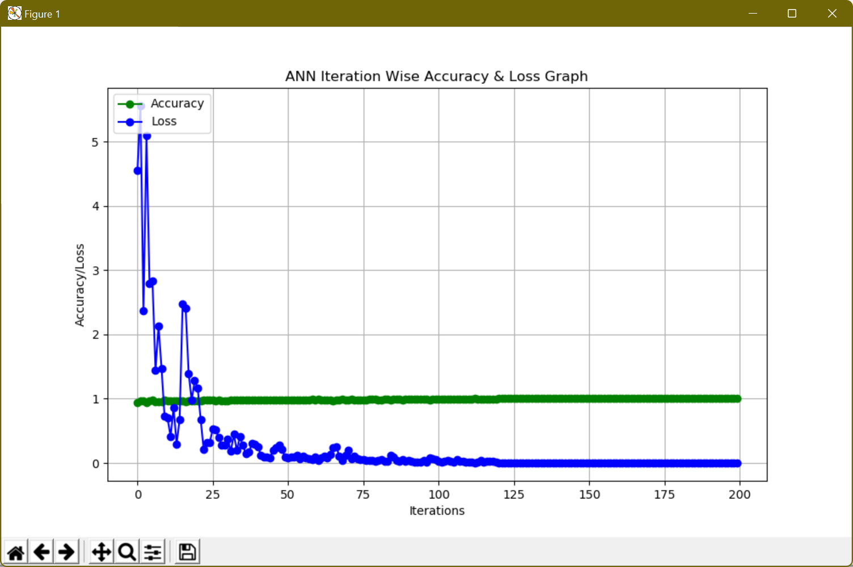
Fig.5.7 ANN Iteration wise accuracy and loss graph
In above graph x-axis represents epoch and y-axis represents accuracy/loss value and in above graph green line represents accuracy and blue line represents loss value and we can see accuracy was increase from 0.90 to 1 and loss value decrease from 7 to 0.1. Now model is ready and now click on ‘Predict Fake/Genuine Profile using ANN’ button to upload test data and then ANN will predict below result
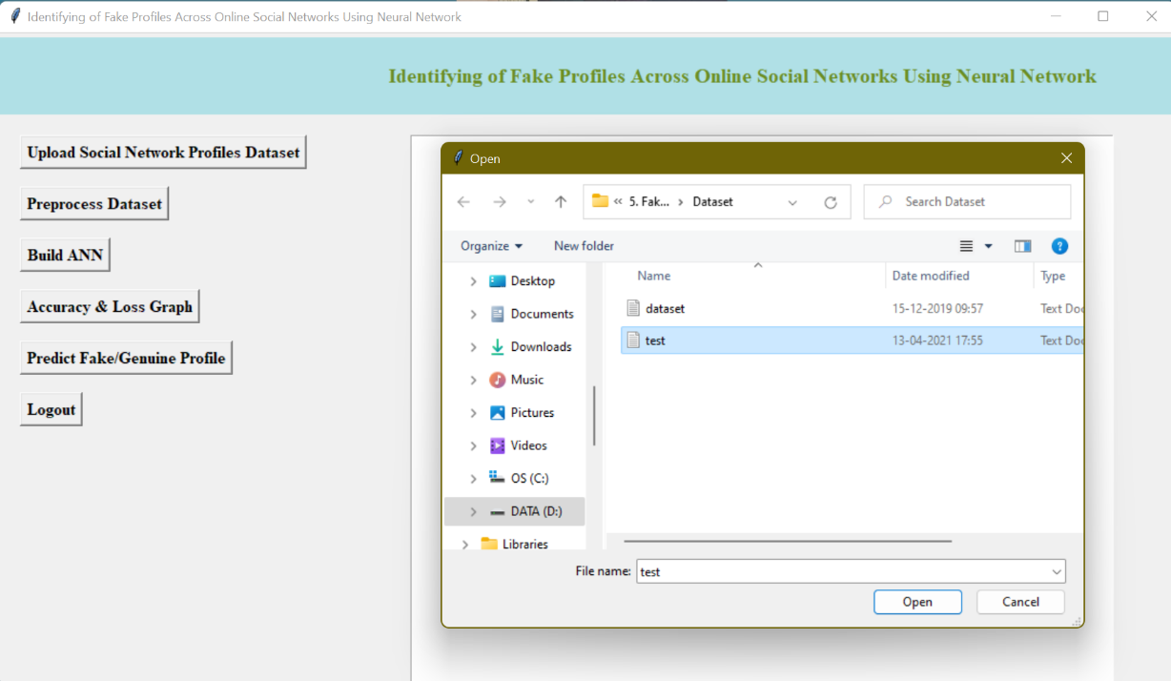
Fig.5.8 selecting and uploading ‘test.txt’ file
In above screen we are selecting and uploading ‘test.txt’ file and then click on ‘Open’ button to load test data and to get below prediction result
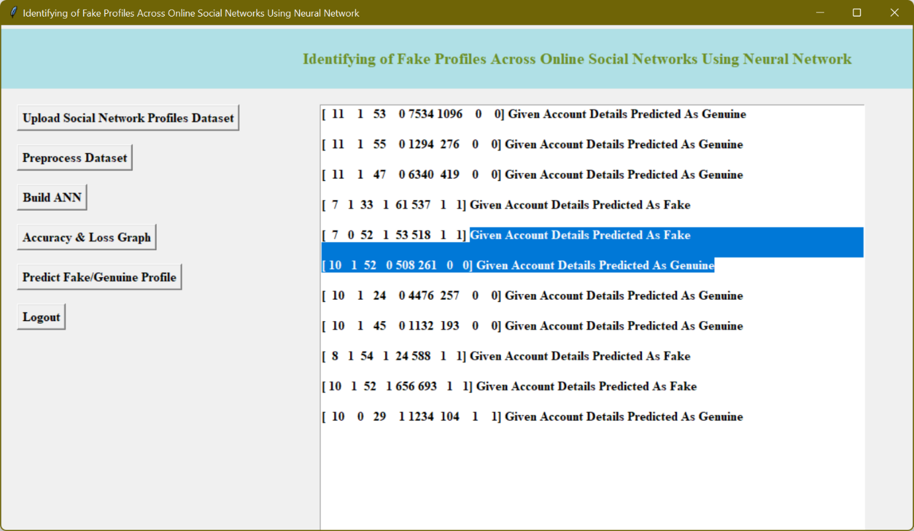
Fig.5.9 uploaded test data and after square bracket
In above screen in square bracket, we can see uploaded test data and after square bracket we can see ANN prediction result as genuine or fake

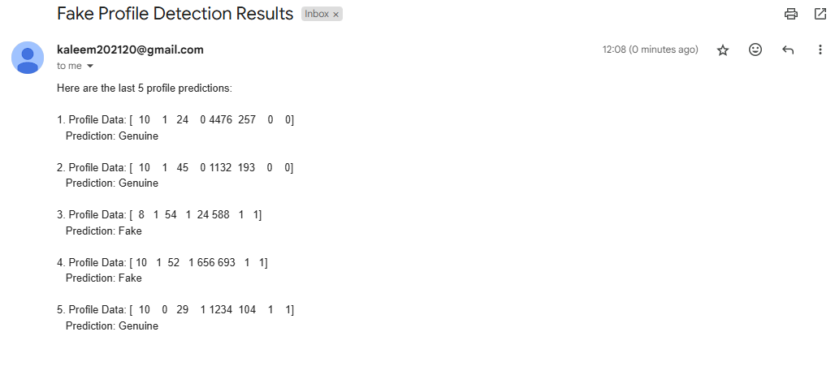
Fig: Output in Gmail
It will send results to admin/system when their email id is entered.

